Functional Specification Document

BMoney Advisor Project

Document Version: 1.6

|  |  |  |  |  |  |  |  |  |  |  |  |  |  |  |  |  |  |  |  |  |  |  |  |  |  |  |  |  |  |  |  |  |  |  |  |  |  |  |  |  |  |  |  |  |  |  |  |  |  |  |  |  |  |  |
| --- | --- | --- | --- | --- | --- | --- | --- | --- | --- | --- | --- | --- | --- | --- | --- | --- | --- | --- | --- | --- | --- | --- | --- | --- | --- | --- | --- | --- | --- | --- | --- | --- | --- | --- | --- | --- | --- | --- | --- | --- | --- | --- | --- | --- | --- | --- | --- | --- | --- | --- | --- | --- | --- | --- |
| **FSD Sign-off form**  This form is used to confirm the FSD’s accuracy, clarity and completeness, and to authorize the initial of the work.   |  |  | | --- | --- | | **Project** | BMoney Advisor Project | | Document Type | FSD | | Document Name | BMoney Advisor Project – V1.6 |   Sign-off by CMC Global   |  |  |  |  | | --- | --- | --- | --- | | Name | Designation | Signature | Date | |  |  |  |  | |  |  |  |  | |  |  |  |  |   Sign-off by BMoney   |  |  |  |  | | --- | --- | --- | --- | | Name | Designation | Signature | Date | |  |  |  |  | |  |  |  |  | |  |  |  |  | |  |  |  |  | |  |  |  |  | |  |  |  |  | |  |  |  |  |   -----------------End of Sign-off form-------------------- |

Contents

1 Introduction 6

1.1 Purpose 6

1.2 Current state of the business 6

1.3 Future state of the business 6

1.4 Intended audience 6

1.5 Definitions, Acronyms and Abbreviations 6

2 Phase Overview 7

3 Detailed process 8

3.1 Channel setup 8

3.2 Product setup 8

3.3 Approval process 8

3.4 Application onboarding 8

3.4.1 Main activity flow 8

3.4.2 Registration 10

User Story 1 - Registration 10

3.4.3 Login 19

User story 2 - Authentication/Login 19

User story 3 - Authentication/RM forgot password 26

User story 4 – RM/Request reactivate account 34

3.4.4 HNWI KYC Management 37

User story 5 – Register for investors 37

User story 5.1 – Investor/ Confirm KYC register 62

User story 6 – Update KYC data for investors 83

User story 6.1 – Investor/ Confirm KYC update 94

3.4.5 Transaction Management 115

User Story 7 – View transaction list 116

User Story 8 – Create instruction/Subscription 124

User story 8.1 – Investor/ Confirm transaction confirmation (Subscription) 134

User Story 9 – Create instruction/Redemption 142

User story 9.1 – Investor/ Confirm transaction confirmation (Redemption) 152

User Story 10 – Create Instruction/Switching 160

User story 10.1 – Investor/ Confirm transaction confirmation 171

3.4.6 Portfolio management 180

User Story 11 – View investor lists 180

User Story 12 – View investor info 188

User Story 13 – View investor’s portfolio detail 191

User Story 14 – View Investor’s Transaction 197

3.4.7 Product management 202

User Story 15 – View/Filter product list 202

User Story 15.1 – View product detail 206

3.4.8 Leads management 211

User Story 16 – RM/Create new lead 211

User story 17 – Register for investors from leads 216

3.4.9 Dashboard management 255

User story 18 – Dashboard Authentication/Login 255

User story 19 - Authentication/ Dashboard user forgot password 257

User Story 20 – Admin/Create dashboard users 262

User Story 21 – Admin/Deactivate-Reactivate dashboard user 265

User Story 22 – Admin/Deactivate-Reactivate RM user 267

User Story 23 – Admin/Manage RM registration request 269

User Story 24 – Admin/Manage investor request 272

User Story 25 – Admin/Manage instruction 274

User Story 26 – Admin/Reassign RM 276

3.4.10 Company setup 279

User Story 27 – Admin/Manage new company creation 279

User Story 28 – Admin/Update company information 282

User Story 29 – Admin/Investor status check 284

3.4.11 Generic function 286

User Story 30 – Logout 286

User story 31 – Setting 287

User story 32 – View FAQ/User manual 289

User story 33 – Admin/Update FAQ 290

# Introduction

## Purpose

## Current state of the business

## Future state of the business

## Intended audience

## Definitions, Acronyms and Abbreviations

# Phase Overview

# Detailed process

## Channel setup

## Product setup

## Approval process

## Application onboarding

### Main activity flow

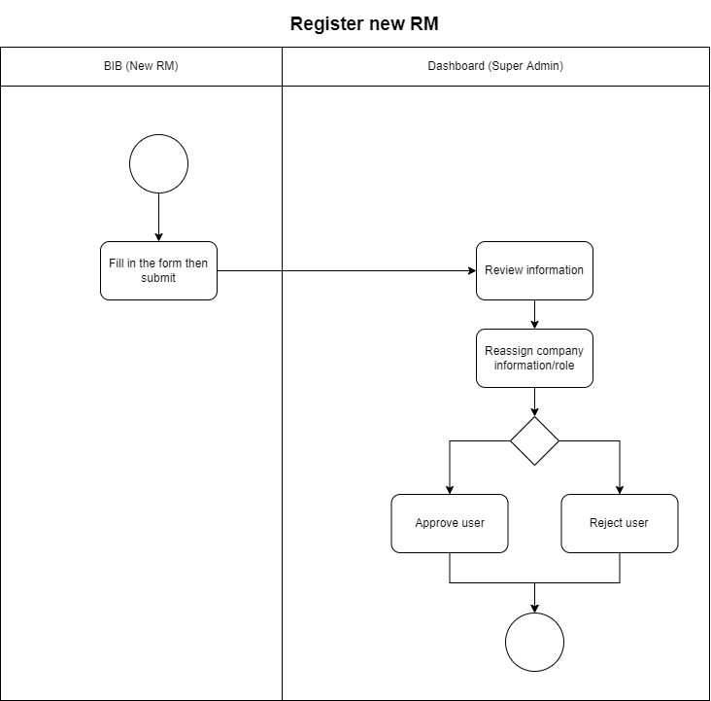

**Reference User Story:**

**User Story 1 - Registration**

User Story 24 – Admin/Manage RM registration request

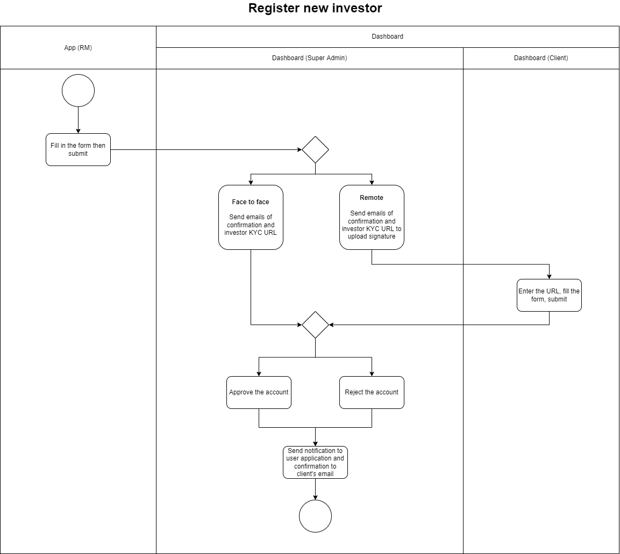

User story 5 – Register for investors

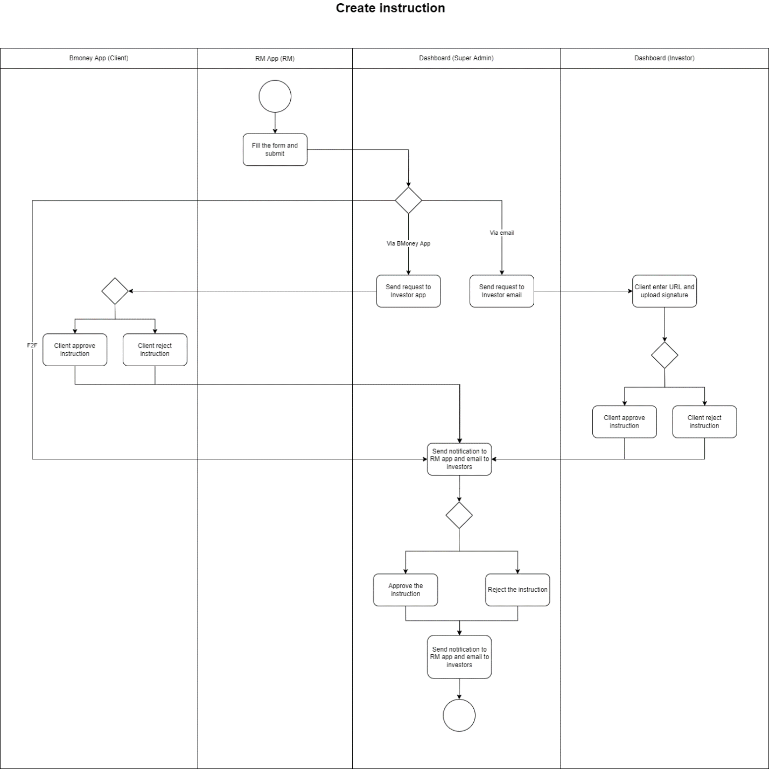

User Story 8 – Create instruction/Subscription

User Story 9 – Create instruction/Redemption

User Story 10 – Create Instruction/Switching

User Story 19 – Admin/Manage instruction

### Registration

#### ****User Story 1 - Registration****

As a Relationship manager, from landing page, I want to register to BMoney application to use the system

**Acceptance criteria**

1. In OTT page:

* User can tap on “Resend your OTT” to request new OTT via SMS
* If user enter wrong OTT for 3 times, user’s account will be deactivated automatically
* If user don’t receive verification code, user will have 4 times to request OTT resend and can request again after 1 hour. Retrigger of OTT resending is prolonged from:
  + 60 seconds (second trial)
  + 120 seconds (third trial)
  + 300 seconds (fourth trial)
  + Prevent the trigger for upcoming 1 hour, reset the trial
* OTT will expire after 15 minutes since generated

1. Password setting rules:

* Password length: 8-20 characters
* Password complexity: Include at least one (1) small cap, big cap, number, symbol
* Password needs to be changed every 90 days
* Password history: Last 5 used password cannot be used

1. If faceID / touchID failed 3 times, password will be required
2. **Page flow**

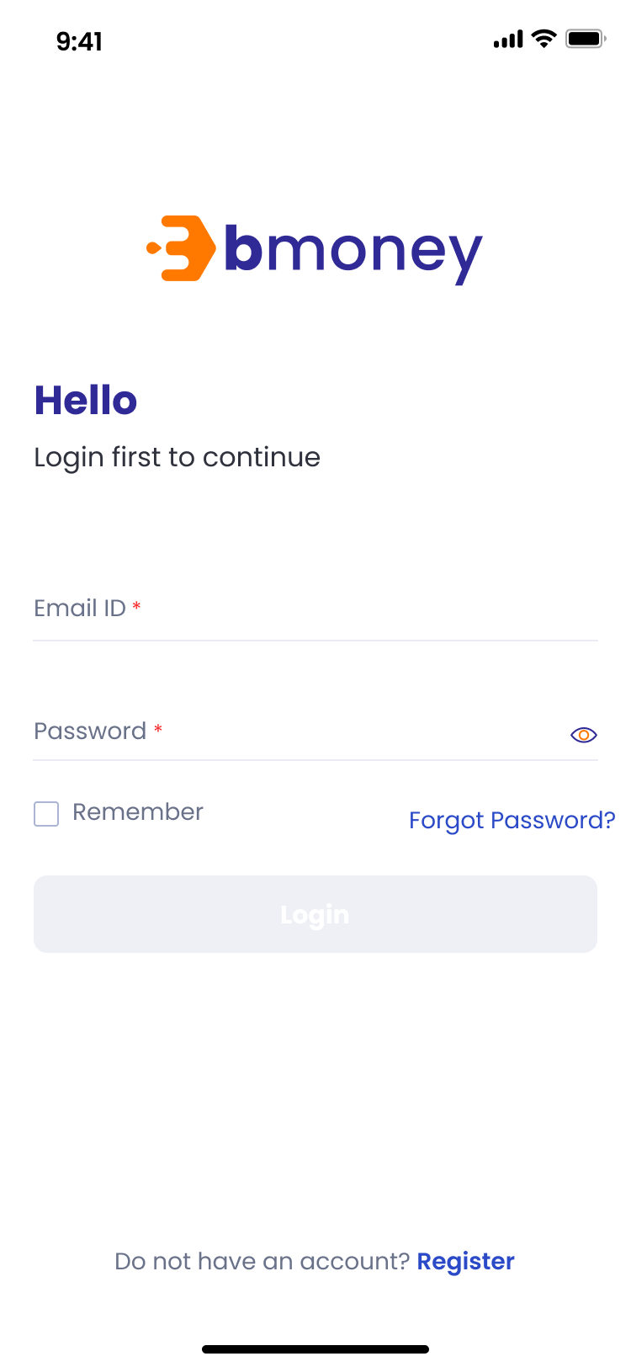 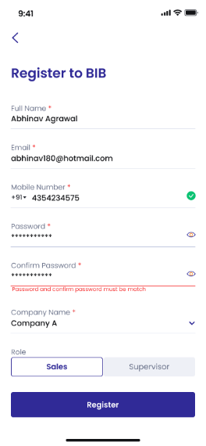

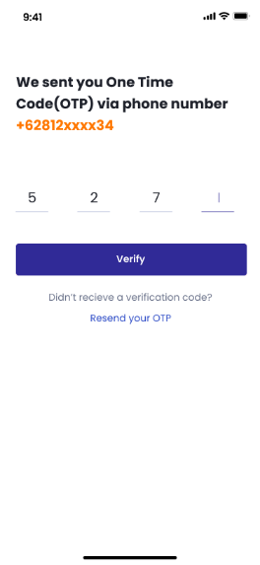 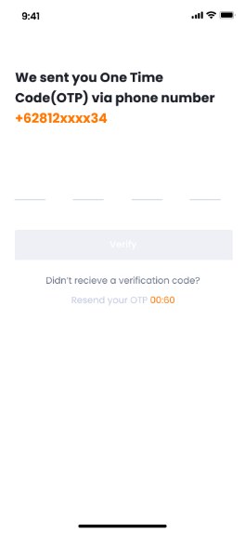

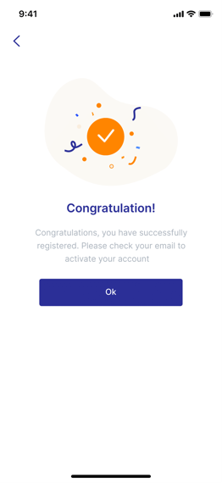 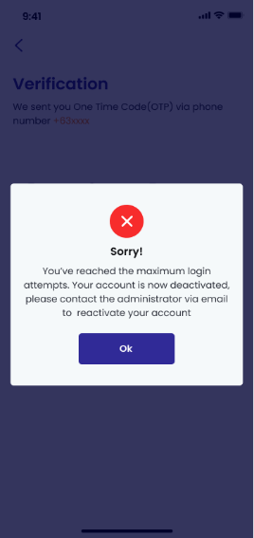

1. **Authorized user**

New RM

1. **Entry point**

Login page

1. **Exit point**

‘Congratulations’ MSG Screen / ‘Deactivated’ MSG Screen

1. **Process flow**
2. User will trigger the BMoney App, then the login page will be shown immediately
3. User will tap on ‘Register’ link button to enter the Register page
4. User will fill in all required fields then submit through ‘Register’ button to enter the OTT page
5. In this page, user can tap on 'Resend your OTT’ to request new OTT via SMS for 2 more times

* If user enter wrong OTT for 1 time, there will be notification: ‘Wrong OTT entered. Please try again. 2 attempts remaining’
* If user enter wrong OTT for 2 times, there will be notification: ‘Wrong OTT entered. Please try again. 1 attempt remaining’
* If user enter wrong OTT for 3 times, user’s account will be automatically deactivated and user will enter ‘Deactivated’ MSG Screen
* If user enter OTT correctly within 3 attempts, user will enter ‘Congratulations’ MSG Screen

1. **Fields and Validations and Verifications**

|  |  |  |  |  |  |  |
| --- | --- | --- | --- | --- | --- | --- |
| **Field** | **Field Type** | **Description** | **Field Length** | **Mandatory** | **Validation** | **In-Line Error Message** |
| BMoney Logo | Picture | Logo | - | Yes |  |  |
| Hello | Label | Hello label  Hello  Login first to continue | - | Yes |  |  |
| Email ID | Text input | Email address  It has to be a valid registered email address on BMoney app  Alphanumeric & symbol keypad required | - | Yes | 1. Must be a valid code of an active user 2. Must be Not Empty | 1. Please check your login information. 2. This field cannot be empty |
| Password | Alphanumerical input | It has to be in accordance to the password rules.  Text is hidden.  Alphanumeric & symbol keypad required | - | Yes | 1. Must be a valid code of an active user 2. Must be Not Empty | 1. Please check your login information. 2. This field cannot be empty |
| Remember | Check box | Tick to remember login info on this device | - | Yes |  |  |
| Forgot password | Button link | Tap on to enter Verification page | - | Yes |  |  |
| Hide/Unhide | Icon | Click icon to hide/unhide password.  Default is hide password | - | Yes |  |  |
| Login | Button | Button to trigger the Login function.  If login successfully, go to Home page  If fail, stay login page and display MSG | - | Yes | All above mandatory fields must be filled in the correct format with valid value to get redirected to home page. | Please check your login information. |
| Login in with fingerprint (TouchID) | Button | 1. This feature will base on System Settings of Phone  2. For the device support both, the default set is faceID  3.If faceID / touchID failed 3 times, password will be required | - | Yes |  |  |
| Login in with FaceID | Button | - | Yes |  |  |
| Full name | Text input | Full name of user  Alphanumeric keypad required | String (150) | Yes | Must not be Empty | 1. This field cannot be empty |
| Mobile phone number | Numeric input | Indonesian phone number  Numeric keypad required | String (10) | Yes | Must not be Empty | This field cannot be empty |
| Email address | Text input | Email address  Alphanumeric & symbol keypad required | String (150) | Yes | 1. Must not be Empty 2. Must not be used before by other users | 1. This field cannot be empty 2. This email address is used before |
| Company name | Auto complete | Company name  The data for this auto complete are from Company Setup in company  Only active companies' name included |  |  | 1. Start suggesting after first character inputted 2. Must not be empty | 1. Please enter a registered company name 2. This field cannot be empty |
| Role option | Tab | Role option, including:   * Sales (default) * Supervisor | - | Yes |  |  |
| Password | Text input | Agent password  It has to be in accordance to the password rules.  Text is hidden.  Alphanumeric keypad required | String (20) | Yes | 1. Password and confirm password must be match 2. Must not be Empty 3. Must follow password rules (Details in Acceptance criteria) | 1. Password and confirm password must be match 2. This field cannot be empty 3. This password does not satisfy the current policy requirements (i) |
| (i) | Hover button | Hover to this button to open the note contains password rules:  1. The password must be 8 to 20 characters  2. The password must include at least one (1) uppercase, one (1) lowercase, one (1) number, one (1) symbol  3. The password must be changed every 90 days  4. Last 5 used password cannot be used | - | Yes |  |  |
| Confirm password | Text input | Agent password  It has to be in accordance to the password typed before.  Text is hidden.  Alphanumeric keypad required | String (20) | Yes | 1. Password and confirm password must be match 2. Must not be Empty | 1. Password and confirm password must be match 2. This field cannot be empty |
| Hide/Unhide | Icon | Click icon to hide/unhide password.  Default is hide password | - | Yes |  |  |
| Register | Button | Button to submit information filled above | - | Yes | All above mandatory fields must be filled in the correct format with valid value to enable this button |  |
| Verification label | Label | Verification label  Verification  We sent you One Time Password (OTT) via phone number [RM registered phone number] | - | Yes |  |  |
| OTT code | Numeric input | It has to be a valid OTT code  Numeric keypad required | String (4) | Yes | 1. Must be a valid OTT code | 1. Please provide valid OTT Code. |
| Verify button | Button | Button to submit inputted OTT Code to request change password | - | Yes | All above mandatory fields must be filled in valid value to enable this button | 1. Wrong OTT entered. Please try again (2 attempts remaining) 2. Wrong OTT entered. Please try again (1 attempts remaining) |
| Didn’t receive a verification code? | Text field | Didn’t receive a verification code? | - | Yes |  |  |
| Resend your OTT | Button link | Button link to request new OTT code | - | Yes | Follow acceptance criteria | Try again in [countdown number] seconds |
| button | Button | button  Tap on to go back to the previous page | - | Yes |  |  |
| ‘Congratulations’ MSG Screen | Screen | Congratulations  You have successfully registered. Please check your email to activate your account  User can tap on OK button to go back to Log in page | - | Yes |  |  |
| ‘Deactivated’ MSG Screen | Label | Sorry  You’ve reached the maximum login attempts. Your account is now deactivated, please contact the administrator via email to reactivate your account  User can tap on OK button to go back to Log in page | - | Yes |  |  |

1. **Messaging Requirement**

Follow the table above

1. **Reference User Story**

N/A

### Login

#### ****User story 2 - Authentication/Login****

As an existing active RM, from Landing page, I want to log into BMoney system

**Acceptance Criteria**

1. Login session of the RM user is terminated after 12 hours of login

Upon termination, user need to reinsert their password.

1. If the device is not yet trusted, OTT (via SMS) is sent to users for 2FA validation
2. **Page flow**

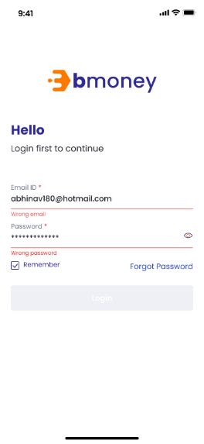 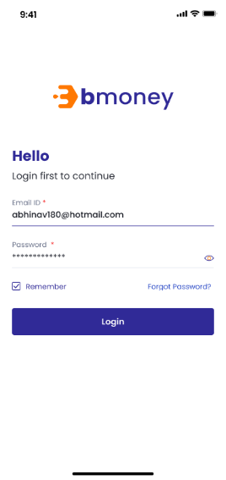 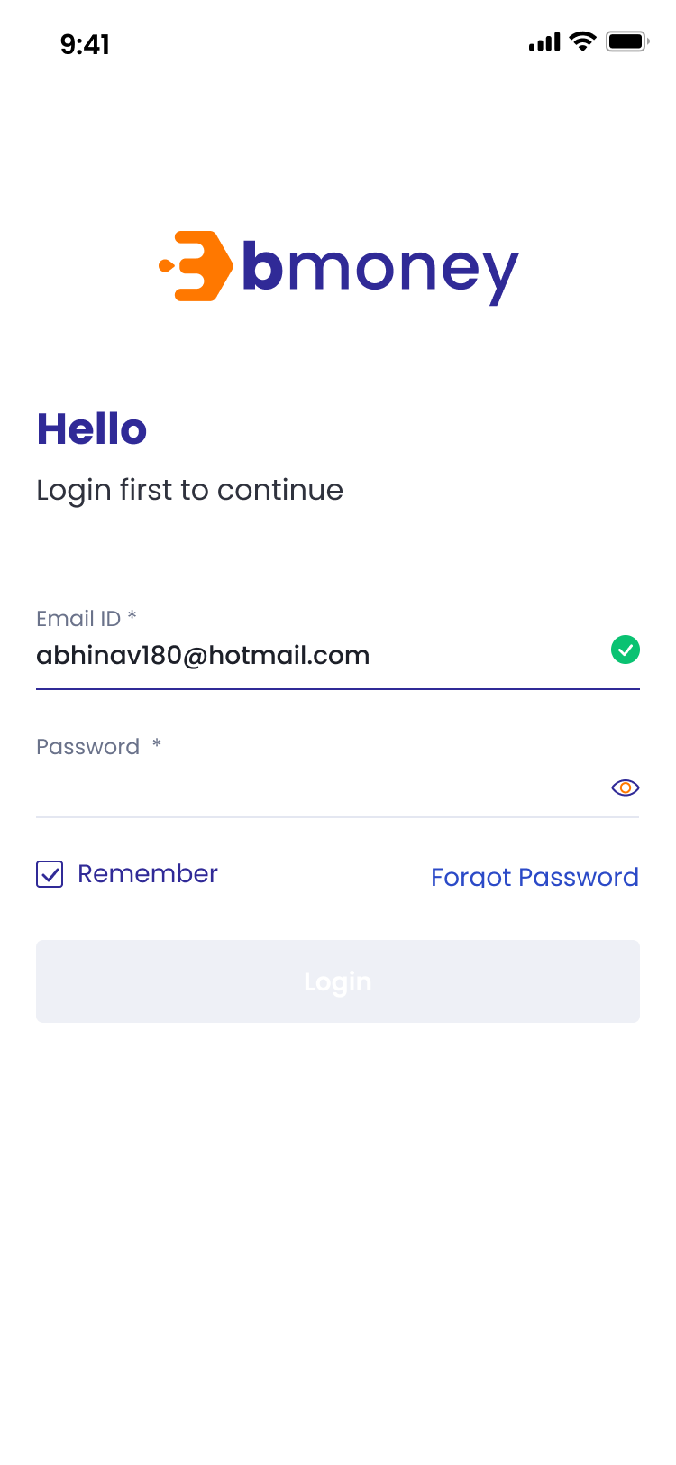

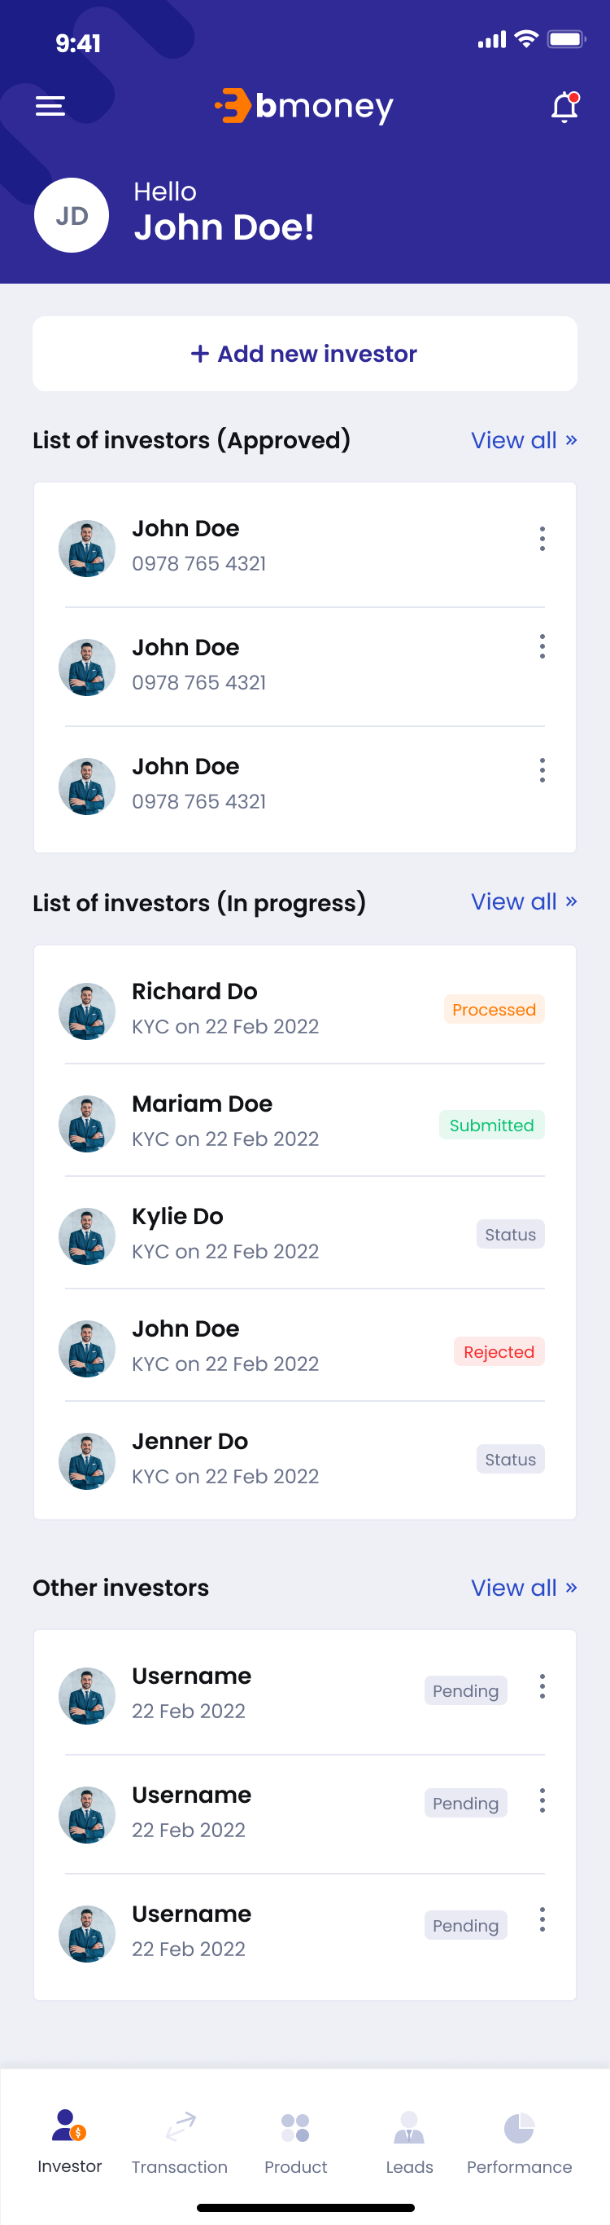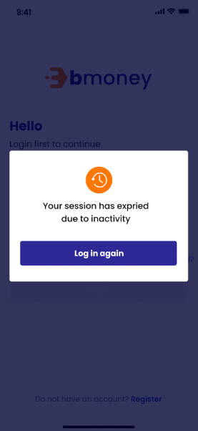

1. **Authorized User**

Existing active Relationship Manager

1. **Entry Point**

Login page

1. **Exit Point**

Home page/Investors tab

1. **Process Flow**
2. User will trigger the BMoney App then enter the Login page
3. In this page, user can tap on “Forgot Password” to request change password and can tick on “Remember” to email address for next login session
4. Two options to login:

* User enter Email and Password then tap on Login.

- If the inputs are valid, user will enter Home page.

- If the inputs are invalid, user will have maximum 3 times to retry logging in before the account deactivated

* + User tap on Login in with fingerprint (TouchID)/Login in with FaceID to use this function

1. **Fields and Validations and Verifications**

|  |  |  |  |  |  |  |
| --- | --- | --- | --- | --- | --- | --- |
| **Field** | **Field Type** | **Description** | **Field Length** | **Mandatory** | **Validation** | **In-Line Error Message** |
| Logo | Logo | BMoney Logo | - | Yes |  |  |
| Hello | Label | Hello  Login first to continue | - | Yes |  |  |
| Email ID | Alphanumeric input | Email address  It has to be a valid registered email address on BMoney app  Alphanumeric keypad required | - | Yes | 1. Must be a valid Email ID of an active RM 2. Must be Not Empty | 1. Please check your login information. 2. This field cannot be empty |
| Password | Alphanumeric input | It has to be in accordance to the password rules.  Text is hidden.  Alphanumeric keypad required | - | Yes | 1. Must be a valid password of an active RM 2. Must be Not Empty | 1. Please check your login information. 2. This field cannot be empty |
| Remember | Check box | Tick to remember login email ID on this device | - | Yes |  |  |
| Forgot password | Button link | Tap on to enter Forgot password page | - | Yes |  |  |
| Hide/Unhide | Icon | Click icon to hide/unhide password.  Default is hide password | - | Yes |  |  |
| Login | Button | Button to trigger the Login function.  If login successfully, go to Home page  If fail, stay login page and display MSG | - | Yes | All above mandatory fields must be filled in the correct format with valid value to get redirected to home page. | Please check your login information. |
| Login in with fingerprint (TouchID) | Button | 1. This feature will base on System Settings of Phone  2. For the device support both, the default set is faceID  3.If faceID / touchID failed 3 times, password will be required |  | Yes |  |  |
| Login in with FaceID | Button |  | Yes |  |  |
|  | Button | Tap on to open Control panel | - | Yes |  |  |
|  | Button | Tap on to open notification list | - | Yes |  |  |
| Hello | Label | Hello  [Full_Name] | - | Yes |  |  |
| Gravatar | Avatar | Avatar of the user | - | Yes |  |  |
| Add new investor | Button | Tap on to enter ‘Register new investor’ page | - | Yes |  |  |
| **List of investors approved panel** | | | | | | |
| List of investors approved panel | Label | List of investors approved panel label | - | Yes |  |  |
| Gravatar | Avatar | Avatar of the user | - | Yes |  |  |
| Full name | Text field | Full name of investor | - | Yes |  |  |
| Phone number | Numeric field | Phone number of investor | - | Yes |  |  |
| button | Button | Tap on to open action list of investor | - | Yes |  |  |
| View all | Link button | Tap on to view list of all approved investors | - | Yes |  |  |
| **List of investors in progress panel** | | | | | | |
| List of investors in progress | Label | List of investors in progress label | - | Yes |  |  |
| Gravatar | Avatar | Avatar of the user | - | Yes |  |  |
| Full name | Text field | Full name of investor | - | Yes |  |  |
| KYC Date | Text field | KYC on [KYC Date] | - | Yes |  |  |
| Status | Text field | Status of investors | - | Yes |  |  |
| View all | Link button | Tap on to view list of all investors in progress | - | Yes |  |  |
| **List of other investors panel** | | | | | | |
| List of investors in progress | Label | List of investors in progress label | - | Yes |  |  |
| Gravatar | Avatar | Avatar of the user | - | Yes |  |  |
| Full name | Text field | Full name of investor | - | Yes |  |  |
| KYC Date | Text field | [KYC Date] | - | Yes |  |  |
| Status | Text field | Status of investors | - | Yes |  |  |
| View all | Link button | Tap on to view list of all investors | - | Yes |  |  |
| **Home panel** | | | | | | |
| Investor | Button | Tap on to go to Home page – Investor panel | - | Yes |  |  |
| Transaction | Button | Tap on to go to Home page – Transaction panel | - | Yes |  |  |
| Leads | Button | Tap on to go to Home page – Leads panel | - | Yes |  |  |
| Report | Button | Tap on to go to Home page – Report panel | - | Yes |  |  |
| Session expired label | Label | Your session has expired due to inactivity | - | Yes |  |  |
| Email ID | Alphanumeric input | Email address  It has to be a valid registered email address on BMoney app  Alphanumeric keypad required | - | Yes | 1. Must be a valid code of an active Agent 2. Must be Not Empty | 1. Please check your login information. 2. This field cannot be empty |
| Password | Alphanumeric input | It has to be in accordance to the password rules.  Text is hidden.  Alphanumeric keypad required | - | Yes | 1. Must be a valid code of an active Agent 2. Must be Not Empty | 1. Please check your login information. 2. This field cannot be empty |
| Login | Button | Button to trigger the Login function.  If login successfully, go to Home page  If fail, stay login page and display MSG | - | Yes | All above mandatory fields must be filled in the correct format with valid value to get redirected to home page. | Please check your login information. |
| Login in with fingerprint (TouchID) | Button | 1. This feature will base on System Settings of Phone  2. For the device support both, the default set is faceID  3.If faceID / touchID failed 3 times, password will be required | - | Yes |  |  |
| Login in with FaceID | Button | - | Yes |  |  |

1. **Messaging Requirement**

Follow the table above

1. **Reference User Story**

N/A

#### User story 3 - Authentication/RM forgot password

As an existing RM, I forgot password when logging into BMoney app, I want to have a text link ‘Forgot Password’ so that I can change my password to login to the system

**Acceptance Criteria**

1- The “Verify” button will be enabled if all required fields are entered

2- The “Update” button will be enabled if all required fields are entered

3- In OTT page:

* User can tap on “Resend your OTT” to request new OTT via SMS
* If user enter wrong OTT for 3 times, user’s account will be deactivated automatically
* If user don’t receive verification code, user will have 4 times to request OTT resend and can request again after 1 hour. Retrigger of OTT resending is prolonged from:
  + 60 seconds (second trial)
  + 120 seconds (third trial)
  + 300 seconds (fourth trial)
  + Prevent the trigger for upcoming 1 hour, reset the trial
* OTT will expire after 15 minutes since generated

4- Password setting rules:

* Password length: 8 -20 characters
* Password complexity: Include at least one (1) small cap, big cap, number, symbol
* Password needs to be changed every 90 days
* Password history: Last 5 used password cannot be used

5- Log in first to turn on FaceID/TouchID on the Settings

6- If there is a green tick mark meaning the email is valid, the TouchID/FaceID will be displayed

1. **Page Flow**

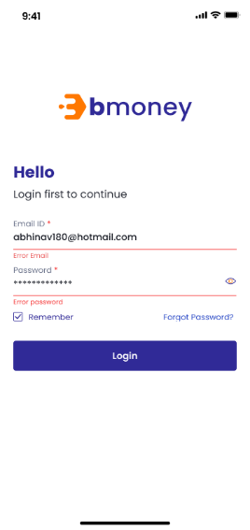 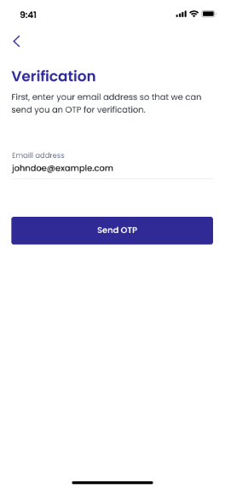 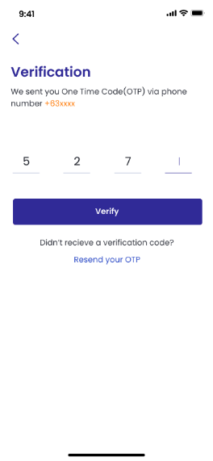 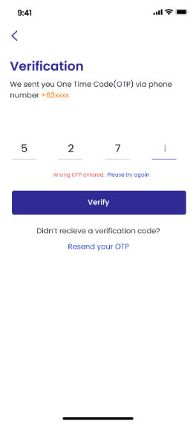

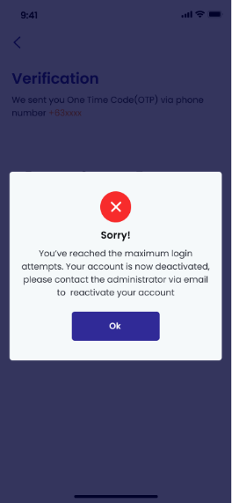 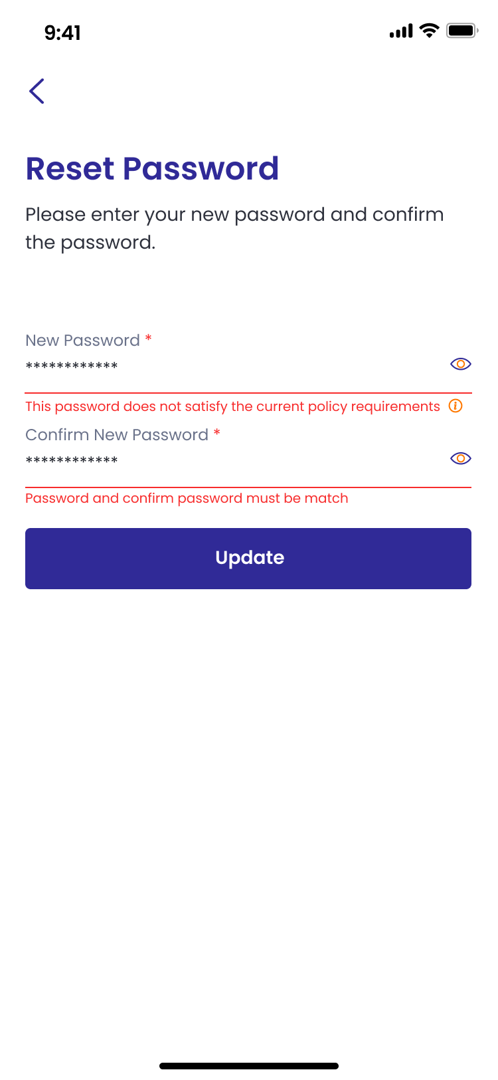 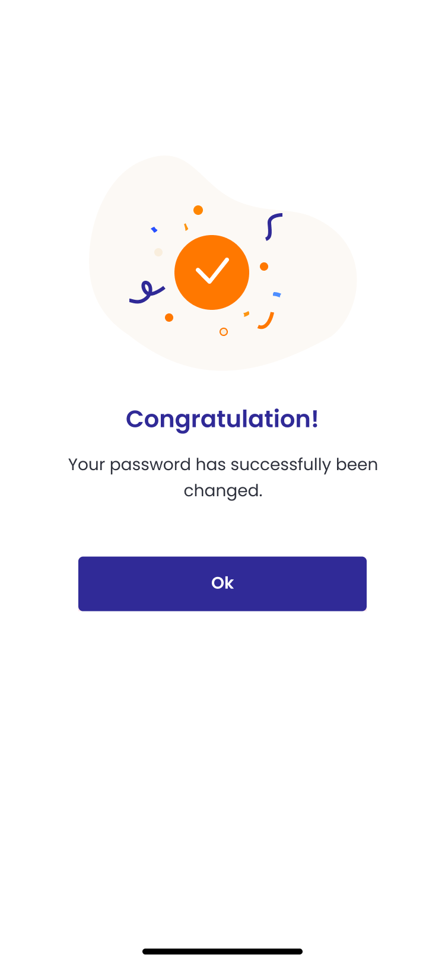

1. **Authorized User**

Existing active RM

1. **Entry Point**

Login Page

1. **Exit Point**

MSG page: Please contact admin

1. **Process Flow**
2. At login page, if user forgets current password, user will tap on “Forgot Password” hyperlink text, there will be “Verification” screen.
3. On Verification screen, user will have to input valid OTT Code sent to his/her registered phone number. If user inputs invalid value, an in-line error message will be shown and he/she can tap on “Resend OTT” to request new OTT via SMS for 2 more times

* If user enter wrong OTT for 1 time, there will be notification: ‘Wrong OTT entered. Please try again. 2 attempts remaining’
* If user enter wrong OTT for 2 times, there will be notification: ‘Wrong OTT entered. Please try again. 1 attempt remaining’
* If user enter wrong OTT for 3 times, user’s account will be automatically deactivated and user will enter ‘Deactivated’ MSG Screen

1. If user enter OTT correctly within 3 attempts, user will enter ‘Reset password’ page. User will type new password and confirm new password. If the password and new password do not match, an in-line error message will be shown
2. By hitting “Update” button, user will enter ‘MSG screen: Update password successfully’ page and be notified to contact admin to activate new password
3. User will tap “OK” to return to login page
4. **Fields and Validations and Verifications**

|  |  |  |  |  |  |  |
| --- | --- | --- | --- | --- | --- | --- |
| **Field** | **Field Type** | **Description** | **Field Length** | **Mandatory** | **Validation** | **In-Line Error Message** |
| BMoney Logo | Picture | Logo | - | Yes |  |  |
| Hello | Label | Hello label  Hello  Login first to continue | - | Yes |  |  |
| Email ID | Text input | Email address  It has to be a valid registered email address on BMoney app  Alphanumeric keypad required | - | Yes | 1. Must be a valid code of an active Agent 2. Must be Not Empty | 1. This email is not registered 2. Please check your login information. 3. This field cannot be empty |
| Password | Alphanumerical input | It has to be in accordance to the password rules.  Text is hidden.  Alphanumeric keypad required | - | Yes | 1. Must be a valid code of an active Agent 2. Must be Not Empty | 1. Please check your login information. 2. This field cannot be empty |
| Remember | Check box | Tick to remember login info on this device |  | Yes |  |  |
| Forgot password | Button link |  | - | Yes |  |  |
| Hide/Unhide | Icon | Click icon to hide/unhide password.  Default is hide password | - | Yes |  |  |
| Login | Button | Button to trigger the Login function.  If login successfully, go to Home page  If fail, stay login page and display MSG | - | Yes | All above mandatory fields must be filled in the correct format with valid value to get redirected to home page. | Please check your login information. |
| Login in with fingerprint (TouchID) | Button | 1. This feature will base on System Settings of Phone  2. For the device support both, the default set is faceID  3.If faceID / touchID failed 3 times, password will be required | - | Yes |  |  |
| Login in with FaceID | Button | - | Yes |  |  |
| Verification label | Label | Verification label  Verification  We sent you One Time Password (OTT) via phone number [RM registered phone number] | - | Yes |  |  |
| OTT code | Numeric input | It has to be a valid OTT code  Numeric keypad required | String(4) | Yes | 1. Must be a valid OTT code 2. Must be Not Empty | 1. Please provide valid OTT Code. 2. This field cannot be empty |
| Verify button | Button | Button to submit inputted OTT Code to request change password | - | Yes | All above mandatory fields must be filled in valid value to enable this button | 1. Wrong OTT entered. Please try again (2 attempts remaining)   Wrong OTT entered. Please try again (1 attempts remaining) |
| Didn’t receive a verification code? | Text field | Didn’t receive a verification code? | - | Yes |  |  |
| Resend your OTT | Button link | Button link to request new OTT code | - | Yes | User can only press 1 time every 60 seconds |  |
| button | Button | button  Tap on to go back to the previous page | - | Yes |  |  |
| Reset password | Label | Reset password  Please enter your new password and confirm the password |  |  |  |  |
| New password | Text input | Agent password  It has to be in accordance to the password rules.  Text is hidden.  Alphanumeric keypad required | String (20) | Yes | 1. Password and confirm password must be match 2. Must not be Empty 3. Must follow password rules (Details in Acceptance criteria) | 1. Password and confirm password must be match 2. This field cannot be empty 3. This password does not satisfy the current policy requirements (i) |
| (i) | Hover button | Hover to this button to open the note contains password rules:  1. The password must be 8 to 20 characters  2. The password must include at least one (1) uppercase, one (1) lowercase, one (1) number, one (1) symbol  3. The password must be changed every 90 days  4. Last 5 used password cannot be used | - | Yes |  |  |
| Confirm password | Text input | Agent password  It has to be in accordance to the password typed before.  Text is hidden.  Alphanumeric keypad required | String (20) | Yes | 1. Password and confirm password must be match 2. Must not be Empty | 1. Password and confirm password must be match 2. This field cannot be empty |
| Hide/Unhide | Icon | Click icon to hide/unhide password.  Default is hide password | - | Yes |  |  |
| Update | Button | Button to submit new password | - | Yes | All above mandatory fields must be filled in the correct format with valid value to enable this button | Please check your information again |
| Screen MSG Congratulation |  | Congratulation! Your password has successfully been changed.  User can tap on OK button to go back to Log in page | - | Yes |  |  |
| ‘Deactivated’ MSG Screen | Label | Sorry  You’ve reached the maximum login attempts. Your account is now deactivated, please contact the administrator via email to reactivate your account  User can tap on OK button to go back to Log in page | - | Yes |  |  |

1. **Messaging Requirement**

Follow message in above table

1. **Reference User Story**

N/A

#### User story 4 – RM/Request reactivate account

As an existing RM, I got my account deactivated and want to request to activate it so that I can log in and use the application

**Acceptance Criteria**

1. **Page Flow**

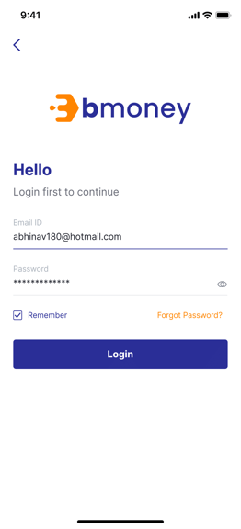 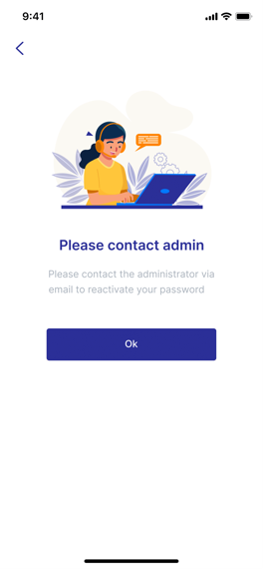

1. **Authorized User**

Existing active RM

1. **Entry Point**

Login Page

1. **Exit Point**

MSG page: Please contact admin

1. **Process Flow**
2. User will trigger the BMoney App to enter Login page
3. After entering Email and Password then tap on Login button, user will go to MSG screen: Please contact admin
4. **Fields and Validations and Verifications**

|  |  |  |  |  |  |  |
| --- | --- | --- | --- | --- | --- | --- |
| **Field** | **Field Type** | **Description** | **Field Length** | **Mandatory** | **Validation** | **In-Line Error Message** |
| Logo | Logo | BMoney Logo | - | Yes |  |  |
| Hello | Label | Hello  Login first to continue | - | Yes |  |  |
| Email ID | Alphanumeric input | Email address  It has to be a valid registered email address on BMoney app  Alphanumeric keypad required | - | Yes | 1. Must be a valid email ID of an active RM 2. Must be Not Empty | 1. Please check your login information. 2. This field cannot be empty |
| Password | Alphanumeric input | It has to be in accordance to the password rules.  Text is hidden.  Alphanumeric keypad required | - | Yes | 1. Must be a valid password of an active RM 2. Must be Not Empty | 1. Please check your login information. 2. This field cannot be empty |
| Remember | Check box | Tick to remember login info on this device |  | Yes |  |  |
| Forgot password | Button link | Tap on to enter Forgot password page | - | Yes |  |  |
| Hide/Unhide | Icon | Click icon to hide/unhide password.  Default is hide password | - | Yes |  |  |
| Login | Button | Button to trigger the Login function.  If login succesfull, go to Home page  If fail, stay login page and display MSG | - | Yes | All above mandatory fields must be filled in the correct format with valid value to get redirected to home page. | Please check your login information. |
| Login in with fingerprint (TouchID) | Button | 1. This feature will base on System Settings of Phone  2. For the device support both, the default set is faceID  3.If faceID / touchID failed 3 times, password will be required |  | Yes |  |  |
| Login in with FaceID | Button |  | Yes |  |  |
| Screen MSG Contact admin |  | Please contact admin  Please contact the administrator via email to activate your new password  User can tap on OK button to go back to Log in page | - | Yes |  |  |

1. **Messaging Requirement**

Follow message in above table

1. **Reference User Story**

N/A

### HNWI KYC Management

#### User story 5 – Register for investors

As an existing RM, I want to register new individual investors (High-Net-Worth Individual) to the system using on behalf KYC so that I can manage and provide services for them.

**Acceptance Criteria**

Dashboard website must be responsive to mobile browser and PC browser

Dashboard website URL must expire after 24 hours since generated

If National ID & NPWP has been registered before, RM can't submit registration request. Show error message National ID/NPWP data has been registered

1. **Page Flow**

 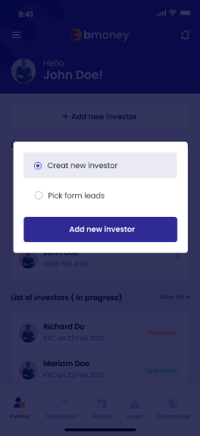

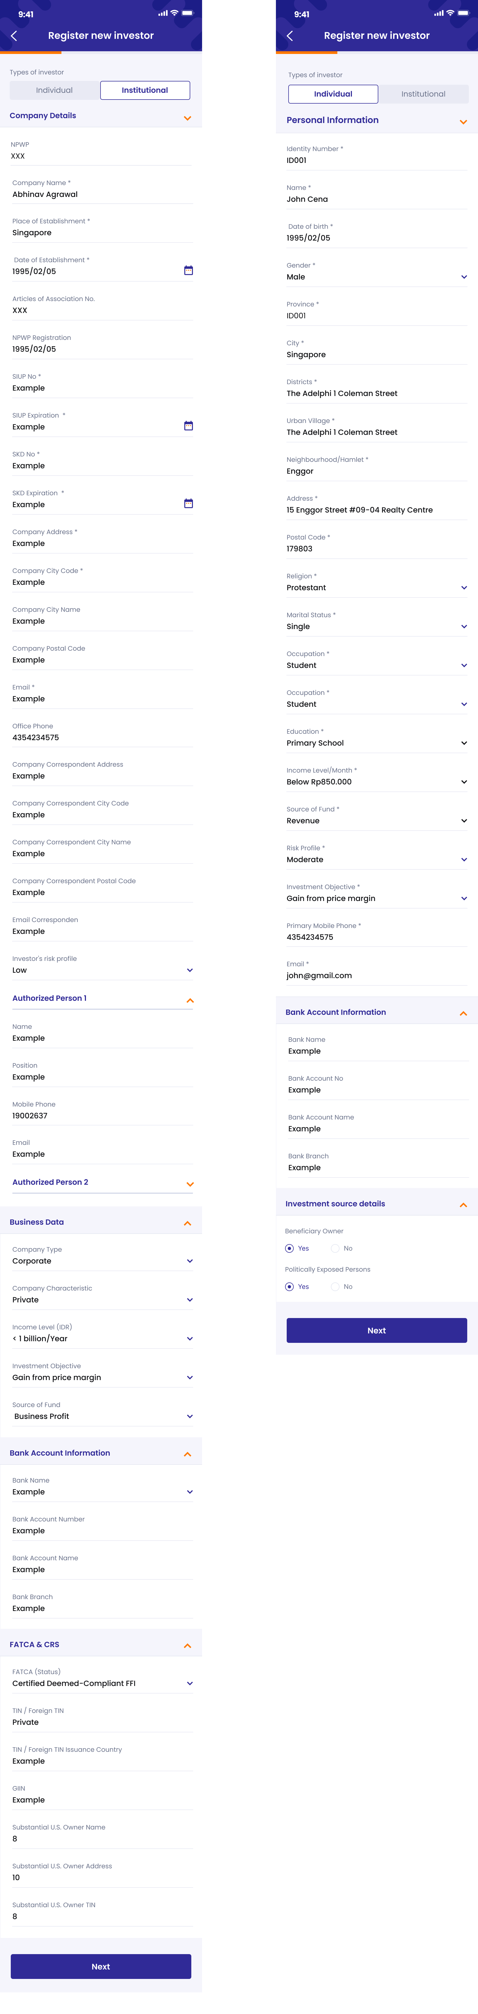

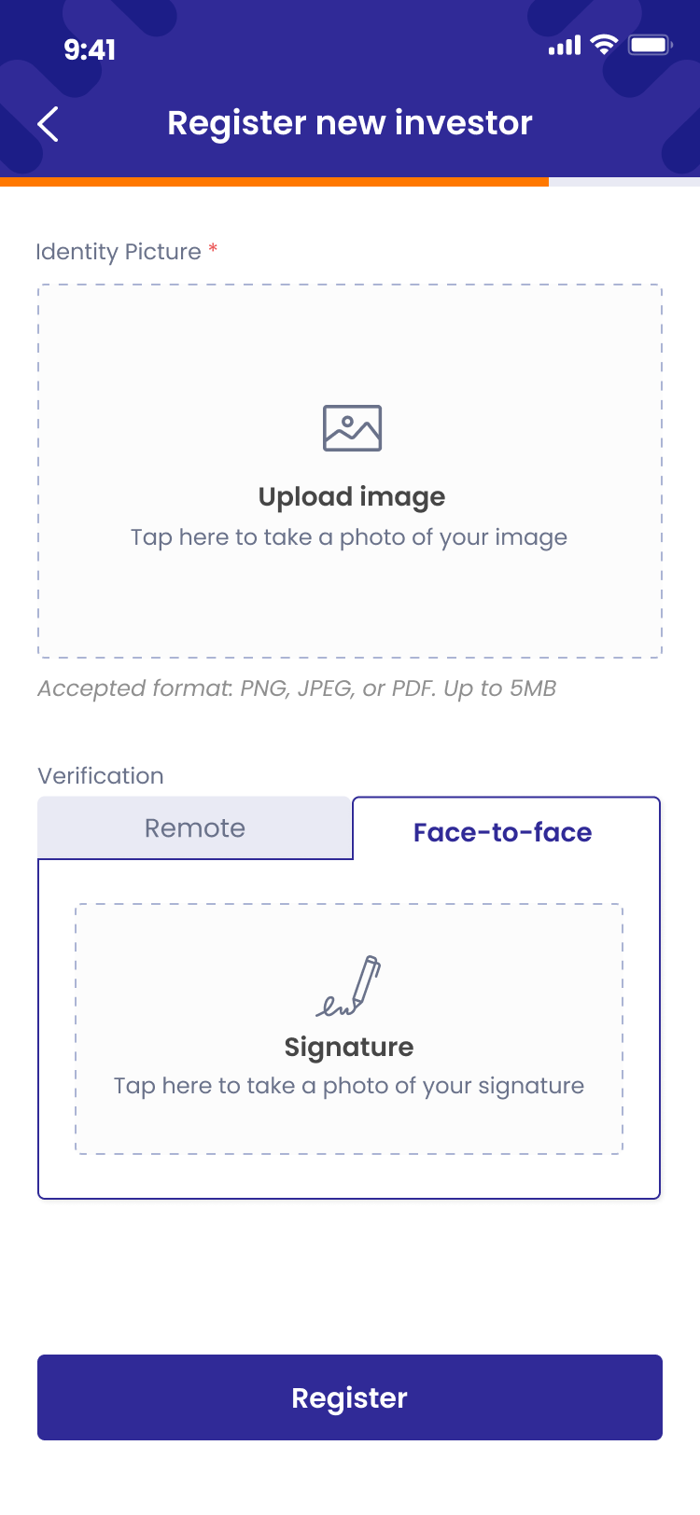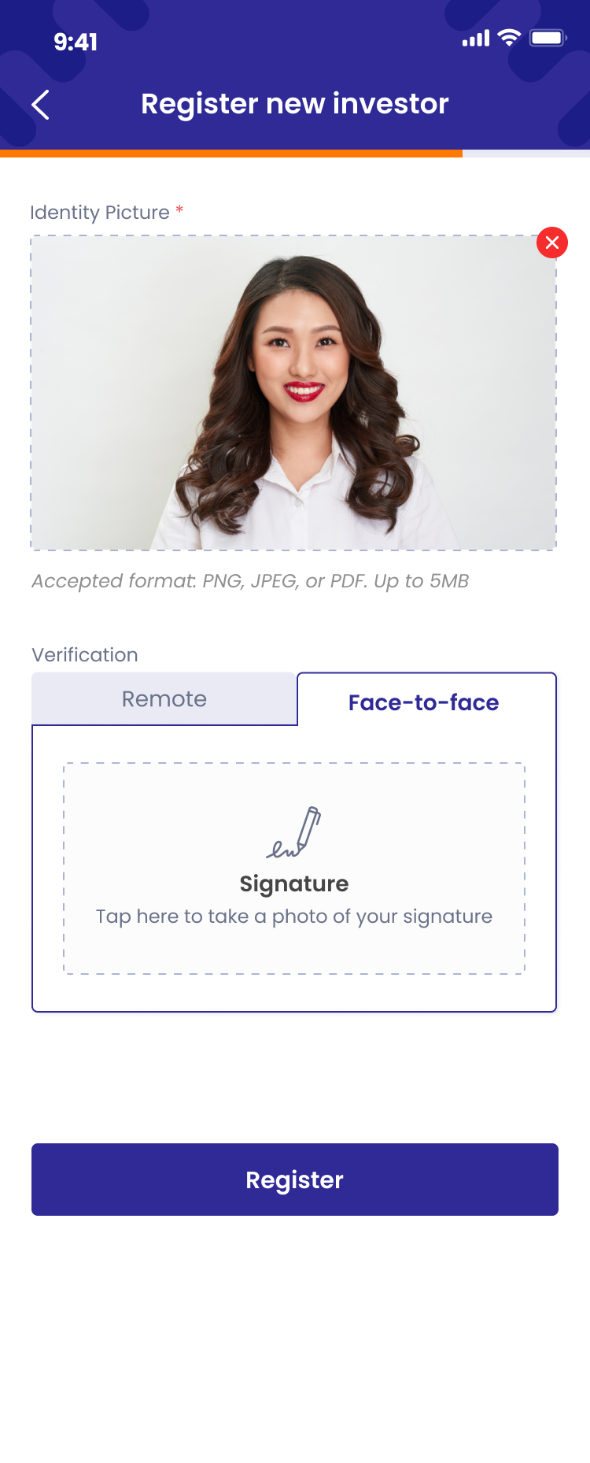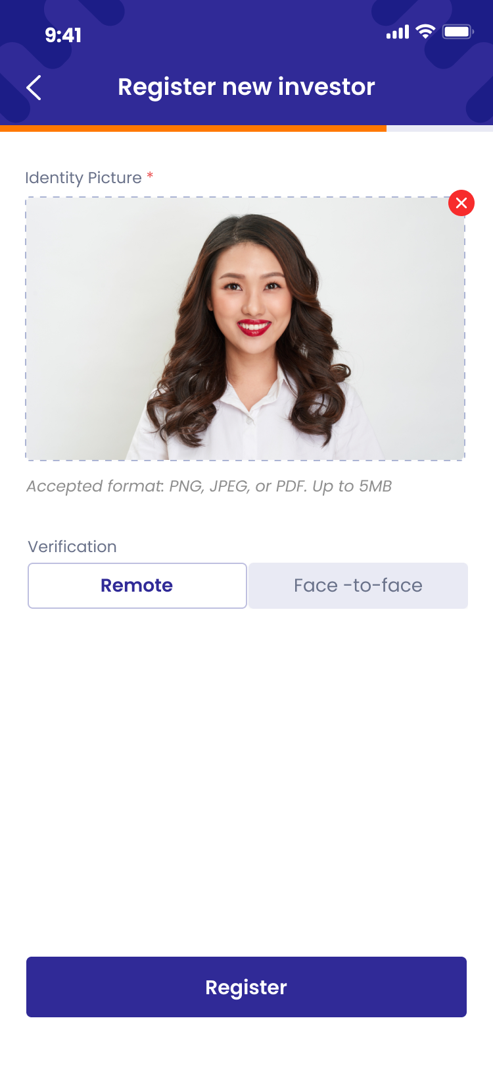

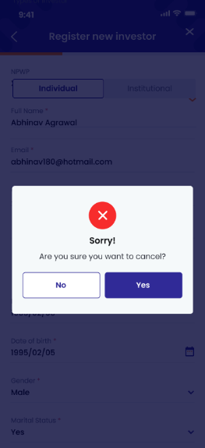 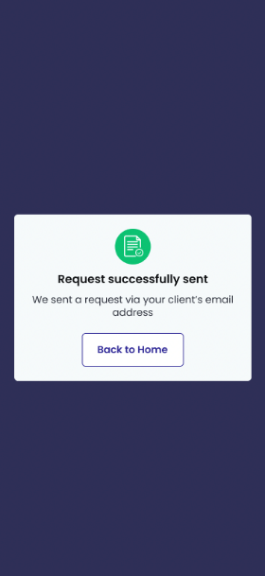

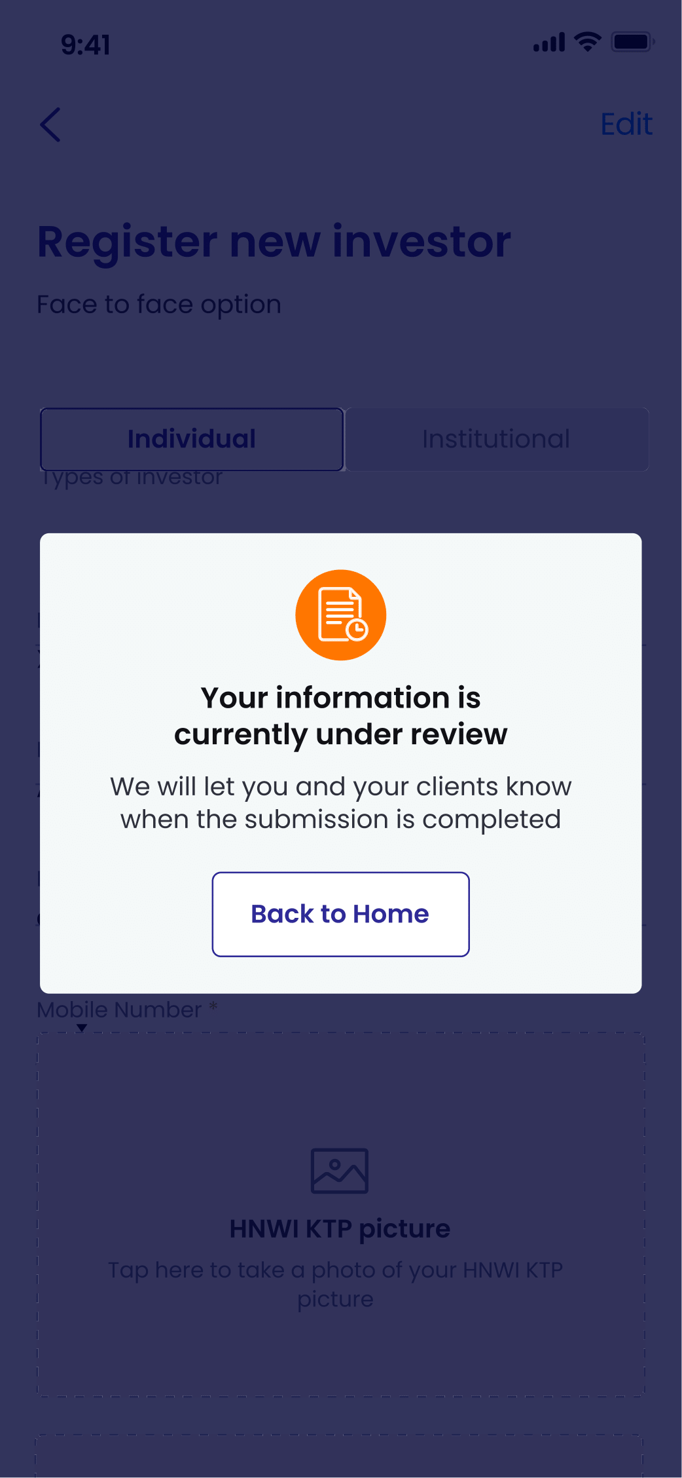

1. **Authorized User**

Existing active RM

1. **Entry Point**

Home page

1. **Exit Point**

‘Submitted’ MSG Screen

1. **Process Flow**
2. From Home page – Investor panel, user will tap on ‘Add new investor’ button to enter ‘Register new investor’ page
3. User will fill in all required fields, take picture as required, sign on the device then tap ‘Submit’ button to send the information
4. If choose individual investor option, the information is ready for review and the system will send emails to investors about their KYC information. There will be ‘Submitted’ MSG Screen.
5. **Fields and Validations and Verifications**

|  |  |  |  |  |  |  |
| --- | --- | --- | --- | --- | --- | --- |
| **Field** | **Field Type** | **Description** | **Field Length** | **Mandatory** | **Validation** | **In-Line Error Message** |
|  | Button | Tap on to open Control panel | - | Yes |  |  |
|  | Button | Tap on to open notification list | - | Yes |  |  |
| Hello | Label | Hello  [Full_Name] | - | Yes |  |  |
| Gravatar | Avatar | Avatar of the user | - | Yes |  |  |
| Add new investor | Button | Tap on to enter ‘Register new investor’ page | - | Yes |  |  |
| **List of investors approved panel** | | | | | | |
| List of investors approved panel | Label | List of investors approved panel label | - | Yes |  |  |
| Gravatar | Image | Avatar of the investor | - | Yes |  |  |
| Full name | Text field | Full name of investor | - | Yes |  |  |
| Phone number | Numeric field | Phone number of investor | - | Yes |  |  |
| button | Button | Tap on to open action list of investor | - | Yes |  |  |
| View investor | Button | Tap on to enter Manage investor page/Investor info tab | - | Yes |  |  |
| See portfolio | Button | Tap on to enter Manage investor page/Porfolio tab | - | Yes |  |  |
| Create transaction | Button | Tap on to enter Instruction type page | - | Yes |  |  |
| View all | Link button | Tap on to view list of all approved investors | - | Yes |  |  |
| **List of investors in progress panel** | | | | | | |
| List of investors in progress | Label | List of investors in progress label | - | Yes |  |  |
| Gravatar | Avatar | Avatar of the user | - | Yes |  |  |
| Full name | Text field | Full name of investor | - | Yes |  |  |
| KYC Date | Text field | KYC on [KYC Date] | - | Yes |  |  |
| Status | Text field | Status of investors | - | Yes |  |  |
| View all | Link button | Tap on to view list of investors in progress | - | Yes |  |  |
| **List of other investors panel** | | | | | | |
| List of other investors | Label | List of other investors label | - | Yes |  |  |
| Gravatar | Avatar | Avatar of the user | - | Yes |  |  |
| Full name | Text field | Full name of investor | - | Yes |  |  |
| KYC Date | Text field | [KYC Date] | - | Yes |  |  |
| Status | Text field | Status of investors | - | Yes |  |  |
| View all | Link button | Tap on to view list of all other investors | - | Yes |  |  |
| button | Button | Tap on to open action list of investor |  | Yes |  |  |
| **Home panel** | | | | | | |
| Investor | Button | Tap on to go to Home page – Investor panel | - | Yes |  |  |
| Transaction | Button | Tap on to go to Home page – Transaction panel | - | Yes |  |  |
| Leads | Button | Tap on to go to Home page – Leads panel | - | Yes |  |  |
| Report | Button | Tap on to go to Home page – Report panel | - | Yes |  |  |
| Create option | Option tab | ‘Create’ option tab   * Create new investor (default) * Pick from leads | - | Yes | If choose Create new investor option, user will enter Register new investor page  If choose Pick from list, user will enter Leads ratio option |  |
| button | Button | Tap on to go back to the previous page and cancel the register without saving any input | - | Yes |  |  |
| Register new investor | Label | Register new investor | - | Yes |  |  |
| Types of investor option | Tab | Types of investor option, including:   * Individual (default) * Insitutional | - | Yes |  |  |
| **Individual option (If user choose Individual in Types of investors option)** | | | | | | |
| **Personal Information** | | | | | | |
| NIK | Numeric input | NIK: Customs Identification Number  It has to be in accordance to the NIK rules.  Numeric keypad required | String (20) | Yes | ‘Types of investor’ has to be set to ‘Individual’ for this field to show  If National ID & NPWP has been registered before, RM can't submit registration request. Show error message National ID/NPWP data has been registered | This field cannot be empty |
| Full name | Text input | Full name  Alphanumeric keypad required | String (50) | Yes | 1. Must be Not Empty | This field cannot be empty |
| Email | Alphanumeric input | Email  Alphanumeric keypad required | String (100) | Yes | 1. Must be in email format: abc@xyz.com 2. Must be Not Empty | This field cannot be empty |
| Phone number | Numeric input | Phone number  Numeric keypad required | String (20) | Yes | 1. Must be Not Empty | This field cannot be empty |
| Place of birth | Alphanumeric input | Place of birth  Alphanumeric keypad required | String (100) | Yes | Must be Not Empty | This field cannot be empty |
| Date of birth | Date picker | Date of birth of investor | Date picker | Yes | Must be Not Empty | This field cannot be empty |
| Gender | Dropdown list | Gender dropdown list:  Male  Female  Private | Dropdown list | Yes | Must be Not Empty | This field cannot be empty |
| Province | Alphanumeric input | Province  Alphanumeric keypad required | String (100) | Yes | Must be Not Empty | This field cannot be empty |
| Districts | Alphanumeric input | Districts  Alphanumeric keypad required | String (100) | Yes | Must be Not Empty | This field cannot be empty |
| Urban village | Alphanumeric input | Urban village  Alphanumeric keypad required | String (100) | Yes | Must be Not Empty | This field cannot be empty |
| Neighbourhood/Hamlet | Alphanumeric input | Neighbourhood/Hamlet  Alphanumeric keypad required | String (100) | Yes | Must be Not Empty | This field cannot be empty |
| Address | Alphanumeric input | Address  Alphanumeric keypad required | String (300) | Yes | Must be Not Empty | This field cannot be empty |
| Postal code | Numeric input | Postal code  Numeric keypad required | String (15) | Yes | Must be Not Empty | This field cannot be empty |
| Religion | Dropdown list | Religion of the investor dropdown  1. Islam  2. Protestant  3. Catholic  4. Hinduism  5. Budhism  6. Confucianism  7. Others  Alphanumeric keypad required |  | Yes | Must be Not Empty | This field cannot be empty |
| Marital Status | Dropdown list | Marital Status dropdown  1. Single  2. Married  3. Divorced |  | Yes | Must be Not Empty | This field cannot be empty |
| Occupation | Dropdown list | Occupation of the investor dropdown  1. Student/Graduate Student/Post Graduate  2. Housewife  3. Enterpreneur  4. Civil Servant  5. Indonesian National Armed Force/Indonesian National Police  6. Retirement  7. Lecturer/Teacher  8. Private Employee  9. Others |  | Yes | Must be Not Empty | This field cannot be empty |
| Education | Dropdown list | Education level of the investors dropdown  1. Primary School  2. Junior High School  3. Senior High School  4. Diploma  5. Undergraduate  6. Post Graduate  7. Doctoral Program  8. Others |  | Yes | Must be Not Empty | This field cannot be empty |
| Income level (IDR) | Dropdown list | Income level dropdown  1. Below Rp850.000  2. Rp850.000 - Rp4.000.000  3. Rp4.000.001 - Rp 8.000.000  4. Rp8.000.001 - Rp41.000.000  5. Rp41.000.001 - Rp83.000.000  6. Above Rp83.000.000 |  | Yes | Must be Not Empty | This field cannot be empty |
| Risk profile | Dropdown list | Risk profile dropdown  1. Low  2. Moderate  3. High |  | Yes | Must be Not Empty | This field cannot be empty |
| Investment Objective | Dropdown list | Investment objective dropdown  1. Gain from price  margin  2. Investment  3. Speculation  4. Gain the revenue or  income  5. Others |  | Yes | Must be Not Empty | This field cannot be empty |
| Source of Fund | Dropdown list | Source of fund dropdown  1. Revenue  2. Business Profit  3. Saving interest  4. Legacy  5. Fund from parents or children  6. Grant  7. Fund from husband or wife  8. Drawing  9. Investment gain  10. Others |  | Yes | Must be Not Empty | This field cannot be empty |
| **Investment Source details** | | | | | | |
| Beneficiary Owner | Dropdown list | Beneficiary Owner dropdown   1. Yes 2. No |  | Yes | Must be Not Empty | This field cannot be empty |
| Politically Exposed Persons | Dropdownlist | Politically Exposed Persons dropdown   1. Yes 2. No |  | Yes | Must be Not Empty | This field cannot be empty |
| **Bank account information** | | | | | | |
| Bank name | Dropdown list | Bank name dropdown list  List retrieved from client's API |  | Yes | Must be Not Empty | This field cannot be empty |
| Bank account | Numeric input | Bank account  Numeric keypad required | String (20) | Yes | Must be Not Empty | This field cannot be empty |
| Bank account name | Alphanumeric input | Bank account name  Alphanumeric keypad required | String (100) | Yes | Must be Not Empty | This field cannot be empty |
| Bank branch | Alphanumeric input | Bank branch  Alphanumeric keypad required | String (300) | Yes | Must be Not Empty | This field cannot be empty |
| **Institutional option (If user choose Institutional in Types of investors option)** | | | | | | |
| **Company Details** | | | | | | |
| Company name | Alphanumeric input | Company name  Alphanumeric keypad required | String (100) | Yes | Must be Not Empty | This field cannot be empty |
| Country of Domicile | Alphanumeric input | Country of Domicile  Alphanumeric keypad required | String (300) | Yes | Must be Not Empty | This field cannot be empty |
| Place of Establishment | Alphanumeric input | Place of Establishment  Alphanumeric keypad required | - | Yes | Must be Not Empty | This field cannot be empty |
| Date of Establishment | Date picker | Date of Establishment | - | Yes |  |  |
| Articles of Association No. | Numeric input | Articles of Association Number | String (40) | Yes | In case 'Company Characteristic' is '5' (i.e. PMA/Foreign Investment Company), either SKD No. or Articles of Association No. can be used. If both SKD and Articles of Association No. are inputted, SKD No. is to be reported to ARIA for Institutional Investor Profile Data(SKD atau AD/ART). |  |
| NPWP | Numeric input | NPWP: Tax number  It has to be in accordance to the NPWP rules.  Numeric keypad required | String (15) | Yes | ‘Types of investor’ has to be set to ‘Institutional’ for this field to show  If National ID & NPWP has been registered before, RM can't submit registration request. Show error message National ID/NPWP data has been registered | This field cannot be empty |
| NPWP Registration Date | Date picker | NPWP Registration Date date picker | - | Yes | Must be a past date |  |
| SIUP No. | Numeric input | SIUP Number | String (100) | Yes | It is mandatory if 'Country of Domicile' is not 'ID' (i.e. Other than Indonesia). |  |
| SIUP Expiration Date | Date picker | SIUP expiration Date date picker | - | Yes | Must be a future date |  |
| SKD No. | Numeric input | SKD Number | String (40) | Yes | In case 'Company Characteristic' is '5' (i.e. PMA/Foreign Investment Company), either SKD No. or Articles of Association No. can be used. If both SKD and Articles of Association No. are inputted, SKD No. is to be reported to ARIA for Institutional Investor Profile Data(SKD atau AD/ART). |  |
| SKD Expiration Date | Date picker | SKD expiration Date date picker | - | Yes | Must be a future date |  |
| Company address | Alphanumeric input | Address of the company  Alphanumeric keypad required | String (200) | Yes | Must be Not Empty | This field cannot be empty |
| Company City Code | Alphanumeric input | Company City Code  Alphanumeric keypad required | String (5) | Yes | Must be Not Empty | This field cannot be empty |
| Company city name | Alphanumeric input | Company Name  Alphanumeric keypad required | String (200) | Yes |  |  |
| Company postal code | Alphanumeric input | Company postal Code  Alphanumeric keypad required | String (4) | Yes |  |  |
| Email | Text input | Email address  Alphanumeric & symbol keypad required | String (150) | Yes | Must be Not Empty | This field cannot be empty |
| Office phone | Numeric input | Office phone number  Numeric keypad required | String (15) |  |  |  |
| Company Correspondent address | Alphanumeric input | Address of the correspondent company  Alphanumeric keypad required | String (200) | - |  |  |
| Company Correspondent city name | Alphanumeric input | Company Correspondent Name  Alphanumeric keypad required | String (200) | - |  |  |
| Company Correspondent City Code | Alphanumeric input | Company Correspondent City Code  Alphanumeric keypad required | String (15) | - |  |  |
| Company postal code | Alphanumeric input | Company Correspondent postal Code  Alphanumeric keypad required | String (10) | - |  |  |
| Email Correspondent | Text input | Email correspondent address  Alphanumeric & symbol keypad required | String (150) | - |  |  |
| Authorized Person 1 - Full Name | Alphanumeric input | Authorized Person 1 - First Name  Alphanumeric keypad required | String (50) | - |  |  |
| Authorized Person 1 – Position | Alphanumeric input | Authorized Person 1 – Position  Alphanumeric keypad required | String (50) | - |  |  |
| Authorized Person 1 – Mobile phone | Numeric input | Authorized Person 1 – Mobile phone  Numeric keypad required | String (15) | - |  |  |
| Authorized Person 1 – Email | Alphanumeric input | Authorized Person 1 – Email  Alphanumeric keypad required | String (100) | - |  |  |
| Authorized Person 2 - Full Name | Alphanumeric input | Authorized Person 2 - First Name  Alphanumeric keypad required | String (50) | - |  |  |
| Authorized Person 2 – Position | Alphanumeric input | Authorized Person 2 – Position  Alphanumeric keypad required | String (50) | - |  |  |
| Authorized Person 2 – Mobile phone | Numeric input | Authorized Person 2 – Mobile phone  Numeric keypad required | String (15) | - |  |  |
| Authorized Person 2 – Email | Alphanumeric input | Authorized Person 2 – Email  Alphanumeric keypad required | String (100) | - |  |  |
|  |  | 2  3 |  |  |  |  |
| **Business Data** | | | | | | |
| Company type | Dropdown list | Company type dropdown list:  1. Corporate  2. Foundation  3. Financial Institution  4. Insurance  5. Mutual Fund  6. Pension Fund  7. Securities Company  8. Others | - | Yes | Must be Not Empty | This field cannot be empty |
| Company Characteristic | Dropdown list | Company Characteristic dropdown list:  1. State Owned  Company/Public  2. Private  3. Social  4. Joint Venture  5. PMA/Foreign  Investment Company  6. Family Company  7. Afiliation  8. Others | - | Yes | Must be Not Empty  In case 'Company Characteristic' is '5' (i.e. PMA/Foreign Investment Company), either SKD No. or Articles of Association No. can be used. If both SKD and Articles of Association No. are inputted, SKD No. is to be reported to ARIA for Institutional Investor Profile Data(SKD atau AD/ART). | This field cannot be empty |
| Income level (IDR) | Dropdown list | Income level dropdown list:  1. < 1 billion/Year  2. > 1– 5 billion/Year  3. > 5 – 10 billion/Year  4. > 10 – 50  billion/Year  5. > 50 billion/Year | - | Yes | Must be Not Empty | This field cannot be empty |
| Investment objective | Dropdown list | Investment objective dropdown list:  1. Gain from price  margin  2. Investment  3. Speculation  4. Gain the revenue or  income  5. Others | - | Yes | Must be Not Empty | This field cannot be empty |
| Source of fund | Dropdown list | Source of fund dropdown  1. Business Profit  2. Pension Funds  3. Saving Interest  4. Investment Gain  5. Others | - | Yes | Must be Not Empty | This field cannot be empty |
| **Bank account information** | | | | | | |
| Bank name | Dropdown list | Bank name dropdown list  List retrieved from client's API |  | Yes | Must be Not Empty | This field cannot be empty |
| Bank account | Numeric input | Bank account  Numeric keypad required | String (20) | Yes | Must be Not Empty | This field cannot be empty |
| Bank account name | Alphanumeric input | Bank account name  Alphanumeric keypad required | String (100) | Yes | Must be Not Empty | This field cannot be empty |
| Bank branch | Alphanumeric input | Bank branch  Alphanumeric keypad required | String (300) | Yes | Must be Not Empty | This field cannot be empty |
| **FATCA & CRS** | | | | | | |
| FATCA (Status) |  | FATCA status dropdown list  . Registered DeemedCompliant FFI  2. Certified DeemedCompliant FFI  3. Owner-Documented  FFI  4. Owner-Documented  FFI with Specified U.S.  Owner  5. Participating FFI  6. Nonparticipating FFI  7. Active NFFE  8. Passive NFFE with  Substantial U.S. Owner  9. Passive NFFE  without Substantial  U.S. Owner  10. Direct Reporting  NFFE  11. Exempt Beneficial  Owner  12. U.S. Financial  Institution |  | Yes |  |  |
| TIN / Foreign TIN | Alphanumeric input | TIN / Foreign TIN  Alphanumeric keypad required | String (30) | - | U.S. taxpayer identification number (employer identification number) or Foreign(non-U.S.) tax identifying number |  |
| TIN / Foreign TIN Issurance Country | Alphanumeric input | TIN / Foreign TIN Issurance Country  Alphanumeric keypad required | String (30) | - | ISO country code |  |
| GIIN | Alphanumeric input | GIIN  Alphanumeric keypad required | String (30) | - | Global intermediary identification number |  |
| Substantial U.S. Owner Name | Alphanumeric input | Substantial U.S. Owner Name  Alphanumeric keypad required | String (100) | - | Applicable for FATCA (Status) no. 4, 8 and 10 |  |
| Substantial U.S. Owner Address | Alphanumeric input | Substantial U.S. Owner Address  Alphanumeric keypad required | String (100) | - | Applicable for FATCA (Status) no. 4, 8 and 10 |  |
| Substantial U.S. Owner TIN | Alphanumeric input | Substantial U.S. Owner TIN  Alphanumeric keypad required | String (10) | - | Applicable for FATCA (Status) no. 4, 8 and 10 |  |
| Identity picture | Image input | Identity picture  - User can upload picture  - User can take a picture |  | Yes | Must be not empty | This field cannot be empty |
| Selfie with Identity Picture | Image input | Selfie with Identity Picture  - User can upload picture  - User can take a picture |  | Yes | Must be not empty | This field cannot be empty |
| Face-to-face/Remote option | Option tab | User can choose either option to register new investors.  1. Face-to-face option (default): there will be a signature input canvas  2. Remote option: there will be no signature input canvas. Instead, there will be an URL via investor’s email to upload signature. |  | Yes |  |  |
| Signature | Image input | Canvas  User can sign on device | - | Yes | Appear only when user choose Face-to-face option  Must be not empty | This field cannot be empty |
| Register | Button | Register Button  Click to submit the KYC information | - | Yes | All above mandatory fields must be filled in the correct format with valid value to enable this button |  |
| ‘Submitted_individual’ MSG Screen |  | Your information is currently under review  We will let you and your clients know when the submission is approved.  Click ‘OK’ button to back to Home page | - | Yes |  |  |

1. **Messaging Requirement**

Follow message in above table

1. **Reference User Story**

N/A

#### User story 5.1 – Investor/ Confirm KYC register

As an investor, I want to view my KYC information and sign so that I can confirm my personal information.

**Acceptance Criteria**

Dashboard website must be responsive to mobile browser and PC browser

Dashboard website URL must expire after 24 hours since generated

1. **Page Flow**

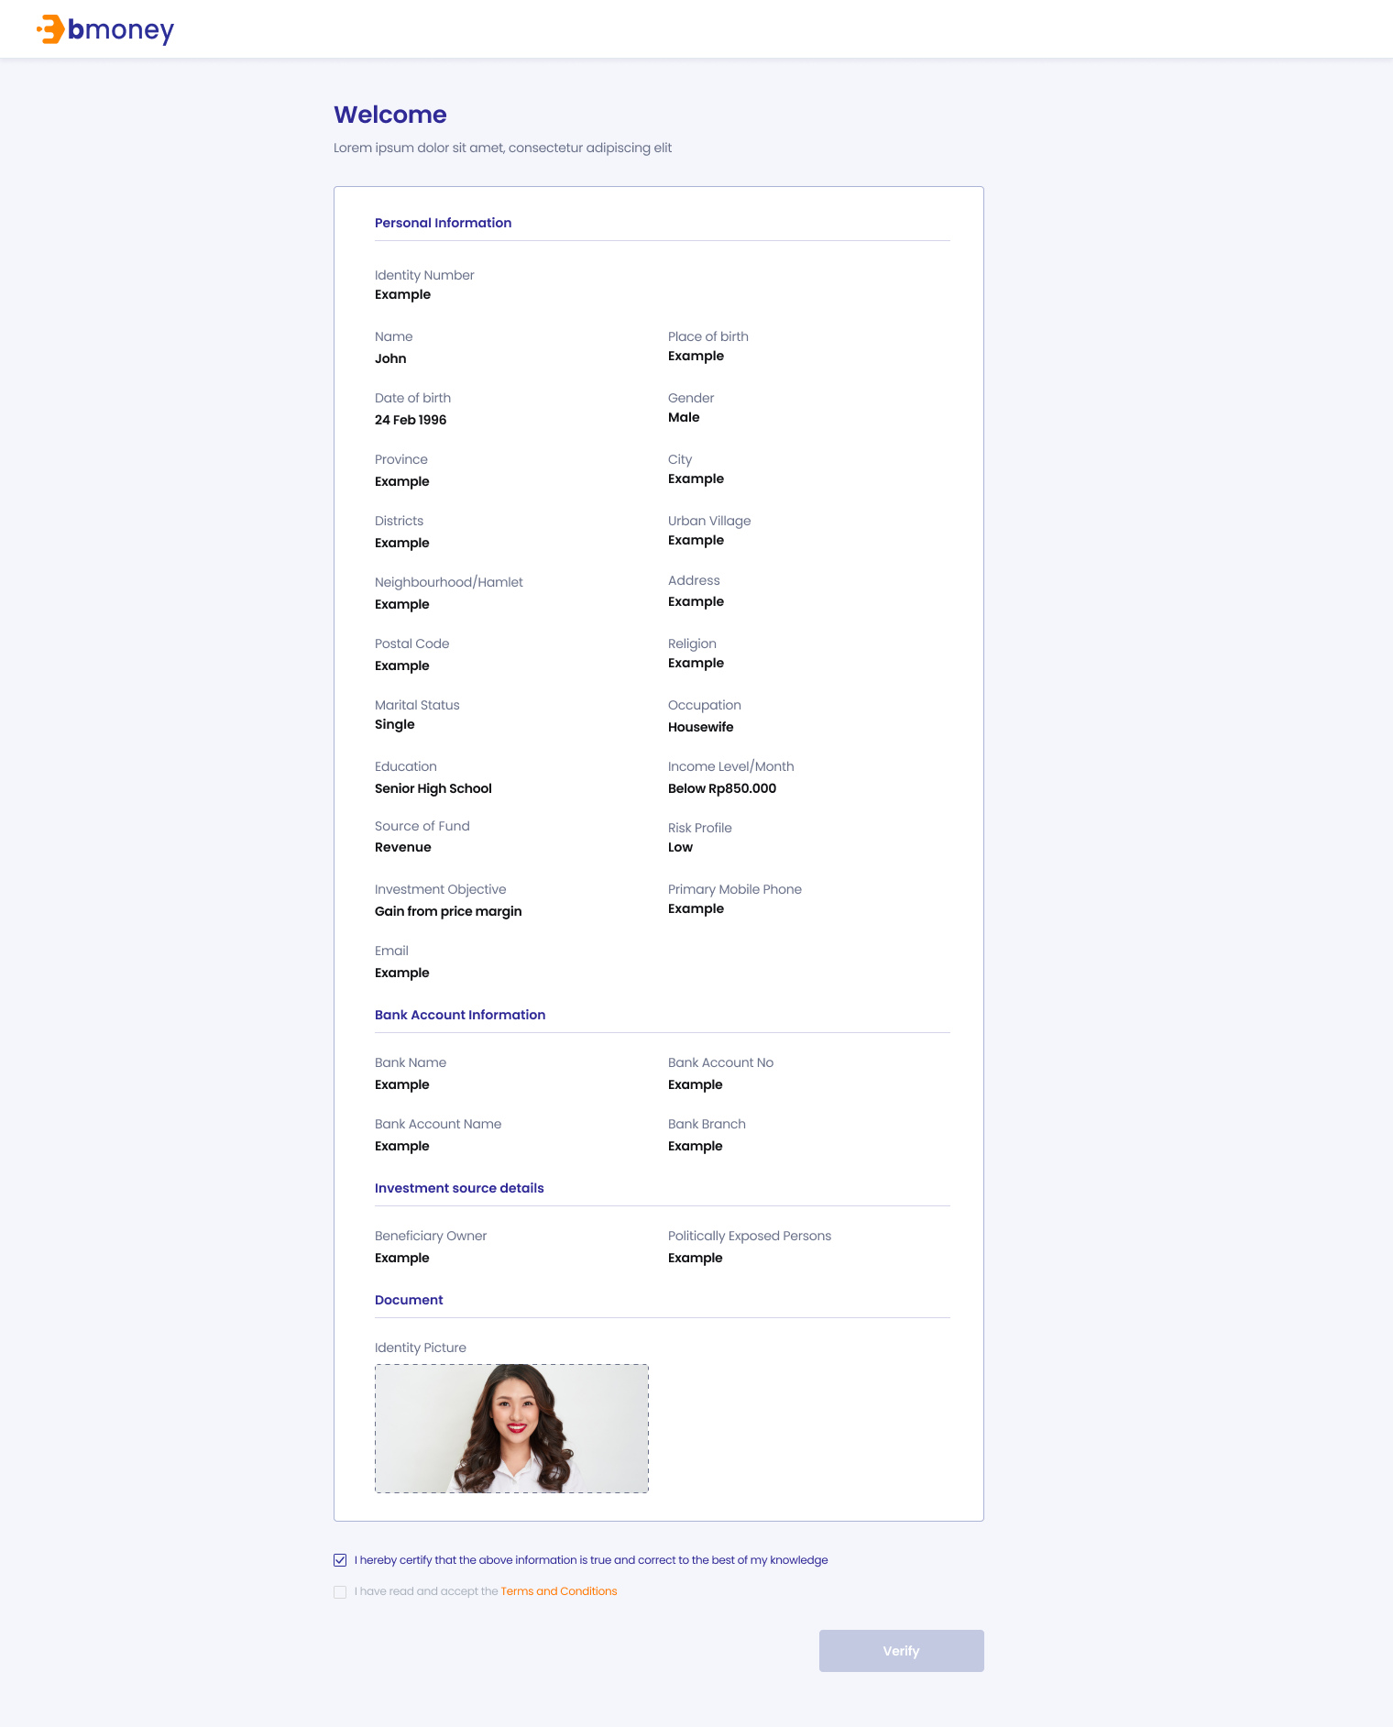

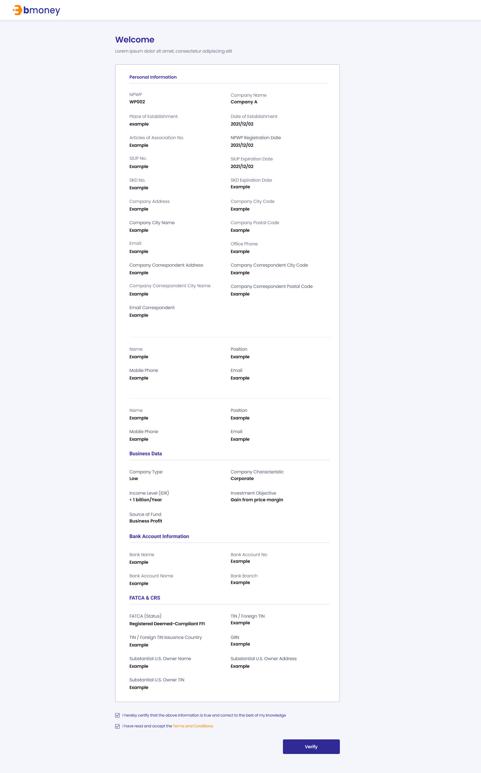

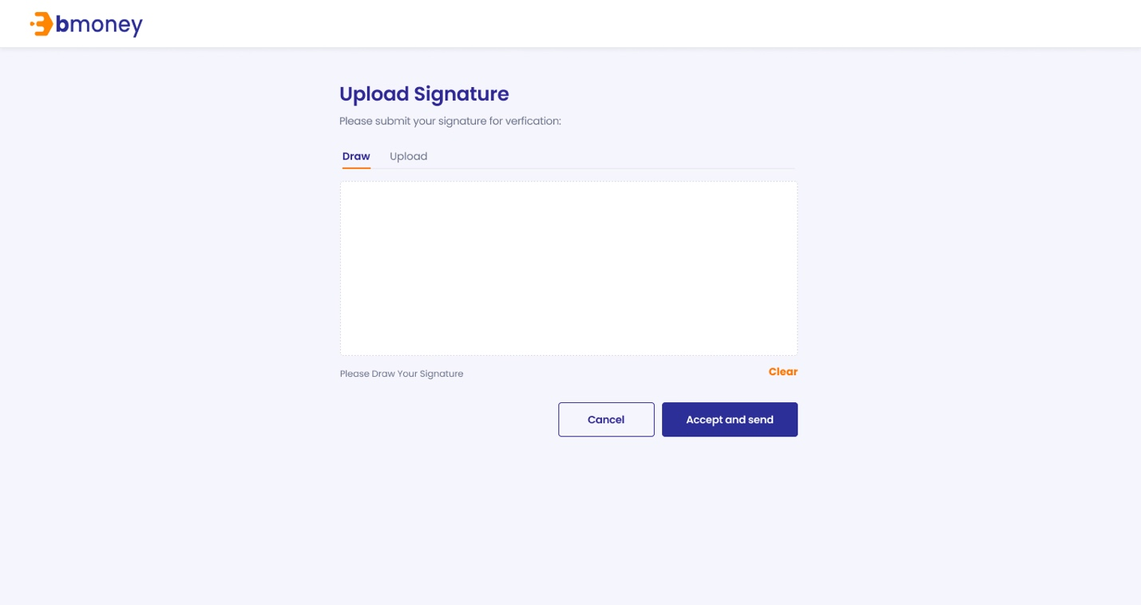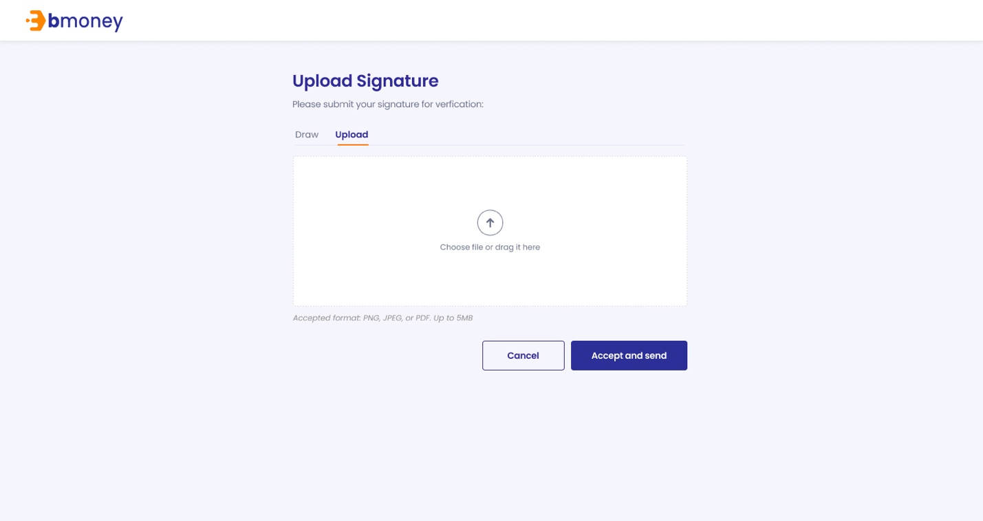

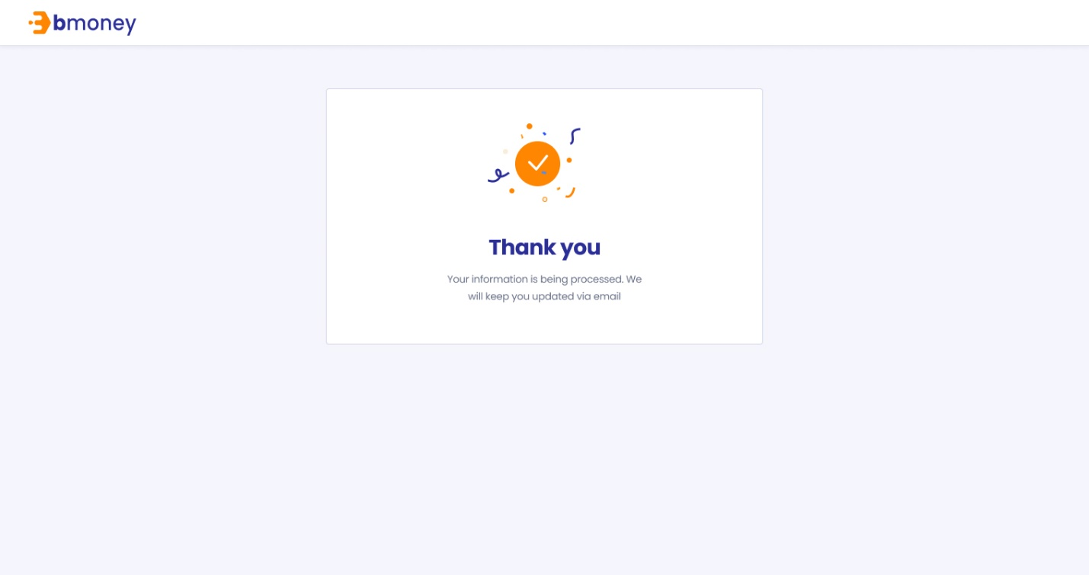

1. **Authorized User**

Existing active investor

1. **Entry Point**

URL from investor’s email

1. **Exit Point**

‘Thank you’ MSG Screen

1. **Process Flow**
2. For Face-to-face option, investors can open the URL from the email, view their KYC information, read T&C and confirm information.

For Remote option, investors can open the URL from the email, view their KYC information, read T&C and sign on device to confirm information

1. There will be Thank you page after investor submitting required information
2. **Fields and Validations and Verifications**

|  |  |  |  |  |  |  |
| --- | --- | --- | --- | --- | --- | --- |
| **Dashboard URL – Individual KYC info** | | | | | | |
| Welcome | Label | Welcome label | - | Yes |  |  |
| NIK | Numeric field | NIK: Customs Identification Number | - | Yes |  |  |
| Full name | Text field | Full name | - | Yes |  |  |
| Email | Text field | Email | - | Yes |  |  |
| Phone number | Numeric field | Phone number | - | Yes |  |  |
| Place of birth | Text field | Place of birth | - | Yes |  |  |
| Date of birth | Text field | Date of birth of investor | - | Yes |  |  |
| Gender | Text field | Gender | - | Yes |  |  |
| Province | Text field | Province | - | Yes |  |  |
| Districts | Text field | Districts | - | Yes |  |  |
| Urban village | Text field | Urban village | - | Yes |  |  |
| Neighbourhood/Hamlet | Text field | Neighbourhood/Hamlet | - | Yes |  |  |
| Address | Text field | Address | - | Yes |  |  |
| Postal code | Numeric field | Postal code | - | Yes |  |  |
| Religion | Text field | Religion of the investor | - | Yes |  |  |
| Marital Status | Text field | Marital Status | - | Yes |  |  |
| Occupation | Text field | Occupation of the investor | - | Yes |  |  |
| Education | Text field | Education level of the investors | - | Yes |  |  |
| Income level (IDR) | Text field | Income level of the investor | - | Yes |  |  |
| Risk profile | Text field | Risk profile | - | Yes |  |  |
| Investment Objective | Text field | Investment objective | - | Yes |  |  |
| Source of Fund | Text field | Source of fund | - | Yes |  |  |
| Beneficiary Owner | Text field | Name of the beneficiary owner | - | Yes |  |  |
| Politically Exposed Persons | Text field | Politically Exposed Persons | - | Yes |  |  |
| Bank name | Text field | Bank name | - | Yes |  |  |
| Bank account | Numeric field | Bank account | - | Yes |  |  |
| Bank account name | Text field | Bank account name | - | Yes |  |  |
| Bank branch | Text field | Bank branch | - | Yes |  |  |
| Certify check box | Check box | I hereby certify that the above information is true and correct to the best of my knowledge | - |  |  |  |
| T&C check box | Check box | I have read and accept the Terms and Conditions | - |  |  |  |
| Terms & Conditions link button | Link button | Tap on to open PDF file Terms & Conditions Individual | - | Yes |  |  |
| Verify | Button | Verify button  Tap on to confirm information and enter the next page   1. Go to Upload/Draw page signature if user choose Remote option 2. Go to Thank you MSG Screen if user choose Face-to-face option | - |  | All above check box fields must be tapped on to enable this button |  |
| Upload Signature | Label | Upload Signature  Please submit your signature for verification | - | Yes |  |  |
| Draw/Upload option | Option tab | Draw/Upload option   * Draw (default) * Upload | - | Yes |  |  |
| Signature canvas | Canvas | Tap on to start draw signature | - | Yes |  |  |
| Please draw your signature | Text field | Please draw your signature | - | Yes |  |  |
| Clear | Button | Clear button  Tap on to clear the signature drawn before and retry | - | Yes |  |  |
| Upload  button | Button | Choose file or drag it here  Tap on to browse offline file | - | Yes |  |  |
| Accepted format | Text field | Accepted format: PNG, JPEG or PDF. Up to 5MB | - | Yes |  |  |
| Cancel button | Button | Cancel button  Tap on to trigger Cancel pop-up | - | Yes |  |  |
| Cancel pop-up | Pop-up label | Do you want to cancel?  This URL will expire after 24 hours. Please submit your signature before the deadlines. | - | Yes |  |  |
| Yes | Button | Yes button  Tap on to cancel submitting signature | - | Yes |  |  |
| No | Button | No button  Tap on to close the pop-up | - | Yes |  |  |
| Accept and send button | Button | Accept and send button  Tap on to trigger Submit pop-up | - | Yes |  |  |
| Submit pop-up | Pop-up label | Are you sure you want to submit your signature? | - | Yes |  |  |
| Yes | Button | Yes button  Tap on to submit the signature | - | Yes |  |  |
| No | Button | No button  Tap on to close the pop-up | - | Yes |  |  |
| Thank you | Label | Thank you  Your information is being processed. We will keep you updated via email | - | Yes |  |  |
| **Dashboard URL – Institutional KYC info** | | | | | | |
| Welcome | Label | Welcome label | - | Yes |  |  |
| Company name | Alphanumeric input | Company name  Alphanumeric keypad required | - | Yes |  |  |
| Country of Domicile | Alphanumeric field | Country of Domicile  Alphanumeric keypad required | - | Yes |  |  |
| Place of Establishment | Text field | Place of Establishment | - | Yes |  |  |
| Articles of Association No. | Numeric field | Articles of Association Number | - | Yes |  |  |
| NPWP | Numeric field | NPWP: Tax number | - | Yes |  |  |
| NPWP Registration Date | Text field | NPWP Registration Date | - | Yes |  |  |
| SIUP No. | Numeric field | SIUP Number | - | Yes |  |  |
| SIUP Expiration Date | Text field | SIUP expiration Date | - | Yes |  |  |
| SKD No. | Numeric field | SKD Number | - | Yes |  |  |
| SKD Expiration Date | Text field | SKD expiration Date | - | Yes |  |  |
| Company address | Text field | Address of the company | - | Yes |  |  |
| Company City Code | Text field | Company City Code | - | Yes |  |  |
| Company city name | Text field | Company Name | - | Yes |  |  |
| Company postal code | Text field | Company postal Code | - | Yes |  |  |
| Email | Text field | Email | - | Yes |  |  |
| Office phone | Numeric field | Office phone number | - | Yes |  |  |
| Company correspondent address | Text field | Address of the correspondent company | - | Yes |  |  |
| Company Correspondent City Code | Text field | Company Correspondent City Code | - | Yes |  |  |
| Company Correspondent city name | Text field | Company Correspondent Name | - | Yes |  |  |
| Company Correspondent postal code | Text field | Company Correspondent Postal Code | - | Yes |  |  |
| Email Correspondent | Text field | Email Correspondent | - | Yess |  |  |
| Authorized Person 1 – full name | Text field | Authorized Person 1 – Full Name | - | Yes |  |  |
| Authorized Person 1 – Position | Text field | Authorized Person 1 – Position | - | Yes |  |  |
| Authorized Person 1 – Mobile phone | Numeric field | Authorized Person 1 – Mobile phone | - | Yes |  |  |
| Authorized Person 1 – Email | Text field | Authorized Person 1 – Email | - | Yes |  |  |
| Authorized Person 2 – full name | Text field | Authorized Person 2 – Full Name | - | Yes |  |  |
| Authorized Person 2 – Position | Text field | Authorized Person 2 – Position | - | Yes |  |  |
| Authorized Person 2 – Mobile phone | Numeric field | Authorized Person 2 – Mobile phone | - | Yes |  |  |
| Authorized Person 1 – Email | Text field | Authorized Person 1 – Email | - | Yes |  |  |
| Investor’s risk profile | Text field | Investor’s risk profile  1. Low  2. Moderate  3. High | - | Yes |  |  |
| Company Type | Text field | Company Type  1. Corporate  2. Foundation  3. Financial Institution  4. Insurance  5. Mutual Fund  6. Pension Fund  7. Securities Company  8. Others | - | Yes |  |  |
| Company Characteristic | Text field | Company Characteristic  1. State Owned Company/Public  2. Private  3. Social  4. Joint Venture  5. PMA/Foreign Investment Company  6. Family Company 7. Affiliation  8. Others | - | Yes |  |  |
| Income level (IDR) | Text field | Income level  1. < 1 billion/Year 2. > 1– 5 billion/Year  3. > 5 – 10 billion/Year  4. > 10 – 50 billion/Year  5. > 50 billion/Year | - | Yes |  |  |
| Investment objective | Text field | Investment objective  1. Gain from price margin  2. Investment  3. Speculation  4. Gain the revenue or income  5. Others | - | Yes |  |  |
| Source of fund | Text field | Source of fund  1. Business Profit  2. Pension Funds  3. Saving Interest  4. Investment Gain 5. Others | - | Yes |  |  |
| Bank name | Text field | Bank name | - | Yes |  |  |
| Bank account | Numeric field | Bank account | - | Yes |  |  |
| Bank account name | Text field | Bank account name | - | Yes |  |  |
| Bank branch | Text field | Bank branch | - | Yes |  |  |
| FATCA (Status) | Text field | FATCA status  1. Registered Deemed-Compliant FFI  2. Certified Deemed-Compliant FFI  3. Owner-Documented FFI  4. Owner-Documented FFI with Specified U.S. Owner  5. Participating FFI 6. Nonparticipating FFI  7. Active NFFE  8. Passive NFFE with Substantial U.S. Owner  9. Passive NFFE without Substantial U.S. Owner  10. Direct Reporting NFFE  11. Exempt Beneficial Owner  12. U.S. Financial Institution | - | Yes |  |  |
| TIN/ Foreign TIN | Text field | TIN/ Foreign TIN | - | Yes |  |  |
| TIN/ Foreign TIN Insurance Country | Text field | TIN/ Foreign TIN Insurance Country | - | Yes |  |  |
| GIIN | Text field | GIIN | - | Yes |  |  |
| Substantial U.S. Owner Name | Text field | Substantial U.S. Owner Name | - | Yes |  |  |
| Substantial U.S. Owner Address | Text field | Substantial U.S. Owner Address | - | Yes |  |  |
| Substantial U.S. Owner TIN | Text field | Substantial U.S. Owner TIN | - | Yes |  |  |
| Certify check box | Check box | I hereby certify that the above information is true and correct to the best of my knowledge | - | Yes |  |  |
| T&C check box | Check box | I have read and accept the Terms and Conditions | - | Yes |  |  |
| Terms & Conditions link button | Link button | Tap on to open PDF file Terms & Conditions Institutional | - | Yes |  |  |
| Verify | Button | Verify button  Tap on to confirm information and enter the next page   1. Go to Upload/Draw page signature if user choose Remote option 2. Go to Thank you MSG Screen if user choose Face-to-face option | - | Yes | All above check box fields must be tapped on to enable this button |  |
| Upload Signature | Label | Upload Signature  Please submit your signature for verification | - | Yes |  |  |
| Draw/Upload option | Option tab | Draw/Upload option   * Draw (default) * Upload | - | Yes |  |  |
| Signature canvas | Canvas | Tap on to start draw signature | - | Yes |  |  |
| Please draw your signature | Text field | Please draw your signature | - | Yes |  |  |
| Clear | Button | Clear button  Tap on to clear the signature drawn before and retry | - | Yes |  |  |
| Upload  button | Button | Choose file or drag it here  Tap on to browse offline file | - | Yes |  |  |
| Accepted format | Text field | Accepted format: PNG, JPEG or PDF. Up to 5MB | - | Yes |  |  |
| Cancel button | Button | Cancel button  Tap on to trigger Cancel pop-up | - | Yes |  |  |
| Cancel pop-up | Pop-up label | Do you want to cancel?  This URL will expire after 24 hours. Please submit your signature before the deadlines. | - | Yes |  |  |
| Yes | Button | Yes button  Tap on to cancel submitting signature | - | Yes |  |  |
| No | Button | No button  Tap on to close the pop-up | - | Yes |  |  |
| Accept and send button | Button | Accept and send button  Tap on to trigger Submit pop-up | - | Yes |  |  |
| Submit pop-up | Pop-up label | Are you sure you want to submit your signature? | - | Yes |  |  |
| Yes | Button | Yes button  Tap on to submit the signature | - | Yes |  |  |
| No | Button | No button  Tap on to close the pop-up | - | Yes |  |  |
| Thank you | Label | Thank you  Your information is being processed. We will keep you updated via email | - | Yes |  |  |

1. **Messaging Requirement**

Follow message in above table

1. **Reference User Story**

N/A



#### User story 6 – Update KYC data for investors

As an existing RM, I want to be able to edit information of investors (High-Net-Worth Individual) to the system so that I can keep their profile up-to-date.

**Acceptance Criteria**

Dashboard website must be responsive to mobile browser and PC browser

Dashboard website URL must expire after 24 hours since generated

1. **Page Flow**

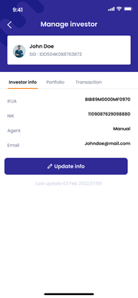 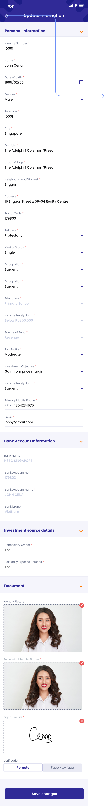 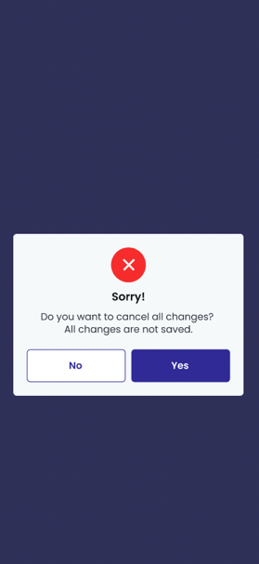

1. **Authorized User**

Existing active RM

1. **Entry Point**

Manage Investor page/Investor info tab

1. **Exit Point**

Manage Investor page/Investor info tab

1. **Process Flow**
2. From Investor detail page, click on ‘Edit’ button to enter Edit page
3. In “Edit” page, user can edit updatable fields accordingly to *Individual KYC List*
4. User will fill in all required fields, take picture as required, sign on the device then tap ‘Submit’ button to send the information
5. If choose individual investor option, the information is ready for review and the system will send emails to investors about their KYC information. There will be ‘Submitted’ MSG Screen.
6. User tap on ‘Cancel’ to cancel editing and go back to Investor detail page

User tap on ‘Apply changes’ to apply changes and go back to Investor detail page

1. **Fields and Validations and Verification**

|  |  |  |  |  |  |  |  |  |  |
| --- | --- | --- | --- | --- | --- | --- | --- | --- | --- |
| **Field** | | **Field Type** | | **Description** | | **Field Length** | **Mandatory** | **Validation** | **In-Line Error Message** |
| Manage investor | | Label | | Manage investor label  [Full name]  SID: [SID number] | | - | Yes |  |  |
| Investor info | | Tab button | | Tap on to enter Manage investor/Investor info | | - | Yes |  |  |
| Portfolio | | Tab button | | Tap on to enter Manage investor/Portfolio | | - | Yes |  |  |
| Transaction | | Tab button | | Tap on to enter Manage investor/Transaction | | - | Yes |  |  |
| IFUA | | Text field | |  | | - | Yes |  |  |
| NIK | | Text field | | NIK: Customs Identification Number | | - | Yes |  |  |
| Agent | | Text field | |  | | - | Yes |  |  |
| Email | | Text field | | Email of the investor | | - | Yes |  |  |
| Update info button | | Button | | Tap on to enter Update info page | | - | Yes |  |  |
| Last update | | Text field | | Last update [last update date], [last update time] | | - | Yes |  |  |
| Edit information | | Label | | Edit information  [Investor name] | | - | Yes |  |  |
| **Individual KYC update** | | | | | | | | | |
| NIK | | Numeric input | | NIK: Customs Identification Number  It has to be in accordance to the NIK rules.  Numeric keypad required | | String (20) | Yes | 1. ‘Types of investor’ has to be set to ‘Individual’ for this field to show 2. User cannot edit this field | 1. This field cannot be empty |
| Full name | | Text input | | Full name  Alphanumeric keypad required | | String (50) | Yes | User cannot edit this field | This field cannot be empty |
| Email | | Alphanumeric input | | Email  Alphanumeric keypad required | | String (100) | Yes | 1. Must be in email format: abc@xyz.com 2. Must be Not Empty 3. User cannot edit this field | 1. This field cannot be empty |
| Phone number | | Numeric input | | Phone number  Numeric keypad required | | String (20) | Yes | 1. Must be Not Empty 2. User cannot edit this field | This field cannot be empty |
| Place of birth | | Alphanumeric input | | Place of birth  Alphanumeric keypad required | | String (100) | Yes | 1. Must be Not Empty 2. User cannot edit this field | This field cannot be empty |
| Date of birth | | Date picker | | Date of birth of investor | | Date picker | Yes | 1. Must be Not Empty   User cannot edit this field | This field cannot be empty |
| Gender | | Dropdown list | | Gender dropdown  1. Male  2. Female  3. Private | | Dropdown list | Yes | 1. Must be Not Empty   User cannot edit this field | This field cannot be empty |
| Province | | Alphanumeric input | | Province  Alphanumeric keypad required | | String (100) | Yes | 1. Must be Not Empty   User cannot edit this field | This field cannot be empty |
| Districts | | Alphanumeric input | | Districts  Alphanumeric keypad required | | String (100) | Yes | 1. Must be Not Empty   User cannot edit this field | This field cannot be empty |
| Urban village | | Alphanumeric input | | Urban village  Alphanumeric keypad required | | String (100) | Yes | 1. Must be Not Empty   User cannot edit this field | This field cannot be empty |
| Neighbourhood/Hamlet | | Alphanumeric input | | Neighbourhood/Hamlet  Alphanumeric keypad required | | String (100) | Yes | 1. Must be Not Empty   User cannot edit this field | This field cannot be empty |
| Address | | Alphanumeric input | | Address  Alphanumeric keypad required | | String (300) | Yes | 1. Must be Not Empty   User cannot edit this field | This field cannot be empty |
| Postal code | | Numeric input | | Postal code  Numeric keypad required | | String (15) | Yes | 1. Must be Not Empty   User cannot edit this field | This field cannot be empty |
| Religion | | Alphanumeric input | | Religion of the investor dropdown  1. Islam  2. Protestant  3. Catholic  4. Hinduism  5. Budhism  6. Confucianism  7. Others | | String (100) | Yes | 1. Must be Not Empty   User cannot edit this field | This field cannot be empty |
| Marital Status | | Dropdown list | | Marital Status dropdown  1. Single  2. Married  3. Divorced | | - | Yes | 1. Must be Not Empty   User cannot edit this field | This field cannot be empty |
| Occupation | | Alphanumeric input | | Occupation of the investor dropdown  1. Student/Graduate Student/Post Graduate  2. Housewife  3. Entrepreneur  4. Civil Servant  5. Indonesian National Armed Force/Indonesian National Police  6. Retirement  7. Lecturer/Teacher  8. Private Employee  9. Others | | String (100) | Yes | 1. Must be Not Empty   User cannot edit this field | This field cannot be empty |
| Education | | Alphanumeric input | | Education level of the investors dropdown  1. Primary School  2. Junior High School  3. Senior High School  4. Diploma  5. Undergraduate  6. Post Graduate  7. Doctoral Program  8. Others | | String (200) | Yes | 1. Must be Not Empty   User cannot edit this field | This field cannot be empty |
| Income level (IDR) | | Dropdown list | | Income level of the investor dropdown  1. Below Rp850.000  2. Rp850.000 - Rp4.000.000  3. Rp4.000.001 - Rp 8.000.000  4. Rp8.000.001 - Rp41.000.000  5. Rp41.000.001 - Rp83.000.000  6. Above Rp83.000.000 | | - | Yes | 1. Must be Not Empty   User cannot edit this field | This field cannot be empty |
| Risk profile | | Dropdown list | | Risk profile dropdown  1. Low  2. Moderate  3. High | | - | Yes | 1. Must be Not Empty   User cannot edit this field | This field cannot be empty |
| Investment Objective | | Dropdown list | | Investment objective dropdown  1. Gain from price  margin  2. Investment  3. Speculation  4. Gain the revenue or  income  5. Others | |  | Yes | 1. Must be Not Empty   User cannot edit this field | This field cannot be empty |
| Source of Fund | | Dropdown list | | Source of fund dropdown  1. Revenue  2. Business Profit  3. Saving interest  4. Legacy  5. Fund from parents or children  6. Grant  7. Fund from husband or wife  8. Drawing  9. Investment gain  10. Others | | - | Yes | 1. Must be Not Empty 2. Editable | This field cannot be empty |
| Beneficiary Owner | | Alphanumeric input | | Name of the beneficiary owner  Alphanumeric keypad required | | String (500) | Yes | 1. Must be Not Empty 2. User cannot edit this field | This field cannot be empty |
| Politically Exposed Persons | | Alphanumeric input | | Politically Exposed Persons  Alphanumeric keypad required | | String (500) | Yes | 1. Must be Not Empty 2. User cannot edit this field | This field cannot be empty |
| Bank name | | Dropdown list | | Bank name dropdown  List retrieved from client's API | |  | Yes | Must be Not Empty  Editable | This field cannot be empty |
| Bank branch | | Alphanumeric input | | Bank branch  Alphanumeric keypad required | | String (300) | Yes | Must be Not Empty  Editable | This field cannot be empty |
| Bank account no | | Numeric input | | Bank account  Numeric keypad required | | String (20) | Yes | Must be Not Empty  Editable | This field cannot be empty |
| Bank account name | | Alphanumeric input | | Bank account name  Alphanumeric keypad required | | String (300) | Yes | Must be Not Empty  Editable | This field cannot be empty |
| **Institutional KYC update** | | | | | | | | | |
| Company name | Alphanumeric input | | Company name  Alphanumeric keypad required | | String (100) | | Yes | Must be Not Empty | This field cannot be empty |
| Country of Domicile | Alphanumeric input | | Country of Domicile  Alphanumeric keypad required | | String (300) | | Yes | Must be Not Empty | This field cannot be empty |
| Place of Establishment | Alphanumeric input | | Place of Establishment  Alphanumeric keypad required | | - | | Yes | Must be Not Empty | This field cannot be empty |
| Date of Establishment | Date picker | | Date of Establishment | | - | | Yes |  |  |
| Articles of Association No. | Numeric input | | Articles of Association Number | | String (40) | | Yes | In case 'Company Characteristic' is '5' (i.e. PMA/Foreign Investment Company), either SKD No. or Articles of Association No. can be used. If both SKD and Articles of Association No. are inputted, SKD No. is to be reported to ARIA for Institutional Investor Profile Data(SKD atau AD/ART). |  |
| NPWP | Numeric input | | NPWP: Tax number  It has to be in accordance to the NPWP rules.  Numeric keypad required | | String (15) | | Yes | ‘Types of investor’ has to be set to ‘Institutional’ for this field to show | This field cannot be empty |
| NPWP Registration Date | Date picker | | NPWP Registration Date date picker | | - | | Yes | Must be a past date |  |
| SIUP No. | Numeric input | | SIUP Number | | String (100) | | Yes | It is mandatory if 'Country of Domicile' is not 'ID' (i.e. Other than Indonesia). |  |
| SIUP Expiration Date | Date picker | | SIUP expiration Date date picker | | - | | Yes | Must be a future date |  |
| SKD No. | Numeric input | | SKD Number | | String (40) | | Yes | In case 'Company Characteristic' is '5' (i.e. PMA/Foreign Investment Company), either SKD No. or Articles of Association No. can be used. If both SKD and Articles of Association No. are inputted, SKD No. is to be reported to ARIA for Institutional Investor Profile Data(SKD atau AD/ART). |  |
| SKD Expiration Date | Date picker | | SKD expiration Date date picker | | - | | Yes | Must be a future date |  |
| Company address | Alphanumeric input | | Address of the company  Alphanumeric keypad required | | String (200) | | Yes | Must be Not Empty | This field cannot be empty |
| Company City Code | Alphanumeric input | | Company City Code  Alphanumeric keypad required | | String (5) | | Yes | Must be Not Empty | This field cannot be empty |
| Company city name | Alphanumeric input | | Company Name  Alphanumeric keypad required | | String (200) | | Yes |  |  |
| Company postal code | Alphanumeric input | | Company postal Code  Alphanumeric keypad required | | String (4) | | Yes |  |  |
| Email | Text input | | Email address  Alphanumeric & symbol keypad required | | String (150) | | Yes | Must be Not Empty | This field cannot be empty |
| Office phone | Numeric input | | Office phone number  Numeric keypad required | | String (15) | |  |  |  |
| Company Correspondent address | Alphanumeric input | | Address of the correspondent company  Alphanumeric keypad required | | String (200) | | - |  |  |
| Company Correspondent city name | Alphanumeric input | | Company Correspondent Name  Alphanumeric keypad required | | String (200) | | - |  |  |
| Company Correspondent City Code | Alphanumeric input | | Company Correspondent City Code  Alphanumeric keypad required | | String (15) | | - |  |  |
| Company postal code | Alphanumeric input | | Company Correspondent postal Code  Alphanumeric keypad required | | String (10) | | - |  |  |
| Email Correspondent | Text input | | Email correspondent address  Alphanumeric & symbol keypad required | | String (150) | | - |  |  |
| Authorized Person 1 - Full Name | Alphanumeric input | | Authorized Person 1 - First Name  Alphanumeric keypad required | | String (50) | | - |  |  |
| Authorized Person 1 – Position | Alphanumeric input | | Authorized Person 1 – Position  Alphanumeric keypad required | | String (50) | | - |  |  |
| Authorized Person 1 – Mobile phone | Numeric input | | Authorized Person 1 – Mobile phone  Numeric keypad required | | String (15) | | - |  |  |
| Authorized Person 1 – Email | Alphanumeric input | | Authorized Person 1 – Email  Alphanumeric keypad required | | String (100) | | - |  |  |
| Authorized Person 2 - Full Name | Alphanumeric input | | Authorized Person 2 - First Name  Alphanumeric keypad required | | String (50) | | - |  |  |
| Authorized Person 2 – Position | Alphanumeric input | | Authorized Person 2 – Position  Alphanumeric keypad required | | String (50) | | - |  |  |
| Authorized Person 2 – Mobile phone | Numeric input | | Authorized Person 2 – Mobile phone  Numeric keypad required | | String (15) | | - |  |  |
| Authorized Person 2 – Email | Alphanumeric input | | Authorized Person 2 – Email  Alphanumeric keypad required | | String (100) | | - |  |  |
| Investor’s risk profile | Dropdown list | | Investor’s risk profile dropdown list:  1. Low  2. Moderate  3. High | | - | | Yes |  |  |
| **Business Data** | | | | | | | | | |
| Company type | Dropdown list | | Company type dropdown list:  1. Corporate  2. Foundation  3. Financial Institution  4. Insurance  5. Mutual Fund  6. Pension Fund  7. Securities Company  8. Others | | - | | Yes | Must be Not Empty | This field cannot be empty |
| Company Characteristic | Dropdown list | | Company Characteristic dropdown list:  1. State Owned  Company/Public  2. Private  3. Social  4. Joint Venture  5. PMA/Foreign  Investment Company  6. Family Company  7. Afiliation  8. Others | | - | | Yes | Must be Not Empty  In case 'Company Characteristic' is '5' (i.e. PMA/Foreign Investment Company), either SKD No. or Articles of Association No. can be used. If both SKD and Articles of Association No. are inputted, SKD No. is to be reported to ARIA for Institutional Investor Profile Data(SKD atau AD/ART). | This field cannot be empty |
| Income level (IDR) | Dropdown list | | Income level dropdown list:  1. < 1 billion/Year  2. > 1– 5 billion/Year  3. > 5 – 10 billion/Year  4. > 10 – 50  billion/Year  5. > 50 billion/Year | | - | | Yes | Must be Not Empty | This field cannot be empty |
| Investment objective | Dropdown list | | Investment objective dropdown list:  1. Gain from price  margin  2. Investment  3. Speculation  4. Gain the revenue or  income  5. Others | | - | | Yes | Must be Not Empty | This field cannot be empty |
| Source of fund | Dropdown list | | Source of fund dropdown  1. Business Profit  2. Pension Funds  3. Saving Interest  4. Investment Gain  5. Others | | - | | Yes | Must be Not Empty | This field cannot be empty |
| **Bank account information** | | | | | | | | | |
| Bank name | Dropdown list | | Bank name dropdown list  List retrieved from client's API | |  | | Yes | Must be Not Empty | This field cannot be empty |
| Bank account | Numeric input | | Bank account  Numeric keypad required | | String (20) | | Yes | Must be Not Empty | This field cannot be empty |
| Bank account name | Alphanumeric input | | Bank account name  Alphanumeric keypad required | | String (100) | | Yes | Must be Not Empty | This field cannot be empty |
| Bank branch | Alphanumeric input | | Bank branch  Alphanumeric keypad required | | String (300) | | Yes | Must be Not Empty | This field cannot be empty |
| **FATCA & CRS** | | | | | | | | | |
| FATCA (Status) |  | | FATCA status dropdown list  . Registered DeemedCompliant FFI  2. Certified DeemedCompliant FFI  3. Owner-Documented  FFI  4. Owner-Documented  FFI with Specified U.S.  Owner  5. Participating FFI  6. Nonparticipating FFI  7. Active NFFE  8. Passive NFFE with  Substantial U.S. Owner  9. Passive NFFE  without Substantial  U.S. Owner  10. Direct Reporting  NFFE  11. Exempt Beneficial  Owner  12. U.S. Financial  Institution | |  | | Yes |  |  |
| TIN / Foreign TIN | Alphanumeric input | | TIN / Foreign TIN  Alphanumeric keypad required | | String (30) | | - | U.S. taxpayer identification number (employer identification number) or Foreign(non-U.S.) tax identifying number |  |
| TIN / Foreign TIN Issurance Country | Alphanumeric input | | TIN / Foreign TIN Issurance Country  Alphanumeric keypad required | | String (30) | | - | ISO country code |  |
| GIIN | Alphanumeric input | | GIIN  Alphanumeric keypad required | | String (30) | | - | Global intermediary identification number |  |
| Substantial U.S. Owner Name | Alphanumeric input | | Substantial U.S. Owner Name  Alphanumeric keypad required | | String (100) | | - | Applicable for FATCA (Status) no. 4, 8 and 10 |  |
| Substantial U.S. Owner Address | Alphanumeric input | | Substantial U.S. Owner Address  Alphanumeric keypad required | | String (100) | | - | Applicable for FATCA (Status) no. 4, 8 and 10 |  |
| Substantial U.S. Owner TIN | Alphanumeric input | | Substantial U.S. Owner TIN  Alphanumeric keypad required | | String (10) | | - | Applicable for FATCA (Status) no. 4, 8 and 10 |  |
| Apply changes button | | Button | | Apply changes button  Tap on to save all changes made | | - |  | All above mandatory fields must be filled in the correct format with valid value to enable this button |  |
| Do you want to cancel all changes | | Label | | Do you want to cancel all changes?  All changes are not saved. | | - | Yes |  |  |
| Yes button | | Button | | Button to proceed with cancel request | | - | Yes |  |  |
| No button | | Button | | Button to return to close the popup | | - | Yes |  |  |
| Close button | | Button | | Button to close the popup | | - | Yes |  |  |

1. **Messaging Requirement**

Follow message in above table

1. **Reference User Story**

N/A

#### User story 6.1 – Investor/ Confirm KYC update

As an investor, I want to view my KYC information updated and sign so that I can confirm my personal information updated.

**Acceptance Criteria**

Dashboard website must be responsive to mobile browser and PC browser

Dashboard website URL must expire after 24 hours since generated

1. **Page Flow**

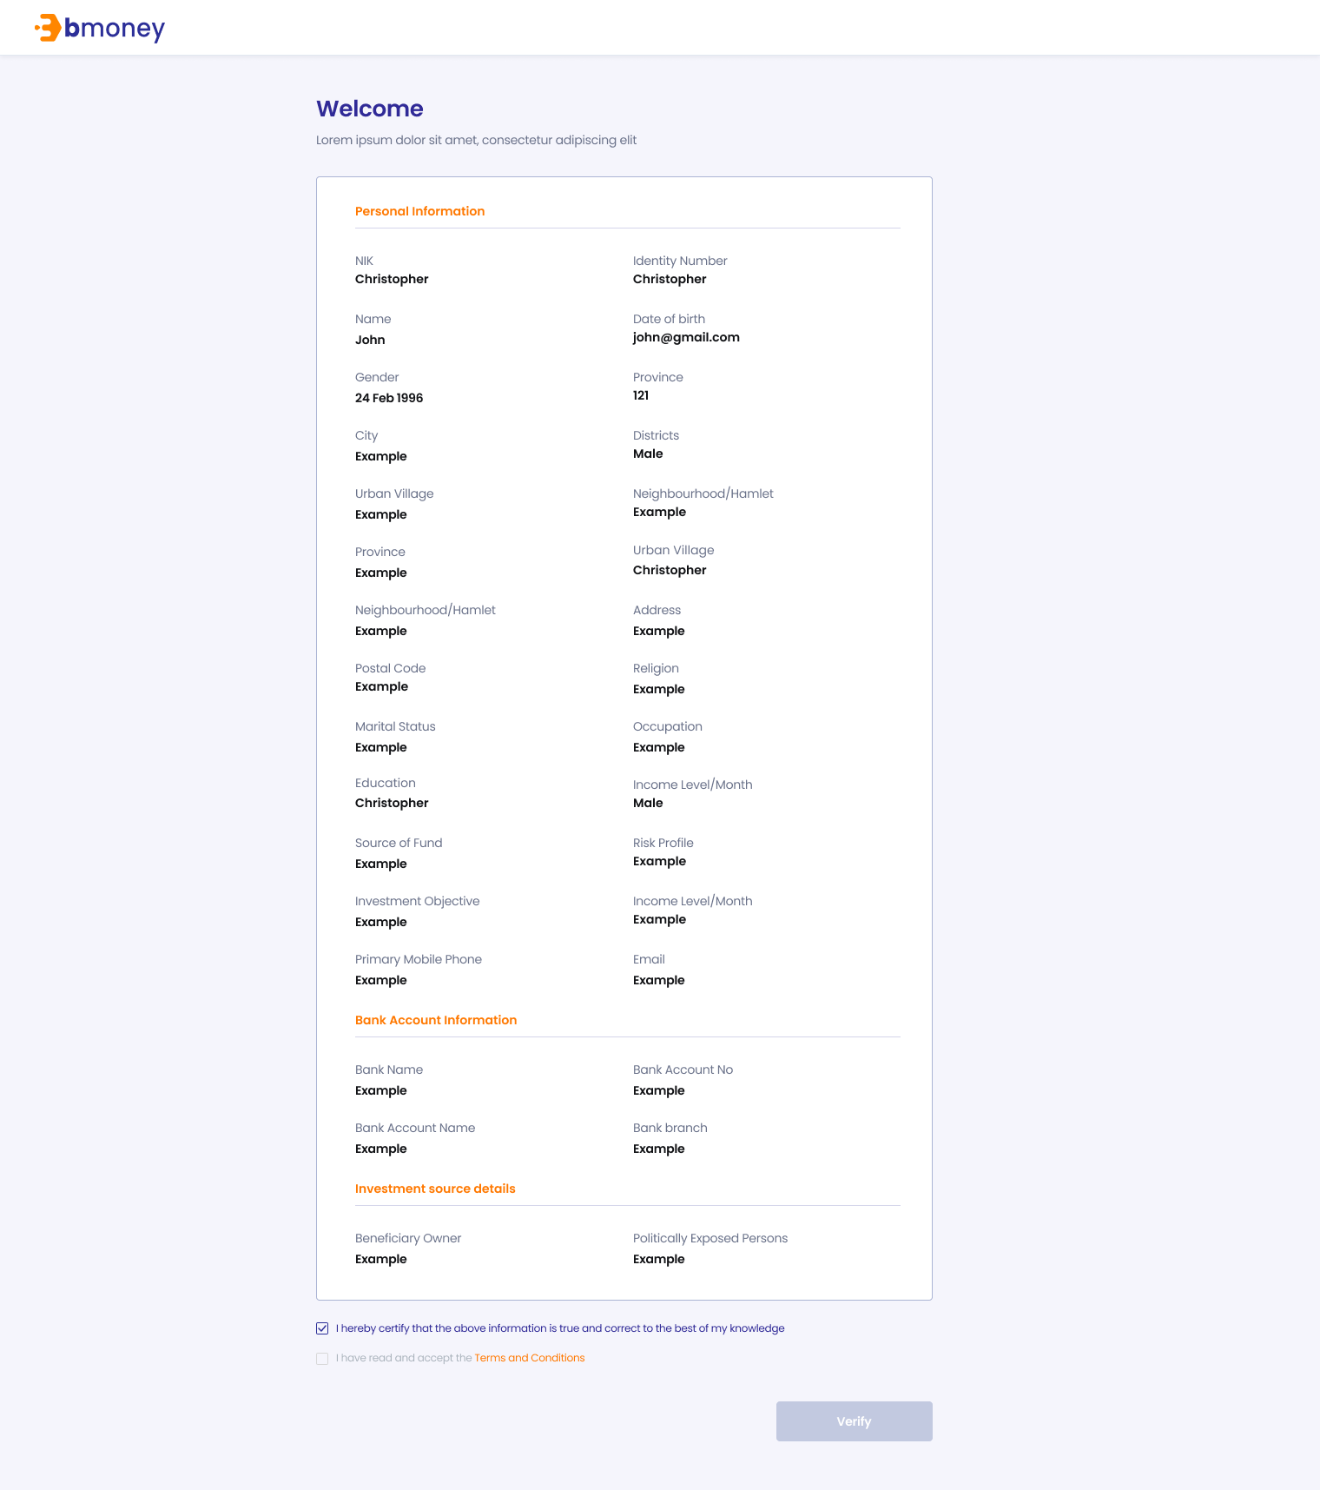

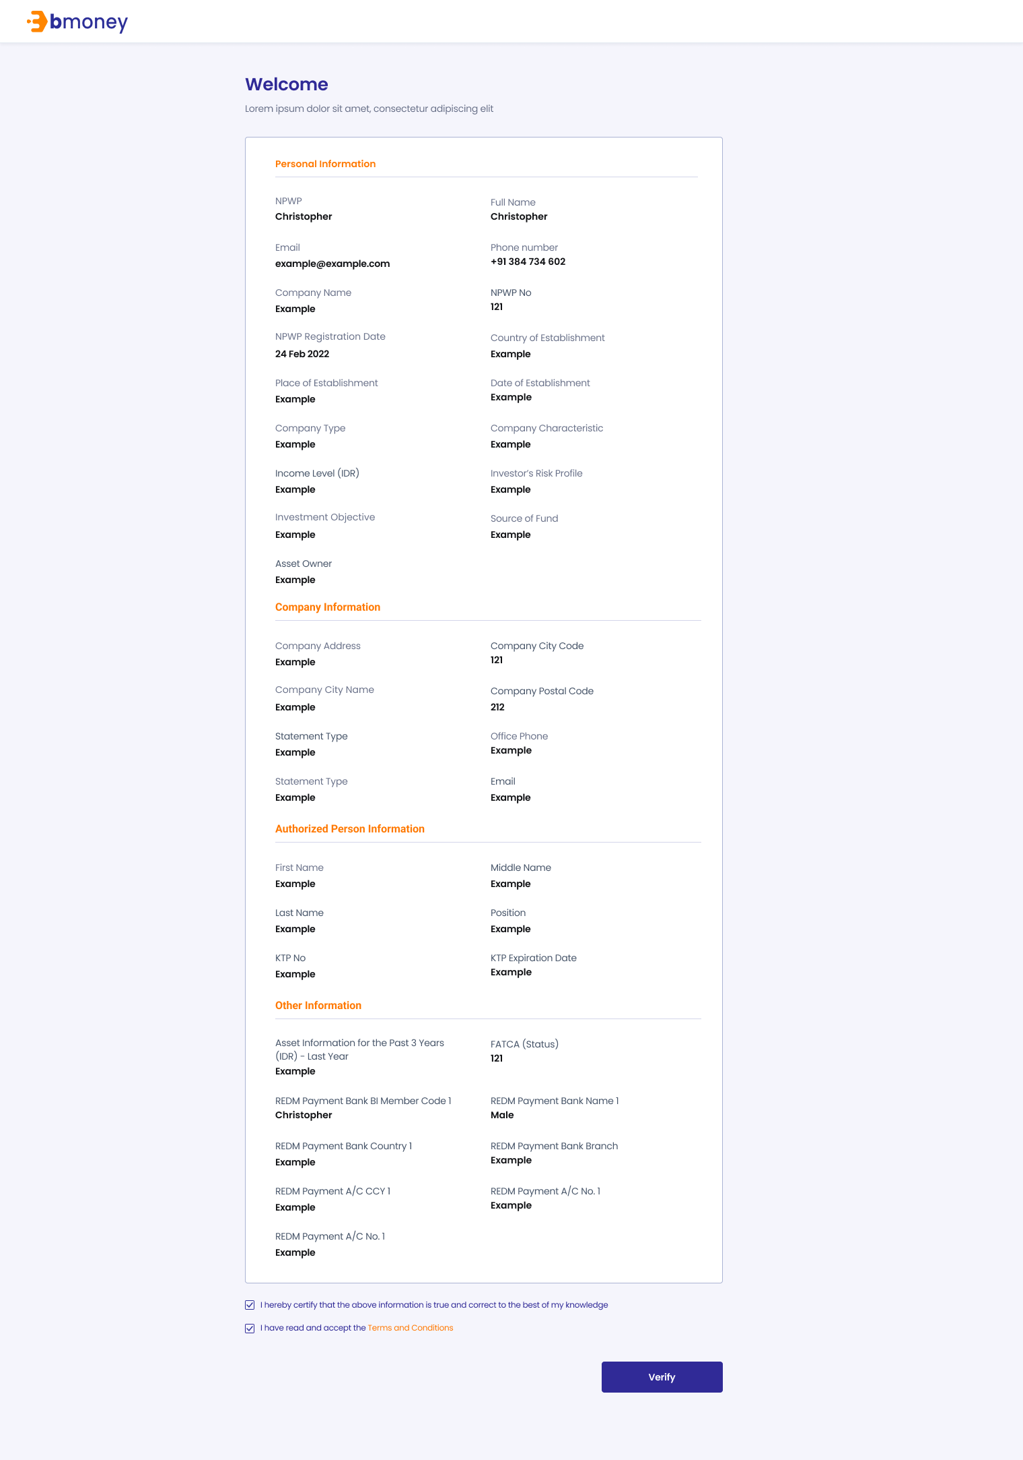





1. **Authorized User**

Existing active investor

1. **Entry Point**

URL from investor’s email

1. **Exit Point**

‘Thank you’ MSG Screen

1. **Process Flow**
2. For Face-to-face option, investors can open the URL from the email, view their KYC information, read T&C and confirm information.

For Remote option, investors can open the URL from the email, view their KYC information, read T&C and sign on device to confirm information

1. There will be Thank you page after investor submitting required information
2. **Fields and Validations and Verifications**

|  |  |  |  |  |  |  |
| --- | --- | --- | --- | --- | --- | --- |
| **Dashboard URL – Individual KYC info** | | | | | | |
| Welcome | Label | Welcome label | - | Yes |  |  |
| NIK | Numeric field | NIK: Customs Identification Number | - | Yes |  |  |
| Full name | Text field | Full name | - | Yes |  |  |
| Email | Text field | Email | - | Yes |  |  |
| Phone number | Numeric field | Phone number | - | Yes |  |  |
| Place of birth | Text field | Place of birth | - | Yes |  |  |
| Date of birth | Text field | Date of birth of investor | - | Yes |  |  |
| Gender | Text field | Gender | - | Yes |  |  |
| Province | Text field | Province | - | Yes |  |  |
| Districts | Text field | Districts | - | Yes |  |  |
| Urban village | Text field | Urban village | - | Yes |  |  |
| Neighbourhood/Hamlet | Text field | Neighbourhood/Hamlet | - | Yes |  |  |
| Address | Text field | Address | - | Yes |  |  |
| Postal code | Numeric field | Postal code | - | Yes |  |  |
| Religion | Text field | Religion of the investor | - | Yes |  |  |
| Marital Status | Text field | Marital Status | - | Yes |  |  |
| Occupation | Text field | Occupation of the investor | - | Yes |  |  |
| Education | Text field | Education level of the investors | - | Yes |  |  |
| Income level (IDR) | Text field | Income level of the investor | - | Yes |  |  |
| Risk profile | Text field | Risk profile | - | Yes |  |  |
| Investment Objective | Text field | Investment objective | - | Yes |  |  |
| Source of Fund | Text field | Source of fund | - | Yes |  |  |
| Beneficiary Owner | Text field | Name of the beneficiary owner | - | Yes |  |  |
| Politically Exposed Persons | Text field | Politically Exposed Persons | - | Yes |  |  |
| Bank name | Text field | Bank name | - | Yes |  |  |
| Bank account | Numeric field | Bank account | - | Yes |  |  |
| Bank account name | Text field | Bank account name | - | Yes |  |  |
| Bank branch | Text field | Bank branch | - | Yes |  |  |
| Certify check box | Check box | I hereby certify that the above information is true and correct to the best of my knowledge | - | Yes |  |  |
| T&C check box | Check box | I have read and accept the Terms and Conditions | - | Yes |  |  |
| Terms & Conditions link button | Link button | Tap on to open PDF file Terms & Conditions Individual | - | Yes |  |  |
| Verify | Button | Verify button  Tap on to confirm information and enter the next page   1. Go to Upload/Draw page signature if user choose Remote option 2. Go to Thank you MSG Screen if user choose Face-to-face option | - | Yes | All above check box fields must be tapped on to enable this button |  |
| Upload Signature | Label | Upload Signature  Please submit your signature for verification | - | Yes |  |  |
| Draw/Upload option | Option tab | Draw/Upload option   * Draw (default) * Upload | - | Yes |  |  |
| Signature canvas | Canvas | Tap on to start draw signature | - | Yes |  |  |
| Please draw your signature | Text field | Please draw your signature | - | Yes |  |  |
| Clear | Button | Clear button  Tap on to clear the signature drawn before and retry | - | Yes |  |  |
| Upload  button | Button | Choose file or drag it here  Tap on to browse offline file | - | Yes |  |  |
| Accepted format | Text field | Accepted format: PNG, JPEG or PDF. Up to 5MB | - | Yes |  |  |
| Cancel button | Button | Cancel button  Tap on to trigger Cancel pop-up | - | Yes |  |  |
| Cancel pop-up | Pop-up label | Do you want to cancel?  This URL will expire after 24 hours. Please submit your signature before the deadlines. | - | Yes |  |  |
| Yes | Button | Yes button  Tap on to cancel submitting signature | - | Yes |  |  |
| No | Button | No button  Tap on to close the pop-up | - | Yes |  |  |
| Accept and send button | Button | Accept and send button  Tap on to trigger Submit pop-up | - | Yes |  |  |
| Submit pop-up | Pop-up label | Are you sure you want to submit your signature? | - | Yes |  |  |
| Yes | Button | Yes button  Tap on to submit the signature | - | Yes |  |  |
| No | Button | No button  Tap on to close the pop-up | - | Yes |  |  |
| Thank you | Label | Thank you  Your information is being processed. We will keep you updated via email | - | Yes |  |  |
| **Dashboard URL – Institutional KYC info** | | | | | | |
| Welcome | Label | Welcome label | - | Yes |  |  |
| Company name | Alphanumeric input | Company name  Alphanumeric keypad required | - | Yes |  |  |
| Country of Domicile | Alphanumeric field | Country of Domicile  Alphanumeric keypad required | - | Yes |  |  |
| Place of Establishment | Text field | Place of Establishment | - | Yes |  |  |
| Articles of Association No. | Numeric field | Articles of Association Number | - | Yes |  |  |
| NPWP | Numeric field | NPWP: Tax number | - | Yes |  |  |
| NPWP Registration Date | Text field | NPWP Registration Date | - | Yes |  |  |
| SIUP No. | Numeric field | SIUP Number | - | Yes |  |  |
| SIUP Expiration Date | Text field | SIUP expiration Date | - | Yes |  |  |
| SKD No. | Numeric field | SKD Number | - | Yes |  |  |
| SKD Expiration Date | Text field | SKD expiration Date | - | Yes |  |  |
| Company address | Text field | Address of the company | - | Yes |  |  |
| Company City Code | Text field | Company City Code | - | Yes |  |  |
| Company city name | Text field | Company Name | - | Yes |  |  |
| Company postal code | Text field | Company postal Code | - | Yes |  |  |
| Email | Text field | Email | - | Yess |  |  |
| Office phone | Numeric field | Office phone number | - | Yes |  |  |
| Company correspondent address | Text field | Address of the correspondent company | - | Yes |  |  |
| Company Correspondent City Code | Text field | Company Correspondent City Code | - | Yes |  |  |
| Company Correspondent city name | Text field | Company Correspondent Name | - | Yes |  |  |
| Company Correspondent postal code | Text field | Company Correspondent Postal Code | - | Yes |  |  |
| Email Correspondent | Text field | Email Correspondent | - | Yess |  |  |
| Authorized Person 1 – full name | Text field | Authorized Person 1 – Full Name | - | Yes |  |  |
| Authorized Person 1 – Position | Text field | Authorized Person 1 – Position | - | Yes |  |  |
| Authorized Person 1 – Mobile phone | Numeric field | Authorized Person 1 – Mobile phone | - | Yes |  |  |
| Authorized Person 1 – Email | Text field | Authorized Person 1 – Email | - | Yes |  |  |
| Authorized Person 2 – full name | Text field | Authorized Person 2 – Full Name | - | Yes |  |  |
| Authorized Person 2 – Position | Text field | Authorized Person 2 – Position | - | Yes |  |  |
| Authorized Person 2 – Mobile phone | Numeric field | Authorized Person 2 – Mobile phone | - | Yes |  |  |
| Authorized Person 1 – Email | Text field | Authorized Person 1 – Email | - | Yes |  |  |
| Investor’s risk profile | Text field | Investor’s risk profile  1. Low  2. Moderate  3. High | - | Yes |  |  |
| Company Type | Text field | Company Type  1. Corporate  2. Foundation  3. Financial Institution  4. Insurance  5. Mutual Fund  6. Pension Fund  7. Securities Company  8. Others | - | Yes |  |  |
| Company Characteristic | Text field | Company Characteristic  1. State Owned Company/Public  2. Private  3. Social  4. Joint Venture  5. PMA/Foreign Investment Company  6. Family Company 7. Affiliation  8. Others | - | Yes |  |  |
| Income level (IDR) | Text field | Income level  1. < 1 billion/Year 2. > 1– 5 billion/Year  3. > 5 – 10 billion/Year  4. > 10 – 50 billion/Year  5. > 50 billion/Year | - | Yes |  |  |
| Investment objective | Text field | Investment objective  1. Gain from price margin  2. Investment  3. Speculation  4. Gain the revenue or income  5. Others | - | Yes |  |  |
| Source of fund | Text field | Source of fund  1. Business Profit  2. Pension Funds  3. Saving Interest  4. Investment Gain 5. Others | - | Yes |  |  |
| Bank name | Text field | Bank name | - | Yes |  |  |
| Bank account | Numeric field | Bank account | - | Yes |  |  |
| Bank account name | Text field | Bank account name | - | Yes |  |  |
| Bank branch | Text field | Bank branch | - | Yes |  |  |
| FATCA (Status) | Text field | FATCA status  1. Registered Deemed-Compliant FFI  2. Certified Deemed-Compliant FFI  3. Owner-Documented FFI  4. Owner-Documented FFI with Specified U.S. Owner  5. Participating FFI 6. Nonparticipating FFI  7. Active NFFE  8. Passive NFFE with Substantial U.S. Owner  9. Passive NFFE without Substantial U.S. Owner  10. Direct Reporting NFFE  11. Exempt Beneficial Owner  12. U.S. Financial Institution | - | Yes |  |  |
| TIN/ Foreign TIN | Text field | TIN/ Foreign TIN | - | Yes |  |  |
| TIN/ Foreign TIN Insurance Country | Text field | TIN/ Foreign TIN Insurance Country | - | Yes |  |  |
| GIIN | Text field | GIIN | - | Yes |  |  |
| Substantial U.S. Owner Name | Text field | Substantial U.S. Owner Name | - | Yes |  |  |
| Substantial U.S. Owner Address | Text field | Substantial U.S. Owner Address | - | Yes |  |  |
| Substantial U.S. Owner TIN | Text field | Substantial U.S. Owner TIN | - | Yes |  |  |
| Certify check box | Check box | I hereby certify that the above information is true and correct to the best of my knowledge | - | Yes |  |  |
| T&C check box | Check box | I have read and accept the Terms and Conditions | - | Yes |  |  |
| Terms & Conditions link button | Link button | Tap on to open PDF file Terms & Conditions | - | Yes |  |  |
| Verify | Button | Verify button  Tap on to confirm information and enter the next page   1. Go to Upload/Draw page signature if user choose Remote option 2. Go to Thank you MSG Screen if user choose Face-to-face option | - | Yes | All above check box fields must be tapped on to enable this button |  |
| Upload Signature | Label | Upload Signature  Please submit your signature for verification | - | Yes |  |  |
| Draw/Upload option | Option tab | Draw/Upload option   * Draw (default) * Upload | - | Yes |  |  |
| Signature canvas | Canvas | Tap on to start draw signature | - | Yes |  |  |
| Please draw your signature | Text field | Please draw your signature | - | Yes |  |  |
| Clear | Button | Clear button  Tap on to clear the signature drawn before and retry | - | Yes |  |  |
| Upload  button | Button | Choose file or drag it here  Tap on to browse offline file | - | Yes |  |  |
| Accepted format | Text field | Accepted format: PNG, JPEG or PDF. Up to 5MB | - | Yes |  |  |
| Cancel button | Button | Cancel button  Tap on to trigger Cancel pop-up | - | Yes |  |  |
| Cancel pop-up | Pop-up label | Do you want to cancel?  This URL will expire after 24 hours. Please submit your signature before the deadlines. | - | Yes |  |  |
| Yes | Button | Yes button  Tap on to cancel submitting signature | - | Yes |  |  |
| No | Button | No button  Tap on to close the pop-up | - | Yes |  |  |
| Accept and send button | Button | Accept and send button  Tap on to trigger Submit pop-up | - | Yes |  |  |
| Submit pop-up | Pop-up label | Are you sure you want to submit your signature? | - | Yes |  |  |
| Yes | Button | Yes button  Tap on to submit the signature | - | Yes |  |  |
| No | Button | No button  Tap on to close the pop-up | - | Yes |  |  |
| Thank you | Label | Thank you  Your information is being processed. We will keep you updated via email | - | Yes |  |  |

1. **Messaging Requirement**

Follow message in above table

1. **Reference User Story**

N/A

### Transaction Management

#### User Story 7 – View transaction list

As an existing RM, I want to view the detail of transactions of my investor to follow and track the status of each transaction

As an existing Supervisor, I want to view the detail of transactions of my investor and of investors within my company to follow and track the status of each transaction

As an existing Supervisor of the Inhouse, I want to view the detail of transactions of my investor, of investors within my company and of other investors from other companies to follow and track the status of each transaction

**Acceptance Criteria**

1. **Page Flow**

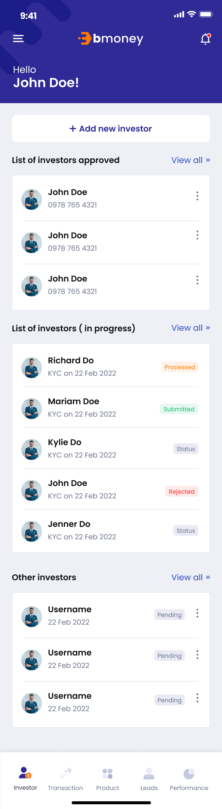 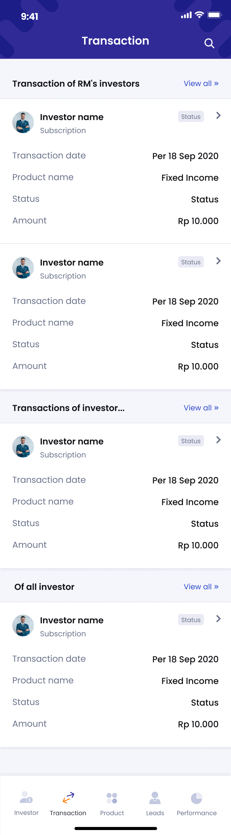

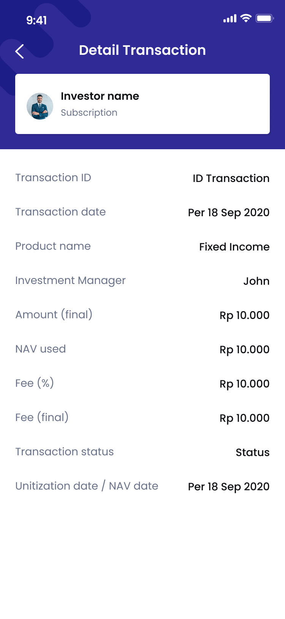 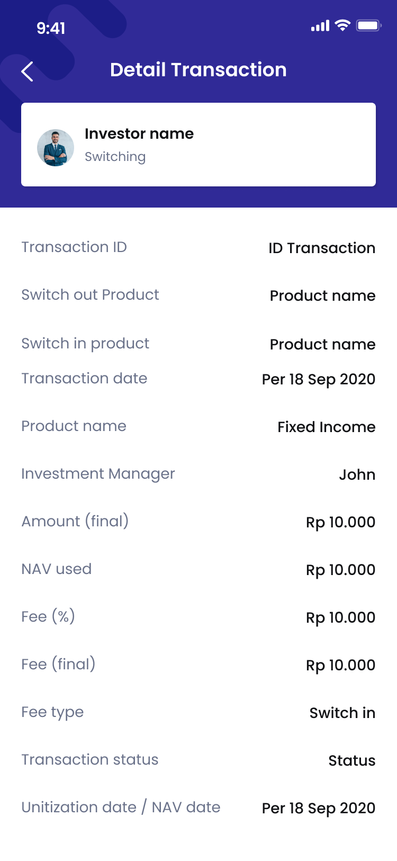 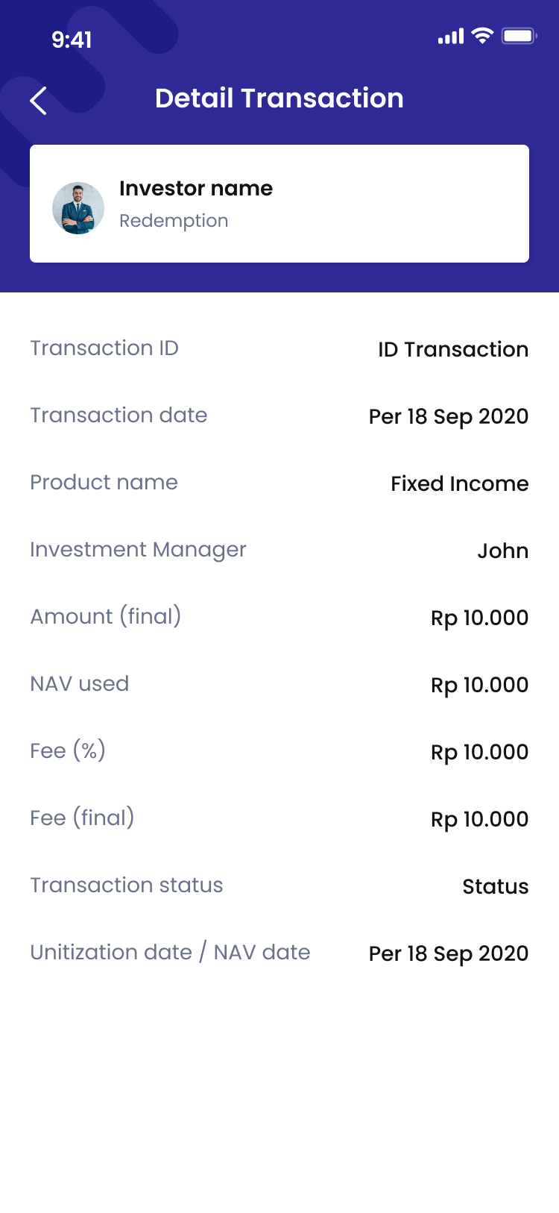 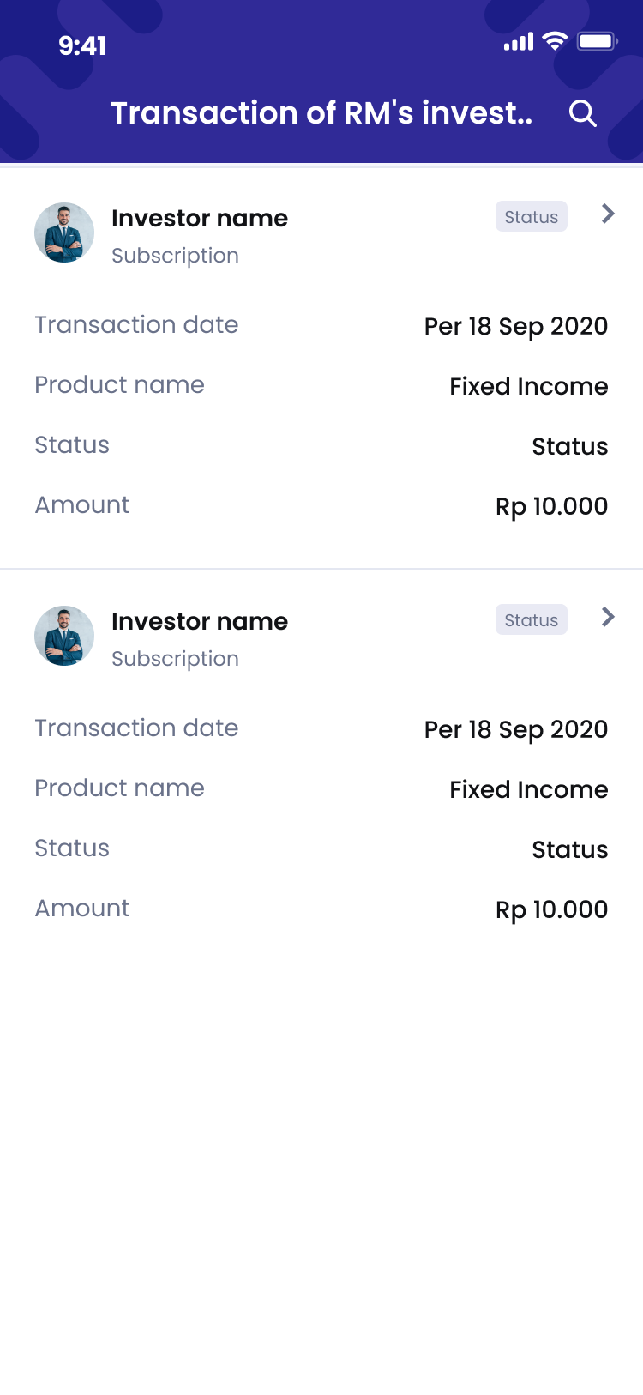

1. **Authorized User**

Existing active RM

1. **Entry Point**

Home page/Investor tab

1. **Exit Point**

Manage investor/Investor info tab

1. **Process Flow**
2. From ‘Home page/Investor tab’, user tap on Transaction tab in the navigation to enter ‘Home page/Transaction tab’
3. In this page:

* RM user can view list of transactions of user’s investor
* Supervisor user can view list of transactions of user’s investor and of investors within user’s company
* Supervisor of the Inhouse user can view the list of transactions of user’s investor, of investors within user’s company and of other investors from other companies to follow and track the status of each transaction
* User can tap on ‘View all’ link button at the top right of each list to enter ‘List of transactions’ page

1. User can tap on button in each transaction to see the transaction details.
2. **Fields and Validations and Verification**

|  |  |  |  |  |  |  |
| --- | --- | --- | --- | --- | --- | --- |
| **Field** | **Field Type** | **Description** | **Field Length** | **Mandatory** | **Validation** | **In-Line Error Message** |
| Transaction | Label | List of transaction label | - | Yes |  |  |
| **Transactions of RM’s investors** | | | | | | |
| Transaction of RM’s investor label | Label | List of transactions of RM’s investor label | - | Yes |  |  |
| View all | Link button | Tap on to view list of all RM’s investors’ transactions | - | Yes |  |  |
| Investor Name | Text field | Full name of investor | - | Yes |  |  |
| Product Date | Text field | Product Date | - | Yes |  |  |
| Status | Label | Status of transaction | - | Yes |  |  |
| Icon  Description automatically generated button | Button | Tap on to open action list of transaction | - | Yes |  |  |
| Transaction Type | Text field | Type of transaction (Subscription/ Redemption/ Switching) | - | Yes |  |  |
| Product Name | Text field | Name of product | - | Yes |  |  |
| Amount | Numeric input | Amount |  |  |  |  |
| **Transactions of investors within company** | | | | | | |
| Of investors within company label | Label | List of transactions of investors within company label | - | Yes |  |  |
| View all | Link button | Tap on to view list of all investors within company’s transactions | - | Yes |  |  |
| Investor Name | Text field | Full name of investor | - | Yes |  |  |
| Product Date | Text field | Product Date | - | Yes |  |  |
| Status | Label | Status of transaction | - | Yes |  |  |
| Icon  Description automatically generated button | Button | Tap on to open action list of transaction | - | Yes |  |  |
| Transaction Type | Text field | Type of transaction (Subscription/ Redemption/ Swtching) | - | Yes |  |  |
| Product Name | Text field | Name of product | - | Yes |  |  |
| Amount | Numeric input | Amount |  |  |  |  |
| **Transactions of all investors** | | | | | | |
| Of allinvestors label | Label | List of transactions of all investors label | - | Yes |  |  |
| View all | Link button | Tap on to view list of all investors’ transactions | - | Yes |  |  |
| Investor Name | Text field | Full name of investor | - | Yes |  |  |
| Product Date | Text field | Product Date | - | Yes |  |  |
| Status | Label | Status of transaction | - | Yes |  |  |
| Icon  Description automatically generated button | Button | Tap on to open action list of transaction | - | Yes |  |  |
| Transaction Type | Text field | Type of transaction (Subscription/ Redemption/ Swtching) | - | Yes |  |  |
| Product Name | Text field | Name of product | - | Yes |  |  |
| Amount | Numeric input | Amount |  |  |  |  |

**Transaction Details (Subcription/ Redemption)**

|  |  |  |  |  |  |  |
| --- | --- | --- | --- | --- | --- | --- |
| **Field** | **Field Type** | **Description** | **Field Length** | **Mandatory** | **Validation** | **In-Line Error Message** |
| Detail Transaction | Label | Transaction Details | - | Yes |  |  |
| **Investor info tab** | | | | | | |
| Investor Name | Text field | Full name of investor | - | Yes |  |  |
| Transaction Type | Text field | Type of transaction   * Subscription * Redemption * Switching | - | Yes |  |  |
| Status | Label | Status of transaction | - | Yes |  |  |
| Transaction ID | Text field | ID of transaction |  | Yes |  |  |
| Product Name | Text field | Name of product | - | Yes |  |  |
| Investment Manager | Text field | Name of investment manager | - | Yes |  |  |
| Amount (final) | Numeric input | Amount | - |  |  |  |
| NAV | Numeric field | NAV of the product at the moment | - | Yes |  |  |
| Fee (%) | Numeric input | Fee  The amount of fee for RM when this transaction is approved  Auto generated default fee after entering valid Product  User can edit the fee for each transaction | String (3) | Yes |  |  |
| Fee (final) | Numeric input | The final fee of the transaction | - | Yes |  |  |
| Transaction status | Text field | Status of transaction | - | Yes |  |  |
| Unitization date/ NAV date | Date |  | - | Yes |  |  |
| Icon  Description automatically generatedbutton | Button | Icon  Description automatically generated button, tap on the button to go back to transaction list page | - | Yes |  |  |

**Transaction Details (Switching)**

|  |  |  |  |  |  |  |
| --- | --- | --- | --- | --- | --- | --- |
| **Field** | **Field Type** | **Description** | **Field Length** | **Mandatory** | **Validation** | **In-Line Error Message** |
| Detail Transaction | Label | Transaction Details | - | Yes |  |  |
| **Investor info tab** | | | | | | |
| Investor Name | Text field | Full name of investor | - | Yes |  |  |
| Transaction Type | Text field | Type of transaction   * Subscription * Redemption   Switching | - | Yes |  |  |
| Status | Label | Status of transaction | - | Yes |  |  |
| Transaction ID | Text field | ID of transaction |  | Yes |  |  |
| Switch out Product | Text field | Name of switch out product | - | Yes |  |  |
| Switch in Product Name | Text field | Name of switch in product | - | Yes |  |  |
| Investment Manager | Text field | Name of investment manager | - | Yes |  |  |
| Amount (final) | Numeric input | Amount | - |  |  |  |
| NAV | Numeric field | NAV of the product at the moment | - | Yes |  |  |
| Fee (%) | Numeric input | Fee  The amount of fee for RM when this transaction is approved  Auto generated default fee after entering valid Product  User can edit the fee for each transaction | String (3) | Yes |  |  |
| Fee (final) | Numeric input | The final fee of the transaction | - | Yes |  |  |
| Fee type | Text field | Type of fee   * Switch out * Switch in | - | Yes |  |  |
| Transaction status | Text field | Status of transaction | - | Yes |  |  |
| Unitization date/ NAV date | Date |  | - | Yes |  |  |
| Icon  Description automatically generatedbutton | Button | Icon  Description automatically generated button, tap on the button to go back to transaction list page | - | Yes |  |  |

1. **Messaging Requirement**

Follow message in above table

1. **Reference User Story**

N/A

#### User Story 8 – Create instruction/Subscription

As an existing RM, I want to create an instruction and send it to my investor for confirmation

**Acceptance Criteria**

For Investor ID, Product autocompleted list, it will display 20 auto filled records only.

1. **Page Flow**

 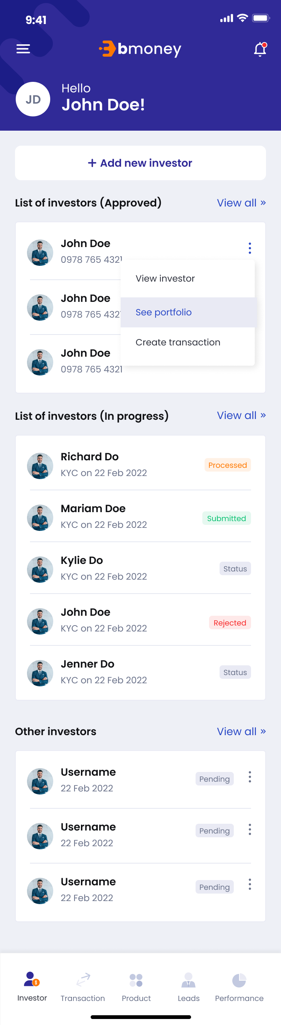

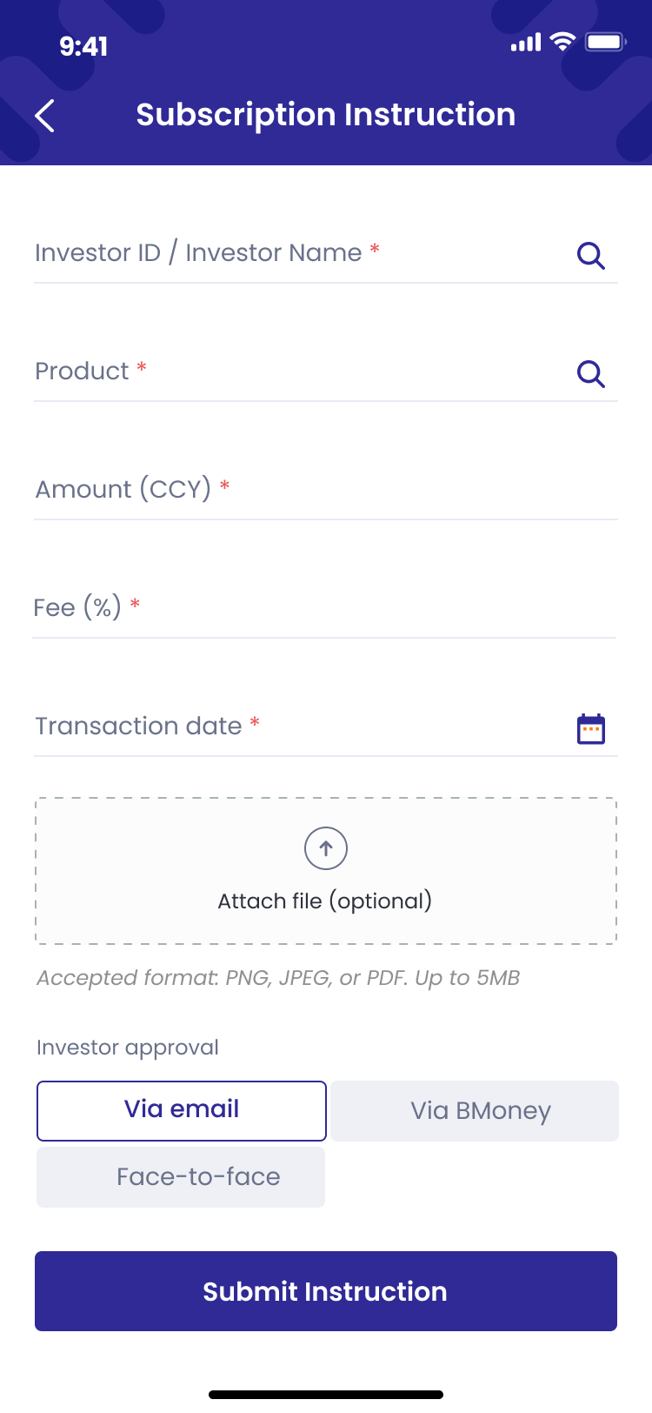 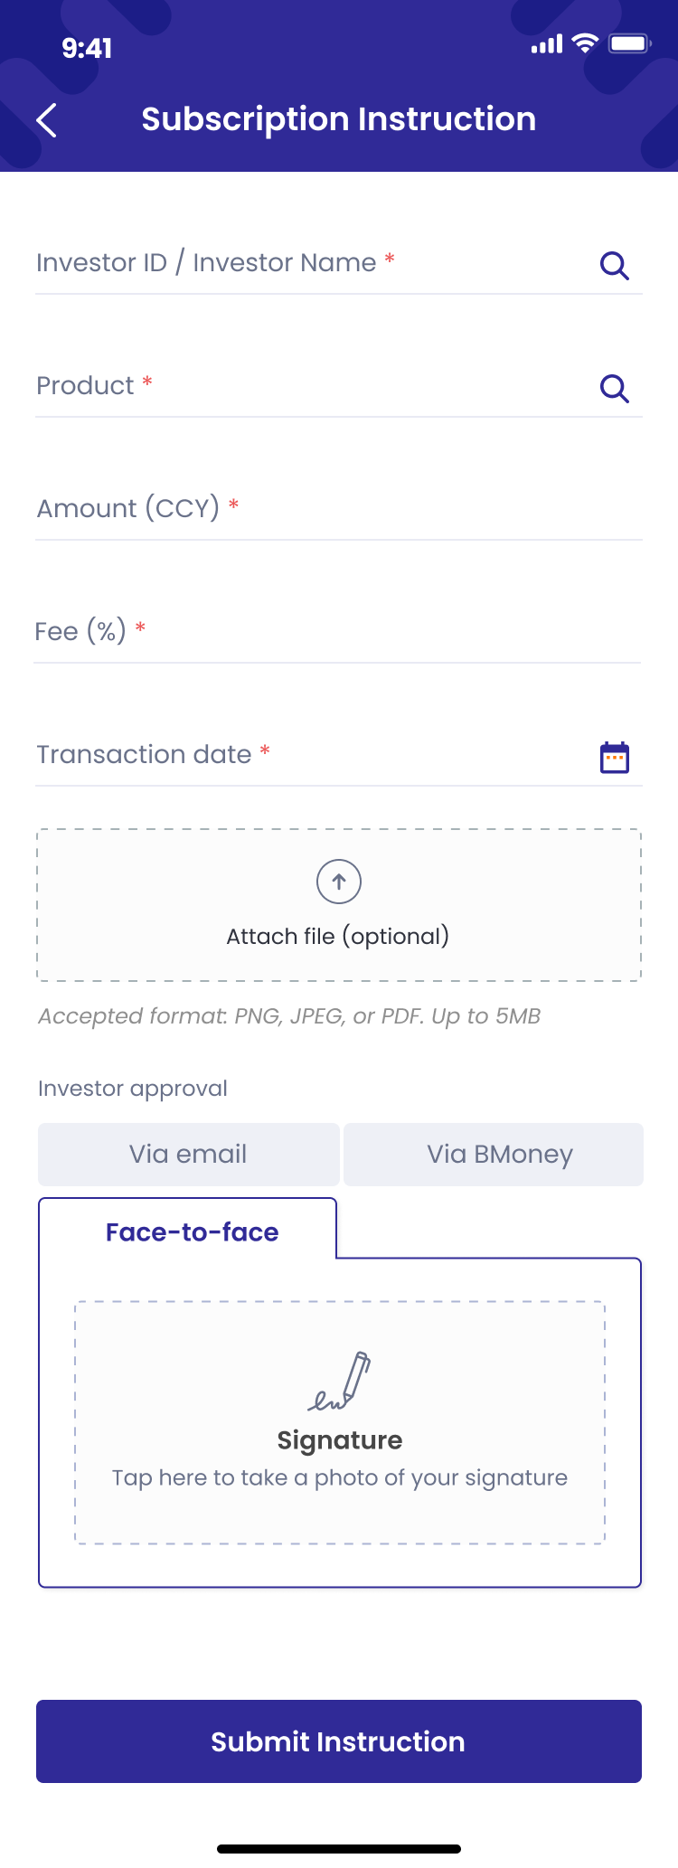

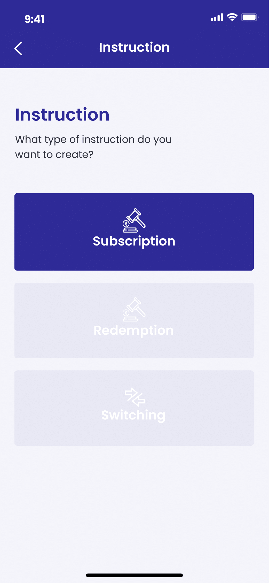

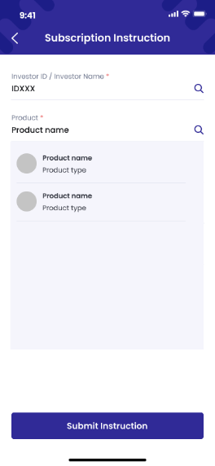 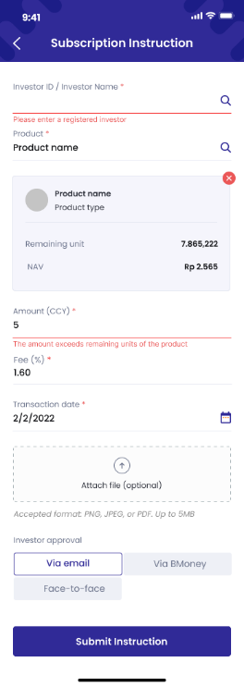

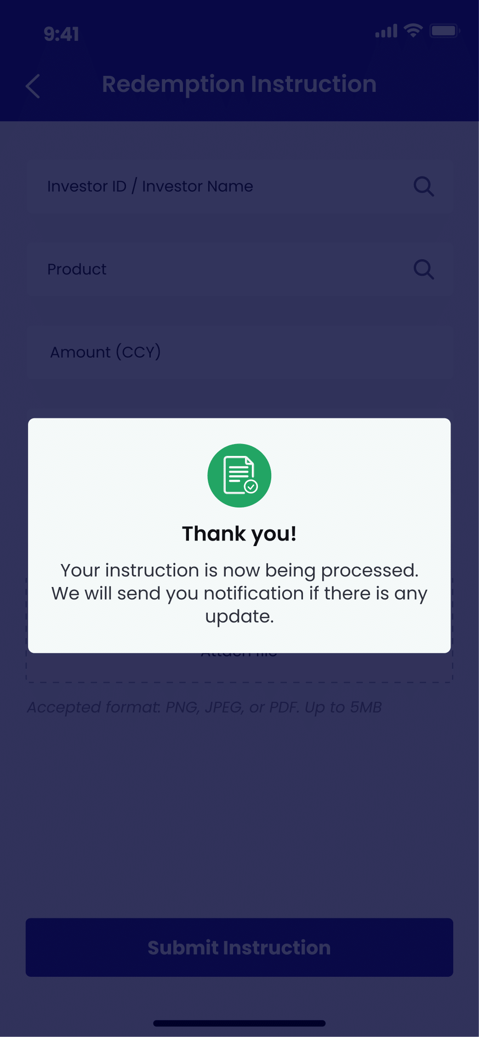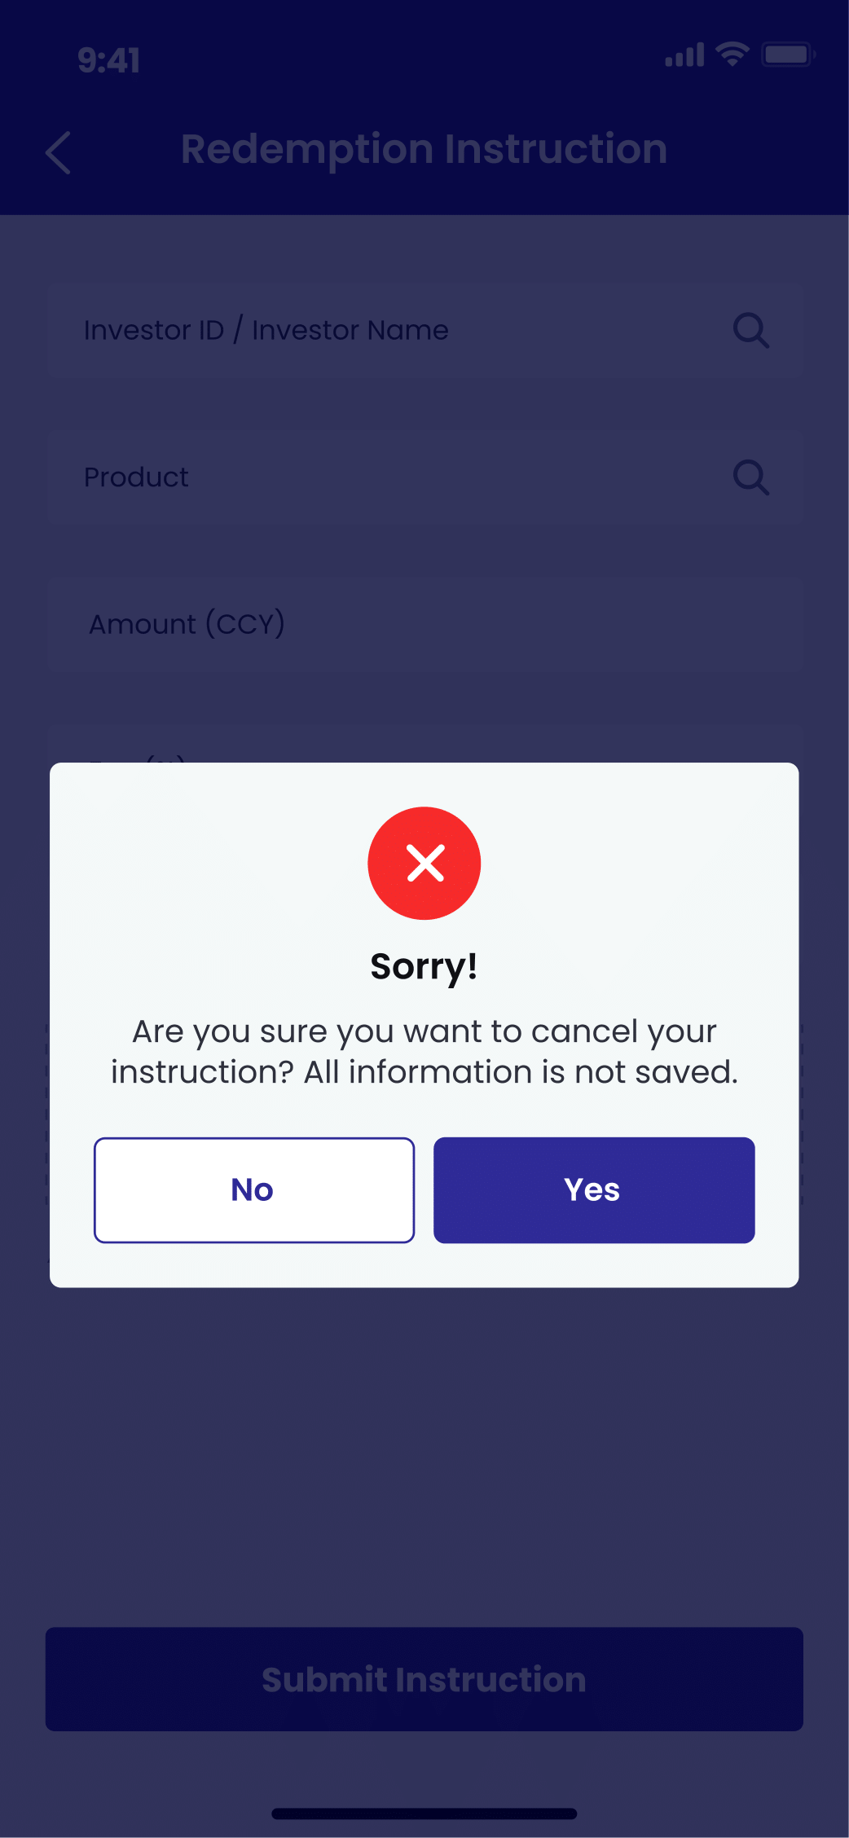

1. **Authorized User**

Existing active RM

1. **Entry Point**

Home page/Investor tab

Home page/Transaction tab

Manage investor page

1. **Exit Point**

Submitted MSG Screen

1. **Process Flow**
2. From Home page/Investor tab/Approved investors panel, user can tap on ‘Create transaction button’ to enter Instruction types page

From Home page/Transaction tab, user can tap on ‘Create new instruction’ button to enter Instruction types page

From Manage investor page/Product portfolio panel, user can tap on Switching button, Sell button or Buy button to enter Create instruction page (Skip step 2)

1. User can choose among 3 types of transaction instruction: Subscription, Redemption, Switching. Tap on:

* Subscription button to buy products from the market. Refer to ***User story 8 – Create instruction/Subscription***
* Redemption button to sell products to the market. Refer to ***User story 9 – Create instruction/Redemption***
* Switching button to exchange product from one type to another in the equal amount. Refer to ***User story 10 – Create instruction/Switching***

1. User fill in required fields then tap on Submit Instruction button.

There will be Submitted MSG Screen. User can tap on OK button to return to My Instruction Page

1. **Fields and Validations and Verification**

|  |  |  |  |  |  |  |
| --- | --- | --- | --- | --- | --- | --- |
| **Field** | **Field Type** | **Description** | **Field Length** | **Mandatory** | **Validation** | **In-Line Error Message** |
|  | Button | Tap on to open Control panel | - | Yes |  |  |
|  | Button | Tap on to open notification list | - | Yes |  |  |
| Hello | Label | Hello  [Full_Name] | - | Yes |  |  |
| Gravatar | Avatar | Avatar of the user | - | Yes |  |  |
| Add new investor | Button | Tap on to enter ‘Register new investor’ page | - | Yes |  |  |
| **List of investors approved panel** | | | | | | |
| List of investors approved panel | Label | List of investors approved panel label | - | Yes |  |  |
| Gravatar | Avatar | Avatar of the user | - | Yes |  |  |
| Full name | Text field | Full name of investor | - | Yes |  |  |
| Phone number | Numeric field | Phone number of investor | - | Yes |  |  |
| button | Button | Tap on to open action list of investor | - | Yes |  |  |
| View investor | Button | Tap on to enter Manage investor page/Investor info tab | - | Yes |  |  |
| See portfolio | Button | Tap on to enter Manage investor page/Porfolio tab | - | Yes |  |  |
| Create transaction | Button | Tap on to enter Instruction type page | - | Yes |  |  |
| View all | Link button | Tap on to view list of all approved investors | - | Yes |  |  |
| **List of investors in progress panel** | | | | | | |
| List of investors in progress | Label | List of investors in progress label | - | Yes |  |  |
| Gravatar | Avatar | Avatar of the user | - | Yes |  |  |
| Full name | Text field | Full name of investor | - | Yes |  |  |
| KYC Date | Text field | KYC on [KYC Date] | - | Yes |  |  |
| Status | Text field | Status of investors | - | Yes |  |  |
| View all | Link button | Tap on to view list of all investors in progress | - | Yes |  |  |
| **List of other investors panel** | | | | | | |
| List of other investors | Label | List of other investors label | - | Yes |  |  |
| Gravatar | Avatar | Avatar of the user | - | Yes |  |  |
| Full name | Text field | Full name of investor | - | Yes |  |  |
| KYC Date | Text field | [KYC Date] | - | Yes |  |  |
| Status | Text field | Status of investors | - | Yes |  |  |
| View all | Link button | Tap on to view list of all other investors | - | Yes |  |  |
| button | Button | Tap on to open action list of investor |  | Yes |  |  |
| **Home panel** | | | | | | |
| Investor | Button | Tap on to go to Home page – Investor panel | - | Yes |  |  |
| Transaction | Button | Tap on to go to Home page – Transaction panel | - | Yes |  |  |
| Leads | Button | Tap on to go to Home page – Leads panel | - | Yes |  |  |
| Report | Button | Tap on to go to Home page – Report panel | - | Yes |  |  |
| Instruction | Label | Instruction  What type of instruction do you want to create? | - | Yes |  |  |
| Subscription button | Button | Subscription button  Tap on to enter Subscription Instruction page | - | Yes |  |  |
| Redemption button | Button | Redemption button  Tap on to enter Redemption Instruction page | - | Yes |  |  |
| Switching button | Button | Switching button  Tap on to enter Switching Instruction page | - | Yes |  |  |
| Subscription Instruction | Label | Subscription Instruction | - | Yes |  |  |
| Investor ID / Investor Name | Auto-complete | Investor ID / Investor Name  For individual investor: [NIK] – [Full name]  For institutional investor: [NPWN] – [Company name]  Alphanumeric keypad required | String (100) | Yes | 1. Start searching after entering first letter 2. Must be Not Empty | 1. This field cannot be empty |
| Product | Auto-complete | Product  Fill in the name/code for the system to suggest products to buy | String (200) | Yes | 1. Start searching after entering first letter 2. Must be Not Empty | 1. This field cannot be empty |
| 1. Product panel (Auto-generated after enter a valid input in ‘Product’) | | | | | | |
| Product name | Text field | Name of the product | - | Yes |  |  |
| Product type | Text field | Type of product, include:   * Money Market * Fixed Income * Balanced * Equity | - | Yes |  |  |
| Remaining unit | Numeric field | Remaining unit of the product for sale on the market | - | Yes |  |  |
| NAV | Numeric field | NAV of the product at the moment | - | Yes |  |  |
| Amount (CYY) | Numeric input | Amount  Enter the amount to buy  Unlimited amount input | String (20) | Yes | 1. Follow CCY for the product 2. Unlimited amount input type. 3. Must be Not Empty 4. Must not exceed Remaining unit of the product | 1. This field cannot be empty 2. The amount exceeds remaining unit of the product |
| Fee (%) | Numeric input | Fee  The amount of fee for RM when this transaction is approved  Auto generated default fee after entering valid Product  User can edit the fee for each transaction | String (3) | Yes | Must be Not Empty | 1. This field cannot be empty |
| Transaction date | Date picker | Transaction date  Choose the date for the transaction to be proceeded |  | Yes | 1. Transaction date is defaulted to today's date if created before 1 PM and defaulted to next business day if created after 1 PM 2. Must be Not Empty | This field cannot be empty |
| Attach file button | Button | Attach file button  Tap on to choose file to attach such as Transaction receipt | - | Yes | Accepted format: PNG, JPEG, or PDF  Up to 5MB |  |
| Submit instruction button | Button | Submit Instruction button  Tap on to submit instruction | - | Yes | All above mandatory fields must be filled in the correct format with valid value to enable this button |  |
| button | Button | button  Tap on the button to trigger Cancel pop-up | - | Yes |  |  |
| Cancel pop-up | Pop up label | Cancel pop-up  Sorry!  Are you sure you want to cancel your instruction? All information is not saved. | - | Yes |  |  |
| Yes button | Button | Yes button  Tap on to go back to My Transaction list | - | Yes |  |  |
| No button | Button | No button  Tap on to close the pop up and continue with the instruction form. | - | Yes |  |  |

1. **Messaging Requirement**

Follow message in above table

1. **Reference User Story**

N/A

#### User story 8.1 – Investor/ Confirm transaction confirmation (Subscription)

As an investor, I want to view my transaction details and sign so that I can confirm my transaction information.

**Acceptance Criteria**

Dashboard website must be responsive to mobile browser and PC browser

Dashboard website URL must expire after 24 hours since generated

**1. Page Flow**

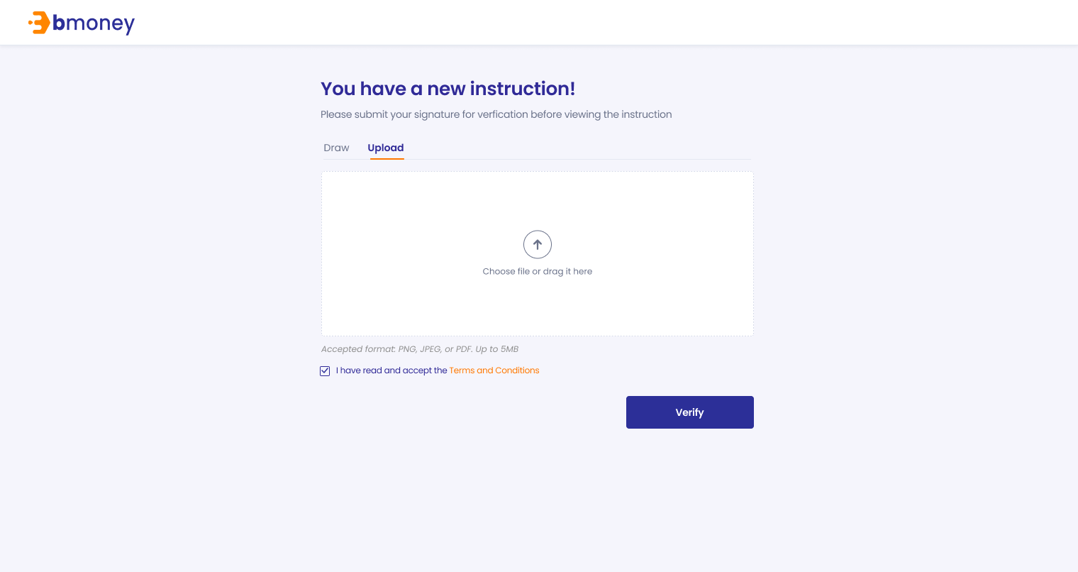

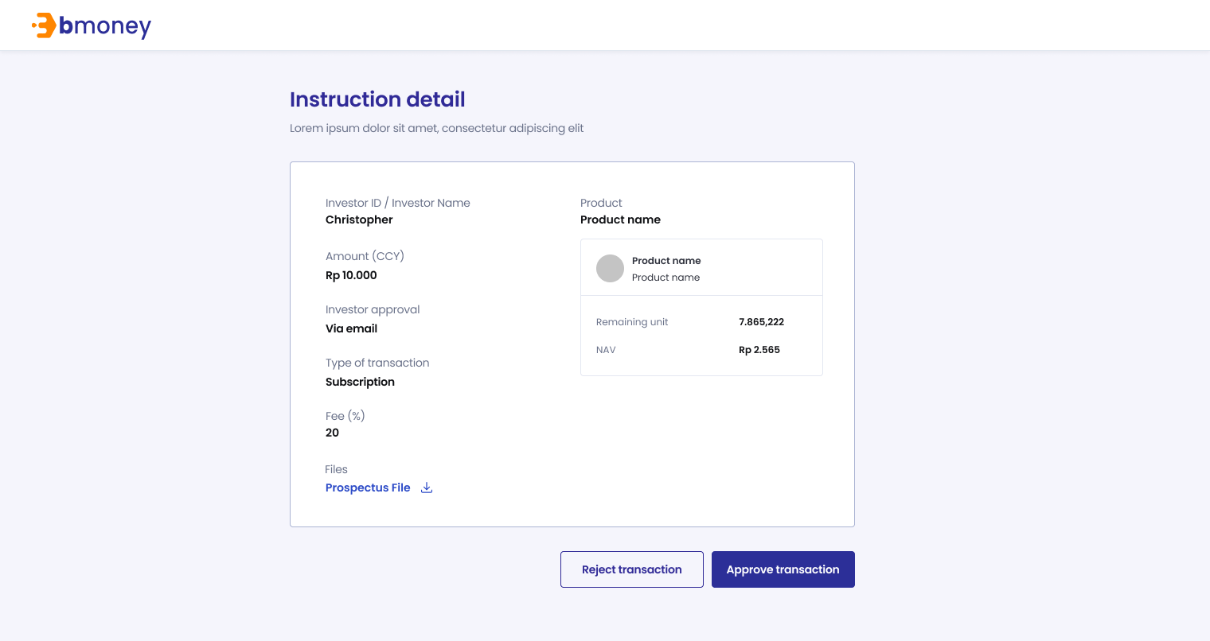

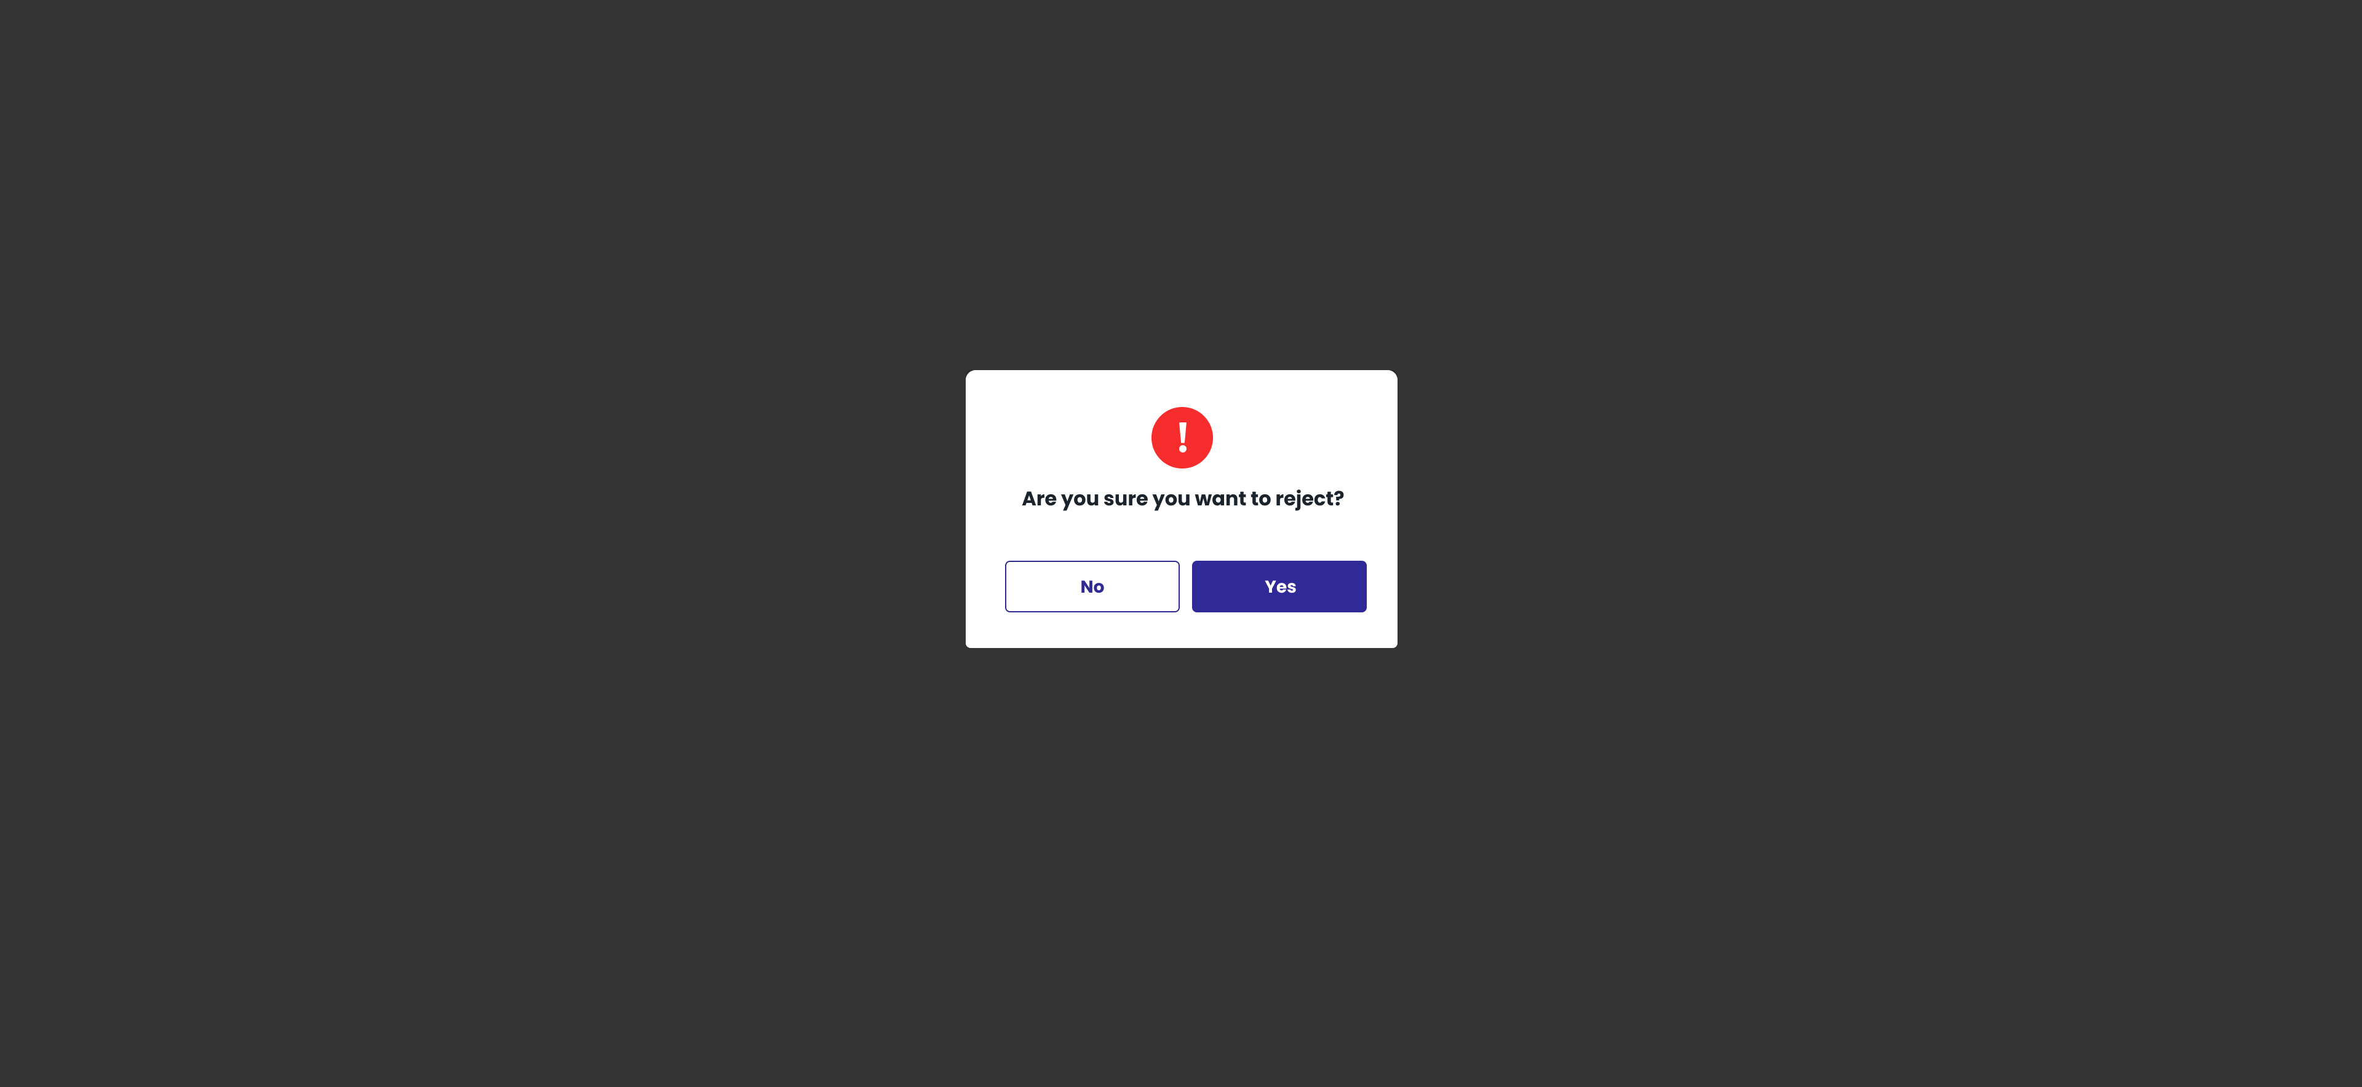

1. **Authorized User**

Existing active investor

1. **Entry Point**

URL from investor’s email

1. **Exit Point**

‘Thank you’ MSG Screen

1. **Process Flow**
2. For Face-to-face option, investors can open the URL from the email, view their transaction information, read T&C and confirm information.

For Remote option, investors can open the URL from the email, view their transaction information, read T&C and sign on device to confirm information

User can reject or approve transaction

If user reject the transaction, there will be mesage box to confirm the action.

1. There will be Thank you page after investor submitting required information
2. **Fields and Validations and Verifications**

|  |  |  |  |  |  |  |
| --- | --- | --- | --- | --- | --- | --- |
| **Field** | **Field Type** | **Description** | **Field Length** | **Mandatory** | **Validation** | **In-Line Error Message** |
| **Dashboard URL – Signature for verification** | | | | | | |
| Upload Signature | Label | Upload Signature  Please submit your signature for verification before viewing the instruction | - | Yes |  |  |
| Draw/Upload option | Option tab | Draw/Upload option   * Draw (default) * Upload | - | Yes |  |  |
| Signature canvas | Canvas | Tap on to start draw signature | - | Yes |  |  |
| Please draw your signature | Text field | Please draw your signature | - | Yes |  |  |
| Clear | Button | Clear button  Tap on to clear the signature drawn before and retry | - | Yes |  |  |
| Upload  button | Button | Choose file or drag it here  Tap on to browse offline file | - | Yes |  |  |
| Accepted format | Text field | Accepted format: PNG, JPEG or PDF. Up to 5MB | - | Yes |  |  |
| T&C check box | Check box | I have read and accept the Terms and Conditions | - |  |  |  |
| Verify | Button | Verify button  Tap on to confirm information and enter the next page   1. Go to Upload/Draw page signature if user choose Remote option 2. Go to Thank you MSG Screen if user choose Face-to-face option | - |  | All above check box fields must be tapped on to enable this button |  |
| Cancel button | Button | Cancel button  Tap on to trigger Cancel pop-up | - | Yes |  |  |
| Cancel pop-up | Pop-up label | Do you want to cancel?  This URL will expire after 24 hours. Please submit your signature before the deadlines. | - | Yes |  |  |
| Yes | Button | Yes button  Tap on to cancel submitting signature | - | Yes |  |  |
| No | Button | No button  Tap on to close the pop-up | - | Yes |  |  |
| Accept and send button | Button | Accept and send button  Tap on to trigger Submit pop-up | - | Yes |  |  |
| Submit pop-up | Pop-up label | Are you sure you want to submit your signature? | - | Yes |  |  |
| Yes | Button | Yes button  Tap on to submit the signature | - | Yes |  |  |
| No | Button | No button  Tap on to close the pop-up | - | Yes |  |  |
| **Dashboard URL – Instruction Detail** | | | | | | |
| Instruction Detail | Label | Instruction Detail |  | Yes |  |  |
| Investor ID / Investor Name | Auto-complete | Investor ID / Investor Name  For individual investor: [NIK] – [Full name]  For institutional investor: [NPWN] – [Company name]  Alphanumeric keypad required | String (100) | Yes | 1. Start searching after entering first letter 2. Must be Not Empty | 1. This field cannot be empty |
| Product | Label | Product | String (200) | Yes | 1. Start searching after entering first letter 2. Must be Not Empty | 1. This field cannot be empty |
| Product name | Text field | Name of the product | - | Yes |  |  |
| Amount (CYY) | Numeric input | Amount  Enter the amount to buy  Unlimited amount input | String (20) | Yes | 1. Follow CCY for the product 2. Unlimited amount input type. 3. Must be Not Empty 4. Must not exceed Remaining unit of the product | 1. This field cannot be empty 2. The amount exceeds remaining unit of the product |
| Investor approval | Text field | Investor approval method  Via email  Face to face |  | Yes |  |  |
| Type of transaction | Text field | Type of transaction  Subscription | - | Yes |  |  |
| Fee (%) | Numeric input | Fee  The amount of fee for RM when this transaction is approved  Auto generated default fee after entering valid Product | String (3) | Yes | Must be Not Empty |  |
| Prospectus File | Link Button | Download Prospectus file |  | Yes |  |  |
| 1. Product panel (Auto-generated after enter a valid input in ‘Product’) | | | | | | |
| Product name | Text field | Name of the product | - | Yes |  |  |
| Product type | Text field | Type of product, include:   * Money Market * Fixed Income * Balanced * Equity | - | Yes |  |  |
| Remaining unit | Numeric field | Remaining unit of the product for sale on the market | - | Yes |  |  |
| NAV | Numeric field | NAV of the product at the moment | - | Yes |  |  |
| Signature Canvas | Canvas | Signature of investor | - | Yes | Display only for face to face option |  |
| Approve button | Button | Tap on to approve the transaction |  | Yes |  |  |
| Reject button | Button | Tap on to reject the transaction |  | Yes |  |  |
| Confirm pop-up | Pop up label | Are you sure you want to reject? | - | Yes |  |  |
| Yes button | Button | Yes button  Tap on to confirm rejection | - | Yes |  |  |
| No button | Button | No button  Tap on to close the pop up and continue with the instruction detail | - | Yes |  |  |
| Thank you | Label | Thank you  Your information is being processed. We will keep you updated via email | - | Yes |  |  |

1. **Messaging Requirement**

Follow message in above table

1. **Reference User Story**

N/A

#### User Story 9 – Create instruction/Redemption

As an existing RM, I want to create an instruction and send it to my investor for confirmation

**Acceptance Criteria**

For Investor ID, Product autocompleted list, it will display 20 auto filled records only.

1. **Page Flow**

 

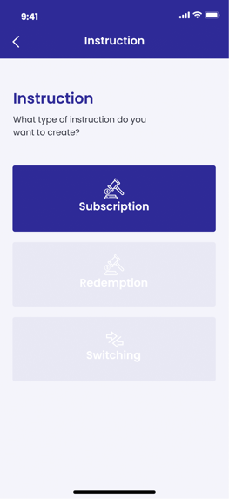 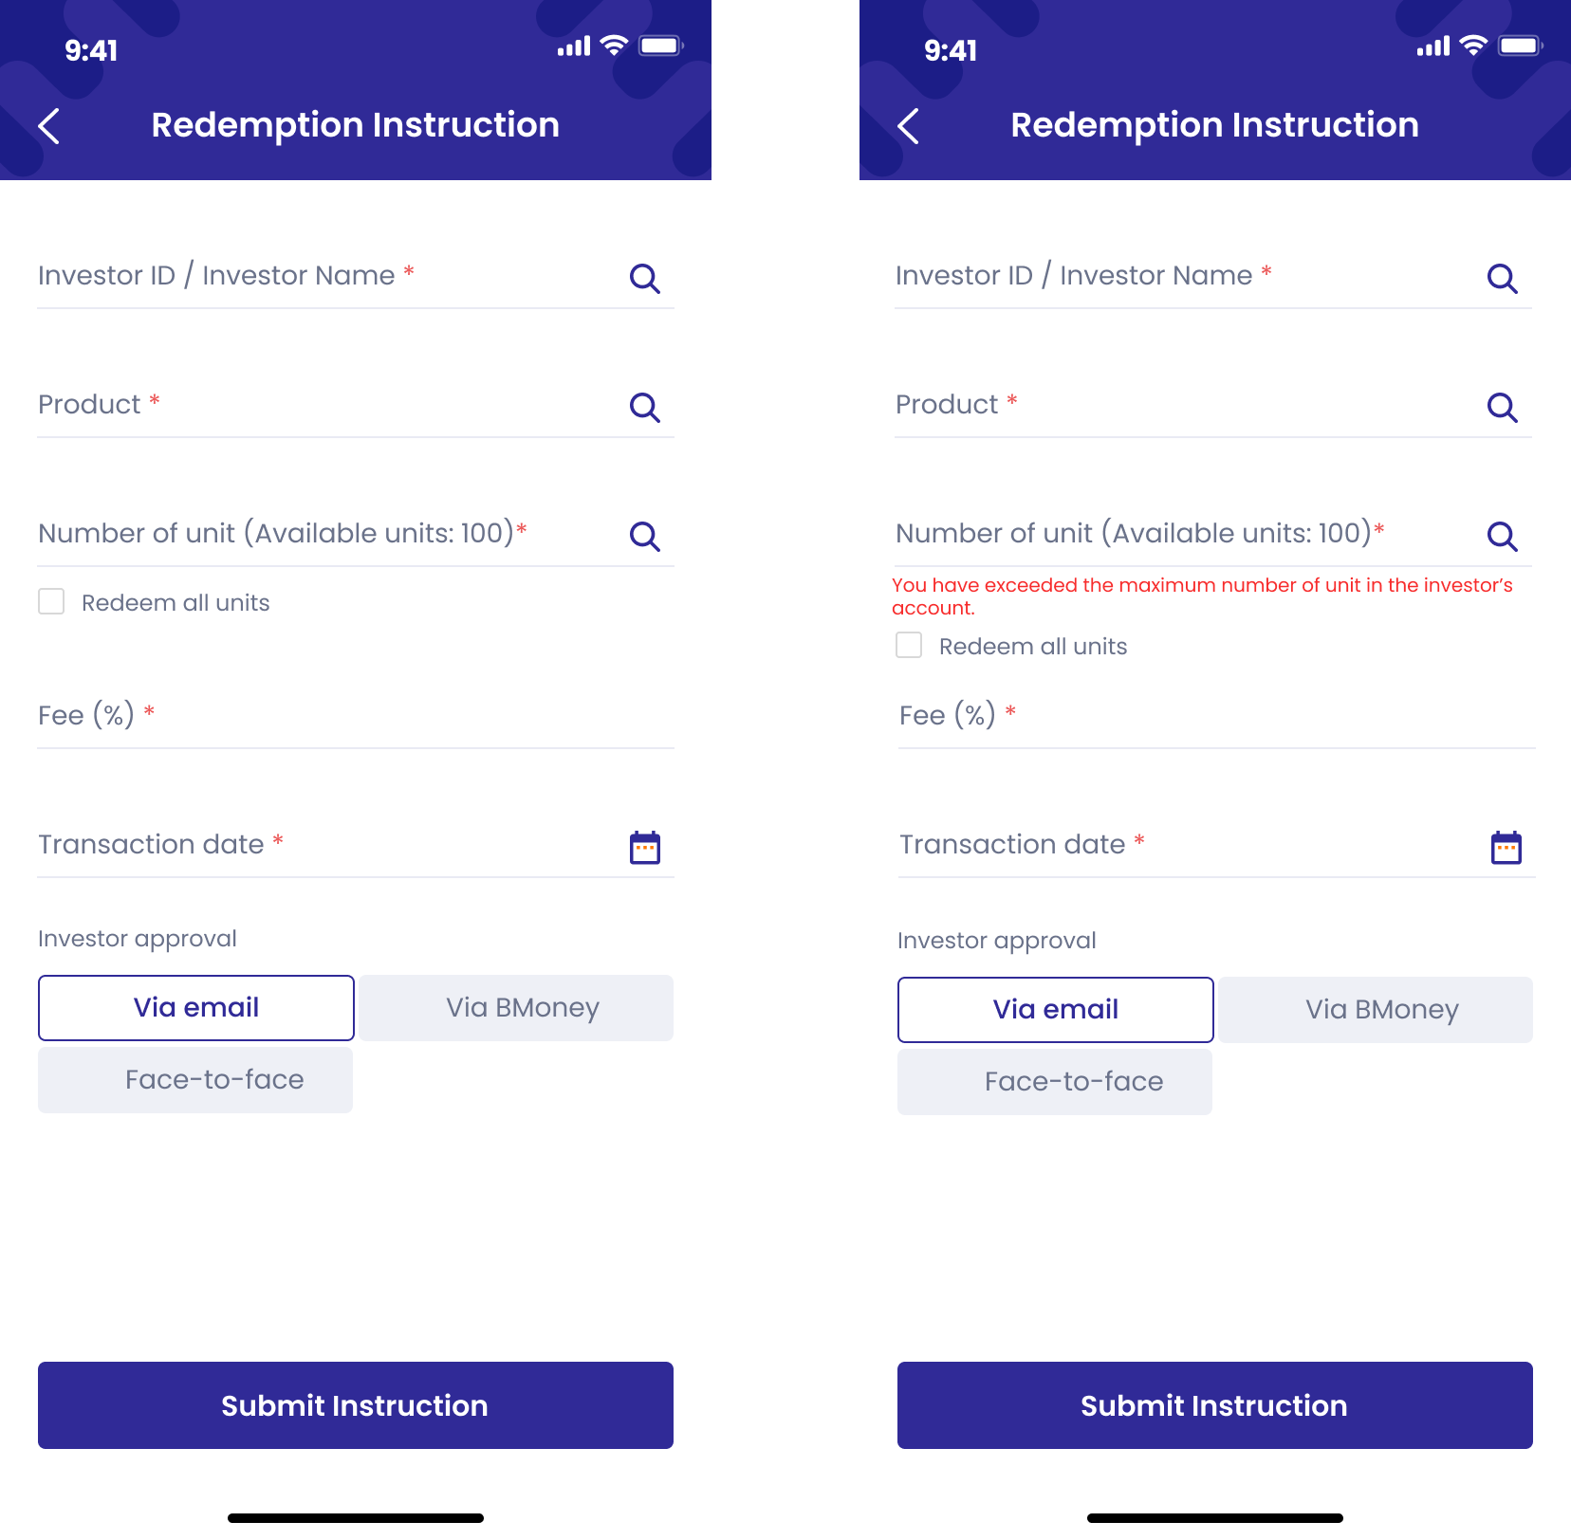 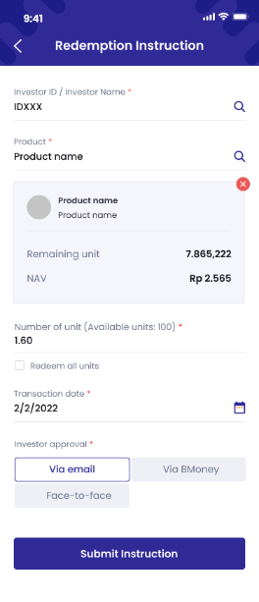

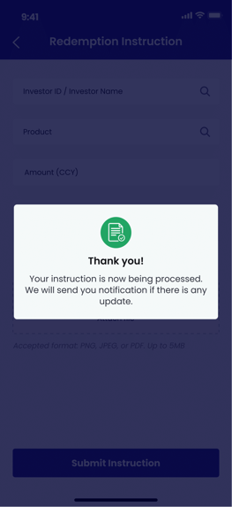 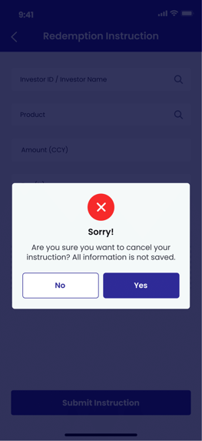

1. **Authorized User**

Existing active RM

1. **Entry Point**

My Instruction page

1. **Exit Point**

Submitted MSG Screen

1. **Process Flow**
2. From Home page/Investor tab/Approved investors panel, user can tap on button to trigger Action list panel. Then tap on ‘Create transaction’ button to enter Instruction types page.

From Home page/Transaction tab, user can tap on ‘Create new instruction’ button to enter Instruction types page.

From Manage investor page/Product portfolio panel, user can tap on Switching button, Sell button or Buy button to enter Create instruction page (Skip step 2)

1. User can choose among 3 types of transaction instruction: Subscription, Redemption, Switching. Tap on:

* Subscription button to buy products from the market. Refer to ***User story 8 – Create instruction/Subscription***
* Redemption button to sell products to the market. Refer to ***User story 9 – Create instruction/Redemption***
* Switching button to exchange product from one type to another in the equal amount. Refer to ***User story 10 – Create instruction/Switching***

1. User fill in required fields then tap on Submit Instruction button.

There will be Submitted MSG Screen. User can tap on OK button to return to My Instruction Page

1. **Fields and Validations and Verification**

|  |  |  |  |  |  |  |
| --- | --- | --- | --- | --- | --- | --- |
| **Field** | **Field Type** | **Description** | **Field Length** | **Mandatory** | **Validation** | **In-Line Error Message** |
|  | Button | Tap on to open Control panel | - | Yes |  |  |
|  | Button | Tap on to open notification list | - | Yes |  |  |
| Hello | Label | Hello  [Full_Name] | - | Yes |  |  |
| Add new investor | Button | Tap on to enter ‘Register new investor’ page | - | Yes |  |  |
| **List of investors approved panel** | | | | | | |
| List of investors approved panel | Label | List of investors approved panel label | - | Yes |  |  |
| Full name | Text field | Full name of investor | - | Yes |  |  |
| Phone number | Numeric field | Phone number of investor | - | Yes |  |  |
| button | Button | Tap on to open action list of investor | - | Yes |  |  |
| View investor | Button | Tap on to enter Manage investor page/Investor info tab | - | Yes |  |  |
| See portfolio | Button | Tap on to enter Manage investor page/Porfolio tab | - | Yes |  |  |
| Create transaction | Button | Tap on to enter Instruction type page | - | Yes |  |  |
| View all | Link button | Tap on to view list of all approved investors | - | Yes |  |  |
| **List of investors in progress panel** | | | | | | |
| List of investors in progress | Label | List of investors in progress label | - | Yes |  |  |
| Full name | Text field | Full name of investor | - | Yes |  |  |
| KYC Date | Text field | KYC on [KYC Date] | - | Yes |  |  |
| Status | Text field | Status of investors | - | Yes |  |  |
| View all | Link button | Tap on to view list of all investors in progress | - | Yes |  |  |
| **List of other investors panel** | | | | | | |
| List of other investors | Label | List of other investors label | - | Yes |  |  |
| Full name | Text field | Full name of investor | - | Yes |  |  |
| KYC Date | Text field | [KYC Date] | - | Yes |  |  |
| Status | Text field | Status of investors | - | Yes |  |  |
| View all | Link button | Tap on to view list of all other investors | - | Yes |  |  |
| button | Button | Tap on to open action list of investor |  | Yes |  |  |
| **Home panel** | | | | | | |
| Investor | Button | Tap on to go to Home page – Investor panel | - | Yes |  |  |
| Transaction | Button | Tap on to go to Home page – Transaction panel | - | Yes |  |  |
| Leads | Button | Tap on to go to Home page – Leads panel | - | Yes |  |  |
| Report | Button | Tap on to go to Home page – Report panel | - | Yes |  |  |
| Instruction | Label | Instruction  What type of instruction do you want to create? | - | Yes |  |  |
| Subscription button | Button | Subscription button  Tap on to enter Subscription Instruction page | - | Yes |  |  |
| Redemption button | Button | Redemption button  Tap on to enter Redemption Instruction page | - | Yes |  |  |
| Switching button | Button | Switching button  Tap on to enter Switching Instruction page | - | Yes |  |  |
| Redemption Instruction | Label | Redemption Instruction | - | Yes |  |  |
| Investor ID / Investor Name | Auto-complete | Investor ID / Investor Name  For individual investor: [NIK] – [Full name]  For institutional investor: [NPWN] – [Company name]  Alphanumeric keypad required | String (100) | Yes | 1. Start searching after entering first letter 2. Must be Not Empty | This field cannot be empty |
| Product | Auto-complete | Product  Fill in the name/code for the system to suggest products to buy | String (200) | Yes | 1. Start searching after entering first letter 2. Must be Not Empty | This field cannot be empty |
| Amount (CYY) | Numeric input | Amount  Enter the amount to buy  Unlimited amount input | String (20) | Yes | 1. Follow CCY for the product 2. Unlimited amount input type. 3. Must be Not Empty 4. Must not exceed Remaining unit of the product 5. Auto-fill to the maximum number of unit if Redeem all unit check box is tapped. | 1. This field cannot be empty 2. The amount exceeds remaining unit of the product 3. The remaining in-stock amount after redemption must not below minimum in-stock amount of the product. You have to redeem all or reduce the amount. |
| Redeem all unit | Check box | Redeem all unit check box  Tap on to choose all available unit of product in investor‘s inventory | - | Yes |  |  |
| Fee (%) | Numeric input | Fee  The amount of fee for RM when this transaction is approved  Auto generated default fee after entering valid Product  User can edit the fee for each transaction | String (3) | Yes | Must be Not Empty | This field cannot be empty |
| Transaction date | Date picker | Transaction date  Choose the date for the transaction to be proceeded |  | Yes | 1. Transaction date is defaulted to today's date if created before 1 PM and defaulted to next business day if created after 1 PM 2. Must be Not Empty | This field cannot be empty |
| Submit instruction button | Button | Submit Instruction button  Tap on to submit instruction |  | Yes | All above mandatory fields must be filled in the correct format with valid value to enable this button |  |
| button | Button | button  Tap on the button to trigger Cancel pop-up | - | Yes |  |  |
| Cancel pop-up | Pop up label | Cancel pop-up  Sorry!  Are you sure you want to cancel your instruction? All information is not saved. | - | Yes |  |  |
| Yes button | Button | Yes button  Tap on to go back to My Transaction list | - | Yes |  |  |
| No button | Button | No button  Tap on to close the pop up and continue with the instruction form. | - | Yes |  |  |
| 1. Product panel (Auto-generated after enter a valid input in ‘Product’) | | | | | | |
| Product name | Text field | Name of the product | - | Yes |  |  |
| Product type | Text field | Type of product, include:   * Money Market * Fixed Income * Balanced * Equity | - | Yes |  |  |
| Remaining unit | Numeric field | Remaining unit of the product for sale on the market | - | Yes |  |  |
| NAV | Numeric field | NAV of the product at the moment | - | Yes |  |  |
| Amount (CYY) | Numeric input | Amount  Enter the amount to buy  Unlimited amount input | String (20) | Yes | 1. Follow CCY for the product 2. Unlimited amount input type. 3. Must be Not Empty 4. Must not exceed Remaining unit of the product | 1. This field cannot be empty 2. The amount exceeds remaining unit of the product |
| Fee (%) | Numeric input | Fee  The amount of fee for RM when this transaction is approved  Auto generated default fee after entering valid Product  User can edit the fee for each transaction | String (3) | Yes | Must be Not Empty | 1. This field cannot be empty |
| Transaction date | Date picker | Transaction date  Choose the date for the transaction to be proceeded |  | Yes | 1. Transaction date is defaulted to today's date if created before 1 PM and defaulted to next business day if created after 1 PM 2. Must be Not Empty | This field cannot be empty |

1. **Messaging Requirement**

Follow message in above table

1. **Reference User Story**

N/A

#### User story 9.1 – Investor/ Confirm transaction confirmation (Redemption)

As an investor, I want to view my transaction details and sign so that I can confirm my transaction information.

**Acceptance Criteria**

Dashboard website must be responsive to mobile browser and PC browser

Dashboard website URL must expire after 24 hours since generated

**1. Page Flow**



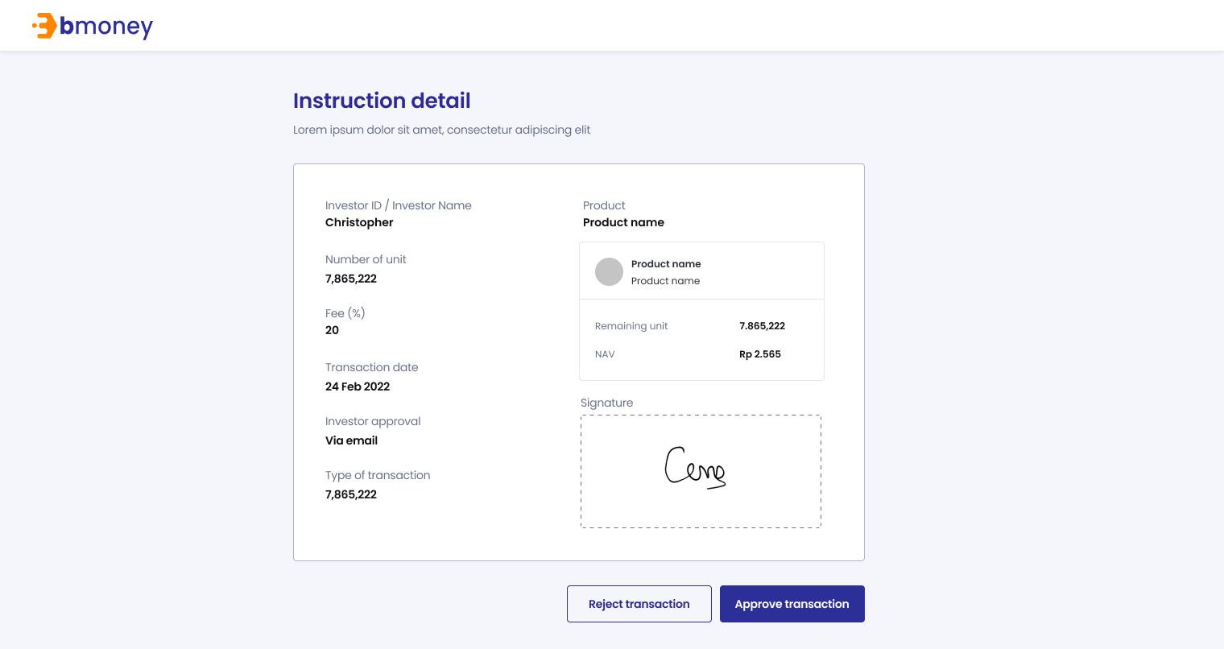



1. **Authorized User**

Existing active investor

1. **Entry Point**

URL from investor’s email

1. **Exit Point**

‘Thank you’ MSG Screen

1. **Process Flow**
2. For Face-to-face option, investors can open the URL from the email, view their transaction information, read T&C and confirm information.

For Remote option, investors can open the URL from the email, view their transaction information, read T&C and sign on device to confirm information

User can reject or approve transaction

If user reject the transaction, there will be mesage box to confirm the action.

1. There will be Thank you page after investor submitting required information
2. **Fields and Validations and Verifications**

|  |  |  |  |  |  |  |
| --- | --- | --- | --- | --- | --- | --- |
| **Field** | **Field Type** | **Description** | **Field Length** | **Mandatory** | **Validation** | **In-Line Error Message** |
| **Dashboard URL – Signature for verification** | | | | | | |
| Upload Signature | Label | Upload Signature  Please submit your signature for verification before viewing the instruction | - | Yes |  |  |
| Draw/Upload option | Option tab | Draw/Upload option   * Draw (default) * Upload | - | Yes |  |  |
| Signature canvas | Canvas | Tap on to start draw signature | - | Yes |  |  |
| Please draw your signature | Text field | Please draw your signature | - | Yes |  |  |
| Clear | Button | Clear button  Tap on to clear the signature drawn before and retry | - | Yes |  |  |
| Upload  button | Button | Choose file or drag it here  Tap on to browse offline file | - | Yes |  |  |
| Accepted format | Text field | Accepted format: PNG, JPEG or PDF. Up to 5MB | - | Yes |  |  |
| T&C check box | Check box | I have read and accept the Terms and Conditions | - |  |  |  |
| Verify | Button | Verify button  Tap on to confirm information and enter the next page   1. Go to Upload/Draw page signature if user choose Remote option 2. Go to Thank you MSG Screen if user choose Face-to-face option | - |  | All above check box fields must be tapped on to enable this button |  |
| Cancel button | Button | Cancel button  Tap on to trigger Cancel pop-up | - | Yes |  |  |
| Cancel pop-up | Pop-up label | Do you want to cancel?  This URL will expire after 24 hours. Please submit your signature before the deadlines. | - | Yes |  |  |
| Yes | Button | Yes button  Tap on to cancel submitting signature | - | Yes |  |  |
| No | Button | No button  Tap on to close the pop-up | - | Yes |  |  |
| Accept and send button | Button | Accept and send button  Tap on to trigger Submit pop-up | - | Yes |  |  |
| Submit pop-up | Pop-up label | Are you sure you want to submit your signature? | - | Yes |  |  |
| Yes | Button | Yes button  Tap on to submit the signature | - | Yes |  |  |
| No | Button | No button  Tap on to close the pop-up | - | Yes |  |  |
| **Dashboard URL – Instruction Detail** | | | | | | |
| Instruction Detail | Label | Instruction Detail |  | Yes |  |  |
| Investor ID / Investor Name | Auto-complete | Investor ID / Investor Name  For individual investor: [NIK] – [Full name]  For institutional investor: [NPWN] – [Company name]  Alphanumeric keypad required | String (100) | Yes | 1. Start searching after entering first letter 2. Must be Not Empty | 1. This field cannot be empty |
| Product | Label | Product | String (200) | Yes | 1. Start searching after entering first letter 2. Must be Not Empty | 1. This field cannot be empty |
| Product name | Text field | Name of the product | - | Yes |  |  |
| Amount (CYY) | Numeric input | Amount  Enter the amount to buy  Unlimited amount input | String (20) | Yes | 1. Follow CCY for the product 2. Unlimited amount input type. 3. Must be Not Empty 4. Must not exceed Remaining unit of the product | 1. This field cannot be empty 2. The amount exceeds remaining unit of the product |
| Investor approval | Text field | Investor approval method  Via email  Face-to-face |  | Yes |  |  |
| Type of transaction | Text field | Type of transaction  Redemption | - | Yes |  |  |
| Fee (%) | Numeric input | Fee  The amount of fee for RM when this transaction is approved  Auto generated default fee after entering valid Product | String (3) | Yes | Must be Not Empty |  |
| Prospectus File | Link Button | Download Prospectus file |  | Yes |  |  |
| 1. Product panel (Auto-generated after enter a valid input in ‘Product’) | | | | | | |
| Product name | Text field | Name of the product | - | Yes |  |  |
| Product type | Text field | Type of product, include:   * Money Market * Fixed Income * Balanced * Equity | - | Yes |  |  |
| Remaining unit | Numeric field | Remaining unit of the product for sale on the market | - | Yes |  |  |
| NAV | Numeric field | NAV of the product at the moment | - | Yes |  |  |
| Signature Canvas | Canvas | Signature of investor | - | Yes | Display only for face to face option |  |
| Approve button | Button | Tap on to approve the transaction |  | Yes |  |  |
| Reject button | Button | Tap on to reject the transaction |  | Yes |  |  |
| Confirm pop-up | Pop up label | Are you sure you want to reject? | - | Yes |  |  |
| Yes button | Button | Yes button  Tap on to confirm rejection | - | Yes |  |  |
| No button | Button | No button  Tap on to close the pop up and continue with the instruction detail | - | Yes |  |  |
| Thank you | Label | Thank you  Your information is being processed. We will keep you updated via email | - | Yes |  |  |

1. **Messaging Requirement**

Follow message in above table

1. **Reference User Story**

N/A

#### User Story 10 – Create Instruction/Switching

As an existing RM, I want to create a Switching instruction and send it to my investor for confirmation

**Acceptance Criteria**

For Investor ID, Switch in Product, Switch out Product autocompleted list, it will display 20 auto filled records only.

1. **Page Flow**

 

 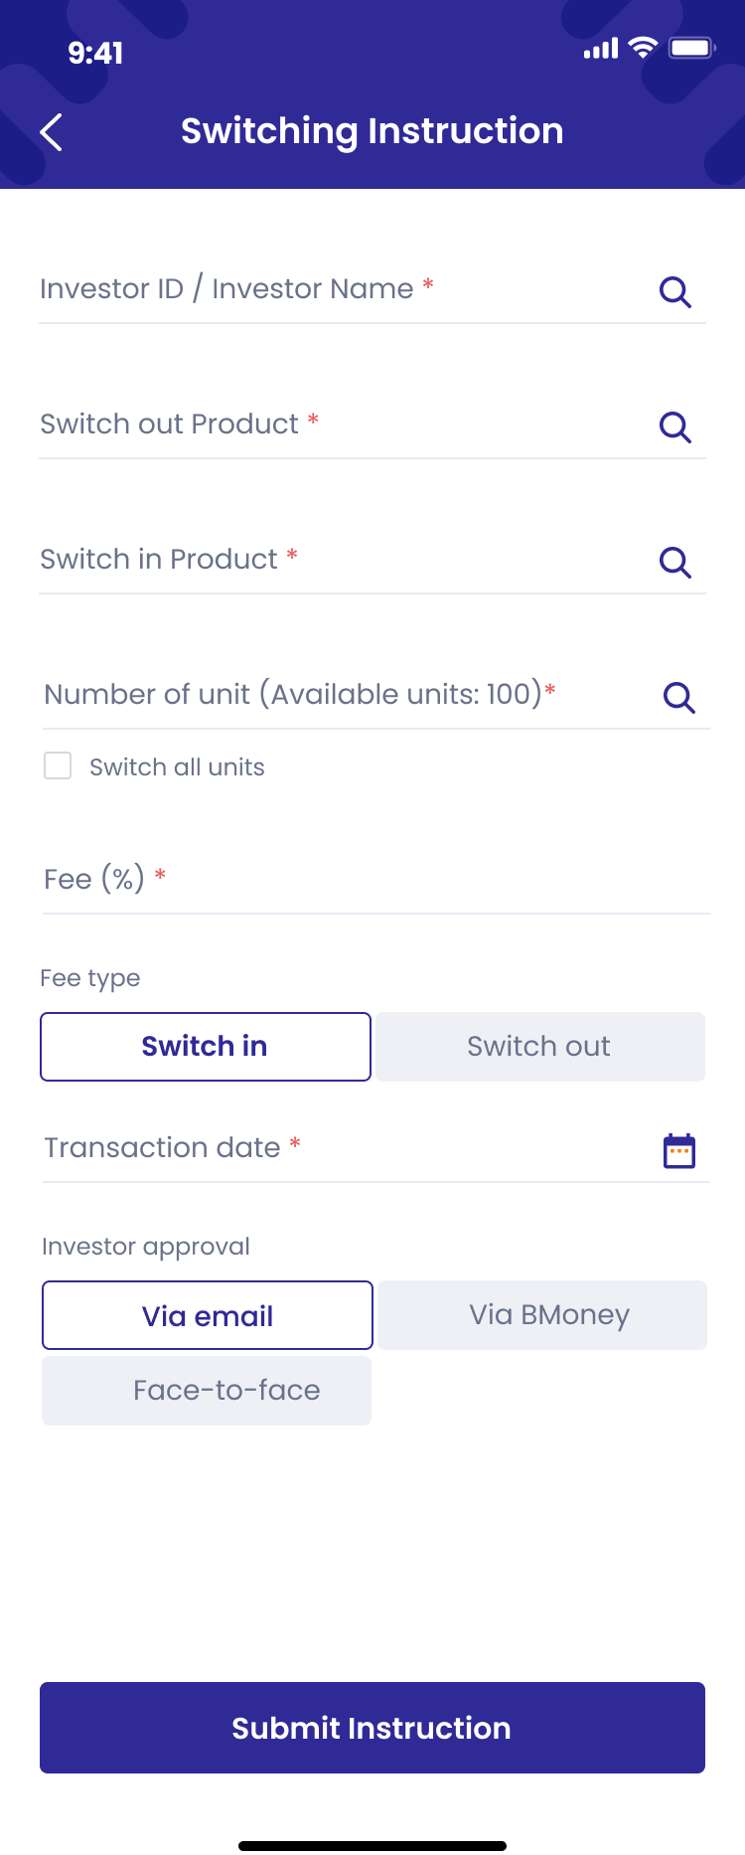 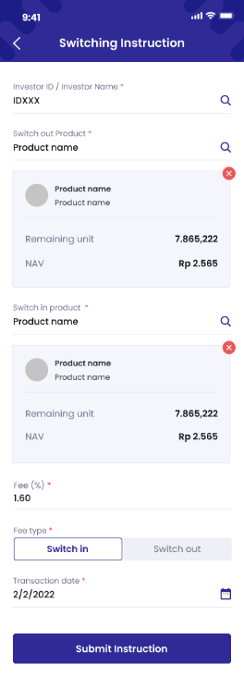

** **

1. **Authorized User**

Existing active RM

1. **Entry Point**

My Instruction page

1. **Exit Point**

Submitted MSG Screen

1. **Process Flow**
2. From Home page/Investor tab/Approved investors panel, user can tap on ‘Create transaction button’ to enter Instruction types page
3. From Home page/Transaction tab, user can tap on ‘Create new instruction’ button to enter Instruction types page

From Manage investor page/Product portfolio panel, user can tap on Switching button, Sell button or Buy button to enter Create instruction page (Skip step 2)

1. User can choose among 3 types of transaction instruction: Subscription, Redemption, Switching. Tap on:

* Subscription button to buy products from the market. Refer to ***User story 8 – Create instruction/Subscription***
* Redemption button to sell products to the market. Refer to ***User story 9 – Create instruction/Redemption***
* Switching button to exchange product from one type to another in the equal amount. Refer to ***User story 10 – Create instruction/Switching***

1. User fill in required fields then tap on Submit Instruction button.

There will be Submitted MSG Screen. User can tap on OK button to return to My Instruction Page

1. **Fields and Validations and Verification**

|  |  |  |  |  |  |  |
| --- | --- | --- | --- | --- | --- | --- |
| **Field** | **Field Type** | **Description** | **Field Length** | **Mandatory** | **Validation** | **In-Line Error Message** |
|  | Button | Tap on to open Control panel | - | Yes |  |  |
|  | Button | Tap on to open notification list | - | Yes |  |  |
| Hello | Label | Hello  [Full_Name] | - | Yes |  |  |
| Add new investor | Button | Tap on to enter ‘Register new investor’ page | - | Yes |  |  |
| **List of investors approved panel** | | | | | | |
| List of investors approved panel | Label | List of investors approved panel label | - | Yes |  |  |
| Full name | Text field | Full name of investor | - | Yes |  |  |
| Phone number | Numeric field | Phone number of investor | - | Yes |  |  |
| button | Button | Tap on to open action list of investor | - | Yes |  |  |
| View investor | Button | Tap on to enter Manage investor page/Investor info tab | - | Yes |  |  |
| See portfolio | Button | Tap on to enter Manage investor page/Porfolio tab | - | Yes |  |  |
| Create transaction | Button | Tap on to enter Instruction type page | - | Yes |  |  |
| View all | Link button | Tap on to view list of all approved investors | - | Yes |  |  |
| **List of investors in progress panel** | | | | | | |
| List of investors in progress | Label | List of investors in progress label | - | Yes |  |  |
| Full name | Text field | Full name of investor | - | Yes |  |  |
| KYC Date | Text field | KYC on [KYC Date] | - | Yes |  |  |
| Status | Text field | Status of investors | - | Yes |  |  |
| View all | Link button | Tap on to view list of all investors in progress | - | Yes |  |  |
| **List of other investors panel** | | | | | | |
| List of other investors | Label | List of other investors label | - | Yes |  |  |
| Full name | Text field | Full name of investor | - | Yes |  |  |
| KYC Date | Text field | [KYC Date] | - | Yes |  |  |
| Status | Text field | Status of investors | - | Yes |  |  |
| View all | Link button | Tap on to view list of all other investors | - | Yes |  |  |
| button | Button | Tap on to open action list of investor |  | Yes |  |  |
| **Home panel** | | | | | | |
| Investor | Button | Tap on to go to Home page – Investor panel | - | Yes |  |  |
| Transaction | Button | Tap on to go to Home page – Transaction panel | - | Yes |  |  |
| Leads | Button | Tap on to go to Home page – Leads panel | - | Yes |  |  |
| Report | Button | Tap on to go to Home page – Report panel | - | Yes |  |  |
| Create new instruction button | Button | Create new transaction button  Tap on button to enter ‘Transaction instruction types’ page | - | Yes |  |  |
| Subscription button | Button | Subscription button  Tap on to enter Subscription Instruction page | - | Yes |  |  |
| Redemption button | Button | Redemption button  Tap on to enter Redemption Instruction page | - | Yes |  |  |
| Switching button | Button | Switching button  Tap on to enter Switching Instruction page | - | Yes |  |  |
| Instruction | Label | Instruction  What type of instruction do you want to create? | - | Yes |  |  |
| Switching Instruction | Label | Switching Instruction | - | Yes |  |  |
| Investor ID / Investor Name | Alphanumeric input | Investor ID / Investor Name  For individual investor: [NIK] – [Full name]  For institutional investor: [NPWN] – [Full name]  Alphanumeric keypad required | String (100) | Yes | 1. Start searching after entering first letter | 1. Must be Not Empty |
| Switching out Product | Auto complete | Switching out Product  Fill in the name/code of the product for investor to switch from | String (200) | Yes | 1. Start searching after entering first letter 2. Must be Not Empty | 1. This field cannot be empty |
| Switch in Product | Auto-complete | Switch in Product  Fill in the name/code of the product for investor to switch to | String (200) | Yes | 1. Start searching after entering first letter 2. Must be Not Empty | 1. This field cannot be empty |
| Number of unit (CYY) | Numeric input | Amount  The amount of product that investor will switch from | String (20) | Yes | 1. Follow CCY for the product 2. Unlimited amount input type. 3. Must be Not Empty 4. Must not exceed Remaining unit of the product 5. Auto-fill to the maximum number of unit if Switch all unit check box is tapped. | 1. This field cannot be empty 2. The amount exceeds remaining unit of the product 3. The remaining in-stock amount after redemption must not below minimum in-stock amount of the product. You have to redeem all or reduce the amount. |
| Switch all units | Check box | Switch all unit check box  Tap on to choose all available unit of product in investor‘s inventory | - | Yes |  |  |
| Fee (%) | Numeric input | Fee  The amount of fee for RM when this transaction is approved  Auto generated default fee after entering valid Product  User can edit the fee for each transaction | String (3) | Yes | Must be Not Empty | This field cannot be empty |
| Transaction date | Date picker | Transaction date  Choose the date for the transaction to be proceeded |  | Yes | 1. Transaction date is defaulted to today's date if created before 1 PM and defaulted to next business day if created after 1 PM 2. Must be Not Empty | This field cannot be empty |
| Submit instruction button | Button | Submit Instruction button  Tap on to submit instruction |  | Yes | All above mandatory fields must be filled in the correct format with valid value to enable this button |  |
| button | Button | button  Tap on the button to trigger Cancel pop-up | - | Yes |  |  |
| Cancel pop-up | Pop up label | Cancel pop-up  Sorry!  Are you sure you want to cancel your instruction? All information is not saved. | - | Yes |  |  |
| Yes button | Button | Yes button  Tap on to go back to My Transaction list | - | Yes |  |  |
| No button | Button | No button  Tap on to close the pop up and continue with the instruction form. | - | Yes |  |  |
| 1. Product panel (Auto-generated after enter a valid input in ‘Product’) | | | | | | |
| Switch out Product name | Text field | Name of the product | - | Yes |  |  |
| Switch out Product type | Text field | Type of product, include:   * Money Market * Fixed Income * Balanced * Equity | - | Yes |  |  |
| Remaining unit | Numeric field | Remaining unit of the product for sale on the market | - | Yes |  |  |
| NAV | Numeric field | NAV of the product at the moment | - | Yes |  |  |
| Switch in Product name | Text field | Name of the product | - | Yes |  |  |
| Switch in Product type | Text field | Type of product, include:   * Money Market * Fixed Income * Balanced * Equity | - | Yes |  |  |
| Remaining unit | Numeric field | Remaining unit of the product for sale on the market | - | Yes |  |  |
| NAV | Numeric field | NAV of the product at the moment | - | Yes |  |  |
| Fee (%) | Numeric input | Fee  The amount of fee for RM when this transaction is approved  Auto generated default fee after entering valid Product  User can edit the fee for each transaction | String (3) | Yes | Must be Not Empty | This field cannot be empty |
| Fee type | Button | Type of fee include:   * Switch in (default) * Switch out   Auto generated default fee type after entering valid Product | - | Yes |  |  |
| Transaction date | Date picker | Transaction date  Choose the date for the transaction to be proceeded | - | Yes | 1. Transaction date is defaulted to today's date if created before 1 PM and defaulted to next business day if created after 1 PM 2. Must be Not Empty 3. Must be a future date | This field cannot be empty  Must be a future date |

1. **Messaging Requirement**

Follow message in above table

1. **Reference User Story**

N/A

#### User story 10.1 – Investor/ Confirm transaction confirmation

As an investor, I want to view my transaction details and sign so that I can confirm my transaction information.

**Acceptance Criteria**

Dashboard website must be responsive to mobile browser and PC browser

Dashboard website URL must expire after 24 hours since generated

**1. Page Flow**







1. **Authorized User**

Existing active investor

1. **Entry Point**

URL from investor’s email

1. **Exit Point**

‘Thank you’ MSG Screen

1. **Process Flow**
2. For Face-to-face option, investors can open the URL from the email, view their transaction information, read T&C and confirm information.

For Remote option, investors can open the URL from the email, view their transaction information, read T&C and sign on device to confirm information

User can reject or approve transaction

If user reject the transaction, there will be mesage box to confirm the action.

1. There will be Thank you page after investor submitting required information
2. **Fields and Validations and Verifications**

|  |  |  |  |  |  |  |
| --- | --- | --- | --- | --- | --- | --- |
| **Field** | **Field Type** | **Description** | **Field Length** | **Mandatory** | **Validation** | **In-Line Error Message** |
| **Dashboard URL – Signature for verification** | | | | | | |
| Upload Signature | Label | Upload Signature  Please submit your signature for verification before viewing the instruction | - | Yes |  |  |
| Draw/Upload option | Option tab | Draw/Upload option   * Draw (default) * Upload | - | Yes |  |  |
| Signature canvas | Canvas | Tap on to start draw signature | - | Yes |  |  |
| Please draw your signature | Text field | Please draw your signature | - | Yes |  |  |
| Clear | Button | Clear button  Tap on to clear the signature drawn before and retry | - | Yes |  |  |
| Upload  button | Button | Choose file or drag it here  Tap on to browse offline file | - | Yes |  |  |
| Accepted format | Text field | Accepted format: PNG, JPEG or PDF. Up to 5MB | - | Yes |  |  |
| T&C check box | Check box | I have read and accept the Terms and Conditions | - |  |  |  |
| Verify | Button | Verify button  Tap on to confirm information and enter the next page   1. Go to Upload/Draw page signature if user choose Remote option 2. Go to Thank you MSG Screen if user choose Face-to-face option | - |  | All above check box fields must be tapped on to enable this button |  |
| Cancel button | Button | Cancel button  Tap on to trigger Cancel pop-up | - | Yes |  |  |
| Cancel pop-up | Pop-up label | Do you want to cancel?  This URL will expire after 24 hours. Please submit your signature before the deadlines. | - | Yes |  |  |
| Yes | Button | Yes button  Tap on to cancel submitting signature | - | Yes |  |  |
| No | Button | No button  Tap on to close the pop-up | - | Yes |  |  |
| Accept and send button | Button | Accept and send button  Tap on to trigger Submit pop-up | - | Yes |  |  |
| Submit pop-up | Pop-up label | Are you sure you want to submit your signature? | - | Yes |  |  |
| Yes | Button | Yes button  Tap on to submit the signature | - | Yes |  |  |
| No | Button | No button  Tap on to close the pop-up | - | Yes |  |  |
| **Dashboard URL – Instruction Detail** | | | | | | |
| Instruction Detail | Label | Instruction Detail |  | Yes |  |  |
| Investor ID / Investor Name | Auto-complete | Investor ID / Investor Name  For individual investor: [NIK] – [Full name]  For institutional investor: [NPWN] – [Company name]  Alphanumeric keypad required | String (100) | Yes | 1. Start searching after entering first letter 2. Must be Not Empty | 1. This field cannot be empty |
| Switch in Product | Auto-complete | Switch in Product  Fill in the name/code of the product for investor to switch to | String (200) | Yes | 1. Start searching after entering first letter 2. Must be Not Empty | 1. This field cannot be empty |
| Product name | Label | Product name | String (200) | Yes | 1. Start searching after entering first letter 2. Must be Not Empty | 1. This field cannot be empty |
| Product name | Text field | Name of the switch in product | - | Yes |  |  |
| Remaining unit | Numeric field | Remaining unit of the product for sale on the market | - | Yes |  |  |
| NAV | Numeric field | NAV of the product at the moment | - | Yes |  |  |
| Switching out Product | Auto complete | Switching out Product  Fill in the name/code of the product for investor to switch from | String (200) | Yes | 1. Start searching after entering first letter 2. Must be Not Empty | 1. This field cannot be empty |
| Product name | Label | Product name | String (200) | Yes | 1. Start searching after entering first letter 2. Must be Not Empty | 1. This field cannot be empty |
| Product name | Text field | Name of the switch out product | - | Yes |  |  |
| Remaining unit | Numeric field | Remaining unit of the product for sale on the market | - | Yes |  |  |
| NAV | Numeric field | NAV of the product at the moment | - | Yes |  |  |
| Type of transaction | Text field | Type of transaction  Switching | - | Yes |  |  |
| Number of unit | Numeric input | Amount  Enter the amount to buy  Unlimited amount input | - | Yes |  |  |
| Transaction date | Date | Transaction date | - | Yes |  |  |
| Fee type | Text field | Type of fee   * Switch in * Switch out |  |  |  |  |
| Fee (%) | Numeric input | Fee  The amount of fee for RM when this transaction is approved  Auto generated default fee after entering valid Product | String (3) | Yes | Must be Not Empty |  |
| Investor approval | Text field | Investor approval method  Via email  Face-to-face |  | Yes |  |  |
| 1. Product panel (Auto-generated after enter a valid input in ‘Product’) | | | | | | |
| Product name | Text field | Name of the product | - | Yes |  |  |
| Product type | Text field | Type of product, include:   * Money Market * Fixed Income * Balanced * Equity | - | Yes |  |  |
| Remaining unit | Numeric field | Remaining unit of the product for sale on the market | - | Yes |  |  |
| NAV | Numeric field | NAV of the product at the moment | - | Yes |  |  |
| Signature Canvas | Canvas | Signature of investor | - | Yes | Display only for face to face option |  |
| Approve button | Button | Tap on to approve the transaction |  | Yes |  |  |
| Reject button | Button | Tap on to reject the transaction |  | Yes |  |  |
| Confirm pop-up | Pop up label | Are you sure you want to reject? | - | Yes |  |  |
| Yes button | Button | Yes button  Tap on to confirm rejection | - | Yes |  |  |
| No button | Button | No button  Tap on to close the pop up and continue with the instruction detail | - | Yes |  |  |
| Thank you | Label | Thank you  Your information is being processed. We will keep you updated via email | - | Yes |  |  |

1. **Messaging Requirement**

Follow message in above table

1. **Reference User Story**

N/A

### Portfolio management

#### User Story 11 – View investor lists

As an existing RM, I want to view investor lists of all approved investors, all in-progress investors onboarded by myself

As an existing Supervisor, I want to view investor lists of all approved investors, all in-progress investors and all other investor managed within my company

As an existing Supervisor of in-house, I want to view investor lists of all approved investors, all in-progress investors and all other investor managed by all companies

**Acceptance Criteria**

1. In Other investor page:

All users can view their investors, users with Supervisor role can view investors within their company; users with Supervisor Role and from in-house company can view investors in all companies

1. User is able to use the Search function to search for Investor by their name, ID or phone number
2. User is able to back to the previous screen (Home page/Investor tab) from the Investor list pages
3. **Page Flow**

 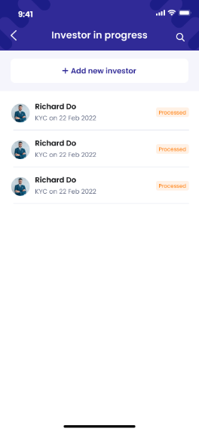  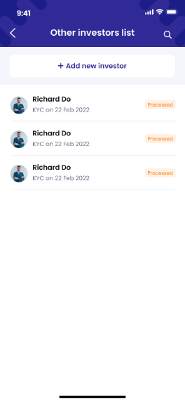



1. **Authorized User**

Existing active RM

1. **Entry Point**

Home page/Investor tab

1. **Exit Point**

List of investors (Approved)

List of investors (In progress)

Other investors

1. **Process Flow**
2. From ‘Home page/Investor tab’:

* User tap on ‘View all’ link button in ‘List of investors (Approved)’ panel to enter List of investors (Approved)’ page.

In this page, user can view the list of all approved investor managed by them

* User tap on ‘View all’ link button in ‘List of investors (In progress)’ panel to enter List of investors (In progress)’ page.

In this page, user can view the list of all in-progress investor managed by them

* User tap on ‘View all’ link button in ‘Other investors’ panel to enter List of other investor’ page.

In this page, all users can view their investors, users with Supervisor role can view investors within their company; users with Supervisor Role and from in-house company can view investors in all companies

In all List pages, user is able to use the Search function to search for Investor by their name, ID or phone number

1. **Fields and Validations and Verification**

|  |  |  |  |  |  |  |
| --- | --- | --- | --- | --- | --- | --- |
| **Field** | **Field Type** | **Description** | **Field Length** | **Mandatory** | **Validation** | **In-Line Error Message** |
|  | Button | Tap on to open Control panel | - | Yes |  |  |
|  | Button | Tap on to open notification list | - | Yes |  |  |
| Hello | Label | Hello  [Full_Name] | - | Yes |  |  |
| Add new investor | Button | Tap on to enter ‘Register new investor’ page | - | Yes |  |  |
| **List of investors approved panel** | | | | | | |
| List of investors approved panel | Label | List of investors approved panel label | - | Yes |  |  |
| Gavatar | Avatar | Avatar of the user | - | Yes |  |  |
| Full name | Text field | Full name of investor | - | Yes |  |  |
| Phone number | Numeric field | Phone number of investor | - | Yes |  |  |
| button | Button | Tap on to open action list of investor | - | Yes |  |  |
| View investor | Button | Tap on to enter Manage investor page/Investor info tab | - | Yes |  |  |
| See portfolio | Button | Tap on to enter Manage investor page/Porfolio tab | - | Yes |  |  |
| Create transaction | Button | Tap on to enter Instruction type page | - | Yes |  |  |
| View all | Link button | Tap on to view list of all approved investors | - | Yes |  |  |
| **List of investors in progress panel** | | | | | | |
| List of investors in progress | Label | List of investors in progress label | - | Yes |  |  |
| Gavatar | Avatar | Avatar of the user | - | Yes |  |  |
| Full name | Text field | Full name of investor | - | Yes |  |  |
| KYC Date | Text field | KYC on [KYC Date] | - | Yes |  |  |
| Status | Text field | Status of investors | - | Yes |  |  |
| View all | Link button | Tap on to view list of all investors in progress | - | Yes |  |  |
| **List of other investors panel** | | | | | | |
| List of other investors | Label | List of other investors label | - | Yes |  |  |
| Gavatar | Avatar | Avatar of the user | - | Yes |  |  |
| Full name | Text field | Full name of investor | - | Yes |  |  |
| KYC Date | Text field | [KYC Date] | - | Yes |  |  |
| Status | Text field | Status of investors | - | Yes |  |  |
| View all | Link button | Tap on to view list of all other investors | - | Yes |  |  |
| button | Button | Tap on to open action list of investor |  | Yes |  |  |
| **Home panel** | | | | | | |
| Investor | Button | Tap on to go to Home page – Investor panel | - | Yes |  |  |
| Transaction | Button | Tap on to go to Home page – Transaction panel | - | Yes |  |  |
| Leads | Button | Tap on to go to Home page – Leads panel | - | Yes |  |  |
| Report | Button | Tap on to go to Home page – Report panel | - | Yes |  |  |
| List of investors (Approved) page | | | | | | |
| List of investors (Approved) | Label | List of investors (Approved) label | - | Yes |  |  |
| Icon  Description automatically generated button | Button | Tap on to open Search box  User can use this Search box to search for investor by name, ID and phone number | - | Yes |  |  |
| Add new investor button | Button | Add new investor button  Tap on to enter Register new investor page | - | Yes |  |  |
| Investor panels | | | | | |  |
| Gavatar | Avatar | Avatar of the user | - | Yes |  |  |
| Investor name | Text field | Full name the investor | - | Yes |  |  |
| Phone number | Numeric field | Phone number of the investor | - | Yes |  |  |
| button | Button | Tap on to open Action list of investors | - | Yes |  |  |
| List of investors (In progress) | | | | | |  |
| List of investors (In progress) | Label | List of investors (In progress) label | - | Yes |  |  |
| Icon  Description automatically generated button | Button | Tap on to open Search box  User can use this Search box to search for investor by name, ID and phone number | - | Yes |  |  |
| Add new investor button | Button | Add new investor button  Tap on to enter Register new investor page | - | Yes |  |  |
| Investor panels | | | | | | |
| Gavatar | Avatar | Avatar of the user | - | Yes |  |  |
| Full name | Text field | Full name of investor | - | Yes |  |  |
| KYC Date | Text field | KYC on [KYC Date] | - | Yes |  |  |
| Status | Text field | Status of investor KYC | - | Yes |  |  |
| Other investors list | | | | | | |
| Other investors list | Label | Other investors list label | - | Yes |  |  |
| Icon  Description automatically generated button | Button | Tap on to open Search box  User can use this Search box to search for investor by name, ID and phone number | - | Yes |  |  |
| Add new investor button | Button | Add new investor button  Tap on to enter Register new investor page | - | Yes |  |  |
| Investor panels | | | | | | |
| Gavatar | Avatar | Avatar of the user | - | Yes |  |  |
| Full name | Text field | Full name of investor | - | Yes |  |  |
| KYC Date | Text field | KYC on [KYC Date] | - | Yes |  |  |
| Status | Text field | Status of investor KYC | - | Yes |  |  |
| Icon  Description automatically generatedbutton | Button | Icon  Description automatically generated button  Tap on the button to go back to the previous page | - | Yes |  |  |

1. **Messaging Requirement**

Follow message in above table

1. **Reference User Story**

N/A

#### User Story 12 – View investor info

As an existing RM, I want to view portfolio of my investors so that I can use their data.

As an existing RM, I want to view portfolio of investors in my company so that I can use their data.

As an existing Supervisor of in-house, I want to view portfolio of investors in my company and other companies so that I can use their data.

**Acceptance Criteria**

1. All users can view portfolio of their investors
2. Users with Supervisor role can view investors within their company
3. Users with Supervisor Role and from in-house company can view portfolios of all investors in all companies
4. User is able to back to the previous screen (Home page/Investor tab) from the Manage investor/Portfolio tab
5. **Page Flow**

  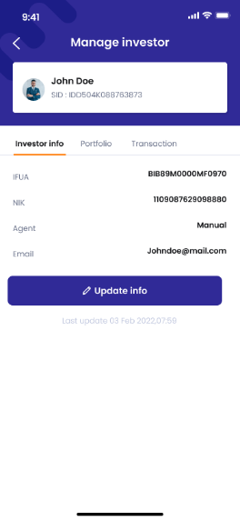

1. **Authorized User**

Existing active RM

1. **Entry Point**

Home page/Investor tab

1. **Exit Point**

Manage investor/Investor info tab

1. **Process Flow**
2. From ‘Home page/Investor tab’, user tap on button next to any Approved investor from ‘Investor list panel’ to open the ‘Action list’.
3. User can tap on ‘View investor’ button to enter ‘Manage investor page/Investor info tab’
4. **Fields and Validations and Verification**

|  |  |  |  |  |  |  |
| --- | --- | --- | --- | --- | --- | --- |
| **Field** | **Field Type** | **Description** | **Field Length** | **Mandatory** | **Validation** | **In-Line Error Message** |
| Manage investor | Label | Manage investor label  [Full name]  SID: [SID number] | - | Yes |  |  |
| Investor info | Tab button | Tap on to enter Manage investor/Investor info | - | Yes |  |  |
| Portfolio | Tab button | Tap on to enter Manage investor/Portfolio | - | Yes |  |  |
| Transaction | Tab button | Tap on to enter Manage investor/Transaction | - | Yes |  |  |
| IFUA | Text field |  | - | Yes |  |  |
| NIK | Text field | NIK: Customs Identification Number | - | Yes |  |  |
| Agent | Text field |  | - | Yes |  |  |
| Email | Text field | Email of the investor | - | Yes |  |  |
| Update info button | Button | Tap on to enter Update info page | - | Yes |  |  |
| Last update | Text field | Last update [last update date], [last update time] | - | Yes |  |  |
| Edit information | Label | Edit information  [Investor name] | - | Yes |  |  |

1. **Messaging Requirement**

Follow message in above table

1. **Reference User Story**

N/A

#### User Story 13 – View investor’s portfolio detail

As an existing RM, I want to view info of my investors in my company

As an existing Supervisor, I want to view info of investors my company

As an existing Supervisor of in-house, I want to view info of investors my company and other companies

**Acceptance Criteria**

1. All users can view portfolio of their investors
2. Users with Supervisor Role can view portfolio of investors in their company
3. Users with Supervisor Role and from in-house company can view portfolios of all investors in all companies
4. User is able to back to the previous screen (Home page/Investor tab) from the Manage investor/Portfolio tab
5. User is able to back to the previous screen (Manage investor/Portfolio tab) from the Portfolio detail page
6. **Page Flow**

  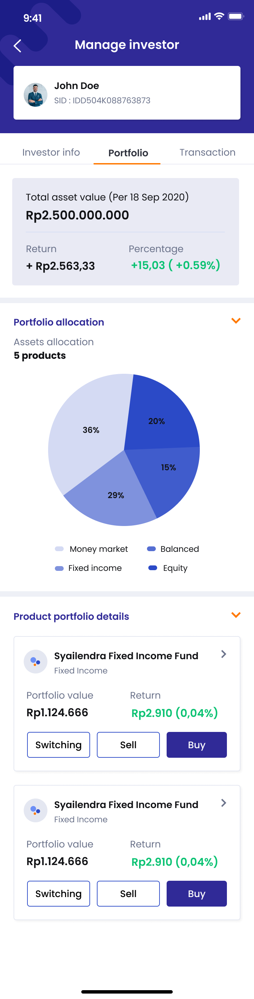 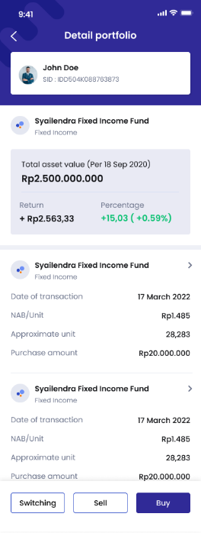

1. **Authorized User**

Existing active RM

1. **Entry Point**

Home page/Investor tab

1. **Exit Point**

Portfolio detail page

1. **Process Flow**
2. From ‘Home page/Investor tab’, user tap on button next to any Approved investor from ‘Investor list panel’ to open the ‘Action list’.
3. User can tap on ‘See portfolio’ button to enter ‘Manage investor page/Portfolio tab’
4. User can tap on button to enter ‘Portfolio detail’ page.

In this page

* User can view detail information of the product and the transaction history on the product by investor
* User can create new transaction by tapping on ‘Switch’, ‘Buy’, ‘Sell’ button

1. **Fields and Validations and Verification**

|  |  |  |  |  |  |  |
| --- | --- | --- | --- | --- | --- | --- |
| **Field** | **Field Type** | **Description** | **Field Length** | **Mandatory** | **Validation** | **In-Line Error Message** |
| Manage investor | Label | Manage investor label  [Full name]  SID: [SID number] | - | Yes |  |  |
| Investor info | Tab button | Tap on to enter Manage investor/Investor info | - | Yes |  |  |
| Investor info | Tab button | Tap on to enter Manage investor/Investor info | - | Yes |  |  |
| Portfolio | Tab button | Tap on to enter Manage investor/Portfolio | - | Yes |  |  |
| Transaction | Tab button | Tap on to enter Manage investor/Transaction | - | Yes |  |  |
| Total asset value | Text box | Total asset value (Per [Today date])  [Asset amount with CYY] | - | Yes |  |  |
| **Portfolio allocation panel** | | | | | | |
| Portfolio allocation | Label | Portfolio allocation label | - | Yes |  |  |
| button | Button | Tap on to expand/collapse Portfolio allocation panel  The default is expand | - | Yes |  |  |
| Assets allocation | Sub label | Assets allocation sub label | - | Yes |  |  |
| Number of product | Text field | [Number of product] product(s) | - | Yes |  |  |
| Product pie chart | Image field | Pie chart illustrating the allocation of different types of asset in investor’s portfolio  Include caption for the charts | - | Yes |  |  |
| **Product portfolio details panel**  Include Product info sub-panels of all product of investors | | | | | | |
| ***Product info sub-panel*** | | | | | | |
| Product name | Text field | Name of the product | - | Yes |  |  |
| Product type | Text field | Type of the product | - | Yes |  |  |
| Portfolio value | Text field | Value of the product (Today value) | - | Yes |  |  |
| Return | Text field | Total return of the all unit of this product that is in investor portfolio | - | Yes |  |  |
| Switching button | Button | Tap on to enter Create instruction/Switching page | - | Yes |  |  |
| Sell button | Button | Tap on to enter Create instruction/Redemption page | - | Yes |  |  |
| Buy button | Button | Tap on to enter Create instruction/ Subscription page | - | Yes |  |  |
| button | Button | Tap on to go back to the previous page | - | Yes |  |  |
| Manage investor | Label | Manage investor label  [Full name]  SID: [SID number] | - | Yes |  |  |
| Investor info | Tab button | Tap on to enter Manage investor/Investor info | - | Yes |  |  |
| Portfolio | Tab button | Tap on to enter Manage investor/Portfolio | - | Yes |  |  |
| Transaction | Tab button | Tap on to enter Manage investor/Transaction | - | Yes |  |  |
| Total asset value | Text box | Total asset value (Per [Today date])  [Asset amount with CYY] | - | Yes |  |  |
| Return | Text field | Total return amount on the product | - | Yes |  |  |
| Percentage | Text field | Return percentage on the product | - | Yes |  |  |
| **Transaction panel** | | | | | |  |
| Product name | Text field | Name of the product | - | Yes |  |  |
| Product type | Text field | Type of product | - | Yes |  |  |
| Date of transaction | Text field | Date of transaction  [DD Month YYYY] | - | Yes |  |  |
| NAB/Unit | Text field | NAB/Unit | - | Yes |  |  |
| Approximate unit | Text field | Approximate unit of product transacted | - | Yes |  |  |
| Purchase amount | Text field | Amount of product transacted | - | Yes |  |  |
| button | Button | Tap on to enter Transaction detail page | - | Yes |  |  |
| Switch button | Button | Tap on to enter Create instruction/Switch page | - | Yes |  |  |
| Sell button | Button | Tap on to enter Create instruction/Sell page | - | Yes |  |  |
| Buy button | Button | Tap on to enter Create instruction/Buy page | - | Yes |  |  |

1. **Messaging Requirement**

Follow message in above table

1. **Reference User Story**

N/A



#### User Story 14 – View Investor’s Transaction

As an existing RM, I want to view transaction of my investors so that I can use their data

As an existing RM, I want to view transaction of investors in my company so that I can use their data

As an existing Supervisor of inhouse, I want to view product portfolio of investors in my company and other companies so that I can use their data.

**Acceptance Criteria**

1. All users can view portfolio of their investors
2. Users with Supervisor Role can view portfolio of investors in their company
3. Users with Supervisor Role and from in-house company can view portfolios of all investors in all companies
4. User is able to back to the previous screen (Home page) from the Manage investor
5. **Page Flow**

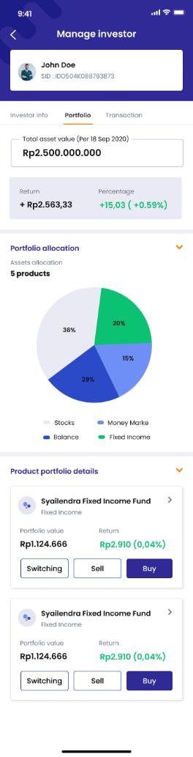 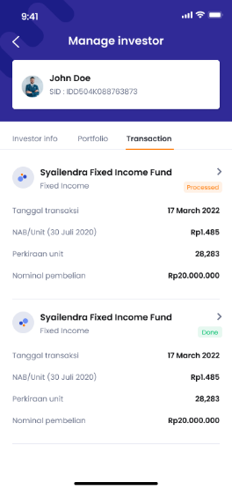

1. **Authorized User**

Existing active RM

1. **Entry Point**

Manage investor page/Investor info tab

Manage investor page/Portfolio tab

1. **Exit Point**

Manage investor page/Portfolio tab

1. **Process Flow**
2. From ‘Manage investor page/Portfolio tab’ or ‘Manage investor page/Investor info tab’, user can tap on Transaction tab button to enter ‘Manage investor page/Transaction tab’
3. **Fields and Validations and Verification**

|  |  |  |  |  |  |  |
| --- | --- | --- | --- | --- | --- | --- |
| **Field** | **Field Type** | **Description** | **Field Length** | **Mandatory** | **Validation** | **In-Line Error Message** |
| Investor info | Tab button | Tap on to enter Manage investor/Investor info | - | Yes |  |  |
| Portfolio | Tab button | Tap on to enter Manage investor/Portfolio | - | Yes |  |  |
| Transaction | Tab button | Tap on to enter Manage investor/Transaction | - | Yes |  |  |
| IFUA | Text field |  | - | Yes |  |  |
| NIK | Text field | NIK: Customs Identification Number | - | Yes |  |  |
| Agent | Text field |  | - | Yes |  |  |
| Email | Text field | Email of the investor | - | Yes |  |  |
| Update info button | Button | Tap on to enter Update info page | - | Yes |  |  |
| Last update | Text field | Last update [last update date], [last update time] | - | Yes |  |  |
| Edit information | Label | Edit information  [Investor name] | - | Yes |  |  |
| button | Button | Tap on to go back to the previous page | - | Yes |  |  |
| Manage investor | Label | Manage investor label  [Full name]  SID: [SID number] | - | Yes |  |  |
| Investor info | Tab button | Tap on to enter Manage investor/Investor info | - | Yes |  |  |
| Investor info | Tab button | Tap on to enter Manage investor/Investor info | - | Yes |  |  |
| Portfolio | Tab button | Tap on to enter Manage investor/Portfolio | - | Yes |  |  |
| Transaction | Tab button | Tap on to enter Manage investor/Transaction | - | Yes |  |  |
| Total asset value | Text box | Total asset value (Per [Today date])  [Asset amount with CYY] | - | Yes |  |  |
| **Portfolio allocation panel** |  |  |  |  |  |  |
| Portfolio allocation | Label | Portfolio allocation label | - | Yes |  |  |
| button | Button | Tap on to expand/collapse Portfolio allocation panel  The default is expand | - | Yes |  |  |
| Assets allocation | Sub label | Assets allocation sub label | - | Yes |  |  |
| Number of product | Text field | [Number of product] product(s) | - | Yes |  |  |
| Product pie chart | Image field | Pie chart illustrating the allocation of different types of asset in investor’s portfolio  Include caption for the charts | - | Yes |  |  |
| **Product portfolio details panel**  Include Product info sub-panels of all product of investors | | | | | | |
| ***Product info sub-panel*** | | | | | | |
| Product name | Text field | Name of the product | - | Yes |  |  |
| Product type | Text field | Type of the product | - | Yes |  |  |
| Portfolio value | Text field | Value of the product (Today value) | - | Yes |  |  |
| Return | Text field | Total return of the all unit of this product that is in investor portfolio | - | Yes |  |  |
| Switching button | Button | Tap on to enter Create instruction/Switching page | - | Yes |  |  |
| Sell button | Button | Tap on to enter Create instruction/Redemption page | - | Yes |  |  |
| Buy button | Button | Tap on to enter Create instruction/ Subscription page | - | Yes |  |  |
| button | Button | Tap on to go back to the previous page | - | Yes |  |  |

1. **Messaging Requirement**

Follow message in above table

1. **Reference User Story**

N/A

### Product management

#### User Story 15 – View/Filter product list

As an existing RM, I want to view the list of all products available on BMoney market

**Acceptance Criteria**

1. **Page Flow**

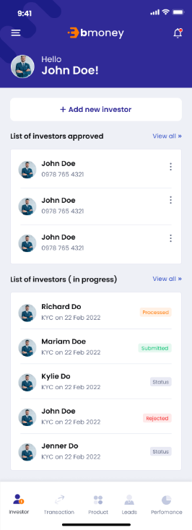 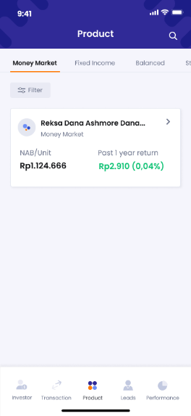 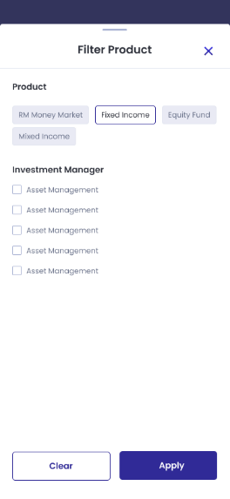

1. **Authorized User**

Existing active RM

1. **Entry Point**

Home page/Investor tab

1. **Exit Point**

Homepage/Product tab

1. **Process Flow**
2. From ‘Home page/Investor tab’, user tap on Product tab in the navigation to enter ‘Home page/Product tab’
3. In this page:

* User can tap on any Product tab to enter Product detail page
* User can use the Filter function based on Asset Class:
  + Money Market
  + Fixed Income
  + Equity Fund
  + Mixed Income
* User can use the Filter function based on Investment Manager

1. **Fields and Validations and Verification**

|  |  |  |  |  |  |  |
| --- | --- | --- | --- | --- | --- | --- |
| **Field** | **Field Type** | **Description** | **Field Length** | **Mandatory** | **Validation** | **In-Line Error Message** |
| Product | Label | Product list label | - | Yes |  |  |
| Product list tab | | | | | | |
| Money market | Tab button | Tap on to enter Money market products list | - | Yes |  |  |
| Fixed income | Tab button | Tap on to enter Fixed income products list | - | Yes |  |  |
| Equity fund | Tab button | Tap on to enter Equity fund products list | - | Yes |  |  |
| Mixed income | Tab button | Tap on to enter Mixed income products list | - | Yes |  |  |
| button | Button | Tap on to open Filter options page | - | Yes |  |  |
| Product tabs | | | | | | |
| Product name | Text field | Name of the product | - | Yes |  |  |
| Product type | Text field | Type of the product:   * Money market * Fixed income * Equity fund * Mixed income | - | Yes |  |  |
| button | Button | Tap on to enter ‘Product detail’ page | - | Yes |  |  |
| NAB/Unit | Text field | NAB/Unit of the product  CYY follow product setting | - | Yes |  |  |
| Past 1 year return | Numeric field | The amount of return in the last 1 year  [CYY Amount of money] [(Percentage)] | - | Yes |  |  |
| Filter Product | Label | Filter product label | - | Yes |  |  |
| swipe icon | Swipe icon | Swipe the icon down to close the Filter Product page | - | Yes |  |  |
| button | Button | Tap on to close the Filter Product page | - | Yes |  |  |
| Product | Label | Label of the filter based on product types | - | Yes |  |  |
| Product types | Multi-select | Product types options:   * Money market * Fixed income * Equity fund * Mixed income | - | Yes | User can select 0-4 product type(s) |  |
| Investment manager | Label | Label of the filter based on investment manager company | - | Yes |  |  |
| Investment manager company | Multi-select | Investment manager company options  The list of options is provided by BMoney | - | Yes |  |  |
| Clear button | Button | Tap on to reset all filter | - | Yes |  |  |
| Apply button | Button | Tap on to apply the filter and view the list of filtered products | - | Yes |  |  |

1. **Messaging Requirement**

Follow message in above table

1. **Reference User Story**

N/A

#### User Story 16 – View product detail

As an existing RM, I want to view details of all products available on BMoney market

**Acceptance Criteria**

1. **Page Flow**

 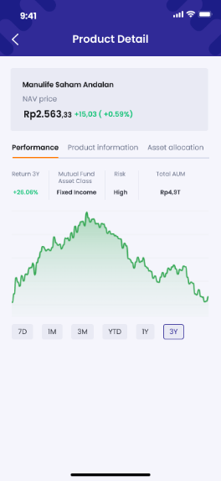 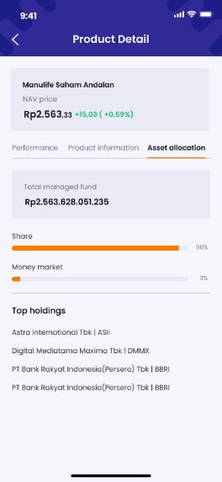 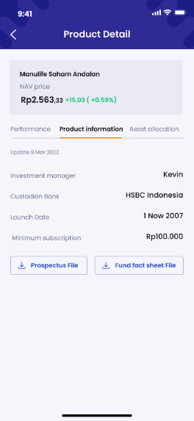

1. **Authorized User**

Existing active RM

1. **Entry Point**

Home page/Product tab

1. **Exit Point**

Product details pages

1. **Process Flow**
2. From ‘Home page/Product tab’, user can tap on  button in the any Product tab from the list to enter ‘Product detail page/Performance tab’
3. In this page:

* User can tap on ‘Performance tab’ button to enter and view ‘Product detail page/Performance tab’.
* User can tab on ‘Product information’ button to enter and view ‘Product detail page/Product information tab’
* User can tab on ‘Asset allocation tab’ button to enter and view ‘Product detail page/ Asset allocation tab’

1. **Fields and Validations and Verification**

|  |  |  |  |  |  |  |
| --- | --- | --- | --- | --- | --- | --- |
| **Field** | **Field Type** | **Description** | **Field Length** | **Mandatory** | **Validation** | **In-Line Error Message** |
| Product | Label | Product list label | - | Yes |  |  |
| Product list tab | | | | | | |
| Money market | Tab button | Tap on to enter Money market products list | - | Yes |  |  |
| Fixed income | Tab button | Tap on to enter Fixed income products list | - | Yes |  |  |
| Equity fund | Tab button | Tap on to enter Equity fund products list | - | Yes |  |  |
| Mixed income | Tab button | Tap on to enter Mixed income products list | - | Yes |  |  |
| button | Button | Tap on to open Filter options page | - | Yes |  |  |
| Product tabs | | | | | | |
| Product name | Text field | Name of the product | - | Yes |  |  |
| Product type | Text field | Type of the product:   * Money market * Fixed income * Equity fund * Mixed income | - | Yes |  |  |
| button | Button | Tap on to enter ‘Product detail’ page | - | Yes |  |  |
| NAB/Unit | Text field | NAB/Unit of the product  CYY follow product setting | - | Yes |  |  |
| Past 1 year return | Numeric field | The amount of return in the last 1 year  [CYY Amount of money] [(Percentage)] | - | Yes |  |  |
| Product detail | Label | Product detail page lable | - | Yes |  |  |
| Icon  Description automatically generatedbutton | Button | Icon  Description automatically generated button  Tap on the button to go back to the previous page | - | Yes |  |  |
| Product panel | | | | | | |
| Product name | Text field | Name of product | - | Yes |  |  |
| NAV price | Numeric field | NAV of the product at the moment | - | Yes |  |  |
| Past 1 year return | Numeric field | [CYY Amount of money] [(Percentage)] | - | Yes |  |  |
| Tabs panel | | | | | | |
| Performance | Tap button | Tap on to enter Performance information | - | Yes |  |  |
| Product information | Tap button | Tap on to enter Product information |  | Yes |  |  |
| Asset allocation | Tap button | Tap on to enter Asset allocation |  | Yes |  |  |
| **Performance tab** | | | | | | |
| Return (duration) | Numeric field | Return [duration] | - | Yes |  |  |
| Asset class | Text field | Asset class   * Money Market; * Fixed Income; * Balanced; * Equity | - | Yes |  |  |
| Risk | Text field | Risk potential:   * High * Medium * Low | - | Yes |  |  |
| Total AUM | Numeric field | Total AUM | - | Yes |  |  |
| Performance graph | Graphical field | Performance graph | - | Yes |  |  |
| Duration filter | | | | | | |
| 7D | Button | Tap to view last 7 days return | - | Yes |  |  |
| 1M | Button | Tap to view last 1 month return | - | Yes |  |  |
| 3M | Button | Tap to view last 3 months return | - | Yes |  |  |
| YTD | Button | Tap to view year-to-date return | - | Yes |  |  |
| 1Y | Button | Tap to view last 1 year return | - | Yes |  |  |
| 3Y | Button | Tap to view last 3 years return | - | Yes |  |  |
| **Product information tab** | | | | | | |
| Updated date | Text field | Last updated date of the product info  Updated [DD MMM YYYY] | - | Yes |  |  |
| Investment manager | Text field | Name of investment manager | - | Yes |  |  |
| Custodian Bank | Text field | Custodian Bank | - | Yes |  |  |
| Launch Date | Date field | Product launch date | - | Yes |  |  |
| Minimum subscription | Numeric field | Minimum amount subscription | - | Yes |  |  |
| Prospectus File download button | Button | Tap on to download propectus file | - | Yes |  |  |
| Fund fact sheet File download button | Button | Tap on to download fund fact sheet file | - | Yes |  |  |
| Asset allocation | | | | | | |
| Total managed fund | Numeric field | Total managed fund of the product | - | Yes |  |  |
| Asset allocation ratio bars | Ratio bars | Types of assets that this fund holds (%) | - | Yes |  |  |
| Top holdings | Label | Top holdings label | - | Yes |  |  |
| Top holdings name list | Text field | List of top 5 holdings name | - | Yes |  |  |

1. **Messaging Requirement**

Follow message in above table

1. **Reference User Story**

N/A

### Leads management

#### User Story 17 ****–**** RM/Create new lead

As an existing RM, I want to create new lead to save the contact and keep track of the lead

**Acceptance Criteria**

1. User is able to back to the previous screen (My leads) from the Lead detail page
2. As mandatory information - unique key checking is based on Mobile number
3. **Page Flow**

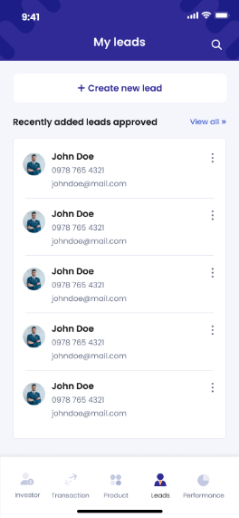 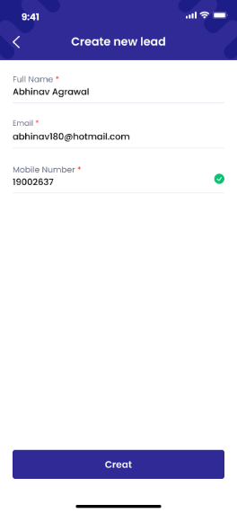 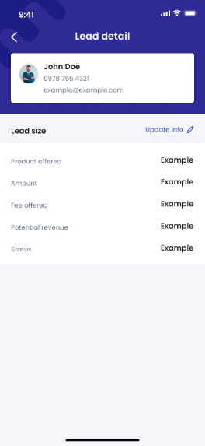

1. **Authorized User**

Active RM user

1. **Entry Point**

Home page/Lead management tab

1. **Exit Point**

Lead detail page

1. **Process Flow**
2. From Home page navigation, tap on Lead tab button to enter Home page/My leads tab
3. In this page, user can use the Search function to search for Leads based on name, ID, phone number or email
4. User will tap on ‘Create new lead’ button to enter ‘Create new lead’ page.
5. User fill in required fields then tap on Create button to enter ‘Lead detail’ page of the new lead
6. **Fields and Validations and Verification**

|  |  |  |  |  |  |  |
| --- | --- | --- | --- | --- | --- | --- |
| **Field** | **Field Type** | **Description** | **Field Length** | **Mandatory** | **Validation** | **In-Line Error Message** |
| My leads | Label | My leads label | - | Yes |  |  |
| Icon  Description automatically generated button | Button | Tap on to open Search box  User can use this Search box to search for leads by name, ID and phone number | - | Yes |  |  |
| Create new lead button | Button | Create new lead button  Tap on to enter ‘Create new lead’ page | - | Yes |  |  |
| Recently added leads | Label | Recently added leads label | - | Yes |  |  |
| View all | Link button | Tap on to enter ‘All leads’ page | - | Yes |  |  |
| Lead tabs | | | | | | |
| Full name | Text field | Full name of the lead | - | Yes |  |  |
| Mobile number | Numeric field | Mobile number of the lead | - | Yes |  |  |
| Email | Text field | Email of the lead | - | Yes |  |  |
| Status |  | Status of the leads  There are 4 values: Initiate, Negotiation. Close, Drop | - | Yes |  |  |
|  |  |  |  |  |  |  |
| Create new lead | Label | Create new lead label | - | Yes |  |  |
| Full name | Text input | Full name of the new lead | String (200) | Yes |  |  |
| Mobile number | Numeric input | Mobile number of the new lead | String (15) | Yes | Valid mobile number must not match with any mobile number from other leads or investors | This phone number is existed. Please enter another phone number. |
| Email | Text input | Email of the new lead | String (200) | Yes |  |  |
| Create button | Button | Create button  Tap on to confirm creating new lead | - | Yes |  |  |
| Icon  Description automatically generatedbutton | Button | button  Tap on the button to trigger Cancel pop-up | - | Yes |  |  |
| Cancel pop-up | Pop up label | Cancel pop-up  Sorry!  Are you sure you want to cancel your instruction? All information is not saved. | - | Yes |  |  |
| Yes button | Button | Yes button  Tap on to go back to My Transaction list | - | Yes |  |  |
| No button | Button | No button  Tap on to close the pop up and continue with the instruction form. | - | Yes |  |  |
| Lead detail | Label | Lead detail label | - | Yes |  |  |
| Lead panel | | | | | | |
| Full name | Text field | Full name of lead | - | Yes |  |  |
| Phone number | Numeric field | Phone number of lead | - | Yes |  |  |
| Email | Alphanumeric input | Email address of lead | - | Yes |  |  |
| Lead size | Label | Lead size label | - | Yes |  |  |
| Update info | Link button | Tap on to update lead’s detail information | - | Yes |  |  |
| Product offered |  |  |  |  |  |  |
| Amount | Numeric input | Amount | - | Yes |  |  |
| Fee offered | Numeric input | Fee | - | Yes |  |  |
| Potential revenue |  |  | - | Yes |  |  |
| Status | Text field |  | - | Yes |  |  |
| Icon  Description automatically generatedbutton | Button | button  Tap on the button to go back to the Home page/Lead tab | - | Yes |  |  |

1. **Messaging Requirement**

Follow message in above table

1. **Reference User Story**

N/A

#### User story 18 – Register for investors from leads

As an existing RM, I want to register new individual investors (High-Net-Worth Individual) from the leads list to the system using on behalf KYC so that I can manage and provide services for them.

**Acceptance Criteria**

Dashboard website must be responsive to mobile browser and PC browser

Dashboard website URL must expire after 24 hours since generated

The “Pick from leads” list shows only leads with “Closed” status

1. **Page Flow**

 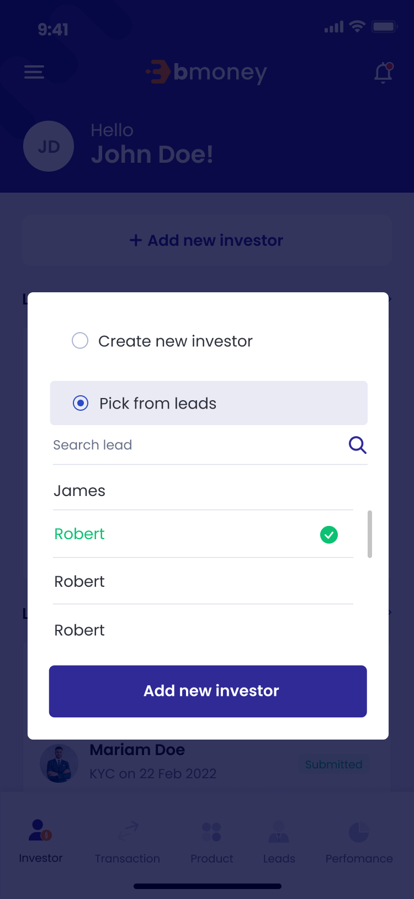





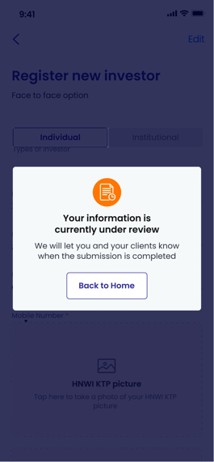  

1. **Authorized User**

Existing active RM

1. **Entry Point**

Home page

1. **Exit Point**

‘Thank you’ MSG Screen

1. **Process Flow**
2. From Home page – Investor panel, user will tap on ‘Add new investor’ button to enter ‘Register new investor’ page
3. User will click on the “Pick from leads” option, there will be a dropdown list of leads and a search field to search for the lead
4. User can choose only one lead to register
5. “Name”, “Phone number”, “Email” are autofilled fields as the information of the lead, user will fill in all required fields, take picture as required, sign on the device then tap ‘Submit’ button to send the information
6. If choose individual investor option, the information is ready for review and the system will send emails to investors about their KYC information. There will be ‘Submitted’ MSG Screen.
7. For Face-to-face option, investors can open the URL from the email, view their KYC information, read T&C and confirm information.

For Remote option, investors can open the URL from the email, view their KYC information, read T&C and sign on device to confirm information

1. There will be Thank you page after investor submitting required information
2. **Fields and Validations and Verifications**

|  |  |  |  |  |  |  |
| --- | --- | --- | --- | --- | --- | --- |
| **Field** | **Field Type** | **Description** | **Field Length** | **Mandatory** | **Validation** | **In-Line Error Message** |
|  | Button | Tap on to open Control panel | - | Yes |  |  |
|  | Button | Tap on to open notification list | - | Yes |  |  |
| Hello | Label | Hello  [Full_Name] | - | Yes |  |  |
| Gravatar | Avatar | Avatar of the user | - | Yes |  |  |
| Add new investor | Button | Tap on to enter ‘Register new investor’ page | - | Yes |  |  |
| **List of investors approved panel** | | | | | | |
| List of investors approved panel | Label | List of investors approved panel label | - | Yes |  |  |
| Gravatar | Image | Avatar of the investor | - | Yes |  |  |
| Full name | Text field | Full name of investor | - | Yes |  |  |
| Phone number | Numeric field | Phone number of investor | - | Yes |  |  |
| button | Button | Tap on to open action list of investor | - | Yes |  |  |
| View investor | Button | Tap on to enter Manage investor page/Investor info tab | - | Yes |  |  |
| See portfolio | Button | Tap on to enter Manage investor page/Porfolio tab | - | Yes |  |  |
| Create transaction | Button | Tap on to enter Instruction type page | - | Yes |  |  |
| View all | Link button | Tap on to view list of all approved investors | - | Yes |  |  |
| **List of investors in progress panel** | | | | | | |
| List of investors in progress | Label | List of investors in progress label | - | Yes |  |  |
| Gravatar | Avatar | Avatar of the user | - | Yes |  |  |
| Full name | Text field | Full name of investor | - | Yes |  |  |
| KYC Date | Text field | KYC on [KYC Date] | - | Yes |  |  |
| Status | Text field | Status of investors | - | Yes |  |  |
| View all | Link button | Tap on to view list of all investors in progress | - | Yes |  |  |
| **List of other investors panel** | | | | | | |
| List of other investors | Label | List of other investors label | - | Yes |  |  |
| Gravatar | Avatar | Avatar of the user | - | Yes |  |  |
| Full name | Text field | Full name of investor | - | Yes |  |  |
| KYC Date | Text field | [KYC Date] | - | Yes |  |  |
| Status | Text field | Status of investors | - | Yes |  |  |
| View all | Link button | Tap on to view list of all other investors | - | Yes |  |  |
| button | Button | Tap on to open action list of investor |  | Yes |  |  |
| **Home panel** | | | | | | |
| Investor | Button | Tap on to go to Home page – Investor panel | - | Yes |  |  |
| Transaction | Button | Tap on to go to Home page – Transaction panel | - | Yes |  |  |
| Leads | Button | Tap on to go to Home page – Leads panel | - | Yes |  |  |
| Report | Button | Tap on to go to Home page – Report panel | - | Yes |  |  |
| Create option | Option tab | ‘Create’ option tab   * Create new investor (default) * Pick from leads | - | Yes | If choose Create new investor option, user will enter Register new investor page  If choose Pick from list, user will enter Leads ratio option |  |
| Icon  Description automatically generated button | Button | Tap on to go back to the previous page and cancel the register without saving any input | - | Yes |  |  |
| Register new investor | Label | Register new investor | - | Yes |  |  |
| Types of investor option | Tab | Types of investor option, including:   * Individual (default) * Insitutional | - | Yes |  |  |
| **Individual option (If user choose Individual in Types of investors option)** | | | | | | |
| **Personal Information** | | | | | | |
| NIK | Numeric input | NIK: Customs Identification Number  It has to be in accordance to the NIK rules.  Numeric keypad required | String (20) | Yes | ‘Types of investor’ has to be set to ‘Individual’ for this field to show | This field cannot be empty |
| Full name | Text input | Full name  Alphanumeric keypad required | String (50) | Yes | 1. Must be Not Empty | This field cannot be empty |
| Email | Alphanumeric input | Email  Alphanumeric keypad required | String (100) | Yes | 1. Must be in email format: abc@xyz.com 2. Must be Not Empty | This field cannot be empty |
| Phone number | Numeric input | Phone number  Numeric keypad required | String (20) | Yes | 1. Must be Not Empty | This field cannot be empty |
| Place of birth | Alphanumeric input | Place of birth  Alphanumeric keypad required | String (100) | Yes | Must be Not Empty | This field cannot be empty |
| Date of birth | Date picker | Date of birth of investor | Date picker | Yes | Must be Not Empty | This field cannot be empty |
| Gender | Dropdown list | Gender dropdown list:  Male  Female  Private | Dropdown list | Yes | Must be Not Empty | This field cannot be empty |
| Province | Alphanumeric input | Province  Alphanumeric keypad required | String (100) | Yes | Must be Not Empty | This field cannot be empty |
| Districts | Alphanumeric input | Districts  Alphanumeric keypad required | String (100) | Yes | Must be Not Empty | This field cannot be empty |
| Urban village | Alphanumeric input | Urban village  Alphanumeric keypad required | String (100) | Yes | Must be Not Empty | This field cannot be empty |
| Neighbourhood/Hamlet | Alphanumeric input | Neighbourhood/Hamlet  Alphanumeric keypad required | String (100) | Yes | Must be Not Empty | This field cannot be empty |
| Address | Alphanumeric input | Address  Alphanumeric keypad required | String (300) | Yes | Must be Not Empty | This field cannot be empty |
| Postal code | Numeric input | Postal code  Numeric keypad required | String (15) | Yes | Must be Not Empty | This field cannot be empty |
| Religion | Dropdown list | Religion of the investor dropdown  1. Islam  2. Protestant  3. Catholic  4. Hinduism  5. Budhism  6. Confucianism  7. Others  Alphanumeric keypad required |  | Yes | Must be Not Empty | This field cannot be empty |
| Marital Status | Dropdown list | Marital Status dropdown  1. Single  2. Married  3. Divorced |  | Yes | Must be Not Empty | This field cannot be empty |
| Occupation | Dropdown list | Occupation of the investor dropdown  1. Student/Graduate Student/Post Graduate  2. Housewife  3. Enterpreneur  4. Civil Servant  5. Indonesian National Armed Force/Indonesian National Police  6. Retirement  7. Lecturer/Teacher  8. Private Employee  9. Others |  | Yes | Must be Not Empty | This field cannot be empty |
| Education | Dropdown list | Education level of the investors dropdown  1. Primary School  2. Junior High School  3. Senior High School  4. Diploma  5. Undergraduate  6. Post Graduate  7. Doctoral Program  8. Others |  | Yes | Must be Not Empty | This field cannot be empty |
| Income level (IDR) | Dropdown list | Income level dropdown  1. Below Rp850.000  2. Rp850.000 - Rp4.000.000  3. Rp4.000.001 - Rp 8.000.000  4. Rp8.000.001 - Rp41.000.000  5. Rp41.000.001 - Rp83.000.000  6. Above Rp83.000.000 |  | Yes | Must be Not Empty | This field cannot be empty |
| Risk profile | Dropdown list | Risk profile dropdown  1. Low  2. Moderate  3. High |  | Yes | Must be Not Empty | This field cannot be empty |
| Investment Objective | Dropdown list | Investment objective dropdown  1. Gain from price  margin  2. Investment  3. Speculation  4. Gain the revenue or  income  5. Others |  | Yes | Must be Not Empty | This field cannot be empty |
| Source of Fund | Dropdown list | Source of fund dropdown  1. Revenue  2. Business Profit  3. Saving interest  4. Legacy  5. Fund from parents or children  6. Grant  7. Fund from husband or wife  8. Drawing  9. Investment gain  10. Others |  | Yes | Must be Not Empty | This field cannot be empty |
| **Investment Source details** | | | | | | |
| Beneficiary Owner | Dropdown list | Beneficiary Owner dropdown   1. Yes 2. No |  | Yes | Must be Not Empty | This field cannot be empty |
| Politically Exposed Persons | Dropdownlist | Politically Exposed Persons dropdown   1. Yes 2. No |  | Yes | Must be Not Empty | This field cannot be empty |
| **Bank account information** | | | | | | |
| Bank name | Dropdown list | Bank name dropdown list  List retrieved from client's API |  | Yes | Must be Not Empty | This field cannot be empty |
| Bank account | Numeric input | Bank account  Numeric keypad required | String (20) | Yes | Must be Not Empty | This field cannot be empty |
| Bank account name | Alphanumeric input | Bank account name  Alphanumeric keypad required | String (100) | Yes | Must be Not Empty | This field cannot be empty |
| Bank branch | Alphanumeric input | Bank branch  Alphanumeric keypad required | String (300) | Yes | Must be Not Empty | This field cannot be empty |
| **Institutional option (If user choose Institutional in Types of investors option)** | | | | | | |
| **Company Details** | | | | | | |
| Company name | Alphanumeric input | Company name  Alphanumeric keypad required | String (100) | Yes | Must be Not Empty | This field cannot be empty |
| Country of Domicile | Alphanumeric input | Country of Domicile  Alphanumeric keypad required | String (300) | Yes | Must be Not Empty | This field cannot be empty |
| Place of Establishment | Alphanumeric input | Place of Establishment  Alphanumeric keypad required | - | Yes | Must be Not Empty | This field cannot be empty |
| Date of Establishment | Date picker | Date of Establishment | - | Yes |  |  |
| Articles of Association No. | Numeric input | Articles of Association Number | String (40) | Yes | In case 'Company Characteristic' is '5' (i.e. PMA/Foreign Investment Company), either SKD No. or Articles of Association No. can be used. If both SKD and Articles of Association No. are inputted, SKD No. is to be reported to ARIA for Institutional Investor Profile Data(SKD atau AD/ART). |  |
| NPWP | Numeric input | NPWP: Tax number  It has to be in accordance to the NPWP rules.  Numeric keypad required | String (15) | Yes | ‘Types of investor’ has to be set to ‘Institutional’ for this field to show | This field cannot be empty |
| NPWP Registration Date | Date picker | NPWP Registration Date date picker | - | Yes | Must be a past date |  |
| SIUP No. | Numeric input | SIUP Number | String (100) | Yes | It is mandatory if 'Country of Domicile' is not 'ID' (i.e. Other than Indonesia). |  |
| SIUP Expiration Date | Date picker | SIUP expiration Date date picker | - | Yes | Must be a future date |  |
| SKD No. | Numeric input | SKD Number | String (40) | Yes | In case 'Company Characteristic' is '5' (i.e. PMA/Foreign Investment Company), either SKD No. or Articles of Association No. can be used. If both SKD and Articles of Association No. are inputted, SKD No. is to be reported to ARIA for Institutional Investor Profile Data(SKD atau AD/ART). |  |
| SKD Expiration Date | Date picker | SKD expiration Date date picker | - | Yes | Must be a future date |  |
| Company address | Alphanumeric input | Address of the company  Alphanumeric keypad required | String (200) | Yes | Must be Not Empty | This field cannot be empty |
| Company City Code | Alphanumeric input | Company City Code  Alphanumeric keypad required | String (5) | Yes | Must be Not Empty | This field cannot be empty |
| Company city name | Alphanumeric input | Company Name  Alphanumeric keypad required | String (200) | Yes |  |  |
| Company postal code | Alphanumeric input | Company postal Code  Alphanumeric keypad required | String (4) | Yes |  |  |
| Email | Text input | Email address  Alphanumeric & symbol keypad required | String (150) | Yes | Must be Not Empty | This field cannot be empty |
| Office phone | Numeric input | Office phone number  Numeric keypad required | String (15) |  |  |  |
| Company Correspondent address | Alphanumeric input | Address of the correspondent company  Alphanumeric keypad required | String (200) | - |  |  |
| Company Correspondent city name | Alphanumeric input | Company Correspondent Name  Alphanumeric keypad required | String (200) | - |  |  |
| Company Correspondent City Code | Alphanumeric input | Company Correspondent City Code  Alphanumeric keypad required | String (15) | - |  |  |
| Company postal code | Alphanumeric input | Company Correspondent postal Code  Alphanumeric keypad required | String (10) | - |  |  |
| Email Correspondent | Text input | Email correspondent address  Alphanumeric & symbol keypad required | String (150) | - |  |  |
| Authorized Person 1 - Full Name | Alphanumeric input | Authorized Person 1 - First Name  Alphanumeric keypad required | String (50) | - |  |  |
| Authorized Person 1 – Position | Alphanumeric input | Authorized Person 1 – Position  Alphanumeric keypad required | String (50) | - |  |  |
| Authorized Person 1 – Mobile phone | Numeric input | Authorized Person 1 – Mobile phone  Numeric keypad required | String (15) | - |  |  |
| Authorized Person 1 – Email | Alphanumeric input | Authorized Person 1 – Email  Alphanumeric keypad required | String (100) | - |  |  |
| Authorized Person 2 - Full Name | Alphanumeric input | Authorized Person 2 - First Name  Alphanumeric keypad required | String (50) | - |  |  |
| Authorized Person 2 – Position | Alphanumeric input | Authorized Person 2 – Position  Alphanumeric keypad required | String (50) | - |  |  |
| Authorized Person 2 – Mobile phone | Numeric input | Authorized Person 2 – Mobile phone  Numeric keypad required | String (15) | - |  |  |
| Authorized Person 2 – Email | Alphanumeric input | Authorized Person 2 – Email  Alphanumeric keypad required | String (100) | - |  |  |
| Investor’s risk profile | Dropdown list | Investor’s risk profile dropdown list:  1. Low  2. Moderate  3. High | - | Yes |  |  |
| **Business Data** | | | | | | |
| Company type | Dropdown list | Company type dropdown list:  1. Corporate  2. Foundation  3. Financial Institution  4. Insurance  5. Mutual Fund  6. Pension Fund  7. Securities Company  8. Others | - | Yes | Must be Not Empty | This field cannot be empty |
| Company Characteristic | Dropdown list | Company Characteristic dropdown list:  1. State Owned  Company/Public  2. Private  3. Social  4. Joint Venture  5. PMA/Foreign  Investment Company  6. Family Company  7. Afiliation  8. Others | - | Yes | Must be Not Empty  In case 'Company Characteristic' is '5' (i.e. PMA/Foreign Investment Company), either SKD No. or Articles of Association No. can be used. If both SKD and Articles of Association No. are inputted, SKD No. is to be reported to ARIA for Institutional Investor Profile Data(SKD atau AD/ART). | This field cannot be empty |
| Income level (IDR) | Dropdown list | Income level dropdown list:  1. < 1 billion/Year  2. > 1– 5 billion/Year  3. > 5 – 10 billion/Year  4. > 10 – 50  billion/Year  5. > 50 billion/Year | - | Yes | Must be Not Empty | This field cannot be empty |
| Investment objective | Dropdown list | Investment objective dropdown list:  1. Gain from price  margin  2. Investment  3. Speculation  4. Gain the revenue or  income  5. Others | - | Yes | Must be Not Empty | This field cannot be empty |
| Source of fund | Dropdown list | Source of fund dropdown  1. Business Profit  2. Pension Funds  3. Saving Interest  4. Investment Gain  5. Others | - | Yes | Must be Not Empty | This field cannot be empty |
| **Bank account information** | | | | | | |
| Bank name | Dropdown list | Bank name dropdown list  List retrieved from client's API |  | Yes | Must be Not Empty | This field cannot be empty |
| Bank account | Numeric input | Bank account  Numeric keypad required | String (20) | Yes | Must be Not Empty | This field cannot be empty |
| Bank account name | Alphanumeric input | Bank account name  Alphanumeric keypad required | String (100) | Yes | Must be Not Empty | This field cannot be empty |
| Bank branch | Alphanumeric input | Bank branch  Alphanumeric keypad required | String (300) | Yes | Must be Not Empty | This field cannot be empty |
| **FATCA & CRS** | | | | | | |
| FATCA (Status) |  | FATCA status dropdown list  . Registered DeemedCompliant FFI  2. Certified DeemedCompliant FFI  3. Owner-Documented  FFI  4. Owner-Documented  FFI with Specified U.S.  Owner  5. Participating FFI  6. Nonparticipating FFI  7. Active NFFE  8. Passive NFFE with  Substantial U.S. Owner  9. Passive NFFE  without Substantial  U.S. Owner  10. Direct Reporting  NFFE  11. Exempt Beneficial  Owner  12. U.S. Financial  Institution |  | Yes |  |  |
| TIN / Foreign TIN | Alphanumeric input | TIN / Foreign TIN  Alphanumeric keypad required | String (30) | - | U.S. taxpayer identification number (employer identification number) or Foreign(non-U.S.) tax identifying number |  |
| TIN / Foreign TIN Issurance Country | Alphanumeric input | TIN / Foreign TIN Issurance Country  Alphanumeric keypad required | String (30) | - | ISO country code |  |
| GIIN | Alphanumeric input | GIIN  Alphanumeric keypad required | String (30) | - | Global intermediary identification number |  |
| Substantial U.S. Owner Name | Alphanumeric input | Substantial U.S. Owner Name  Alphanumeric keypad required | String (100) | - | Applicable for FATCA (Status) no. 4, 8 and 10 |  |
| Substantial U.S. Owner Address | Alphanumeric input | Substantial U.S. Owner Address  Alphanumeric keypad required | String (100) | - | Applicable for FATCA (Status) no. 4, 8 and 10 |  |
| Substantial U.S. Owner TIN | Alphanumeric input | Substantial U.S. Owner TIN  Alphanumeric keypad required | String (10) | - | Applicable for FATCA (Status) no. 4, 8 and 10 |  |
| Identity picture | Image input | Identity picture  - User can upload picture  - User can take a picture |  | Yes | Must be not empty | This field cannot be empty |
| Selfie with Identity Picture | Image input | Selfie with Identity Picture  - User can upload picture  - User can take a picture |  | Yes | Must be not empty | This field cannot be empty |
| Face-to-face/Remote option | Option tab | User can choose either option to register new investors.  1. Face-to-face option (default): there will be a signature input canvas  2. Remote option: there will be no signature input canvas. Instead, there will be an URL via investor’s email to upload signature. |  | Yes |  |  |
| Signature | Image input | Canvas  User can sign on device | - | Yes | Appear only when user choose Face-to-face option  Must be not empty | This field cannot be empty |
| Register | Button | Register Button  Click to submit the KYC information | - | Yes | All above mandatory fields must be filled in the correct format with valid value to enable this button |  |
| ‘Submitted_individual’ MSG Screen |  | Your information is currently under review  We will let you and your clients know when the submission is approved.  Click ‘OK’ button to back to Home page | - | Yes |  |  |

1. **Messaging Requirement**

Follow message in above table

1. **Reference User Story**

User story 5

### Performance

#### User Story 19: Supervisor/Send reports

As an existing RM with supervisor role of BIB, I want to be able to send report of any company to an email address

As an existing RM with supervisor role of any company other than BIB, I want to be able to send report of my company to an email address

**Acceptance Criteria**

1. Only RM with supervisor role can access to Performance tab

Performance tab is hidden for RM with sale role

1. Company dropdown list will display different data for supervisors of different companies.

* Supervisor of BIB can view and select all companies from BIB companies list.
* Supervisor of other company than BIB can view and select only his/her company.

1. Send report button and Send button is disable until all above required fields are filled
2. **Page Flow**

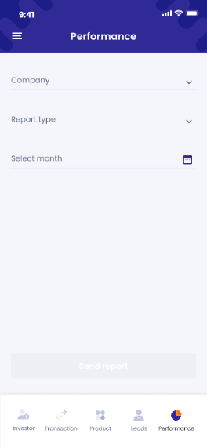 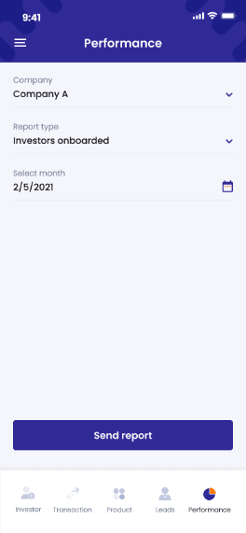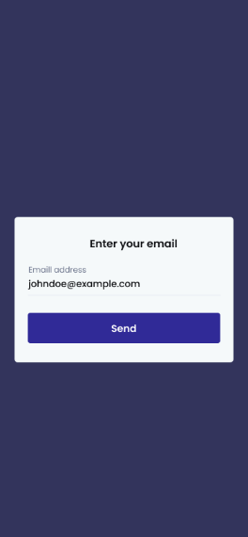

1. **Authorized User**

Existing user

1. **Entry Point**

Performance tab

1. **Exit Point**

Successful pop-up

1. **Process Flow**
2. From Performance tab, user can fill in all dropdown list to generate a report
3. User can click on send request to open Enter your email pop-up
4. User can fill an email then tap on Send to send the report to the email address.
5. There will be a successful pop-up afterward
6. **Fields and Validations and Verification**

|  |  |  |  |  |  |  |
| --- | --- | --- | --- | --- | --- | --- |
| **Field** | **Field Type** | **Description** | **Field Length** | **Mandatory** | **Validation** | **In-Line Error Message** |
|  | Button | Tap on to open Control panel | - | Yes |  |  |
| Performance label | Label | Performance label | - | Yes |  |  |
| Company | Dropdown list | Tap on to select company  Supervisor of BIB can view and select all companies from BIB companies list.  Supervisor of other company than BIB can view and select only his/her company | - | Yes | 1. Must not be empty | 1. This field cannot be empty |
| Report type | Dropdown list | Tap on to select Report types   * Investors onboarded * Transactions * Leads on active pipeline | - | Yes | 1. Must not be empty | This field cannot be empty |
| Month | Month picker | Tap on to select Month  Hide all future month |  |  | Must be past or present month  Must not be empty | This field cannot be empty |
| Send report button | Button | Tap on to enter Enter your email pop-up | - | Yes | All above mandatory fields must be filled in the correct format with valid value to enable this button |  |
| Enter your email | Pop-up label | Enter your email pop-up label | - | Yes |  |  |
| Email address | Text input | Tap on to enter email address | String (200) | Yes | 1. Must not be empty 2. Must be in email format: xxx@xxx.xxx | 1. This field cannot be empty 2. Please enter a valid email address |
| Send button | Button | Tap on to send the report to the email address | - | Yes | All above mandatory fields must be filled in the correct format with valid value to enable this button |  |
| Successfully pop-up label | Pop-up label | Successfully pop-up label  Successfully!  Your report has been sent.  Tap on OK button to go back to Performance tab | - | Yes |  |  |

1. **Messaging Requirement**

Follow message in above table

1. **Reference User Story**

N/A

#### User Story 20 - Admin/View report

As an existing Super Admin/maker/checker, I want to be able to check report information

**Acceptance Criteria**

Can be access in dashboard

1. **Page Flow**

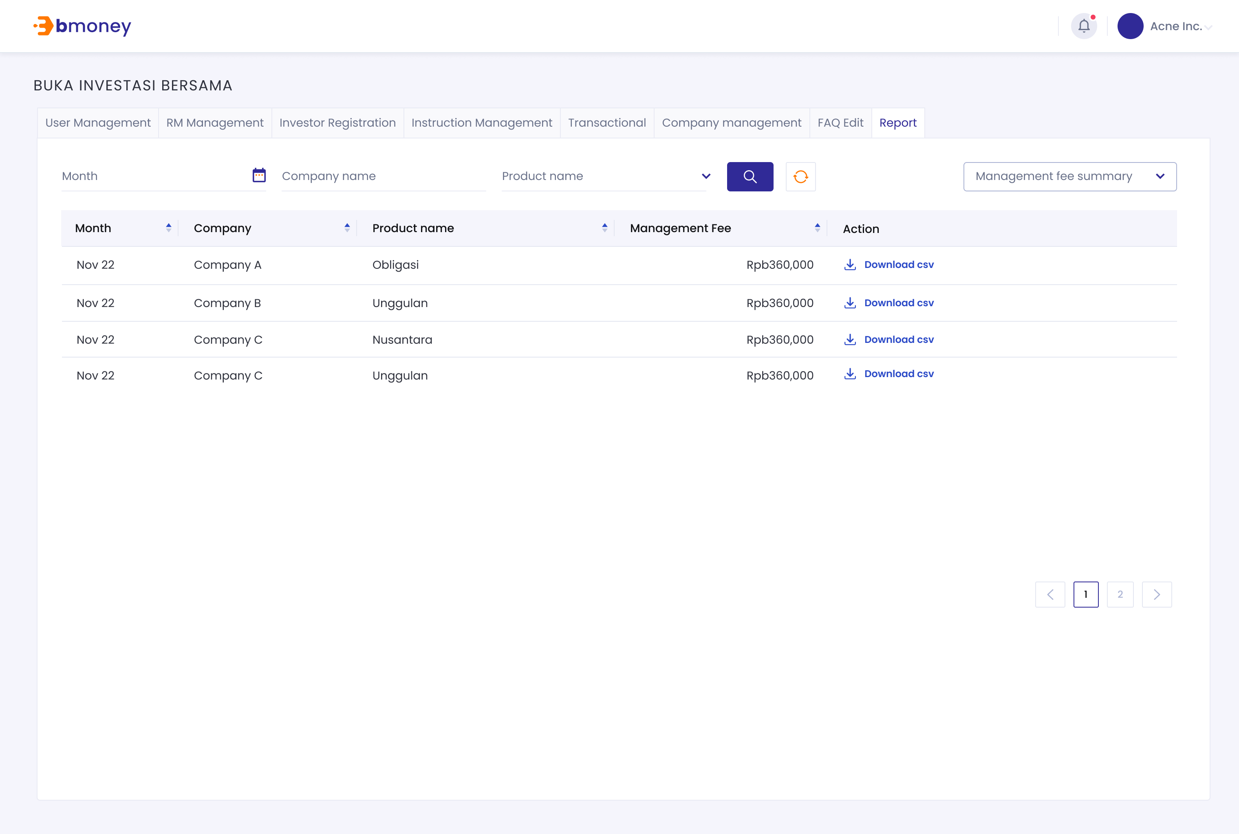

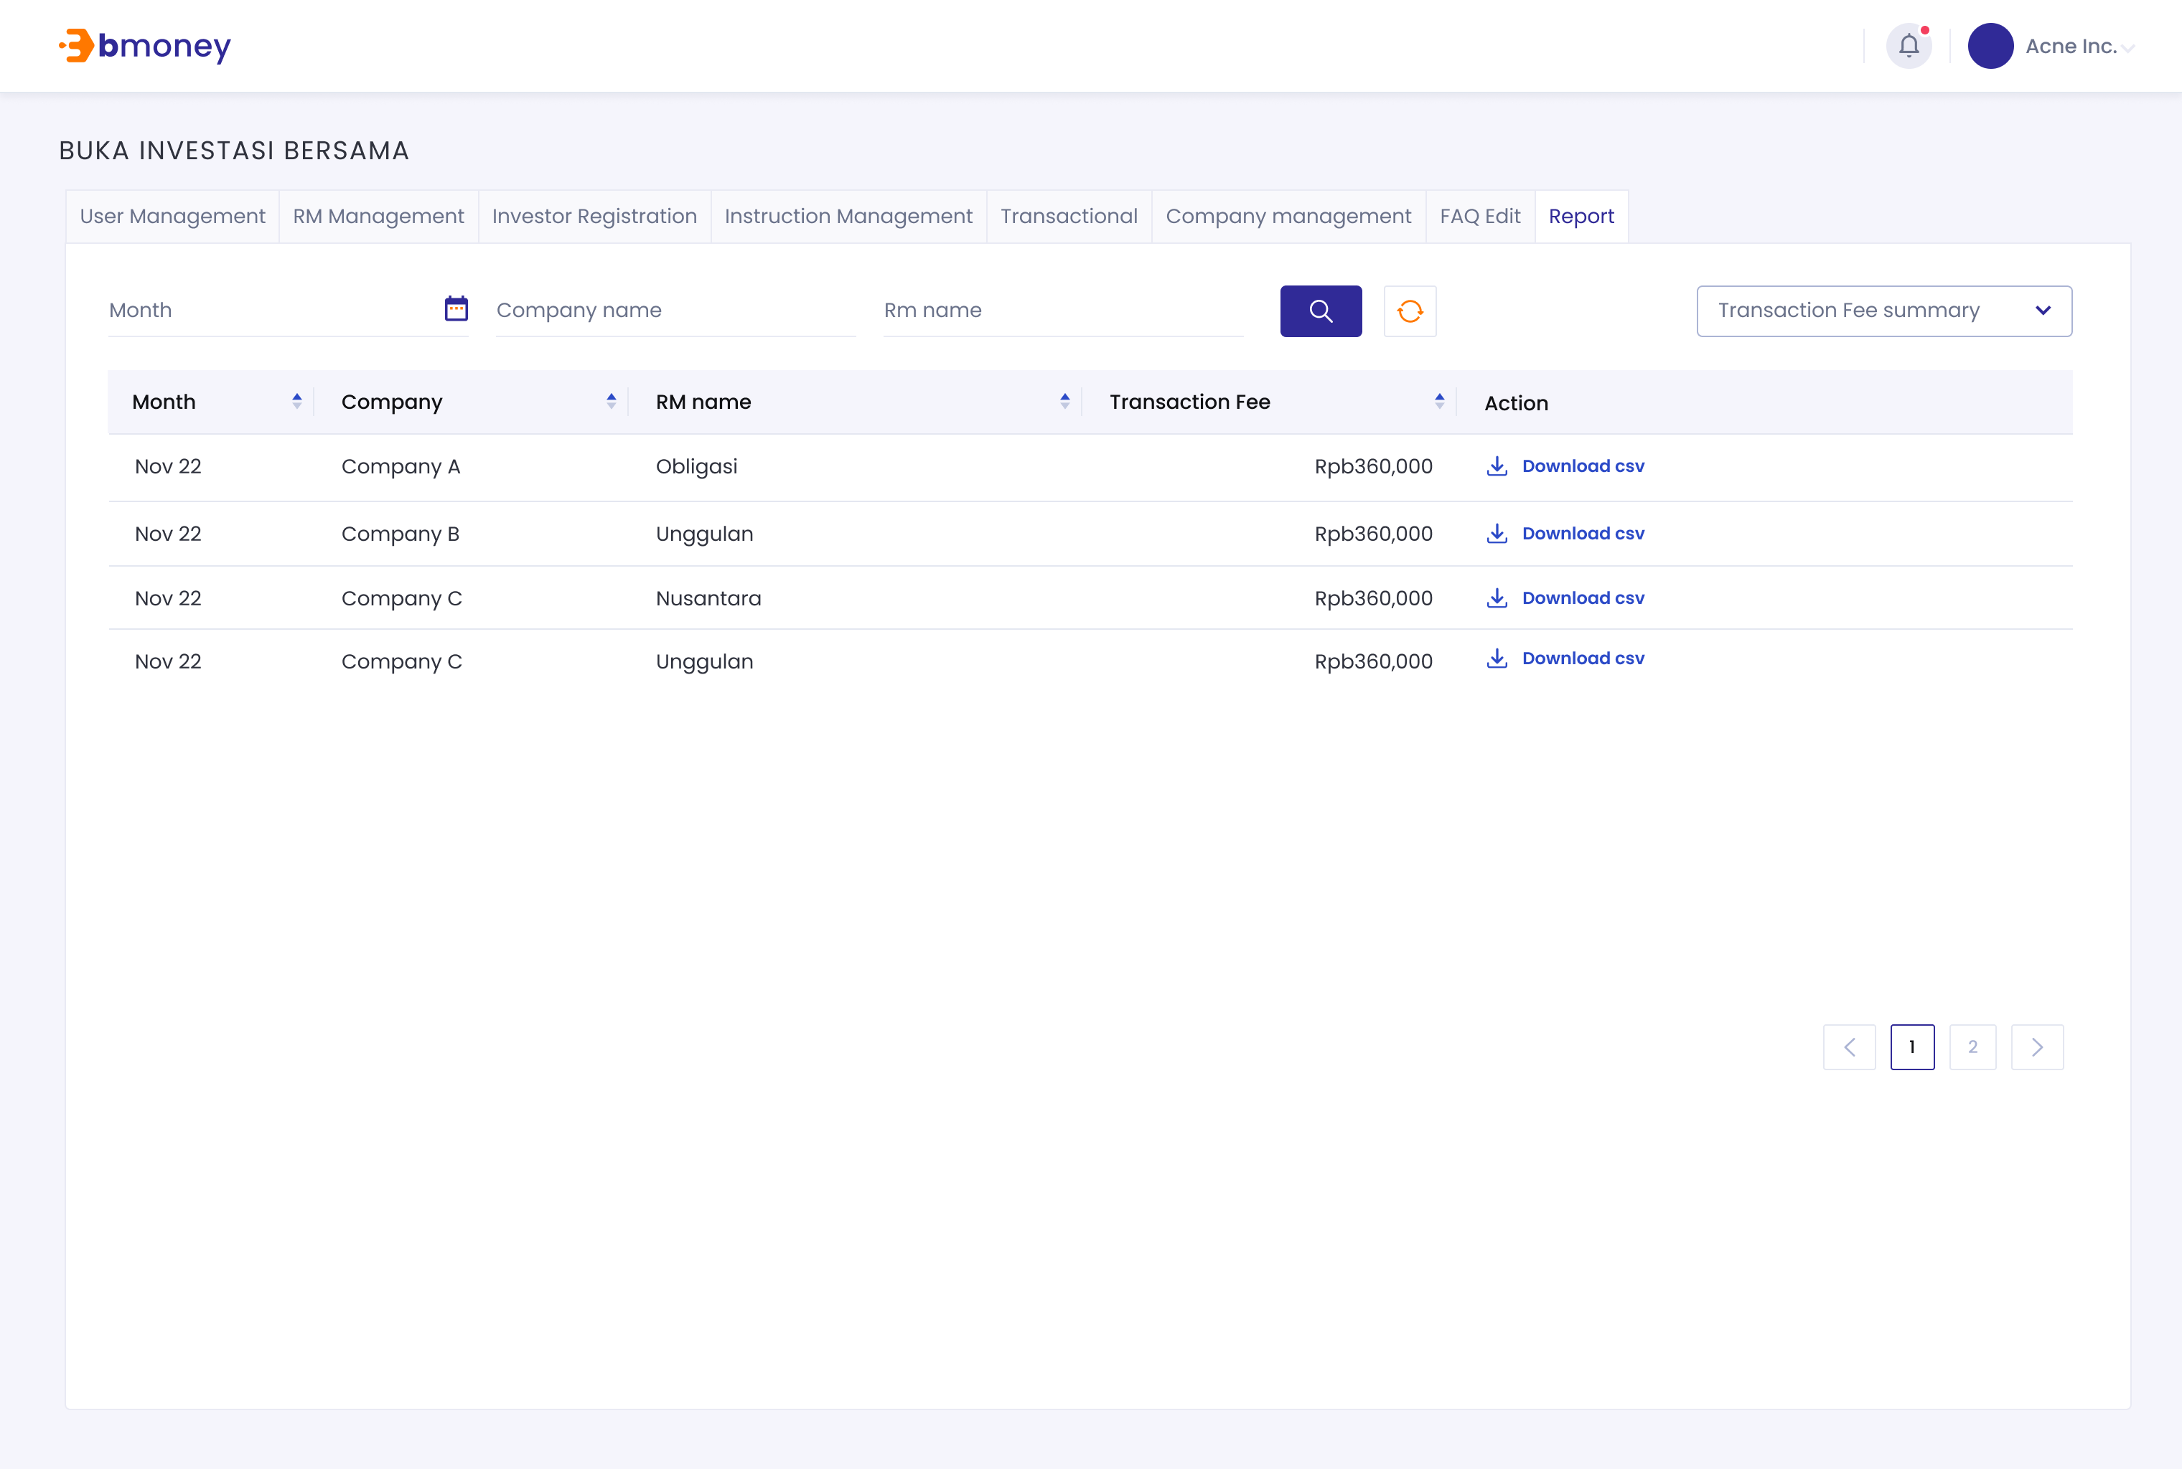

1. **Authorized User**

Existing active dashboard user

1. **Entry Point**

Report page

1. **Exit Point**

Report page

1. **Process Flow**

1. From Report page, User can check monthly data per agency and product/RM

2. User can click on “Download csv” button to check the details information

3. User can search for data by month and product

1. **Fields and Validations and Verification**

|  |  |  |  |  |  |  |
| --- | --- | --- | --- | --- | --- | --- |
| **Field** | **Field Type** | **Description** | **Field Length** | **Mandatory** | **Validation** | **In-Line Error Message** |
| Report | Tab button | Tap on to enter Report page | - | Yes |  |  |
| Month picker | Date picker | Month | - | Yes |  |  |
| Product | Dropdown list | Product name | - | Yes |  |  |
| Button | Button | Tap on to search for data by month and product | - | Yes |  |  |
| Fee summary dropdown | Dropdown list | Choose from dropdown list to display data for:   * Management fee summary * Transaction fee summary | - | Yes |  |  |
| Management Fee Summary | | | | | | |
| Month | Text | Date and month | - | Yes | Each page will only show 50 results |  |
| Company | Text | Company Name | - | Yes | Each page will only show 50 results |  |
| Product Name | Text | Product Name | - | Yes | Each page will only show 50 results |  |
| Management fee | Numeric | Management fee | - | Yes |  |  |
| Button | Link button | Tap on button to download csv file | - | Yes |  |  |
| Transaction Fee Summary | | | | | | |
| Month | Text | Date and month | - | Yes | Each page will only show 50 results |  |
| Company | Text | Company Name | - | Yes | Each page will only show 50 results |  |
| RM Name | Text | RM Name | - | Yes | Each page will only show 50 results |  |
| Transaction fee | Numeric | Transaction fee | - | Yes |  |  |
| Button | Link button | Tap on button to download csv file | - | Yes |  |  |
| Page number | | | | | | |
| Page number | Link | Click on to move to the desire page | - | Yes | Number only |  |

1. **Messaging Requirement**

Follow message in above table

1. **Reference User Story**

N/A

### Dashboard management

#### ****User story 21 – Dashboard Authentication/Login****

As an existing active dashboard user, from Landing page, I want to log in to dashboard

**Acceptance Criteria**

1. Login session of dashboard user is terminated after 12 hours
2. Can be access in both PC and mobile
3. Upon termination, user need to relog in
4. Must follow Password setting rules:

- Minimum password length: 8 characters

- Password complexity: Include at least one (1) small cap, big cap, number, symbol

- Password needs to be changed every 90 days

- Password history: Last 5 used password cannot be used

1. **Page flow**



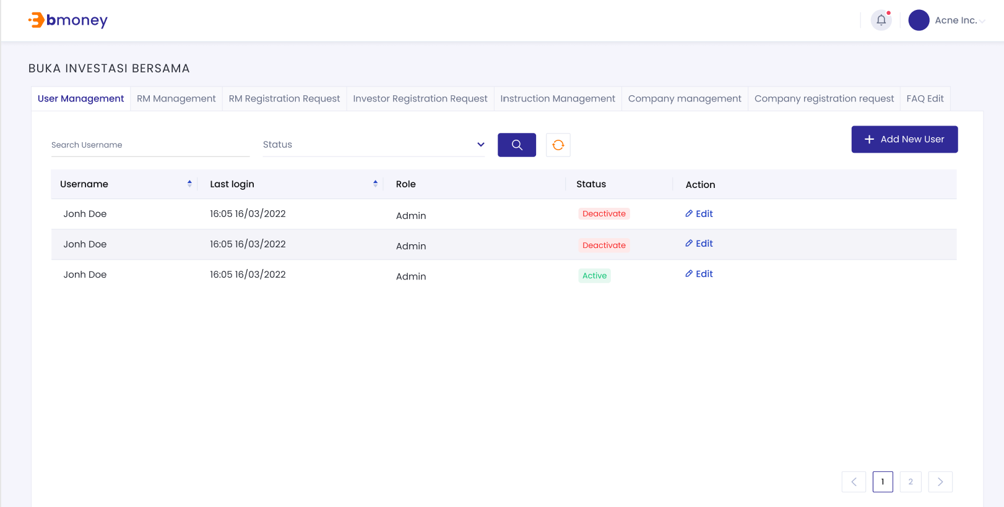

1. **Authorized User**

Existing active dashboard user

1. **Entry Point**

Login page

1. **Exit Point**

User Management page

1. **Process Flow**
2. User will enter dashboard website
3. Users enter Email and Password then tap on Login.

If the inputs are valid, user will enter home page.

If the inputs are invalid, user will have maximum 3 times to retry logging in

1. **Fields and Validations and Verifications**

|  |  |  |  |  |  |  |
| --- | --- | --- | --- | --- | --- | --- |
| **Field** | **Field Type** | **Description** | **Field Length** | **Mandatory** | **Validation** | **In-Line Error Message** |
| Logo | Logo | BMoney Logo | - | Yes |  |  |
| Email ID | Alphanumeric input | Email address  It has to be a valid registered email address  Alphanumeric keypad required | - | Yes | 1. Must be a valid email 2. Must be Not Empty | 1. Please check your login information. 2. This field cannot be empty |
| Password | Alphanumeric input | Text is hidden.  Alphanumeric keypad required | - | Yes | 1. It has to be in accordance to the password rules. 2. Must be Not Empty | 1. Please check your login information. 2. This field cannot be empty |
| Remember me | Check box | Tick to remember login info on this device |  | Yes |  |  |
| Forgot password | Button link | Tap on to enter Forgot password page | - | Yes |  |  |
| Hide/Unhide | Icon | Click icon Icon  Description automatically generatedto hide/unhide password.  Default is hide password | - | Yes |  |  |
| Login | Button | Button to trigger the Login function.  If login succesfull, go to Home page  If fail, stay login page and display MSG | - | Yes | All above mandatory fields must be filled in the correct format with valid value to get redirected to home page. | Please check your login information. |
| Session expired label | Label | Your session has expired due to inactivity | - | Yes |  |  |

1. **Messaging Requirement**

Follow the table above

1. **Reference User Story**

N/A

#### User Story 22 – Admin/Create dashboard users

As an existing Super Admin/Maker, I want to be able to create a dashboard user.

**Acceptance Criteria**

Username is not already in the system

Can be access in both PC and mobile

1. **Page Flow**

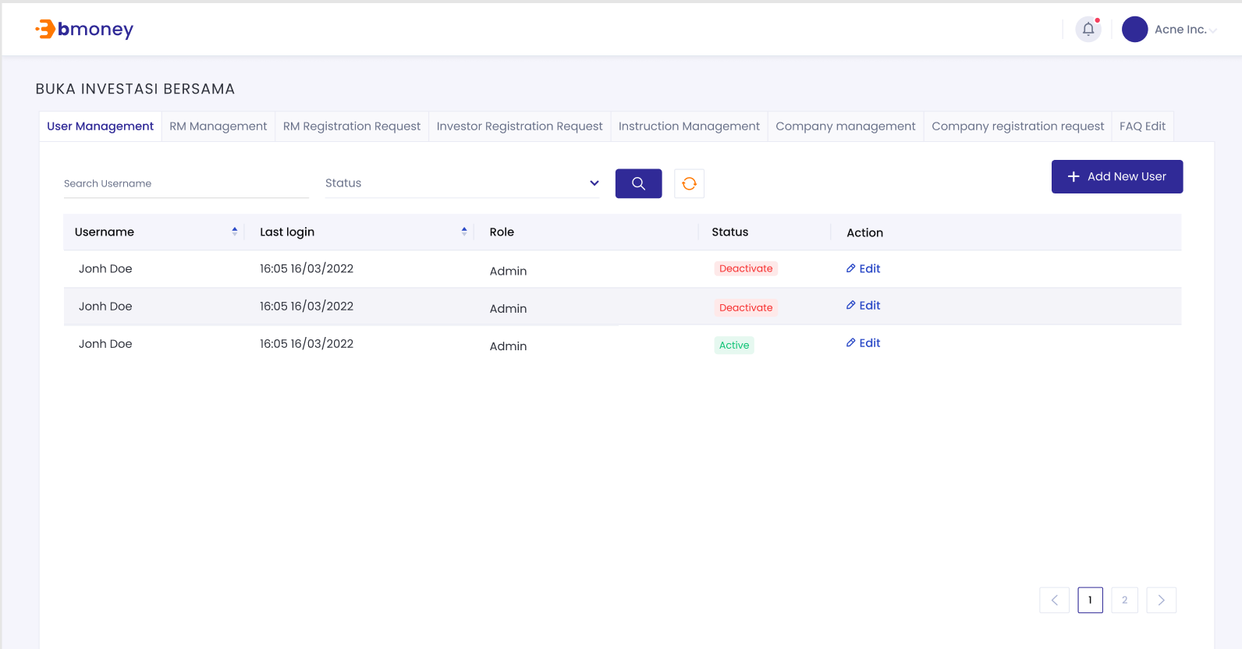

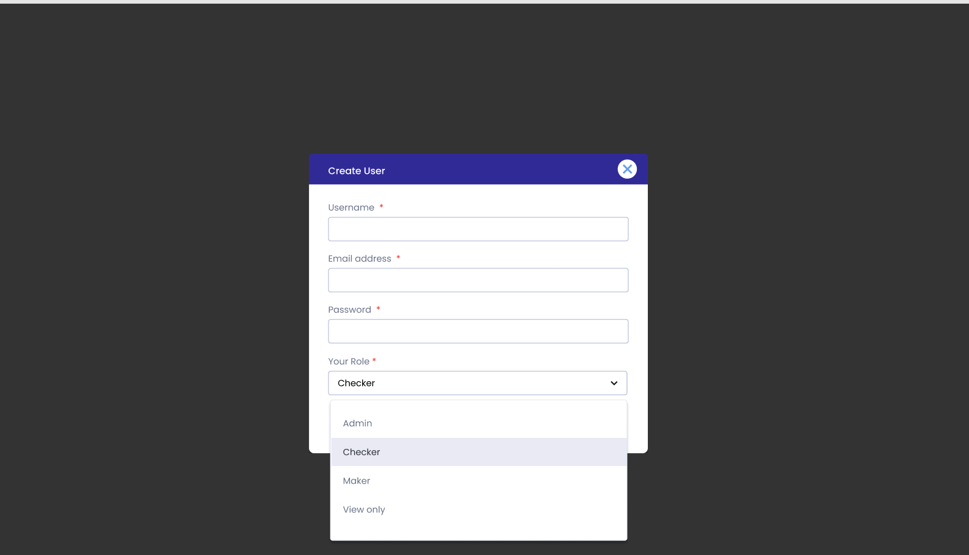

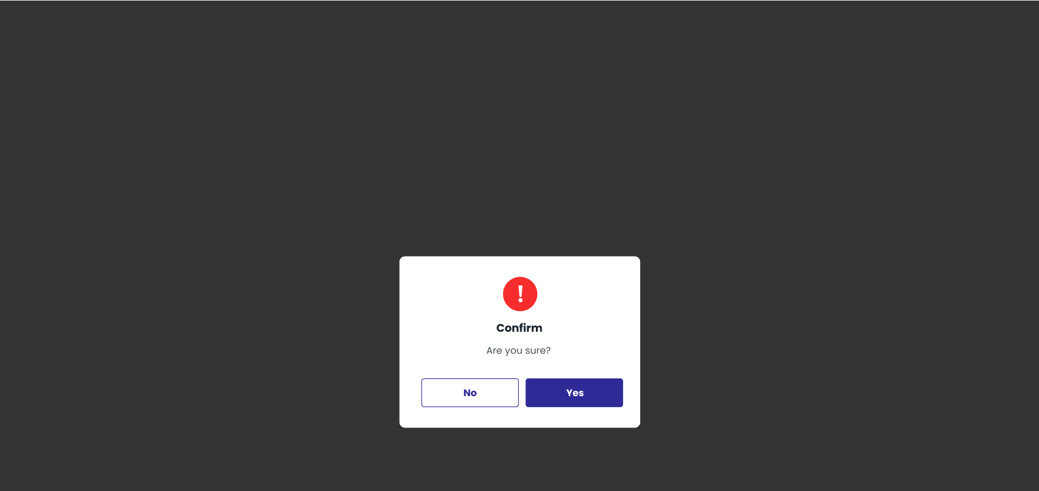

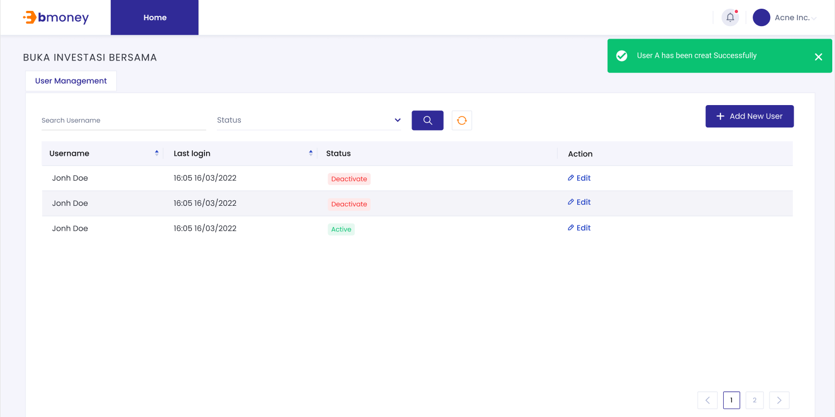

1. **Authorized User**

Existing active Super Admin

1. **Entry Point**

User Management page

1. **Exit Point**

Submitted MSG screen

1. **Process Flow**
2. From user management page, click on Create new user button to enter user creation page
3. User fill in required fields then tap on Submit button.

If successful, there will be a submitted MSG Screen. User can tap on OK button to return to user creation page

If fail, there will be popup screen to ask user to try again. Error fields will be highlight.

Must follow Password setting rules:

- Minimum password length: 8 characters

- Password complexity: Include at least one (1) small cap, big cap, number, symbol

- Password needs to be changed every 90 days

- Password history: Last 5 used password cannot be used

1. **Fields and Validations and Verification**

|  |  |  |  |  |  |  |
| --- | --- | --- | --- | --- | --- | --- |
| **Field** | **Field Type** | **Description** | **Field Length** | **Mandatory** | **Validation** | **In-Line Error Message** |
| Create new user | Button | Create new user button  Tap on button to create new user | - | Yes |  |  |
| Username | Text input | Username follow company guideline | String (150) | Yes | Must not be Empty | 1. Username had been used. 2. This field cannot be empty |
| Email address | Text input | Email address  Alphanumeric keypad required | String (150) | Yes | Must not be Empty | 1. Email had been used. 2. This field cannot be empty |
| Password | Text input | Fill in the password. Must follow Password setting rules  Appear only as “****..” | String (500) | Yes | Must not be Empty | 1. This field cannot be empty |
| Role option | Tab | Role option, including:   * 1.maker: create new company, create new dashboard user * 2.Checker: approve/reject dashboard user creation, RM user register, company creation request * 3.View only: can only view the page * 4. Super Admin: all checker maker privilege, deactivate/reactivate users, reassign RM | Dropdown list | Yes |  | 1. This field cannot be empty |
| Screen MSG successfully |  | Success  New user had been created |  |  | Screen MSG successfully |  |

1. **Messaging Requirement**

Follow message in above table

1. **Reference User Story**

N/A

#### User Story 23 – Admin/Deactivate-Reactivate dashboard user

As an existing Super Admin, I want to be able to Deactivate-Reactivate dashboard user.

**Acceptance Criteria**

Dashboard user is in the system

Can be access in both PC and mobile

1. **Page Flow**



1. **Authorized User**

Existing active Super Admin

1. **Entry Point**

User Management page

1. **Exit Point**

User Management page

1. **Process Flow**
2. User can see a list of dashboard user in the system
3. Admin can click on status to toggle active/deactivated user status
4. User can search for a specific account by username
5. **Fields and Validations and Verification**

|  |  |  |  |  |  |  |
| --- | --- | --- | --- | --- | --- | --- |
| **Field** | **Field Type** | **Description** | **Field Length** | **Mandatory** | **Validation** | **In-Line Error Message** |
| User name | Text | Username of dashboard user | - | Yes |  |  |
| Last login | Date Time | Last login time of users | - | Yes |  |  |
| Status | Dropdown list | User account status | - | Yes | Can be edit if user is SuperAdmin |  |
| Edit | Button | Edit button  Tap on button to edit user info | - | Yes |  | Only SuperAdmin can edit user status |
| Page number | | | | | | |
| Page number | Link | Click on to move to the desire page | - | Yes | Number only  Each page will only contain 50 users |  |

1. **Messaging Requirement**

Follow message in above table

1. **Reference User Story**

N/A

#### User Story 24 – Admin/RM Management

As an existing Super Admin/checker, I want to be able to manage RM registration via dashboard with maker checker functionality

As an existing Super Admin/maker/checker, I want to be able to Deactivate-Reactivate dashboard user.

As an existing Super Admin/maker, I want to be able to re-assign RM to investor

**Acceptance Criteria**

RM user is in the system

Can be access in both PC and mobile

Deactive RM user cannot login to RM tools app

1. **Page Flow**

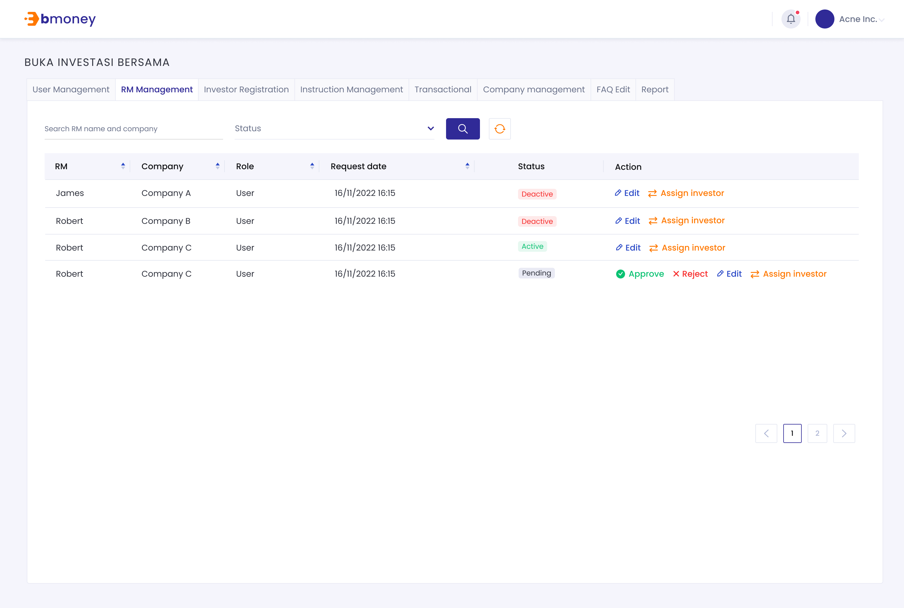

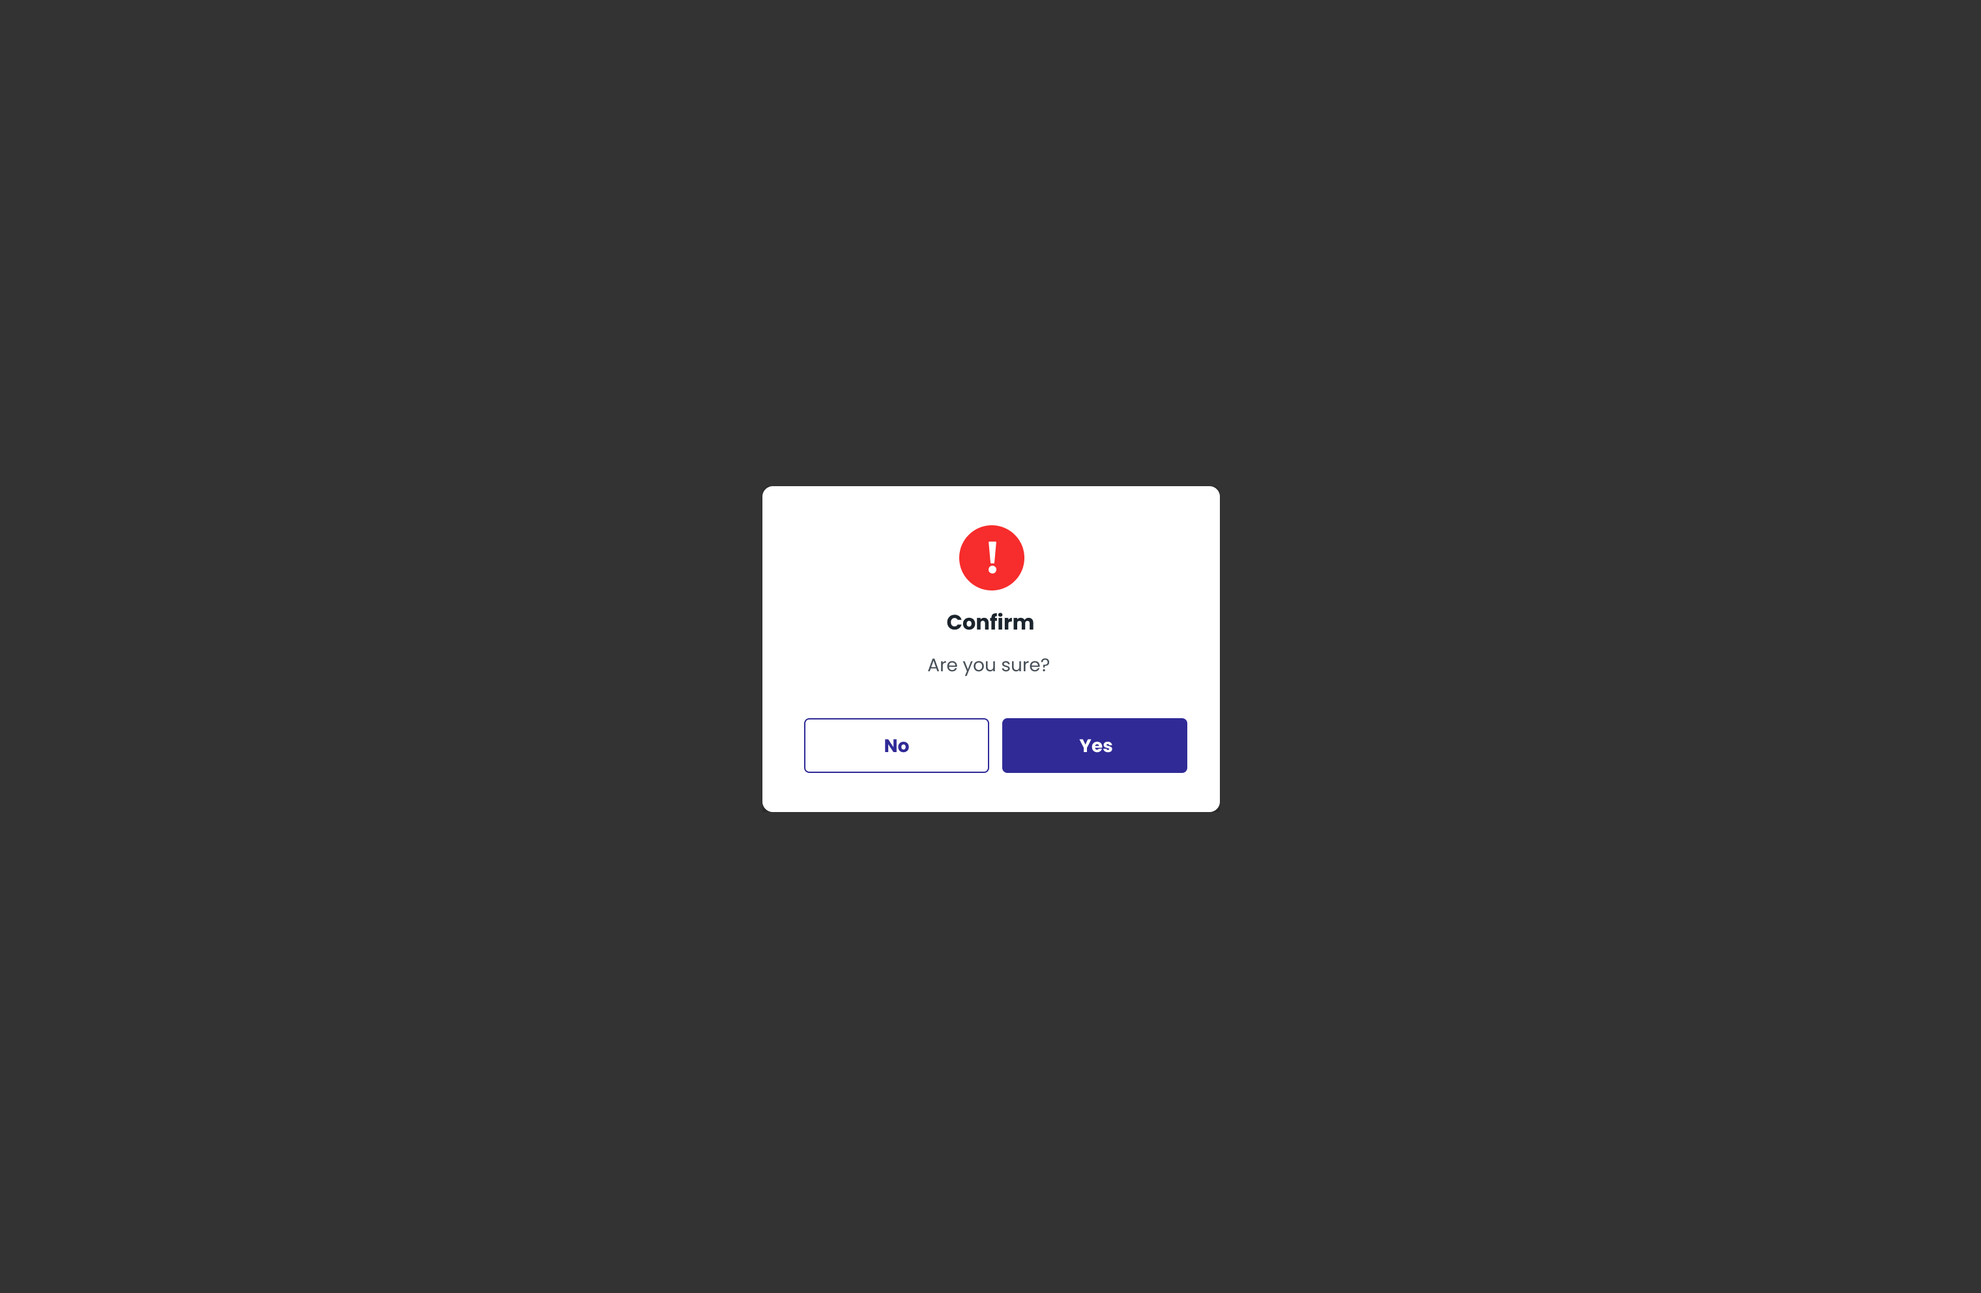

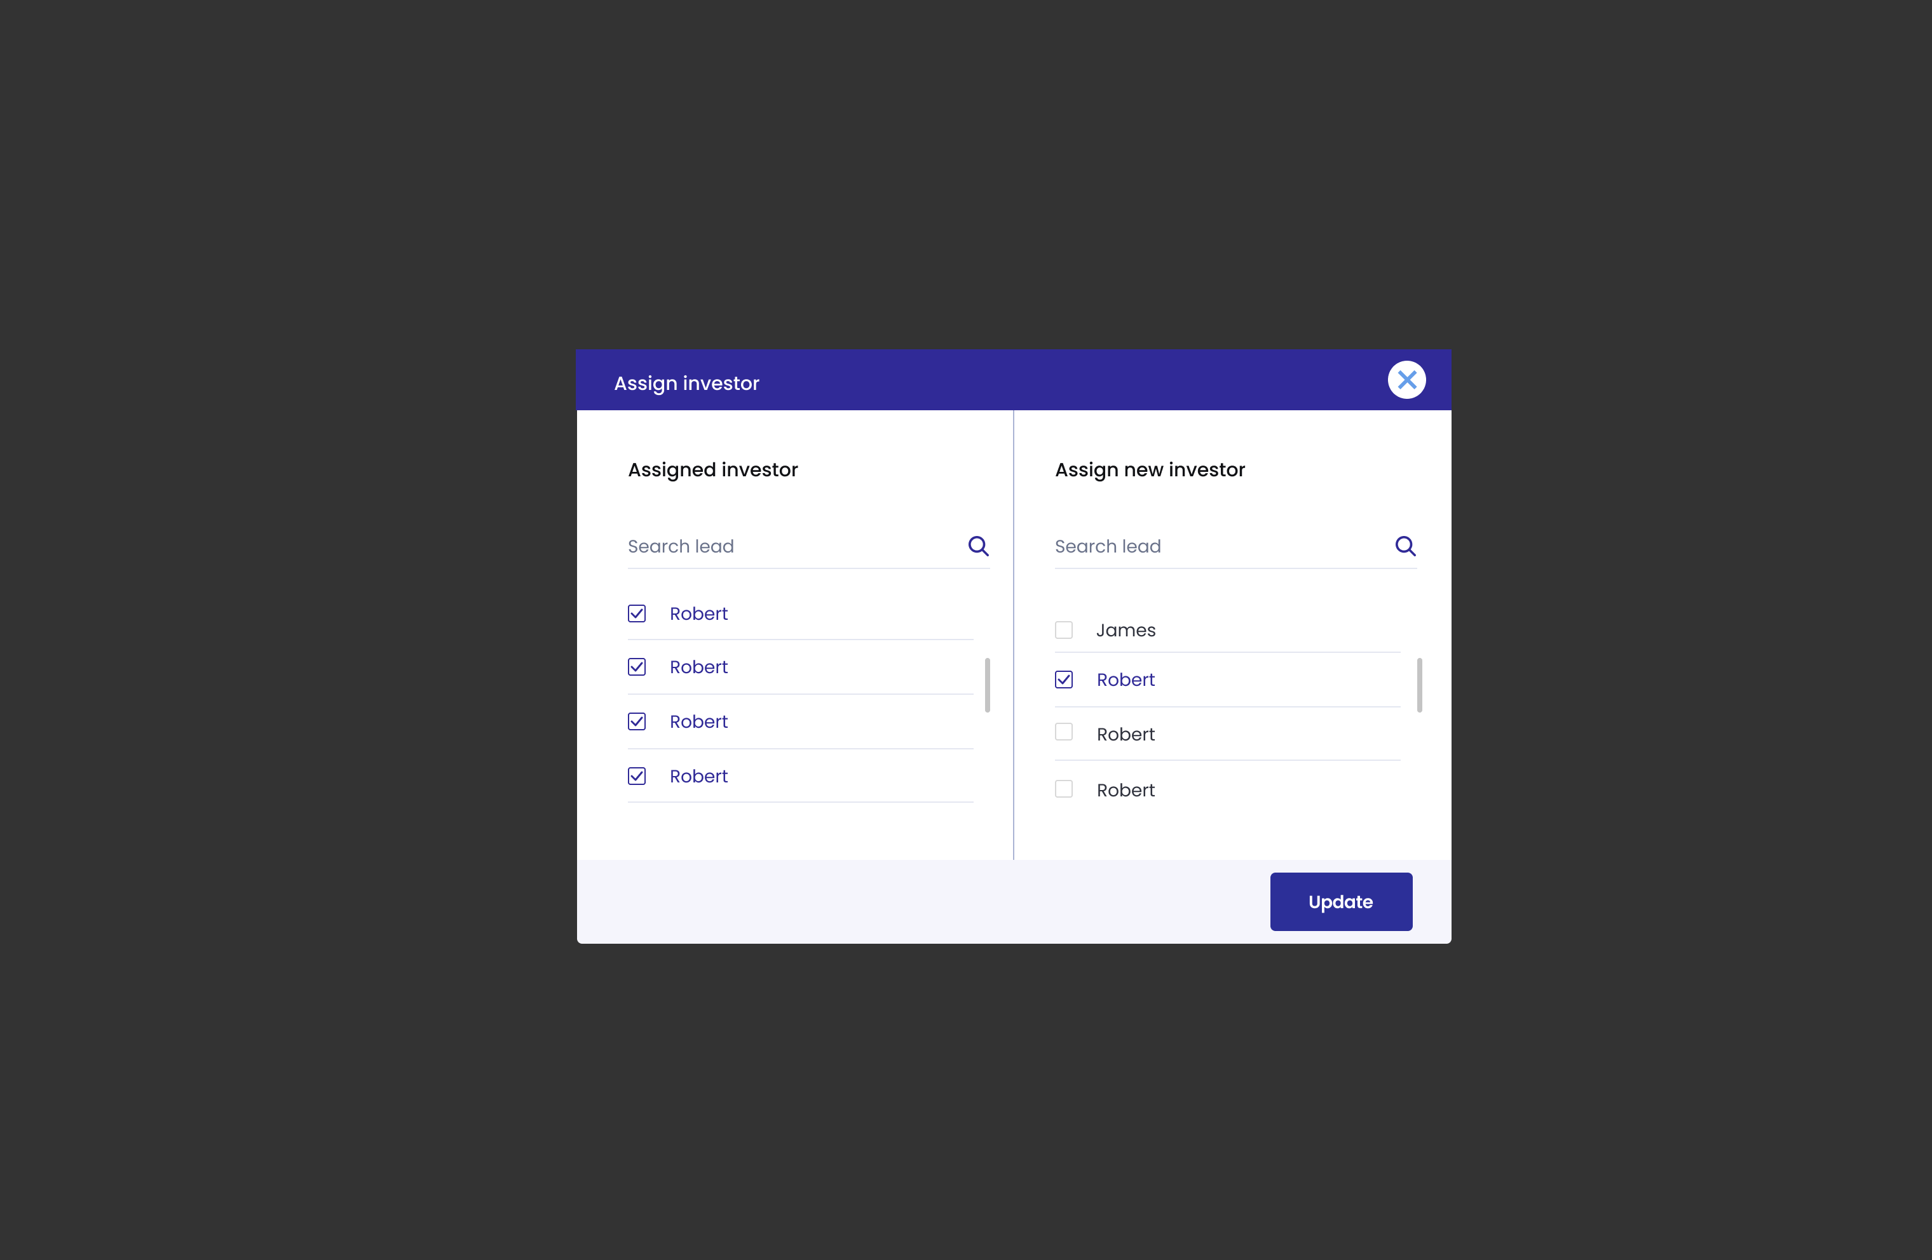

1. **Authorized User**

Existing active Super Admin/maker/checker

1. **Entry Point**

User Management page

1. **Exit Point**

User Management page

1. **Process Flow**
2. User can see a list of RM user in the system
3. Admin/checker can click on “Approve/Reject” button to approve/reject selected RM register request. There will be confirm MSG screen
4. Admin can click on “Edit” button to change active/deactivated user status
5. Admin can click on “Assign investor” button to re-assign investors to RM. Admin/maker can assign/reassign RM to an investor. After assign/reassign, select confirm to approve of the changes.
6. User can search for a specific account by username
7. Reactivated user will receive email notification with reset password link/instruction for login
8. **Fields and Validations and Verification**

|  |  |  |  |  |  |  |
| --- | --- | --- | --- | --- | --- | --- |
| **Field** | **Field Type** | **Description** | **Field Length** | **Mandatory** | **Validation** | **In-Line Error Message** |
| User name | Text | Username of dashboard user | - | Yes |  |  |
| Search for RM name or company | Search field | Type to search for a specific RM or company | - | Yes |  |  |
| Status dropdown filter | Dropdown list | Click on to select the filtered status | - | Yes |  |  |
| Icon  Description automatically generated button | Button | Click on to search for filtered information | - | Yes­­ |  |  |
| button | Button | Click on to refresh page, update all RM’s status | - | Yes |  |  |
| RM registration request | Text | RM registration request | - | Yes | Each page will only show 50 results |  |
| Approve | Button | Approve button  Tap on button to approve the request | - | Yes | Can only approve one request at a time | There has been an error please try again |
| Reject | Button | Reject button  Tap on button to Reject the request | - | Yes | Can only reject one request at a time | There has been an error please try again |
| Edit | Button | Edit button  Tap on button to change user status | - | Yes |  | Only SuperAdmin can edit user status |
| Last login | Date Time | Last login time of users | - | Yes |  |  |
| Status | Dropdown list | User account status | - | Yes | Can be edit if user is SuperAdmin |  |
| Assign Investor | Button | Tap on to assign RM to an investor | - | Yes |  | Super Admin/maker can assign |
| Assign investor page | | | | | | |
| Assigned investors | Label | Assigned investor of the selected RM | - | Yes |  |  |
| Assign new investor | Label | Label | - | Yes |  |  |
| List of assigned investors | Checkbox list | List of assigned investors of the selected RM  Click on checkbox to unassign investor | - | Yes |  |  |
| List of investors | Check box list | List of all investors  Click on checkbox to assign new investor to selected RM | - | Yes |  |  |
| Search lead | Search field | Type to search for specific lead | - | Yes |  |  |
| Icon  Description automatically generated button | Button | Click on to search for lead | - | Yes­­ |  |  |
| button | Button | Tap on to close Assign investor page | - | Yes |  |  |
| button | Button | Tap on to update the list | - | Yes |  |  |
| Page number | | | | | | |
| Page number | Link | Click on to move to the desire page | - | Yes | Number only  Each page will only contain 50 users |  |
| Confirm MSG | Pop-up MSG | Confirm  Are you sure? | - | Yes |  |  |
| Yes button | Button | Yes button  Click to confirm | - | Yes |  |  |
| No button | Button | No button  Click to close pop-up and continue with the RM management tab | - | Yes |  |  |

1. **Messaging Requirement**

Follow message in above table

1. **Reference User Story**

N/A

#### User Story 25 – Admin/Manage instruction

As an existing Super Admin/checker, I want to be able to review then approve/reject the instruction created by RM before sending to investor for confirmation

**Acceptance Criteria**

Instruction request been sent

Can be access in both PC and Mobile

1. **Page Flow**

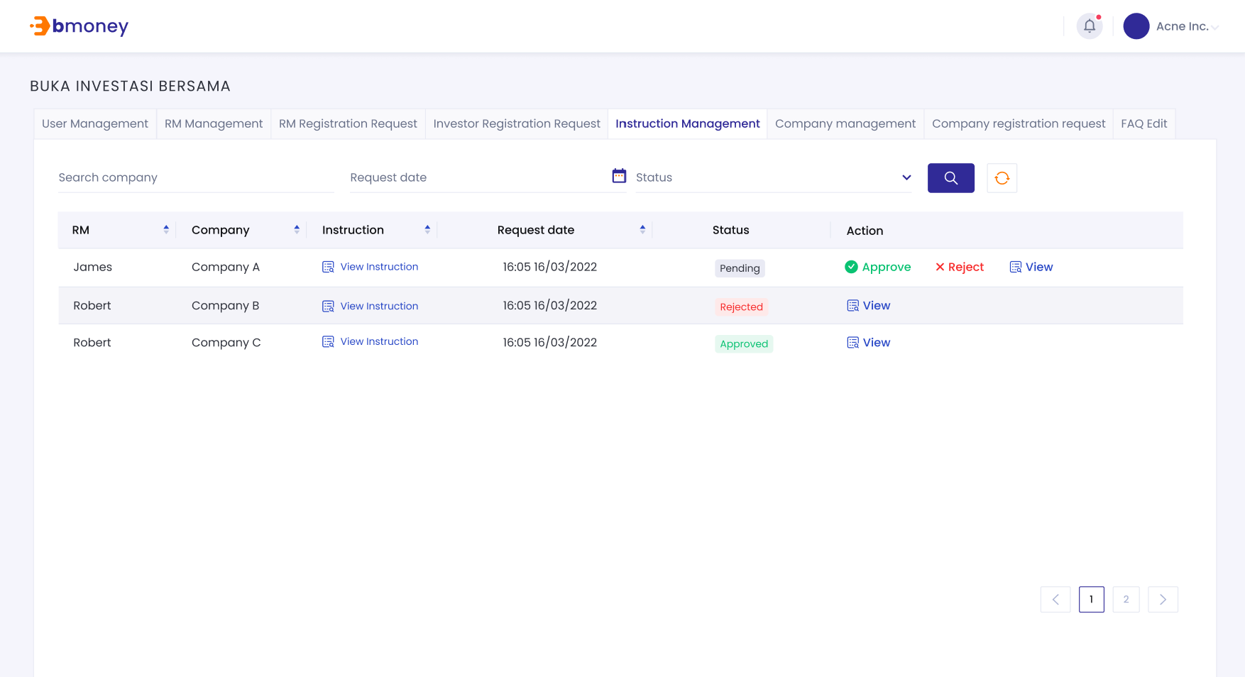

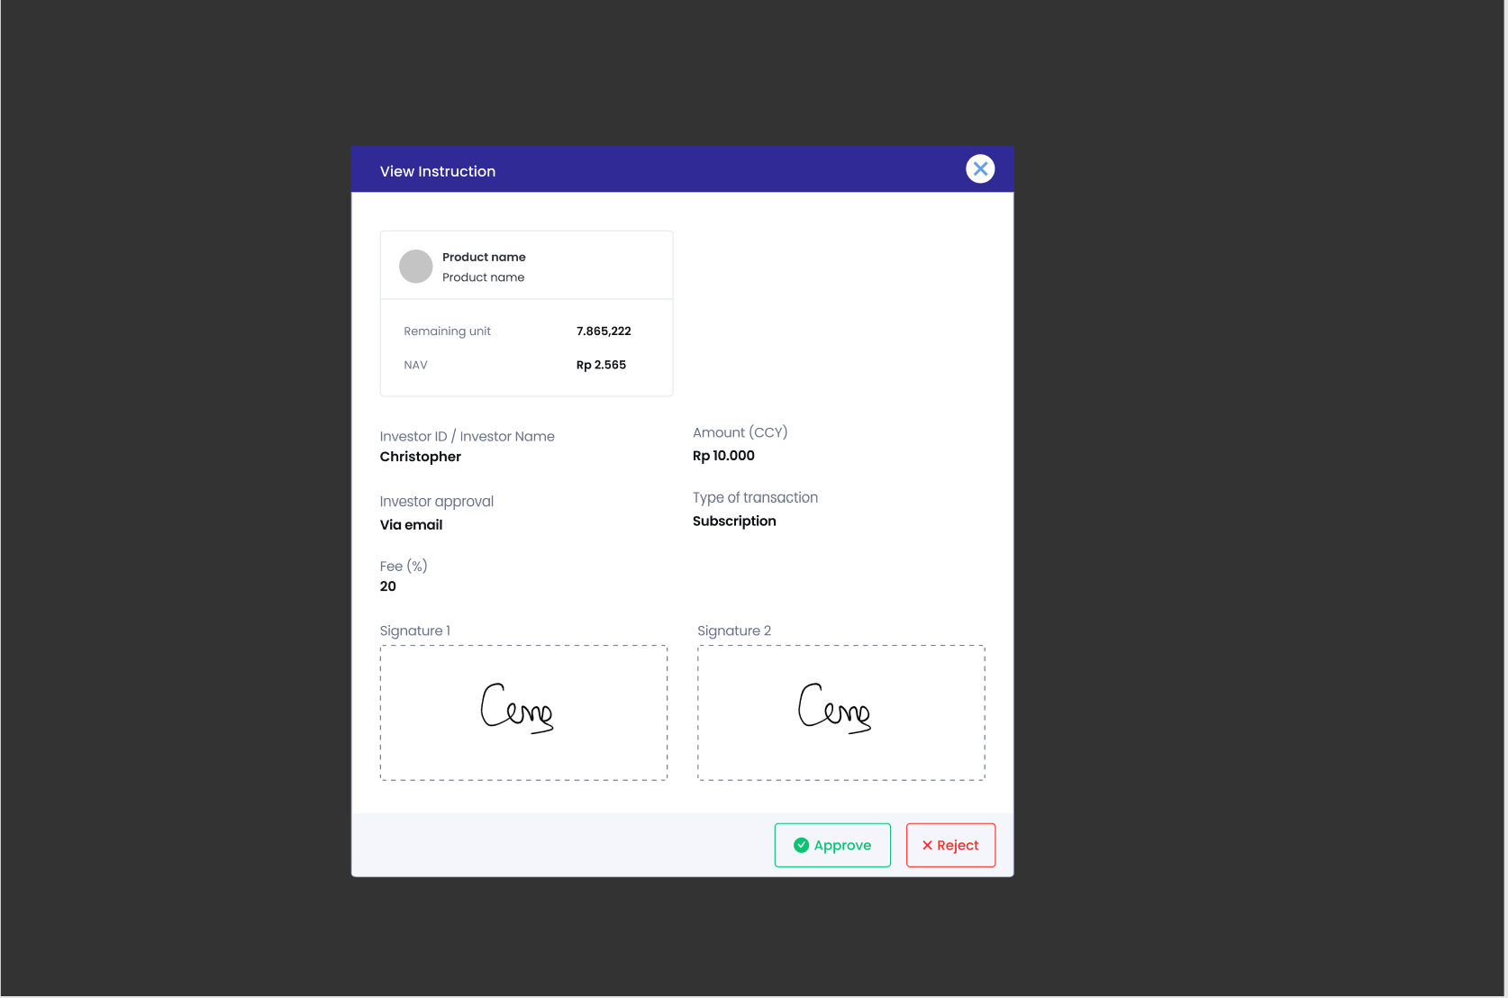

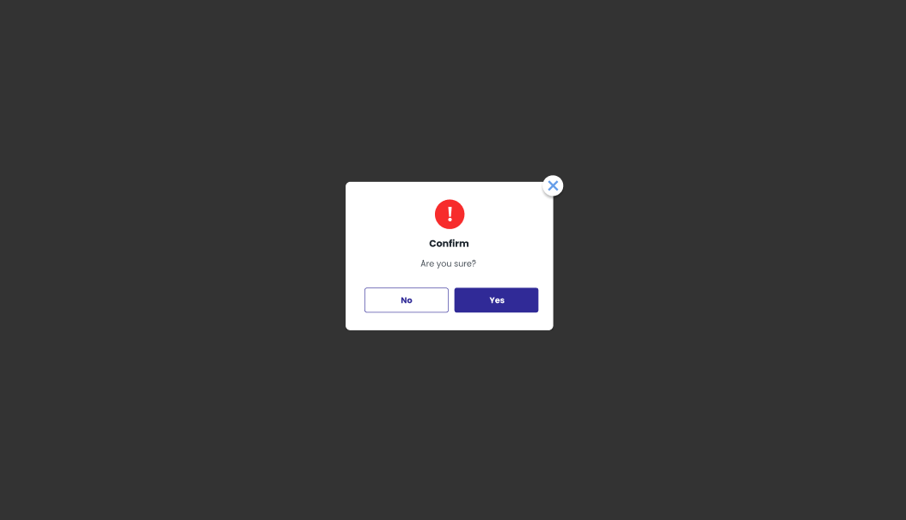

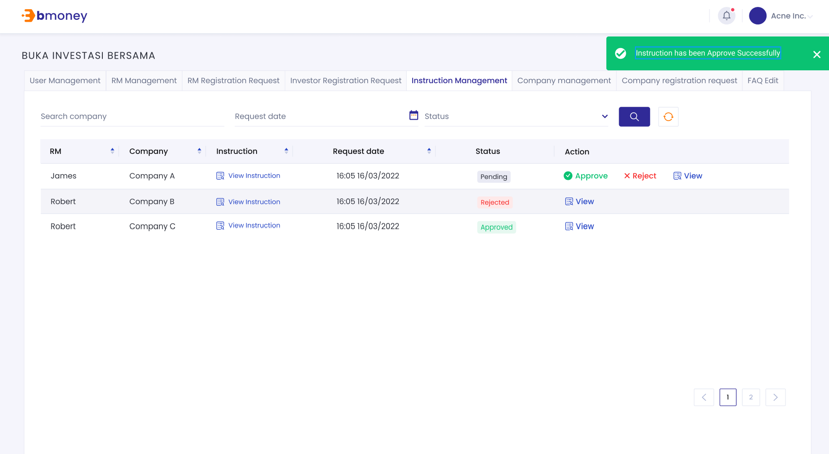

1. **Authorized User**

Existing active Super Admin/checker

1. **Entry Point**

Instruction Management page

1. **Exit Point**

Submitted MSG screen

1. **Process Flow**
2. From Instruction Management page, Admin can see a list of instruction request by RM to send to investor.
3. Admin can select and view details of each instruction
4. Admin can click on approve/reject button to approve/reject the selected instruction sends out request
5. User can search for a specific instruction by RM Name

If successful, there will be Submitted MSG Screen.

1. **Fields and Validations and Verification**

|  |  |  |  |  |  |  |
| --- | --- | --- | --- | --- | --- | --- |
| **Field** | **Field Type** | **Description** | **Field Length** | **Mandatory** | **Validation** | **In-Line Error Message** |
| Instruction request | Text | Instruction request | - | Yes | Each page will only show 50 results |  |
| Approve | Button | Approve button  Tap on button to approve the request | - | Yes | Can only approve one request at a time | There has been an error please try again |
| Reject | Button | Reject button  Tap on button to Reject the request | - | Yes | Can only reject one request at a time | There has been an error please try again |
| View | Button | View button  Tap on button to View details of the request | - | Yes |  | There has been an error please try again |
| Page number | | | | | | |
| Page number | Link | Click on to move to the desire page | - | Yes | Number only |  |
| Screen MSG successfully |  | Success  Instruction requests approved  Or  Instruction request rejected |  |  | Screen MSG successfully |  |

1. **Messaging Requirement**

Follow message in above table

1. **Reference User Story**

N/A

#### User Story 26 - Admin/Investor status check

As an existing Super Admin/maker, I want to be able to check investor status information

**Acceptance Criteria**

Can be access in both PC and Mobile

1. **Page Flow**

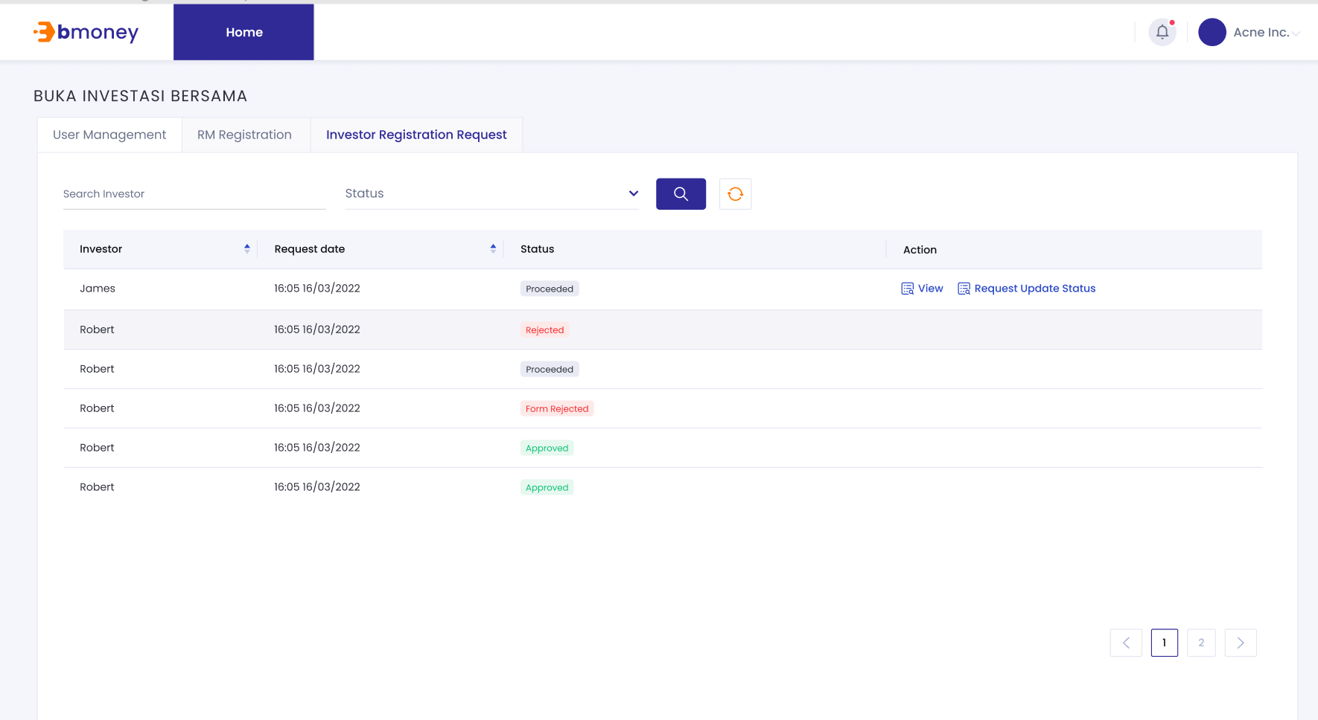

1. **Authorized User**

Existing active dashboard user

1. **Entry Point**

Investor management page

1. **Exit Point**

Investor management page

1. **Process Flow**

1.From Investor Management page, User can check status and info details of investor request

2.User can click on request update status to load the newest status from Bmoney backend

3.Investor status will be updated real time using message queue

1. **Fields and Validations and Verification**

|  |  |  |  |  |  |  |
| --- | --- | --- | --- | --- | --- | --- |
| **Field** | **Field Type** | **Description** | **Field Length** | **Mandatory** | **Validation** | **In-Line Error Message** |
| Investor | Text | Investor Name | - | Yes | Each page will only show 50 results |  |
| View | Button | View button  Tap on button to View details of the request | - | Yes |  | There has been an error please try again |
| Request update status | Button | Tap on button to load the newest status from Bmoney backend | - | Yes |  | There has been an error please try again |
| Page number | | | | | | |
| Page number | Link | Click on to move to the desire page | - | Yes | Number only |  |

1. **Messaging Requirement**

Follow message in above table

1. **Reference User Story**

N/A

### Company setup

#### User Story 27 - Admin/Manage company

As an existing Super Admin/maker, I want to be able to add new company

As an existing Super Admin/check, I want to be able to approve/reject company creation request

As an existing Super Admin, I want to be able to update company information

**Acceptance Criteria**

Can be access in both PC and Mobile

1. **Page Flow**

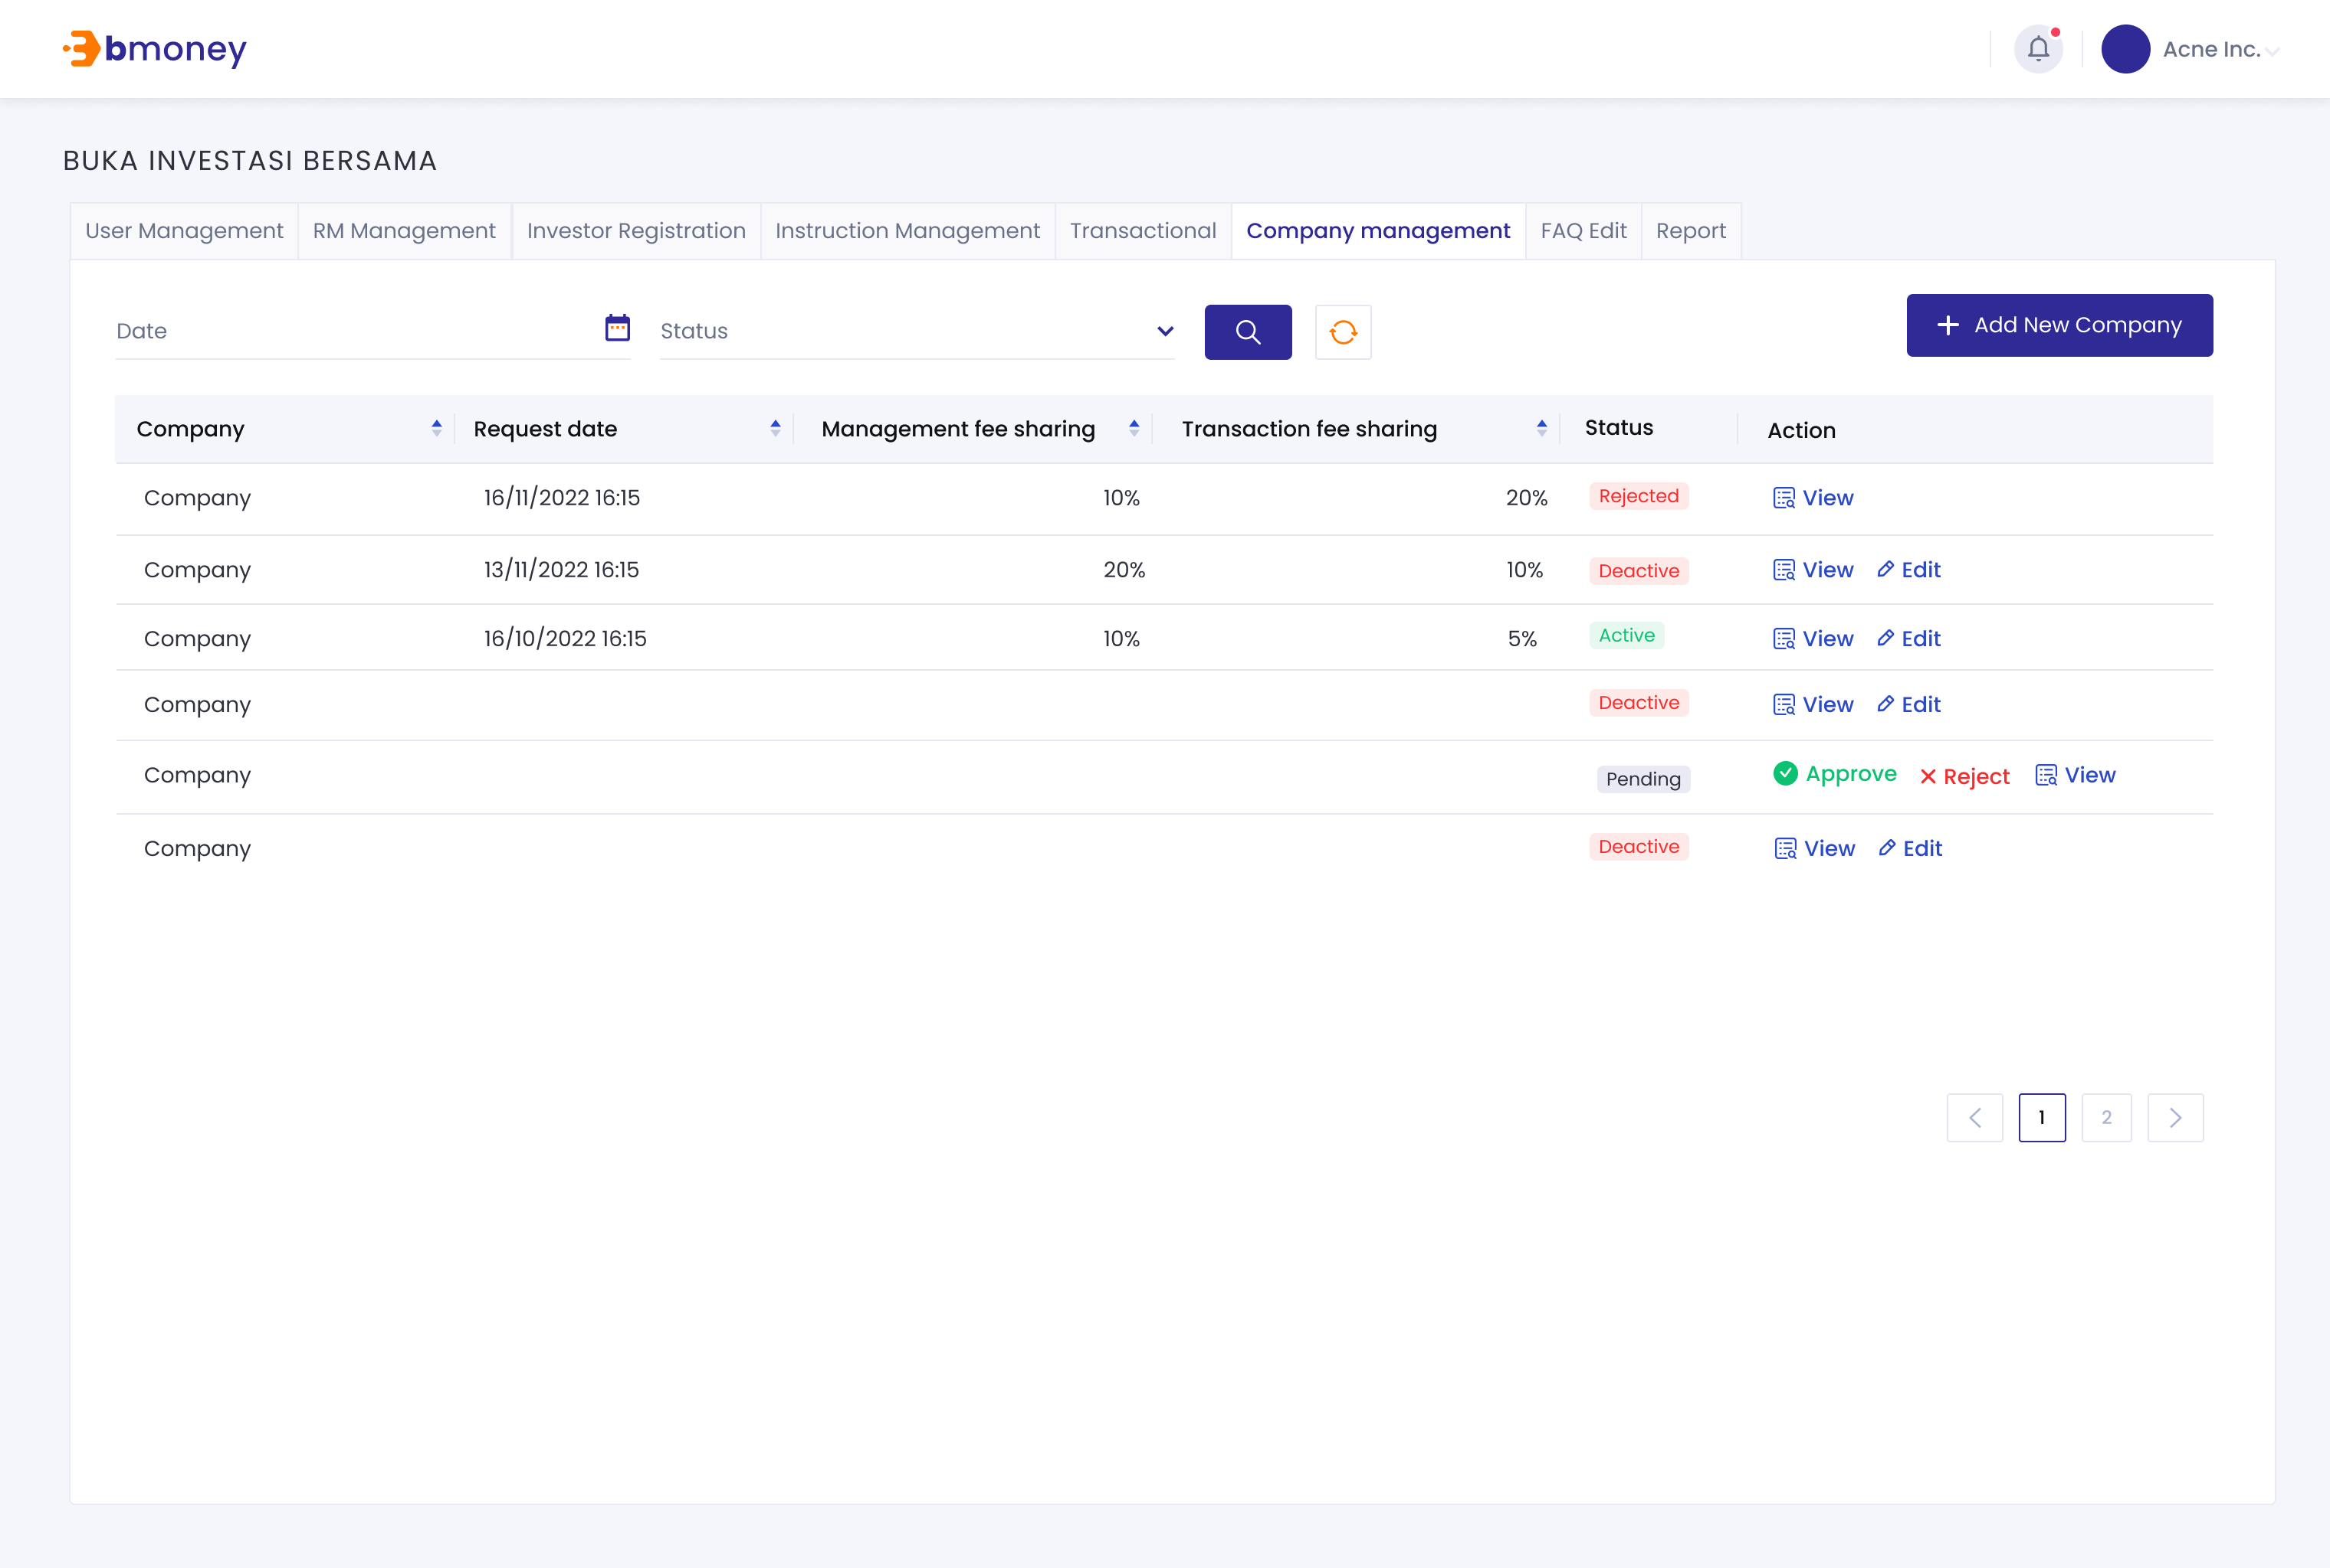

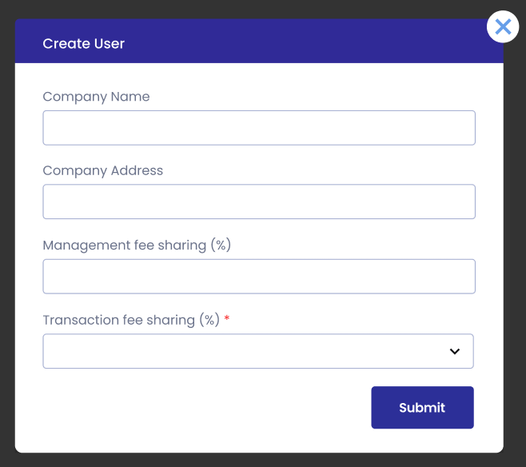



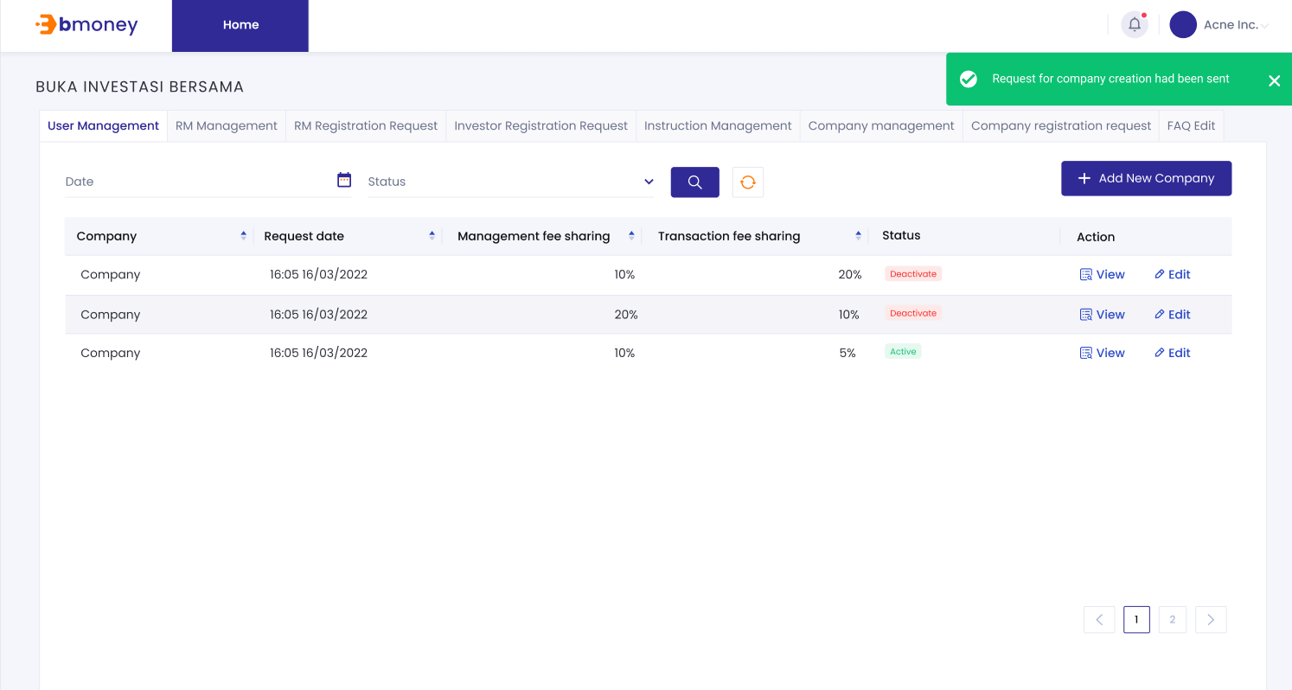

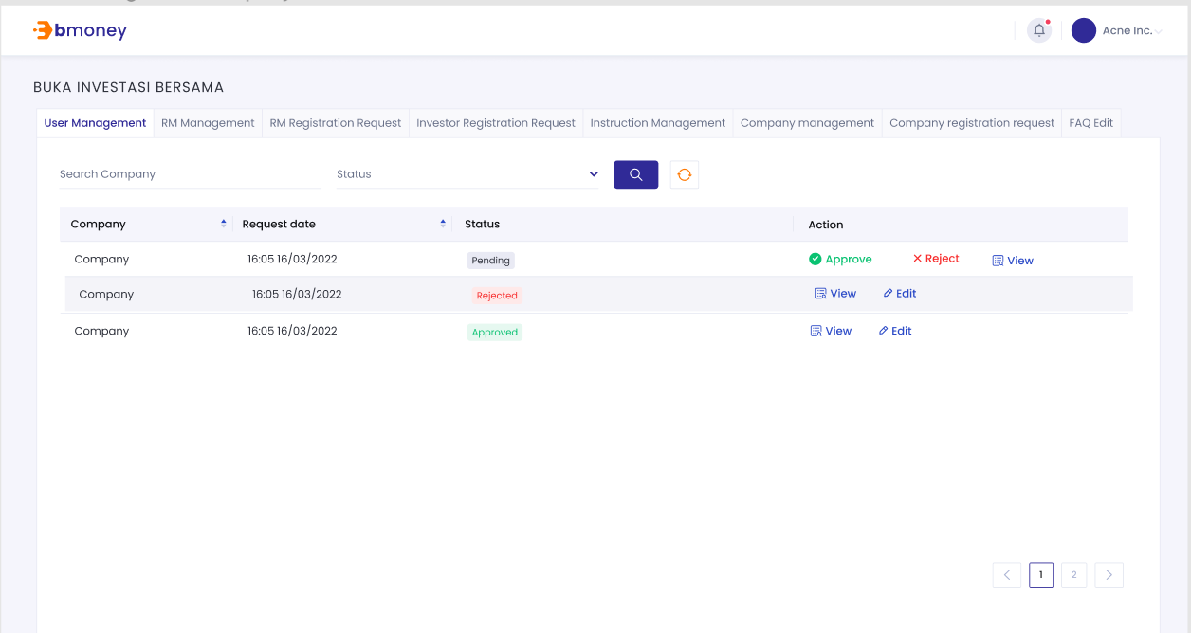

1. **Authorized User**

Existing active Super Admin/maker

1. **Entry Point**

Company Management page

1. **Exit Point**

Company Management page

1. **Process Flow**
2. From Company Management page, Admin/maker can add in new company
3. Fill in the form
4. Submit the form. After submitting, a request will be send.
5. Super Admin/maker will review and approve in Company registration request page
6. From Company Management page, Admin/maker can see a list of company
7. Admin/maker can select and view details of each company
8. Admin/maker can click on edit button to edit the company information (Pending/ Rejected status cannot be edited)
9. After finish editing, Admin/maker can click on Submit button
10. **Fields and Validations and Verification**

|  |  |  |  |  |  |  |
| --- | --- | --- | --- | --- | --- | --- |
| **Field** | **Field Type** | **Description** | **Field Length** | **Mandatory** | **Validation** | **In-Line Error Message** |
| Company creation request | Text | Company Name | - | Yes | Each page will only show 50 results |  |
| Approve | Button | Approve button  Tap on button to approve the request | - | Yes | Can only approve one request at a time | There has been an error please try again |
| Reject | Button | Reject button  Tap on button to Reject the request | - | Yes | Can only reject one request at a time | There has been an error please try again |
| View | Button | View button  Tap on button to View details of the instruction request | - | Yes |  | There has been an error please try again |
| View details page | | | | | | |
| Edit | Button | Edit button  Tap on button to edit company info | - | Yes |  | There has been an error please try again |
| Submit | Button | Submit button  Tap on button to save edit information | - | Yes |  | There has been an error please try again |
| Page number | | | | | | |
| Page number | Link | Click on to move to the desire page | - | Yes | Number only |  |
| Screen MSG successfully |  | Success  Company creation approved  Or  Company creation rejected |  |  | Screen MSG successfully |  |

1. **Messaging Requirement**

Follow message in above table

1. **Reference User Story**

N/A

### Generic function

#### User Story 28 - Logout

As an existing active user, I want to be able to log out of the application

**Acceptance Criteria**

Currently log in

1. **Page flow**

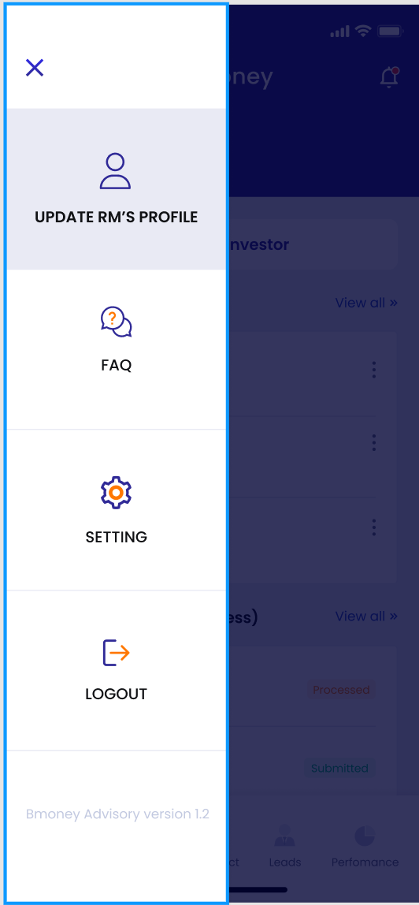

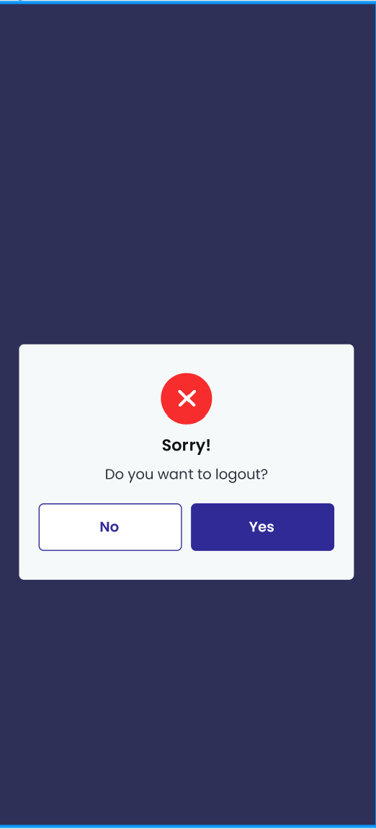

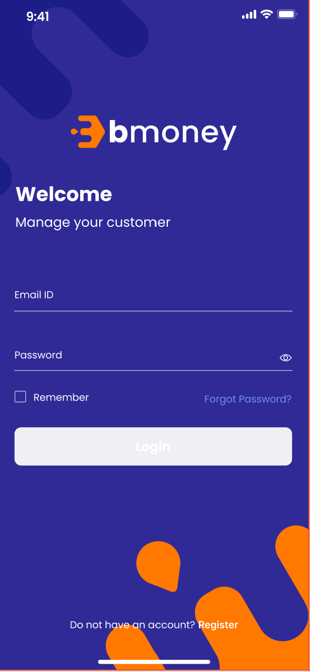

1. **Authorized User**

Existing active user

1. **Entry Point**

Menu page

1. **Exit Point**

Log in page

1. **Process Flow**
2. Users can access logout by pressing on the  button
3. Users can log out by pressing the logout button.
4. Users confirm to log out on the pop up
5. After pressing logout, will bounce to the login page
6. **Fields and Validations and Verifications**

|  |  |  |  |  |  |  |
| --- | --- | --- | --- | --- | --- | --- |
| **Field** | **Field Type** | **Description** | **Field Length** | **Mandatory** | **Validation** | **In-Line Error Message** |
| Update RM profile | Button | Button to access RM profile | - | Yes |  |  |
| FAQ | Button | Button to access FAQ | - | Yes |  |  |
| Setting | Button | Button to access Setting | - | Yes |  |  |
| Logout | Button | Tap on to trigger confirm popup | - | Yes |  |  |
| Confirm Popup | | | | | | |
| Yes | Button | Button to log out of application and return to log in screen | - | Yes |  |  |
| No | Button | Button to exit current screen and return to previous screen | - | Yes |  |  |

1. **Messaging Requirement**

Follow the table above

1. **Reference User Story**

N/A

#### ****User story 29 – Setting****

As an existing active user, I want to be able to access Setting of the application

**Acceptance Criteria**

1. **Page flow**

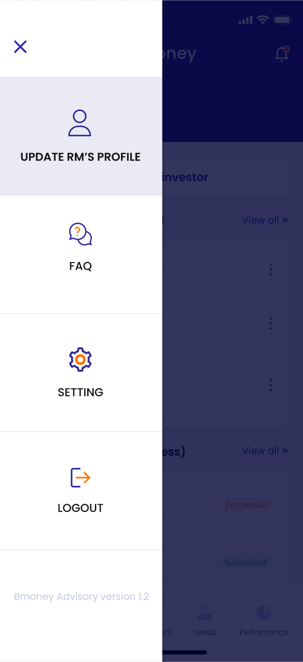

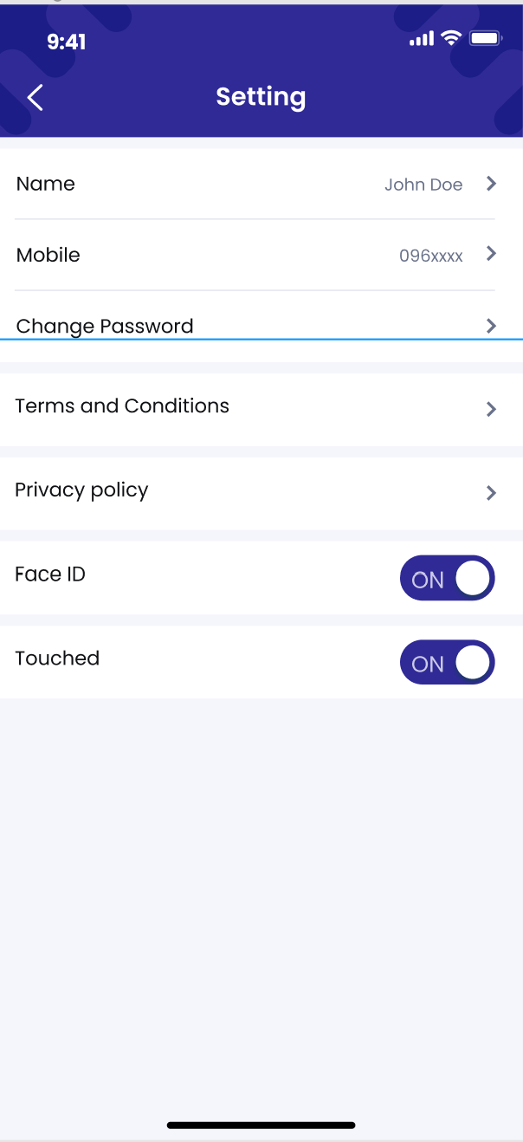

1. **Authorized User**

Existing active user

1. **Entry Point**

Menu page

1. **Exit Point**

Setting page

1. **Process Flow**
2. Users can access setting by pressing on the  button
3. User can select Change name, change mobile phone, turn on/off faceid/touched, change password, Privacy Policy, terms and conditions,
4. **Fields and Validations and Verifications**

|  |  |  |  |  |  |  |
| --- | --- | --- | --- | --- | --- | --- |
| **Field** | **Field Type** | **Description** | **Field Length** | **Mandatory** | **Validation** | **In-Line Error Message** |
| Change name | Button | Change user name | - | Yes |  |  |
| Change password | Button | Link to change password workflow | - | Yes |  |  |
| Change mobile phone | Button | Change mobile phone | - | Yes |  |  |
| turn on/off faceid/touched | Button | To turn on or off faceid/touched | - | Yes |  |  |
| Privacy Policy | Button | Open Privacy Policy pdf | - | Yes |  |  |
| terms and conditions | Button | Open terms and conditions pdf | - | Yes |  |  |
| <- | Button | Button to exit current screen and return to previous screen | - | Yes |  |  |

1. **Messaging Requirement**

Follow the table above

1. **Reference User Story**

N/A

#### ****User story 30 – Setting – Change Name****

As an existing active user, I want to be able to access Setting and change Name

**Acceptance Criteria**

1. **Page flow**





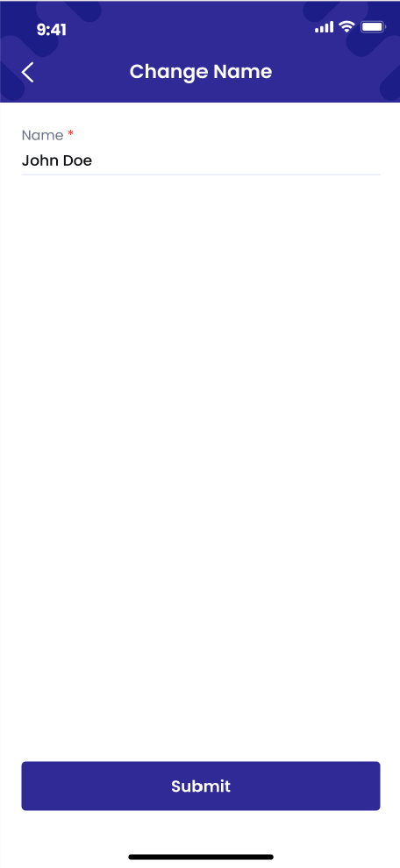

1. **Authorized User**

Existing active user

1. **Entry Point**

Menu page

1. **Exit Point**

Setting page

1. **Process Flow**
2. Users can access setting by pressing on the  button
3. User can select Change name
4. User change name
5. User press submit
6. **Fields and Validations and Verifications**

|  |  |  |  |  |  |  |
| --- | --- | --- | --- | --- | --- | --- |
| **Field** | **Field Type** | **Description** | **Field Length** | **Mandatory** | **Validation** | **In-Line Error Message** |
| Change name | Button | Change user name | - | Yes |  |  |
| Change password | Button | Link to change password workflow | - | Yes |  |  |
| Change mobile phone | Button | Change mobile phone | - | Yes |  |  |
| turn on/off faceid/touched | Button | To turn on or off faceid/touched | - | Yes |  |  |
| Privacy Policy | Button | Open Privacy Policy pdf | - | Yes |  |  |
| terms and conditions | Button | Open terms and conditions pdf | - | Yes |  |  |
| <- | Button | Button to exit current screen and return to previous screen | - | Yes |  |  |
| Change Name Page | | | | | | |
| Name | Field | Fill in the new name | - | Yes |  |  |
| Submit | Button | Submit button to update the name | - | Yes |  |  |
| <- | Button | Button to exit current screen and return to previous screen | - | Yes |  |  |

1. **Messaging Requirement**

Follow the table above

1. **Reference User Story**

N/A

#### ****User story 31 – Setting – Change Mobile****

As an existing active user, I want to be able to access Setting and change Mobile

**Acceptance Criteria**

1. **Page flow**





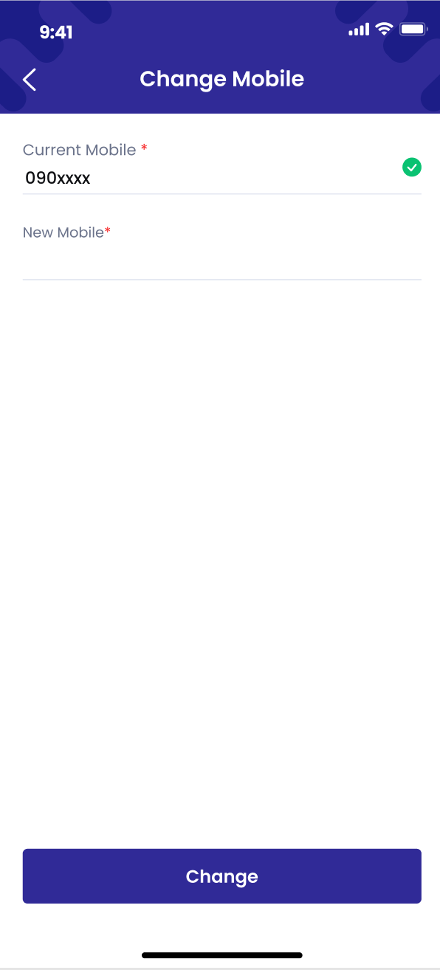

1. **Authorized User**

Existing active user

1. **Entry Point**

Menu page

1. **Exit Point**

Setting page

1. **Process Flow**
2. Users can access setting by pressing on the  button
3. User can select Change mobile
4. User change mobile
5. User press submit
6. **Fields and Validations and Verifications**

|  |  |  |  |  |  |  |
| --- | --- | --- | --- | --- | --- | --- |
| **Field** | **Field Type** | **Description** | **Field Length** | **Mandatory** | **Validation** | **In-Line Error Message** |
| Change name | Button | Change user name | - | Yes |  |  |
| Change password | Button | Link to change password workflow | - | Yes |  |  |
| Change mobile phone | Button | Change mobile phone | - | Yes |  |  |
| turn on/off faceid/touched | Button | To turn on or off faceid/touched | - | Yes |  |  |
| Privacy Policy | Button | Open Privacy Policy pdf | - | Yes |  |  |
| terms and conditions | Button | Open terms and conditions pdf | - | Yes |  |  |
| <- | Button | Button to exit current screen and return to previous screen | - | Yes |  |  |
| Change Mobile Page | | | | | | |
| Current Mobile | Field | Current mobile | - | Yes | Cannot be edit |  |
| New Mobile | Field | Fill in the new mobile |  |  |  |  |
| Submit | Button | Submit button to update the mobile | - | Yes |  |  |
| <- | Button | Button to exit current screen and return to previous screen | - | Yes |  |  |

1. **Messaging Requirement**

Follow the table above

1. **Reference User Story**

N/A

#### ****User story 32 – Setting – Change Password****

As an existing active user, I want to be able to access Setting and change password

**Acceptance Criteria**

1. **Page flow**





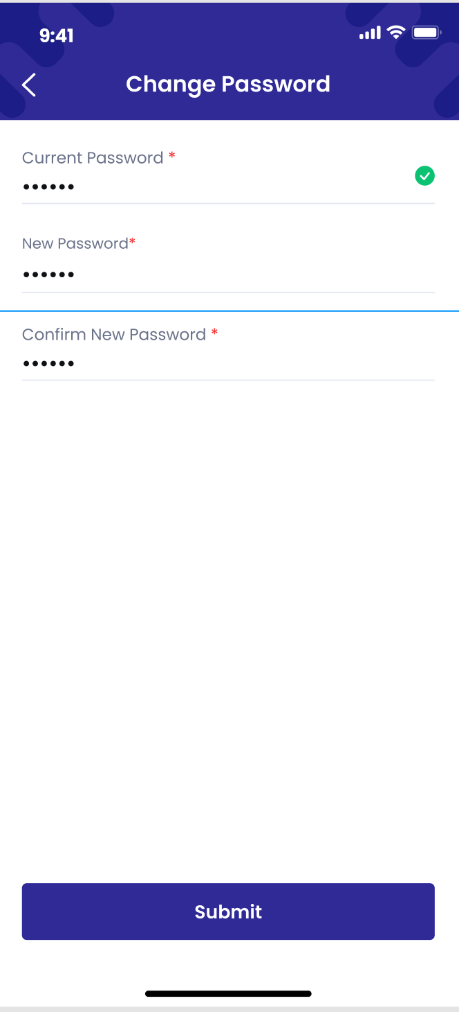

1. **Authorized User**

Existing active user

1. **Entry Point**

Menu page

1. **Exit Point**

Setting page

1. **Process Flow**
2. Users can access setting by pressing on the  button
3. User can select Change Password
4. User fill in current password
5. User fill in new password
6. User fill in confirm new password
7. User press submit
8. **Fields and Validations and Verifications**

|  |  |  |  |  |  |  |
| --- | --- | --- | --- | --- | --- | --- |
| **Field** | **Field Type** | **Description** | **Field Length** | **Mandatory** | **Validation** | **In-Line Error Message** |
| Change name | Button | Change user name | - | Yes |  |  |
| Change password | Button | Link to change password workflow | - | Yes |  |  |
| Change mobile phone | Button | Change mobile phone | - | Yes |  |  |
| turn on/off faceid/touched | Button | To turn on or off faceid/touched | - | Yes |  |  |
| Privacy Policy | Button | Open Privacy Policy pdf | - | Yes |  |  |
| terms and conditions | Button | Open terms and conditions pdf | - | Yes |  |  |
| <- | Button | Button to exit current screen and return to previous screen | - | Yes |  |  |
| Change Password Page | | | | | | |
| Current Password | Field | Fill in the Current PW | - | Yes |  |  |
| New Password | Field | Fill in the new PW | - | Yes |  |  |
| Confirm New Password | Field | Fill in the new PW | - | Yes |  |  |
| Submit | Button | Submit button to update the password | - | Yes |  |  |
| <- | Button | Button to exit current screen and return to previous screen | - | Yes |  |  |

1. **Messaging Requirement**

Follow the table above

1. **Reference User Story**

N/A

#### ****User story 33 – Setting – Terms and conditions****

As an existing active user, I want to be able to access Setting and view terms and conditions

**Acceptance Criteria**

1. **Page flow**





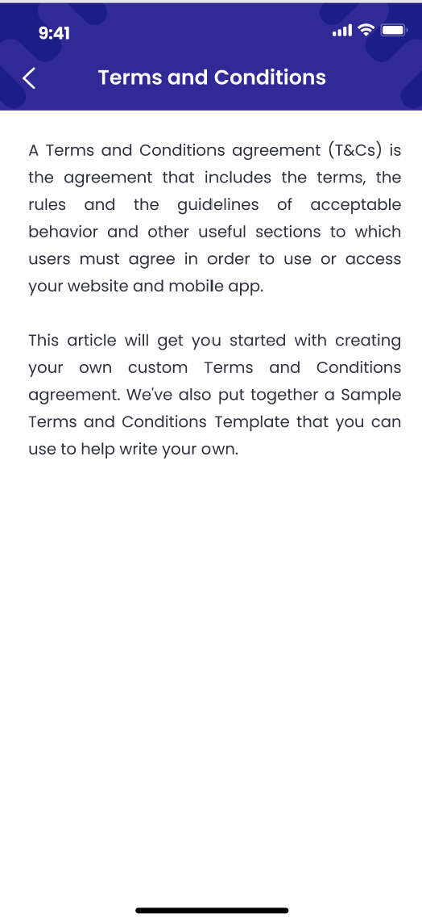

1. **Authorized User**

Existing active user

1. **Entry Point**

Menu page

1. **Exit Point**

Setting page

1. **Process Flow**
2. Users can access setting by pressing on the  button
3. User can select terms and conditions
4. **Fields and Validations and Verifications**

|  |  |  |  |  |  |  |
| --- | --- | --- | --- | --- | --- | --- |
| **Field** | **Field Type** | **Description** | **Field Length** | **Mandatory** | **Validation** | **In-Line Error Message** |
| Change name | Button | Change user name | - | Yes |  |  |
| Change password | Button | Link to change password workflow | - | Yes |  |  |
| Change mobile phone | Button | Change mobile phone | - | Yes |  |  |
| turn on/off faceid/touched | Button | To turn on or off faceid/touched | - | Yes |  |  |
| Privacy Policy | Button | Open Privacy Policy pdf | - | Yes |  |  |
| terms and conditions | Button | Open terms and conditions pdf | - | Yes |  |  |
| <- | Button | Button to exit current screen and return to previous screen | - | Yes |  |  |
| Terms and conditions page | | | | | | |
| <- | Button | Button to exit current screen and return to previous screen | - | Yes |  |  |

1. **Messaging Requirement**

Follow the table above

1. **Reference User Story**

N/A

#### ****User story 34 – Setting – Private Policy****

As an existing active user, I want to be able to access Setting and view **Private Policy**

**Acceptance Criteria**

1. **Page flow**





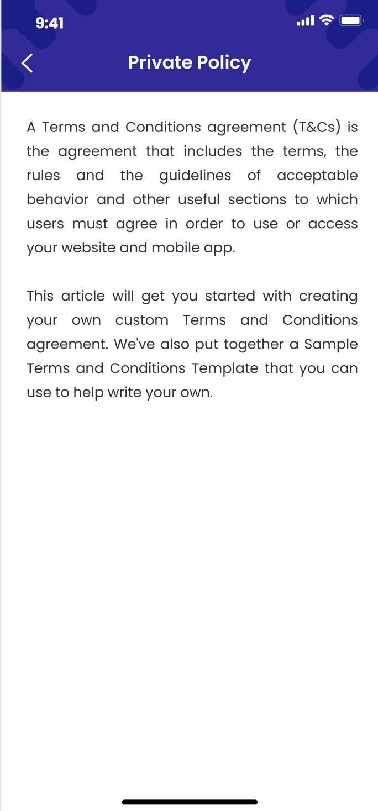

1. **Authorized User**

Existing active user

1. **Entry Point**

Menu page

1. **Exit Point**

Setting page

1. **Process Flow**
2. Users can access setting by pressing on the  button
3. User can select **Private Policy**
4. **Fields and Validations and Verifications**

|  |  |  |  |  |  |  |
| --- | --- | --- | --- | --- | --- | --- |
| **Field** | **Field Type** | **Description** | **Field Length** | **Mandatory** | **Validation** | **In-Line Error Message** |
| Change name | Button | Change user name | - | Yes |  |  |
| Change password | Button | Link to change password workflow | - | Yes |  |  |
| Change mobile phone | Button | Change mobile phone | - | Yes |  |  |
| turn on/off faceid/touched | Button | To turn on or off faceid/touched | - | Yes |  |  |
| Privacy Policy | Button | Open Privacy Policy pdf | - | Yes |  |  |
| terms and conditions | Button | Open terms and conditions pdf | - | Yes |  |  |
| <- | Button | Button to exit current screen and return to previous screen | - | Yes |  |  |
| **Private Policy** page | | | | | | |
| <- | Button | Button to exit current screen and return to previous screen | - | Yes |  |  |

1. **Messaging Requirement**

Follow the table above

1. **Reference User Story**

N/A

#### ****User story 35 – View FAQ/User manual****

As an existing active user, I want to be able to access FAQ

**Acceptance Criteria**

1. **Page flow**
2. **Authorized User**

Existing active user

1. **Entry Point**

Setting page

1. **Exit Point**

Faq Page

1. **Process Flow**

Users can access setting by pressing on the  button

User can select to

* Check FAQ

1. **Fields and Validations and Verifications**

|  |  |  |  |  |  |  |
| --- | --- | --- | --- | --- | --- | --- |
| **Field** | **Field Type** | **Description** | **Field Length** | **Mandatory** | **Validation** | **In-Line Error Message** |
| Update RM profile | Button | Button to access RM profile | - | Yes |  |  |
| FAQ | Button | Button to access FAQ | - | Yes |  |  |
| Setting | Button | Button to access Setting | - | Yes |  |  |
| Logout | Button | Button to trigger the Logout function.  If logout successful, go to log in page | - | Yes |  |  |
| FAQ page | | | | | | |
| <- | Button | Button to exit current screen and return to previous screen | - | Yes |  |  |

1. **Messaging Requirement**

Follow the table above

1. **Reference User Story**

N/A

#### ****User story 36 – Admin/Update FAQ****

As an existing admin, I want to be able to update FAQ page

**Acceptance Criteria**

1. **Page flow**

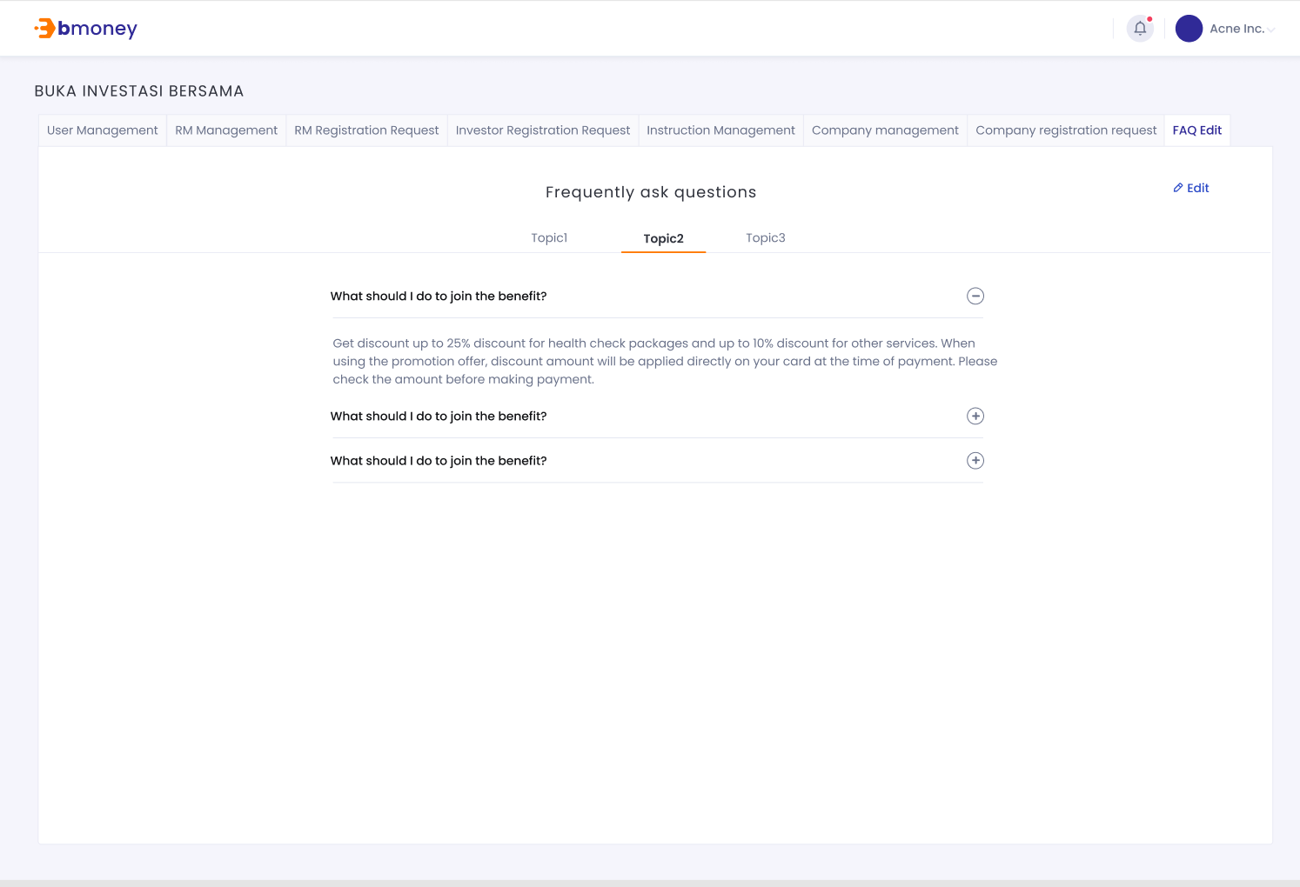

1. **Authorized User**

Existing active admin

1. **Entry Point**

FAQ page

1. **Exit Point**

FAQ Page

1. **Process Flow**

* Users can access Faq edit page
* User can then select edit to edit the FAQ page

1. **Fields and Validations and Verifications**

|  |  |  |  |  |  |  |
| --- | --- | --- | --- | --- | --- | --- |
| **Field** | **Field Type** | **Description** | **Field Length** | **Mandatory** | **Validation** | **In-Line Error Message** |
| Edit | Button | Button to start edit the page | - | Yes |  |  |

1. **Messaging Requirement**

Follow the table above

1. **Reference User Story**

N/A

### Notification

#### ****User story 37 – KYC management/ In-app, email notification for HNWI KYC status update****

As an existing active user, I want to be informed when my investor’s signature is submitted and whether the application is approved/ rejected

**Acceptance Criteria**

Admin change KYC status on dashboard

1. **Page flow**

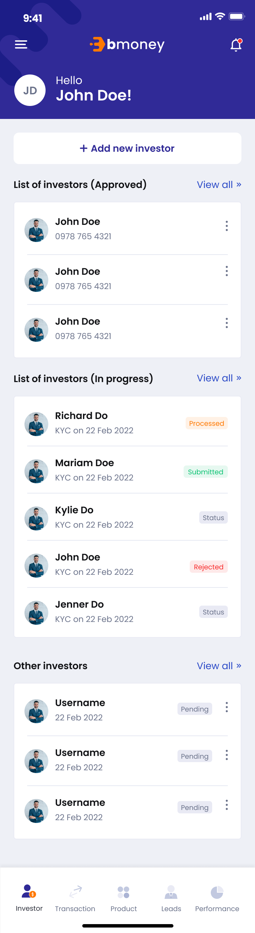 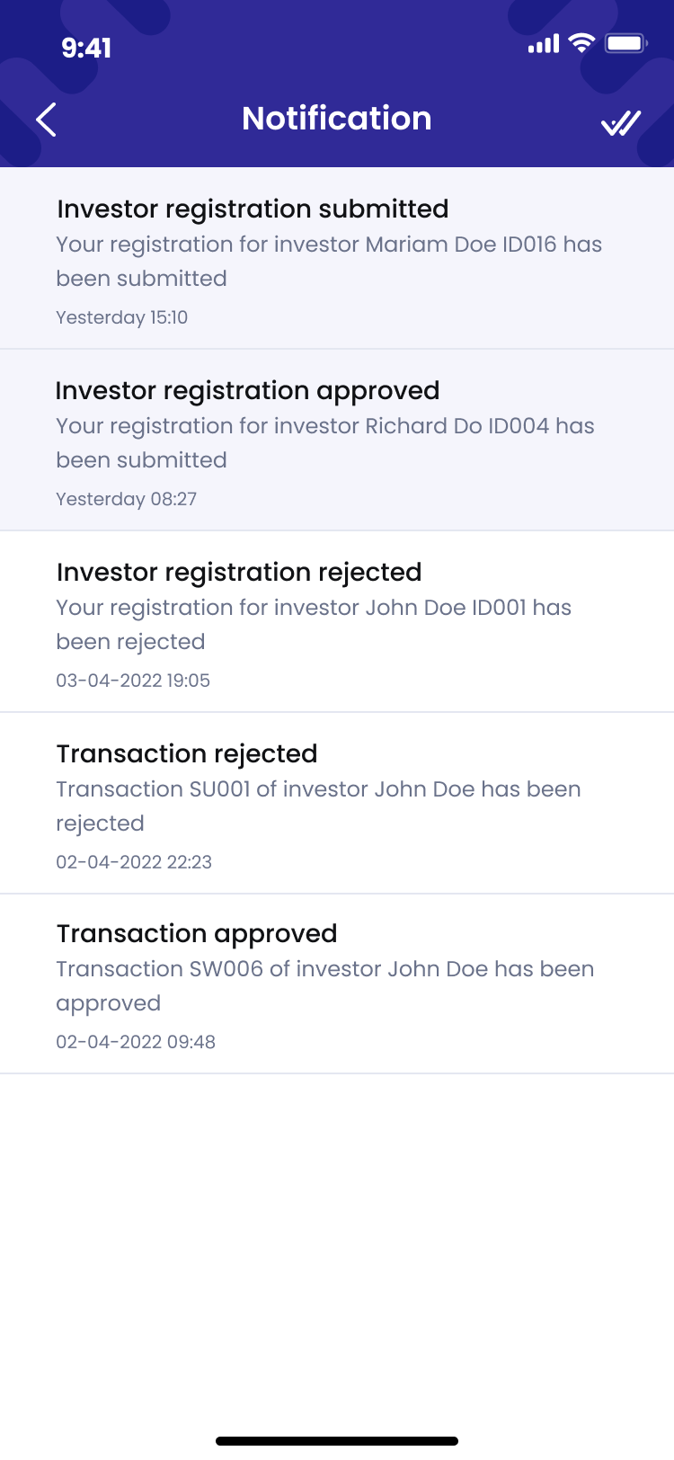 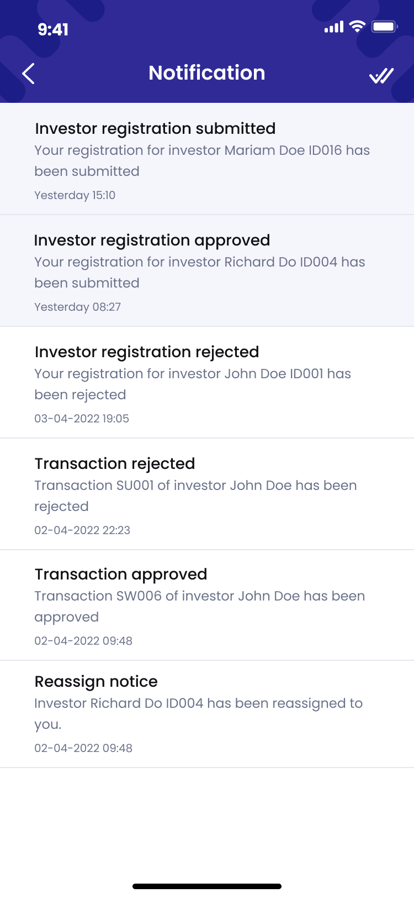

1. **Authorized User**

Existing active user

1. **Entry Point**

Home page

1. **Exit Point**

Notification board

1. Process flow

In-app notification

* 1. After the admin approve/ reject the submission, the user will be notified
  2. From homepage, users can tap on the  button to open the notification board
  3. User can tap on the notification message to enter the manage investors page and see the investor detail
  4. From the notification board, users can tap on  to mark all notifications as read
  5. From the notification board, users can tap on  to go back to Homepage

Email notification

1. After the admin approve/ reject the submission, the user will be notified through email
2. The email will be sent to RM with format:

* Submitted

Dear Mr/Ms [Full name], Thank you for joining our Bmoney service.

Your registration for investor [Investor Name] [Investor ID] has been submitted.

If you have any questions please contact us at [[Email Address]](mailto:xxxx@gmail.com).

Best regards,

Bmoney team.

* Signature Submission

Dear Mr/Ms [Full name]

Your investor [Investor Name] [Investor ID] has agreed with T&C and submitted his/ her e-signature

If you have any questions please contact us at [[Email Address]](mailto:xxxx@gmail.com).

Best regards,

Bmoney team

* Approved  
  Dear Mr./Ms. [Full name],

Your registration for investor [Investor Name] [Investor ID] has been approved.

If you have any questions please contact us at [[Email Address]](mailto:xxxx@gmail.com).

Best regards,

Bmoney team

* Rejected

Dear Mr/Ms [Full name],

Your registration for investor [Investor Name] [Investor ID] has been rejected.

If you have any questions please contact us at [[Email Address]](mailto:xxxx@gmail.com).

Best regards,

The Bmoney Team

1. **Fields and Validations and Verifications**

|  |  |  |  |  |  |  |
| --- | --- | --- | --- | --- | --- | --- |
| **Field** | **Field Type** | **Description** | **Field Length** | **Mandatory** | **Validation** | **In-Line Error Message** |
|  | Button | Tap on to open notification list | - | Yes |  |  |
| **Notification board** | | | | | | |
| Notification | Label | Notification label | - | Yes |  |  |
| Notification message | Text field | Notification message | - | Yes |  | Your registration for investor “Investor Name” “Investor ID” has been submitted/ approved/ rejected |
| Icon  Description automatically generated button | Button | Tap on to go back to the previous page (Home) | - | Yes |  |  |
| button | Button | Mark all messages as read button | - | Yes |  |  |
| **Investor details** | | | | | | |
| Manage investor | Label | Manage investor label  [Full name]  SID: [SID number] | - | Yes |  |  |
| Investor info | Tab button | Tap on to enter Manage investor/Investor info | - | Yes |  |  |
| Portfolio | Tab button | Tap on to enter Manage investor/Portfolio | - | Yes |  |  |
| Transaction | Tab button | Tap on to enter Manage investor/Transaction | - | Yes |  |  |
| IFUA | Text field |  | - | Yes |  |  |
| NIK | Text field | NIK: Customs Identification Number | - | Yes |  |  |
| Agent | Text field |  | - | Yes |  |  |
| Email | Text field | Email of the investor | - | Yes |  |  |
| Update info button | Button | Tap on to enter Update info page | - | Yes |  |  |
| Last update | Text field | Last update [last update date], [last update time] | - | Yes |  |  |
| Edit information | Label | Edit information  [Investor name] | - | Yes |  |  |

1. **Messaging Requirement**
2. **Reference User Story**

User story 5, 6

#### ****User story 38 – KYC management/ Email notification to investor for HNWI KYC status update****

As an investor, I want to be informed when my HNWI KYC is submitted/ approved/ rejected

**Acceptance Criteria**

Admin change KYC status on dashboard

1. **Page flow**
2. **Authorized User**

Existing active investor

1. **Entry Point**
2. **Exit Point**
3. **Process Flow**
   1. After the admin approve/ reject the submission, the user will be notified through email
   2. The email will be sent to investor with format:

* Submitted

Dear Mr/Ms [Full name], Thank you for joining our Bmoney service.

An account for you had been created by our RM [RM Full Name].

If you have any questions please contact us at [[Email Address]](mailto:xxxx@gmail.com).

Best regards,

Bmoney team.

* Signature Submission

Dear Mr/Ms [Full name]

Thank you for joining our Bmoney service.

Here is our terms and conditions: xxxxx.com/123435346

If you agree with our terms and conditions, please submit your e-signature Kindly follow the below link to submit your e-signature: [xxxxx.com/123435346](http://xxxxx.com/123435346) If you have any questions please contact us at [[Email Address]](mailto:xxxx@gmail.com).

Best regards,

Bmoney team

* Approved  
  Dear Mr./Ms. [Full name],

Your application to join Bmoney service has been approved.

If you have any questions please contact us at [[Email Address]](mailto:xxxx@gmail.com).

Best regards,

Bmoney team

* Rejected

Dear Mr/Ms [Full name],

Thanks for joining our Bmoney service.

Our apologize but your application to join our Bmoney service had been rejected.

If you have any questions please contact us at [[Email Address]](mailto:xxxx@gmail.com).

Best regards,

The Bmoney Team

1. **Fields and Validations and Verifications**
2. **Messaging Requirement**
3. **Reference User Story**

User story 5, 6

#### ****User story 39 – Transaction Management/ In-app notification for transaction status update****

As an existing active user, I want to be informed when the transaction I create is being processed/ approved/ rejected

**Acceptance Criteria**

Admin change transaction status on dashboard

1. **Page flow**

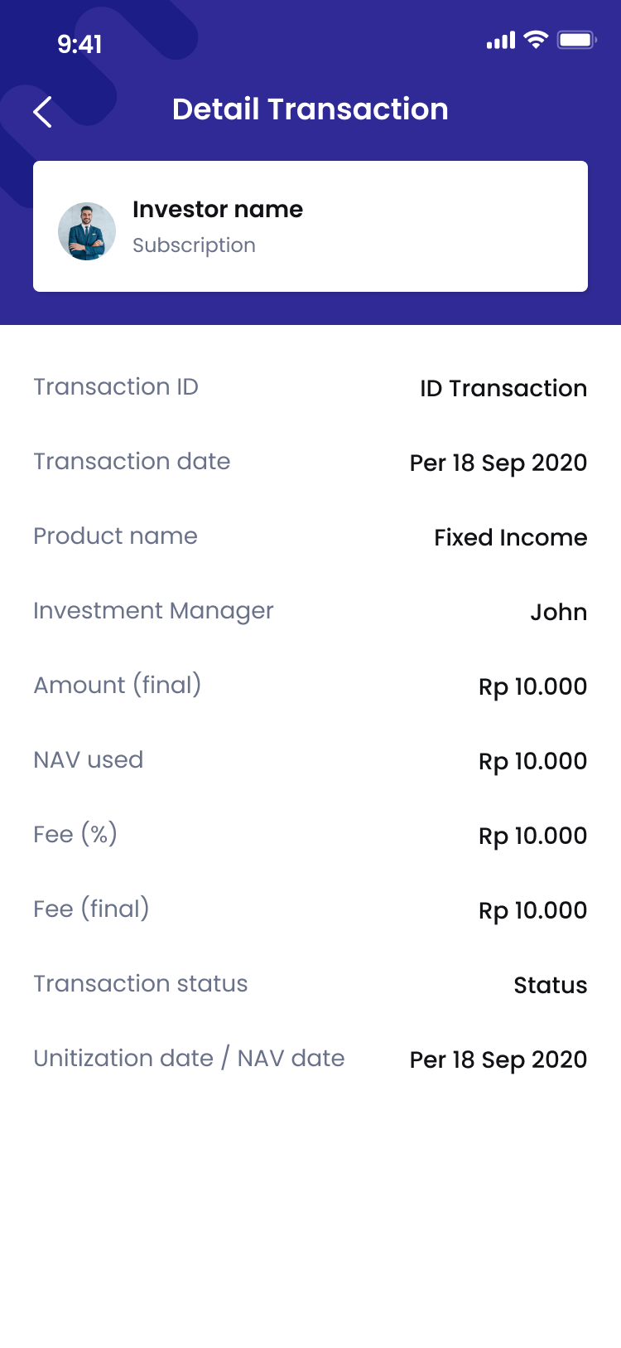

1. **Authorized User**

Existing active user

1. **Entry Point**

Home page

1. **Exit Point**

Notification board

1. **Process Flow**
2. After the admin receive and start processing the submission, the user will be notified
3. From homepage, users can tap on the  button to open the notification board
4. User can tap on the notification message to enter the transaction page and see the transaction details
5. From the notification board, users can tap on  to mark all notifications as read
6. From the notification board, users can tap on  to go back to Homepage
7. **Fields and Validations and Verifications**

|  |  |  |  |  |  |  |
| --- | --- | --- | --- | --- | --- | --- |
| **Field** | **Field Type** | **Description** | **Field Length** | **Mandatory** | **Validation** | **In-Line Error Message** |
|  | Button | Tap on to open notification list | - | Yes |  |  |
| **Notification board** | | | | | | |
| Notification | Label | Notification label | - | Yes |  |  |
| Notification message | Text field | Notification message | - | Yes |  | Your registration for investor “Investor Name” “Investor ID” has been submitted/ approved/ rejected |
| Icon  Description automatically generated button | Button | Tap on to go back to the previous page (Home) | - | Yes |  |  |
| button | Button | Mark all messages as read button | - | Yes |  |  |

**Transaction Details (Subcription/ Redemption)**

|  |  |  |  |  |  |  |
| --- | --- | --- | --- | --- | --- | --- |
| **Field** | **Field Type** | **Description** | **Field Length** | **Mandatory** | **Validation** | **In-Line Error Message** |
| Detail Transaction | Label | Transaction Details | - | Yes |  |  |
| **Investor info tab** | | | | | | |
| Investor Name | Text field | Full name of investor | - | Yes |  |  |
| Transaction Type | Text field | Type of transaction   * Subscription * Redemption * Switching | - | Yes |  |  |
| Status | Label | Status of transaction | - | Yes |  |  |
| Transaction ID | Text field | ID of transaction |  | Yes |  |  |
| Product Name | Text field | Name of product | - | Yes |  |  |
| Investment Manager | Text field | Name of investment manager | - | Yes |  |  |
| Amount (final) | Numbberic input | Amount | - |  |  |  |
| NAV | Numeric field | NAV of the product at the moment | - | Yes |  |  |
| Fee (%) | Numeric input | Fee  The amount of fee for RM when this transaction is approved  Auto generated default fee after entering valid Product  User can edit the fee for each transaction | String (3) | Yes |  |  |
| Fee (final) | Numeric input | The final fee of the transaction | - | Yes |  |  |
| Transaction status | Text field | Status of transaction | - | Yes |  |  |
| Unitization date/ NAV date | Date |  | - | Yes |  |  |
| Icon  Description automatically generatedbutton | Button | Icon  Description automatically generated button, tap on the button to go back to transaction list page | - | Yes |  |  |

**Transaction Details (Switching)**

|  |  |  |  |  |  |  |
| --- | --- | --- | --- | --- | --- | --- |
| **Field** | **Field Type** | **Description** | **Field Length** | **Mandatory** | **Validation** | **In-Line Error Message** |
| Detail Transaction | Label | Transaction Details | - | Yes |  |  |
| **Investor info tab** | | | | | | |
| Investor Name | Text field | Full name of investor | - | Yes |  |  |
| Transaction Type | Text field | Type of transaction   * Subscription * Redemption   Switching | - | Yes |  |  |
| Status | Label | Status of transaction | - | Yes |  |  |
| Transaction ID | Text field | ID of transaction |  | Yes |  |  |
| Switch out Product | Text field | Name of switch out product | - | Yes |  |  |
| Switch in Product Name | Text field | Name of switch in product | - | Yes |  |  |
| Investment Manager | Text field | Name of investment manager | - | Yes |  |  |
| Amount (final) | Numbberic input | Amount | - |  |  |  |
| NAV | Numeric field | NAV of the product at the moment | - | Yes |  |  |
| Fee (%) | Numeric input | Fee  The amount of fee for RM when this transaction is approved  Auto generated default fee after entering valid Product  User can edit the fee for each transaction | String (3) | Yes |  |  |
| Fee (final) | Numeric input | The final fee of the transaction | - | Yes |  |  |
| Fee type | Text field | Type of fee   * Switch out * Switch in | - | Yes |  |  |
| Transaction status | Text field | Status of transaction | - | Yes |  |  |
| Unitization date/ NAV date | Date |  | - | Yes |  |  |
| Icon  Description automatically generatedbutton | Button | Icon  Description automatically generated button, tap on the button to go back to transaction list page | - | Yes |  |  |

1. **Messaging Requirement**
2. **Reference User Story**

User story 8,9,10

#### ****User story 40 – Transaction management/ Email notification to investor for transaction status update****

As an investor, I want to be informed when my transaction is submitted/ approved/ rejected

**Acceptance Criteria**

Admin change transaction status on dashboard

1. **Page flow**
2. **Authorized User**

Existing active investor

1. **Entry Point**
2. **Exit Point**
3. **Process Flow**
   1. After the transaction is successfully submitted, admin approve/ reject the transaction, the investor will be notified through email
   2. The email will be sent to investor with format:

* Submitted

Dear Mr./Ms. [Full name],

Your relationship manager has sent you an instruction for transaction. Please click on this URL to view the detail and approve/reject the transaction: [URL] If you have any further question, please contact our admin service via email address: [Email adress].

Best regards,

The Bmoney team.

* Approved  
  Dear Mr./Ms. [Full name],

Your instruction [Instruction ID] has been approved. If you have any further question, please contact our admin service via email address: [Email adress].

Best regards,

The Bmoney Team

* Rejected

Dear Mr./Ms. [Full name],

Your instruction [Instruction ID] has been rejected.

If you have any further question, please contact our admin service via email address: [Email adress].

Best regards,

The Bmoney Team

1. **Fields and Validations and Verifications**
2. **Messaging Requirement**
3. **Reference User Story**

User story 5, 6